An approach for fabrication of Quad Pixel Modules

Definitions

Hybrid: flexible printed circuit board with polyimide as a base material.
Silicon assembly: four FE-I4B readout ASICs bump bonded to silicon pixel sensor.
Quad Pixel Module: hybrid and Silicon package glued together.

Introduction

A special hybrid circuit board [1] has been designed to interface pixel readout chips [2] to data acquisition system of the ATLAS Detector [3]. Each of these hybrids attached to a silicon assembly comprising four FE-I4B integrated circuits flip-chip bump bonded to one planar silicon pixel sensor [4] forms a Quad Pixel Module.

Several methods have been considered for bonding hybrids and silicon assemblies [5], [6], [7] all with various degree of complexity, trade-offs and success rate. This paper describes what is believed to be the simplest and very reliable approach based on paper laminate. Detailed specs for necessary tooling are also given.

Semiconductor grade epoxy recommended for production of Quad Pixel Modules is Epolite FH 5313A [8]. It sets in approximately 6 hours at room temperature. The design of a jig for holding glued parts together considered long curing time with regards to risks of edge wetting associated with glue viscosity and possible temperature variations. Due to complexity and costs of components, especially bump bonded silicon assembly, it was decided to glue each module on an individual jig whose design simplicity allows for provision of sufficient number of jigs to cope with the module production schedule for the ATLAS upgrade [9].

Gluing method

"Amplitude C6-99" paper impregnated with Epolite FH 5313A adhesive is being used to bind hybrid to the silicon assembly. Long staple fibres of this paper form a firm mesh to control the amount of adhesive near hybrid edges to avoid their wetting and contamination of wire bond pads. The uniform thickness of laminate material helps to keep the hybrid flat during glue curing period that in turn ensures high yield and reliability of bond wires connecting readout ASICs to the PCB. C6-99 paper benefits from moderate sodium ion content together with low extractable levels [10] with regards to radiation effects in constituents of the Quad Pixel Module.

Fibre-epoxy composite improves thermal performance of the Quad Pixel Module compared to gluing methods based on bare adhesive. Large mismatch in thermal expansion coefficient of epoxy resins (ranging between 50 and 100 ppm/K), polyimide (20 ppm/K) and silicon (3 ppm/K) causes mechanical stress to the latter impacting its properties and performance. Irradiated sensors have to stand bias voltages in excess of 1 kV for bulk depletion sufficient enough to register ionising particles. Any strain-induced defects in the silicon crystal are likely to raise its leakage current resulting in early breakdown and thermal runaway. In addition, thermal cycling of Pixel Modules between -55 C and +60 C required by ATLAS Local Support Design Parameters creates risk of PCB delaminating and as a consequence failure of bond wires due to shear strain from large mismatch in CTE of module's constituents. References [11] and [12] show that non-woven epoxy composite has its lateral CTE (in machine direction) just slightly above that of the laminate material in the broad range of its fibre volume. It suggests that low density C6-99 paper with 16 g/m2 basis weigh and CTE in order of 5..7 ppm/K should keep the CTE of epoxy composite under 20 ppm/K thus making it a perfect thermal interface between silicon assembly and polyimide PCB. Thermal expansion of composite in transverse direction for approximately 50um thick paper could be neglected. Experimental tests are being prepared to compare peel strength of hybrids glued with and without paper laminate. Samples will be irradiated by 60 MeV protons to doses up to 1e16 cm-2 and thermally cycled in accordance with ATLAS design rules.

Depleting of the silicon pixel sensor requires bias voltage up to 1.5 kV applied to aluminised detector’s backplane to which the hybrid is glued. The glue layer should therefore provide adequate electrical insulation for the HV creepage. This could easily be achieved with epoxy composite material whose uniform thickness ensures insulation gap between hybrid and silicon. In addition, hybrid surface could be made sufficiently flat for wire bonding if some pressure were applied to the glued parts with fibre mesh as a spacer and for retaining glue between them.

Gluing Jig

The tool for gluing contains 5 parts shown in figure 1. Base plate (part 1) is being used to support and align further components by means of two dowel pins. Perspex is an affordable DIY option for making the plate. If elevated temperature curing is considered then carbon fibre, plywood, mild steel or some aluminium alloys are recommended material for the plate because of their moderate CTE.

"Amplitude C6-99" paper cushion (part 2) between the base plate and silicon protects the latter from mechanical stress caused potentially by rough contact surfaces.

Paper guide (part 3) resting on the base plate has a rectangle cut for precise positioning of a silicon assembly which fits perfectly into a tailored aperture. Paper thickness is chosen to be roughly equal to that of the readout ASICs to support overhanging edges of the silicon sensor, figure 2. Paper frame (part 4) secures the laminate leaf (part 5) in exact position on top of the silicon pixel sensor.

Parts 2 to 5 have routinely being produced using Silhouette CAMEO 3 desktop cutting machine with auto adjust blade and low tack carrier sheet [13].
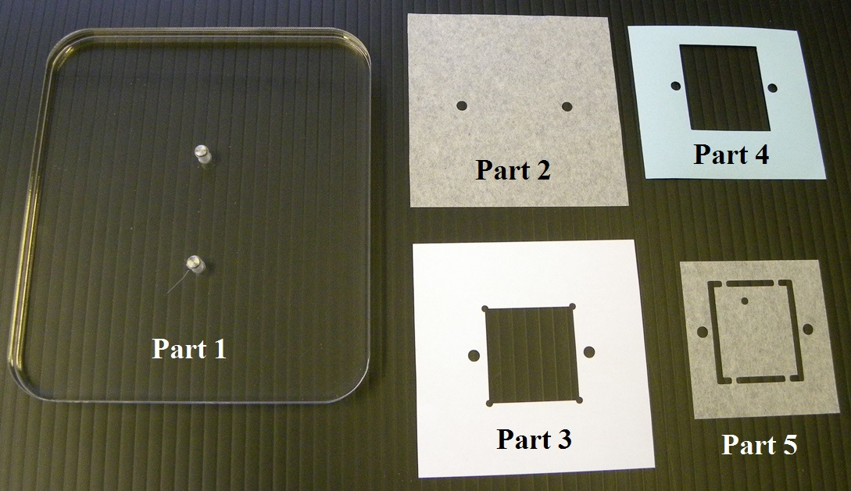

Figure 1 | Parts of the gluing jig: base plate (1), cushion (2), guide (3),  frame (4), laminate leaf (5).

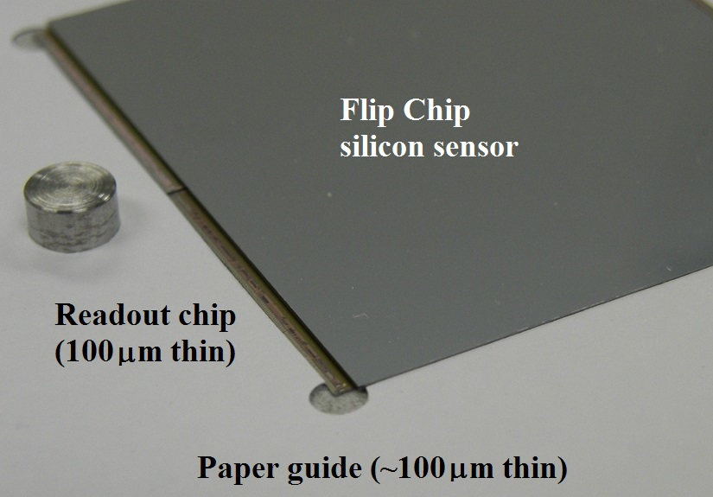

Picture 2 | Alignment of silicon assembly by means of the paper guide: four readout ASICs insert into rectangle opening in a paper shim whose thickness is chosen to support overhanging edges of the pixel sensor.
Gluing Procedure

The following pictures will demonstrate step by step an assembly workflow:

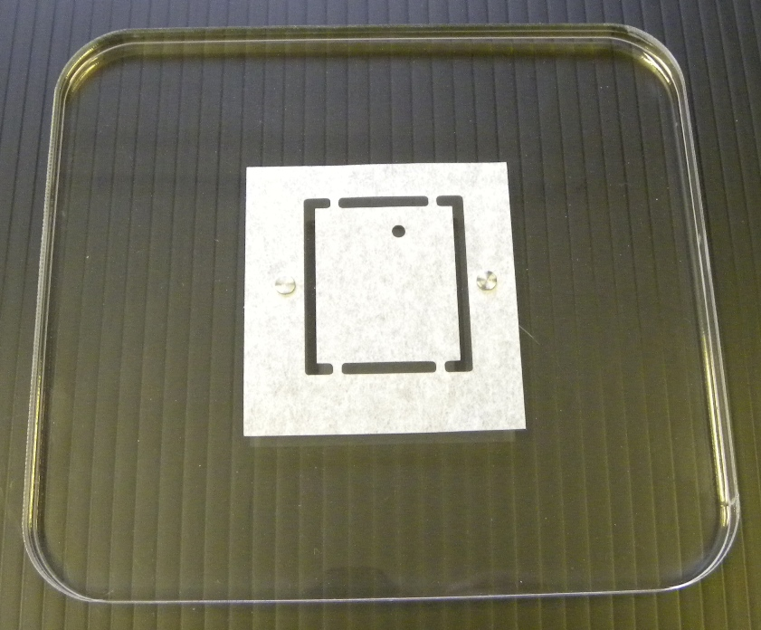

Step 1. Place laminate leaf (part 5) face down on the base plate (part 1).

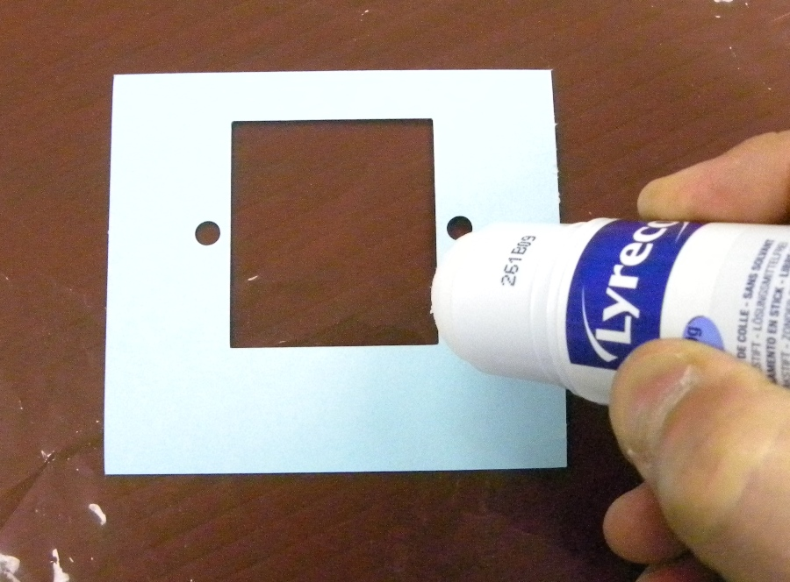

Step 2. Apply glue sparingly to the frame (part 4)
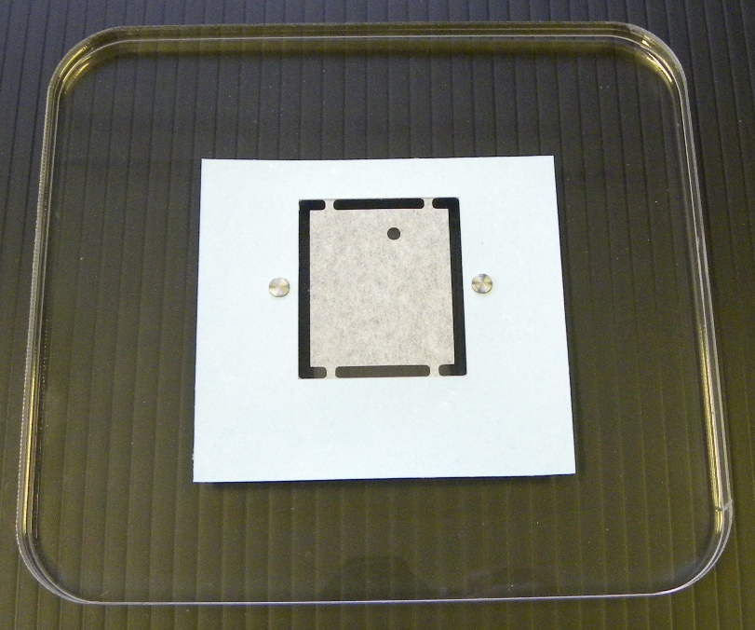

Step 3. Place the frame with glue facing down onto laminate leaf.

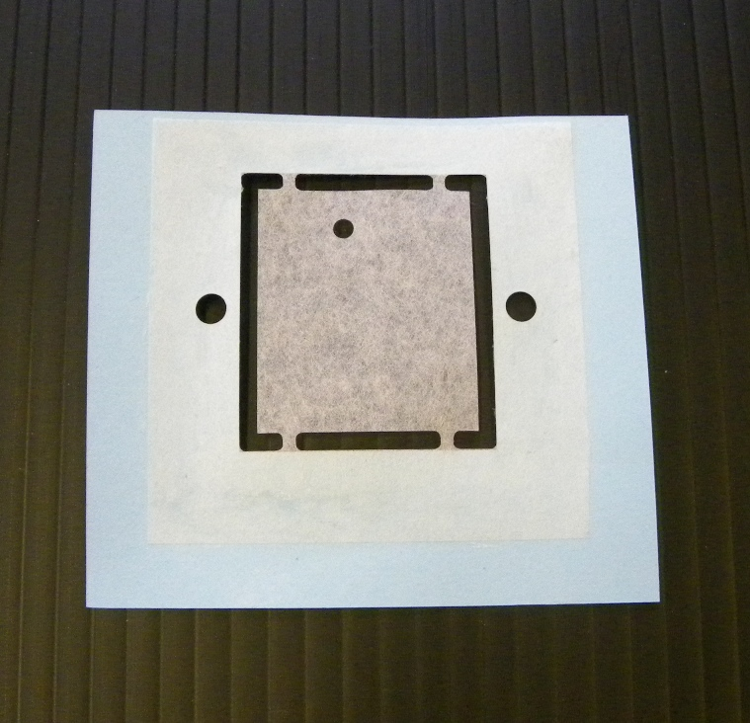

Step 4. Remove framed laminate leaf from the base.
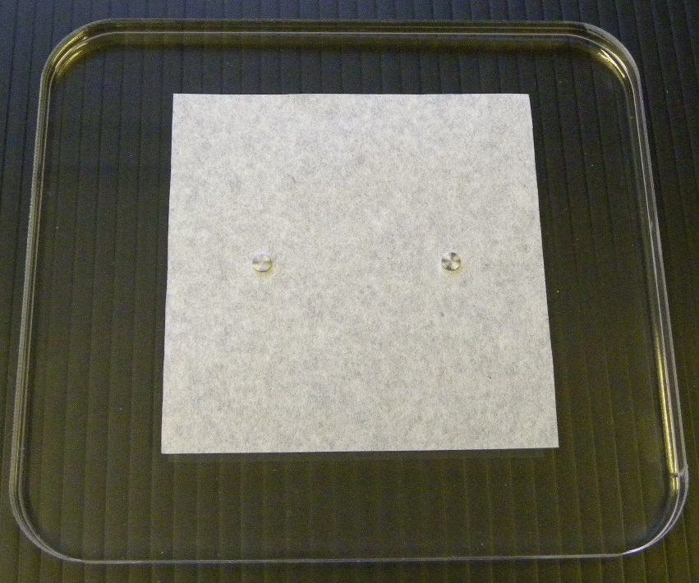

Step 5. Place cushion (part 2) onto base plate (part 1).

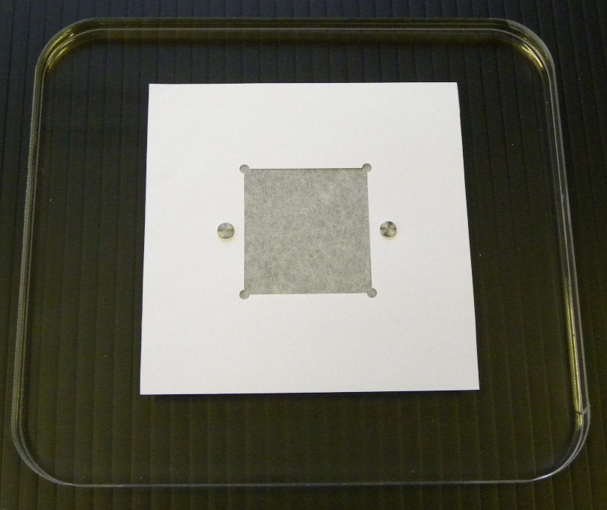

Step 6. Place guide (part 3) on top of the cushion.
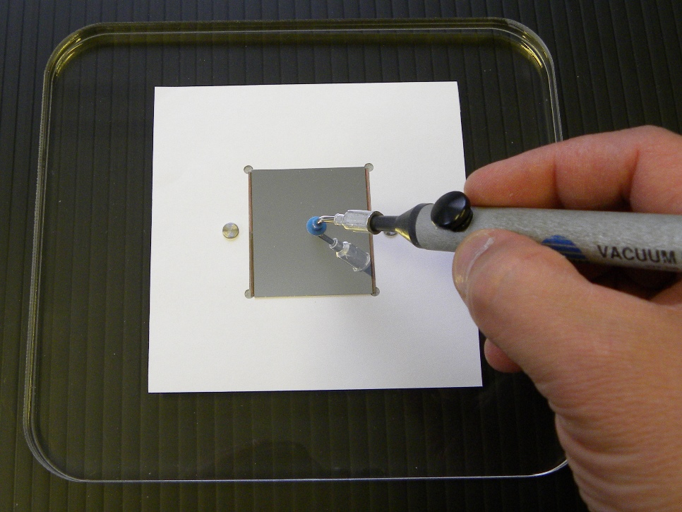

Step 7. Place silicon package inside opening in the guide shim.

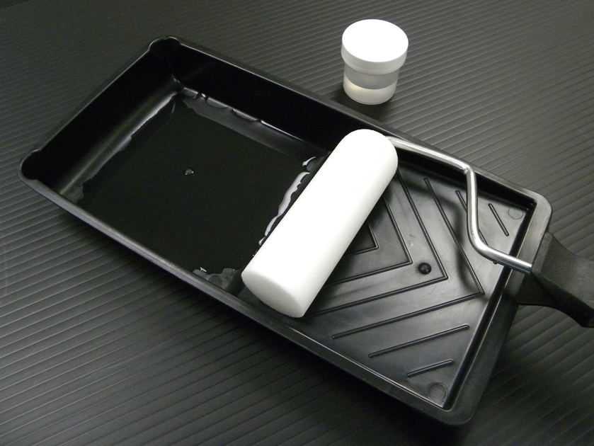

Step 8. Prepare epoxy adhesive.
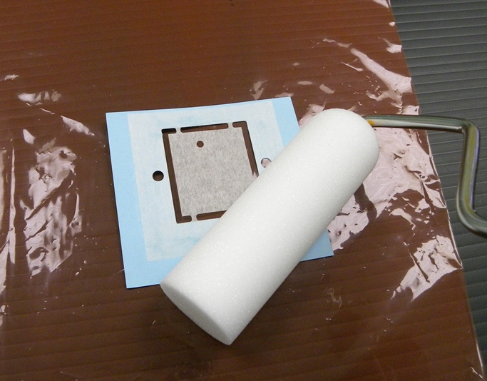

Step 9. Apply adhesive to the framed laminate facing up.
Use dry roller to remove glue excess from paper.

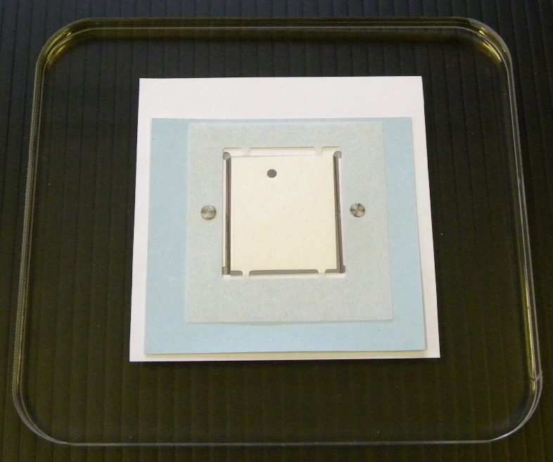

Step 10. Place impregnated laminate on top of silicon package.
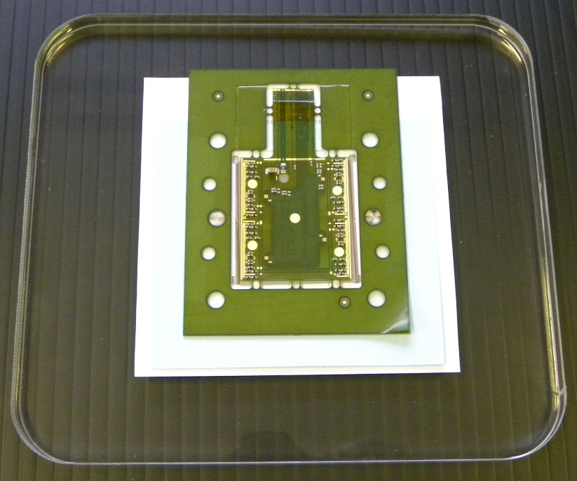

Step 11. Place hybrid over laminate

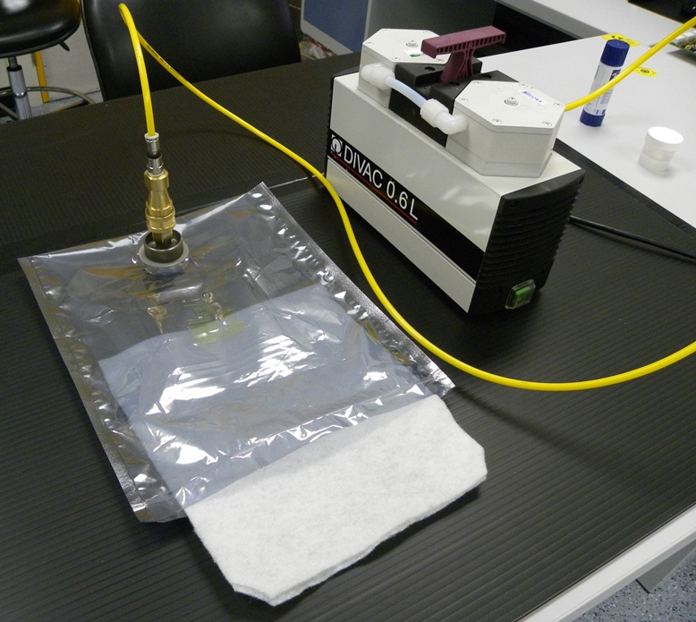

Step 12. Prepare antistatic grip seal bag with a vacuum port and a breather cloth.
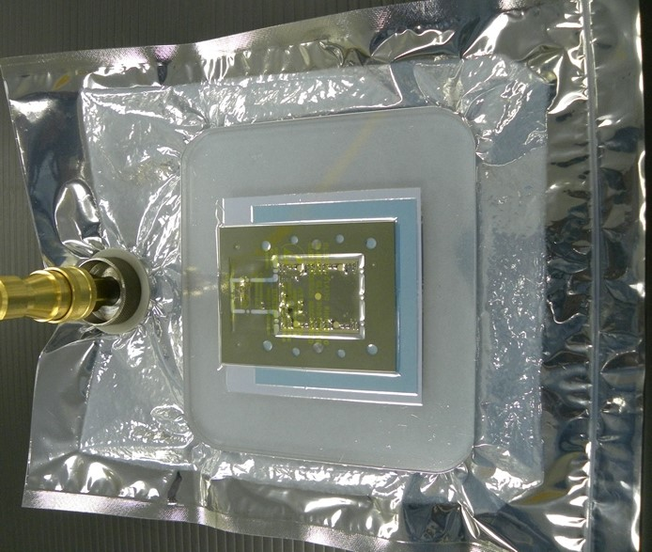

Step 13. Place jig on top of the breather inside the bag, close seal and apply vacuum.

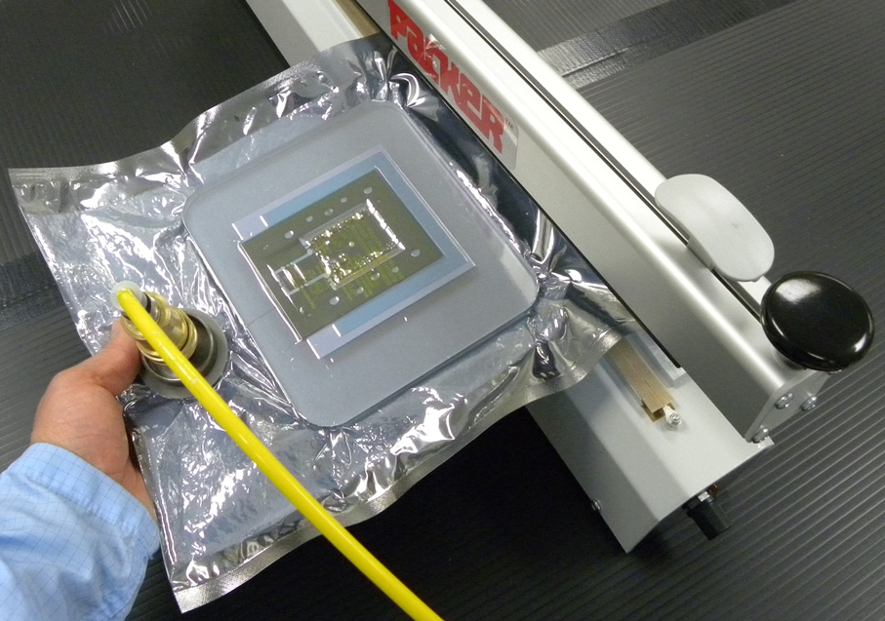

Step 14. Use heat sealer for the bag in case of thin air leaks.
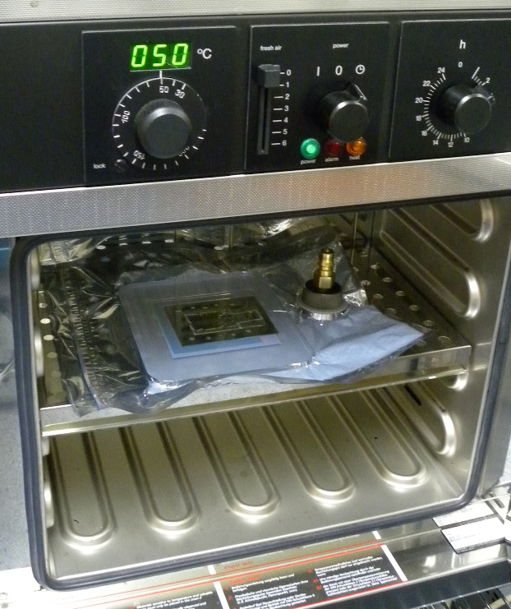

Step 15. Detach the vacuum hose from the bag and put the bag into preheat oven.

The pixel module should now be left on a jig for epoxy curing which could be accelerated by heat. FH 5313A resin will set in about 2 hours at 40 degrees Celsius. Its hardening could be tested using control samples, for example dab of glue undergoing same temperature treatment as the pixel module itself. It is worth noting that this gluing method is tolerant to speedy curing because expanding parts are not constrained and hence do not create stresses in the system. Glue thickness defined by the laminate material will therefore remain uniform.

Elevated temperature curing is also recommended because it produces a more complete reaction with a greater degree of cross-linking than lower temperatures [14]. “High cross-link density formation will enable cured material to exhibit the best possible mechanical and physical properties such as CTE, outgassing, and moisture uptake which will be minimized. Alternatively, increasing the length of time for a lower temperature cure does not always yield the same degree of crosslinking”.

The whole assembly process besides curing time takes approximately 2 minutes per module. Laminate leaves on a paper frame could be pre-fabricated reducing assembly time even further.
It has been discussed whether or not should Quad Pixel Modules be kept on a frame after assembly for all their tests until final mounting onto half-ring supports. Paper frame has one big advantage in this case as it could easily be trimmed for convenient handling.

Drawings of jig parts together with DXF data for their production could be found at:

http://hep.ph.liv.ac.uk/~tsurin/POOL/Atlas/Pixel/JigV2/
(Liverpool HEP twiki page would be better)

Detaching Quad Pixel Module from the frame

Polyimide and paper tabs connecting module with its frame could simply be cut by scissors through the frame materials. Alternatively the Quad Pixel Module could be placed on a jig with a card holder and tabs could be clipped using trimming knife. The card piece prepared on a Silhouette machine features large opening for the pixel module itself and provides firm support for the tabs being cut.

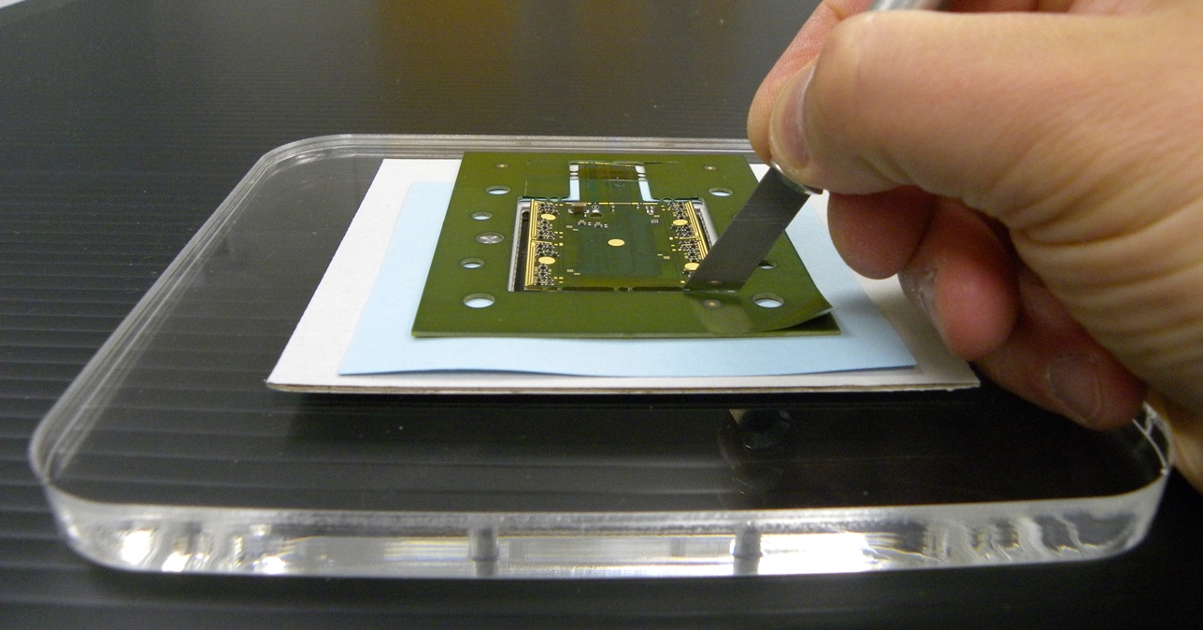

Step 16. Cut polyimide and paper tabs using trimming knife.

Peculiarities

1. Specific ions

C6-99 amplitude paper contains sodium ions in concentration of 200 ppm accordingly its data specs. Test method IEST-RP-CC004.2 [15] requires soaking

samples soaked in water at room temperature for 24 hours.

laundry different adhesive evaluating different material

2.

Characterisation of adhesive bonds using test structures

References

1. Development of hybrid for EndCap Quad Pixel Module, contribution to Atlas Upgrade Week in Freiburg 2014, http://indico.cern.ch/event/311426/contribution/8/material/slides/0.ppt

2. The FE-I4 pixel readout integrated circuit, M.Garcia-Sciveres et all, NIM A 636 (2011), pages S155-S159.

3. The ATLAS Experiment at the CERN Large Hadron Collider, ATLAS Collaboration, JINST 3 (2008) S08003

4. Development of planar pixel modules for the ATLAS high luminosity LHC tracker upgrade, P.P. Allport et al, NIM A 765 (2014) pages 109-113

5. Building CMS Pixel Barrel Detector Modules, S. Koenig at al, NIM A 582 (2007) pages 776-780

6. Design and assembly of double-sided silicon strip module prototypes for the ATLAS upgrade strip tracker, ATLAS UPGRADE-PUB-2011-002

7. High bandwidth pixel detector modules for the ATLAS Insertable B-Layer, CERN-THESIS-2013-303 page 42

8. Silicon strip staves and petals for the ATLAS Upgrade tracker of the HL-LHC, S.Diesz on behalf of the ATLAS collaboration, NIM A 699 (2013) pages 93-96

9. ATLAS Phase-II Upgrade Scoping Document, CERN LHCC Report 2015-020

10. Amplitude(TM) optical-grade paper datasheet
www.contecinc.com/media/datasheets/amplitude%20optic%20wipe.pdf

11. Electronic materials handbook Volume 1: Packaging (1989) by Merrill L. Minges
ISBN-10: 0871702851

12. Thermal Expansion Properties of Composite Materials R.R. Johnson, G.B. Mackey, NASA Contractor Report 165632 (1981) via Google search

13. Silhouette desktop cutter and accessories www.silhouetteamerica.com

14. Epotek technical aids www.epotek.com/site/files/brochures/pdfs/Cure_Matters_Final.pdf

15. Evaluating Wiping Materials Used in Cleanrooms and Other Controlled Environments http://www.iest.org/Standards-RPs/Recommended-Practices/IEST-RP-CC004

