Cross referencing all H&K 820’s in the UK for compatible bond pull strengths.
Using a Cicorel board supplied by Hesse and Knipps. The intention is to write multiple reference systems and have a slight variation in parameters from each sample board. The cicorel board is set out 10 by 9 sample boards as below.Program name :- UOL_pull_tests.bpx on the h&K 820
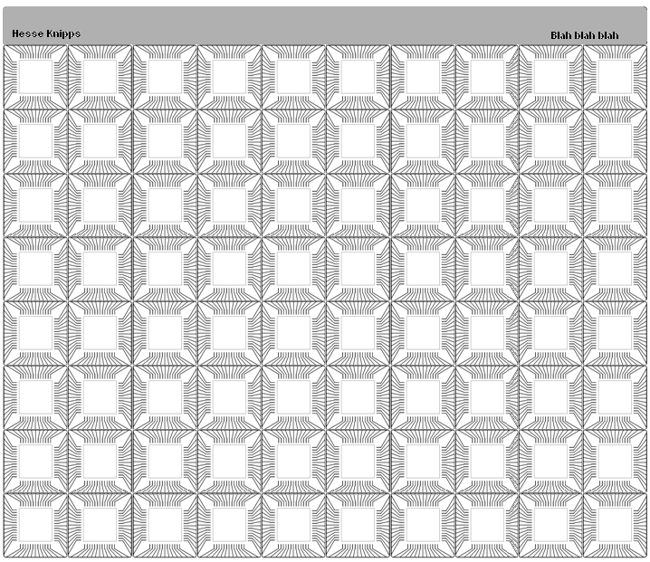
Sample 1 sample 10
Sample 11 sample 20
Sample 21 sample 30

Method:-
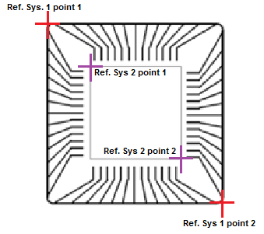
Place cicorel board on vac plate and seal edges with kapton tape to ensure good vacuum.
Load program UOL_pull_tests.bpx
Re teach reference systems, heights and lighting to suit your machine.
Reference points for all the odd numbers are the same as Ref sys.1
Reference points for all the even numbers are the same as Ref sys.2

I have written the program into 30 samples, each sample has 2 reference systems therefore there are 60 reference systems in total.
I have used the loop parameters as set out by Birmingham (30 degree loop) for all systems.
Each sample has one parameter change from the control (sample 1)

See pages three and four for the Parameter chart

Bond all the wires then pull them using the dage pull tester, you should pull the wires in the same orientation for each
sample and record each sample to a separate cvs file.

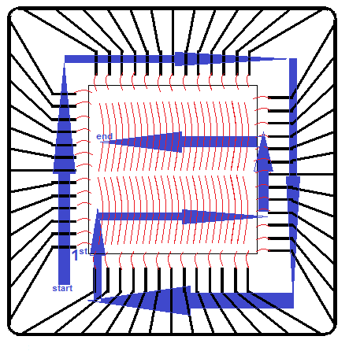
Orientation of pulls per sample as below:

 |  |  |  | welding parameters
 | reference systems | touchdown force | overtravel | stop after | ultra sonic | force
sample 1 | 1 | 20 | 25 | 38 | 18 | 18
 | 2 | 20 | 25 | 38 | 18 | 18
sample 2 | 3 | 20 | 25 | 36 | 18 | 18
 | 4 | 20 | 25 | 36 | 18 | 18
sample 3 | 5 | 20 | 25 | 34 | 18 | 18
 | 6 | 20 | 25 | 34 | 18 | 18
sample 4 | 7 | 20 | 25 | 32 | 18 | 18
 | 8 | 20 | 25 | 32 | 18 | 18
sample 5 | 9 | 20 | 25 | 30 | 18 | 18
 | 10 | 20 | 25 | 30 | 18 | 18
sample 6 | 11 | 20 | 25 | 38 | 16 | 18
 | 12 | 20 | 25 | 38 | 16 | 18
sample 7 | 13 | 20 | 25 | 38 | 14 | 18
 | 14 | 20 | 25 | 38 | 14 | 18
sample 8 | 15 | 20 | 25 | 38 | 12 | 18
 | 16 | 20 | 25 | 38 | 12 | 18
sample 9 | 17 | 20 | 25 | 38 | 20 | 18
 | 18 | 20 | 25 | 38 | 20 | 18
sample 10 | 19 | 20 | 25 | 38 | 22 | 18
 | 20 | 20 | 25 | 38 | 22 | 18
sample 11 | 21 | 20 | 25 | 38 | 18 | 16
 | 22 | 20 | 25 | 38 | 18 | 16
sample 12 | 23 | 20 | 25 | 38 | 18 | 14
 | 24 | 20 | 25 | 38 | 18 | 14
sample 13 | 25 | 20 | 25 | 38 | 18 | 12
 | 26 | 20 | 25 | 38 | 18 | 12
sample 14 | 27 | 20 | 25 | 38 | 18 | 20
 | 28 | 20 | 25 | 38 | 18 | 20
sample 15 | 29 | 20 | 25 | 38 | 18 | 22
 | 30 | 20 | 25 | 38 | 18 | 22
sample 16 | 31 | 20 | 18 | 38 | 18 | 18
 | 32 | 20 | 18 | 38 | 18 | 18
sample 17 | 33 | 20 | 20 | 38 | 18 | 18
 | 34 | 20 | 20 | 38 | 18 | 18
sample 18 | 35 | 20 | 22 | 38 | 18 | 18
 | 36 | 20 | 22 | 38 | 18 | 18
sample 19 | 37 | 20 | 24 | 38 | 18 | 18
 | 38 | 20 | 24 | 38 | 18 | 18
sample 20 | 39 | 20 | 26 | 38 | 18 | 18
 | 40 | 20 | 26 | 38 | 18 | 18
sample 21 | 41 | 20 | 28 | 38 | 18 | 18
 | 42 | 20 | 28 | 38 | 18 | 18
sample 22 | 43 | 20 | 30 | 38 | 18 | 18
 | 44 | 20 | 30 | 38 | 18 | 18
sample 23 | 45 | 16 | 25 | 38 | 18 | 18
 | 46 | 16 | 25 | 38 | 18 | 18
sample 24 | 47 | 18 | 25 | 38 | 18 | 18
 | 48 | 18 | 25 | 38 | 18 | 18
sample 25 | 49 | 22 | 25 | 38 | 18 | 18
 | 50 | 22 | 25 | 38 | 18 | 18
sample 26 | 51 | 24 | 25 | 38 | 18 | 18
 | 52 | 24 | 25 | 38 | 18 | 18
sample 27 | 53 | 20 | 25 | 38 | 16 | 16
 | 54 | 20 | 25 | 38 | 16 | 16
sample 28 | 55 | 20 | 25 | 38 | 17 | 17
 | 56 | 20 | 25 | 38 | 17 | 17
sample 29 | 57 | 20 | 25 | 38 | 19 | 19
 | 58 | 20 | 25 | 38 | 19 | 19
sample 30 | 59 | 20 | 25 | 38 | 20 | 20
 | 60 | 20 | 25 | 38 | 20 | 20

See excel folder UOL_PULL_Results.xlsb for full set of parameters and pull test results.

