Cross referencing all H&K 820’s in the UK for compatible bond pull strengths.
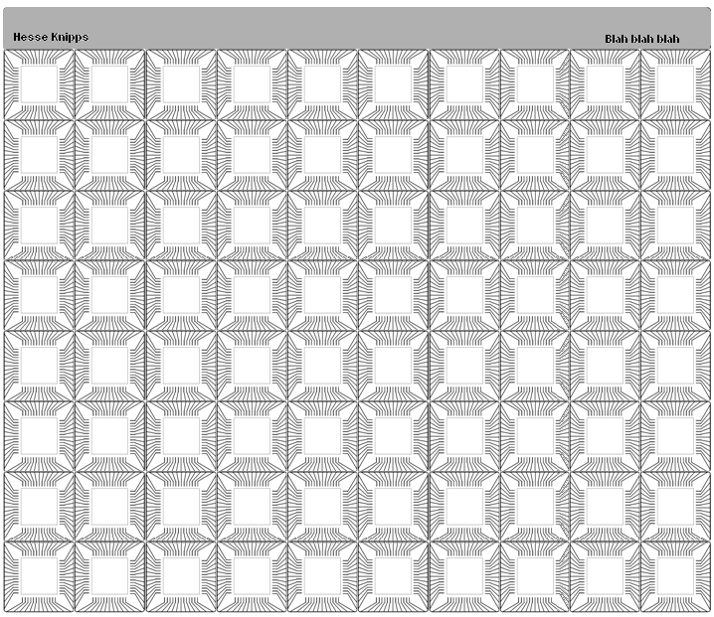
Using a Cicorel board supplied by Hesse and Knipps. The intention is to write multiple reference systems and have a slight variation in parameters from each sample board. The cicorel board is set out 10 by 9 sample boards as below.

