Transport of End-cap C

Peter Cooke, Richard French, Stephen Haywood, Neil Jackson, Peter Sutcliffe

Tech Spec ATL-IS-CS-0016
Procedures ATL-IS-CS-0023

Guiding principle:
Copy the procedures used by Barrel: CERN/Danzas

See: http://hepwww.rl.ac.uk/atlas-sct/engineering/ec/transport/

Procedures – see ATL-IS-CS-0023

Preliminary Test Run

See talk on Contractual Status

Before

- Organise Lorry – needs at least 2 weeks
- Just before, check weather
- When Lorry arrives, undertake “Final Test Run” with empty Lorry and Shock-log (if desired)
Preparation of EC – see Peter Cooke for more details

- Move electronics & CMM out of way
- Build Transport Frame around Assembly Frame
- Attach Inner Box to Assembly Frame
- Cover Services & Thermal Plug with ESD-safe film
- Ensure suitable electrical connections within Frame
- Attach inner Shock-log
- Move over Pallet
- Swap wheels from Transport Frame to Pallet
- Attach Outer Box to Pallet
- Attach outer Shock-log

Movement out of Clean-room – from Peter, may need updating
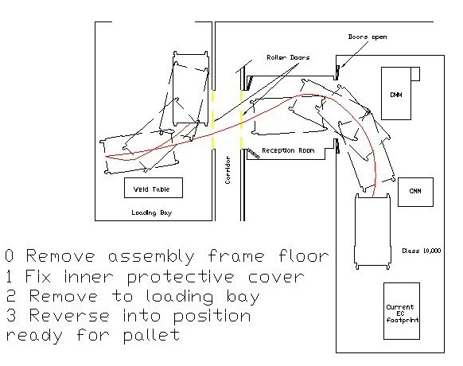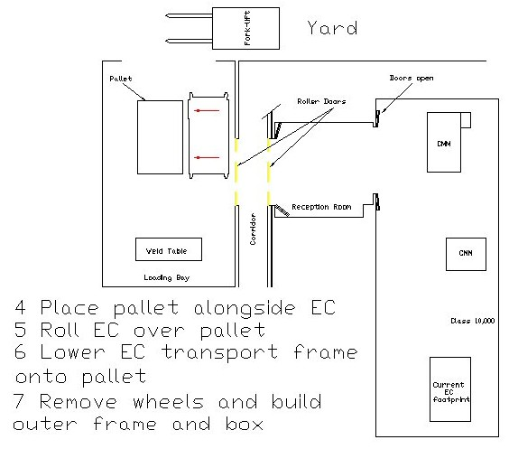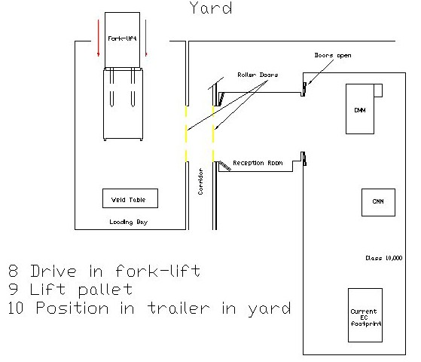
- Add cling-film if concerned about rain/snow.

Loading of End-cap

Responsibility of Andy Park
- EC should be placed to one side and wheeled into centre
- Wheels should be raised
- EC should be secured with load-lock bars
- Driver should be given documents and pep talk
Travel to CERN

- After ~30 mins, Lorry will stop and the Shock-logs checked
- Lorry will go via Channel Tunnel
- Lorry will enter France on weekday and will proceed to Bat 904 in Prevessin for customs clearance
- Finally, the lorry will proceed to SR1

Unloading at CERN

- EC will be placed at entrance of SR1
- Remove Outer Box
- Examine Shock-logs immediately
- Swap wheels from Pallet to Transport Frame
- Wheel Box off Pallet and into Clean Room
- Examine End-cap
Transportation Conditions

New Lorry:
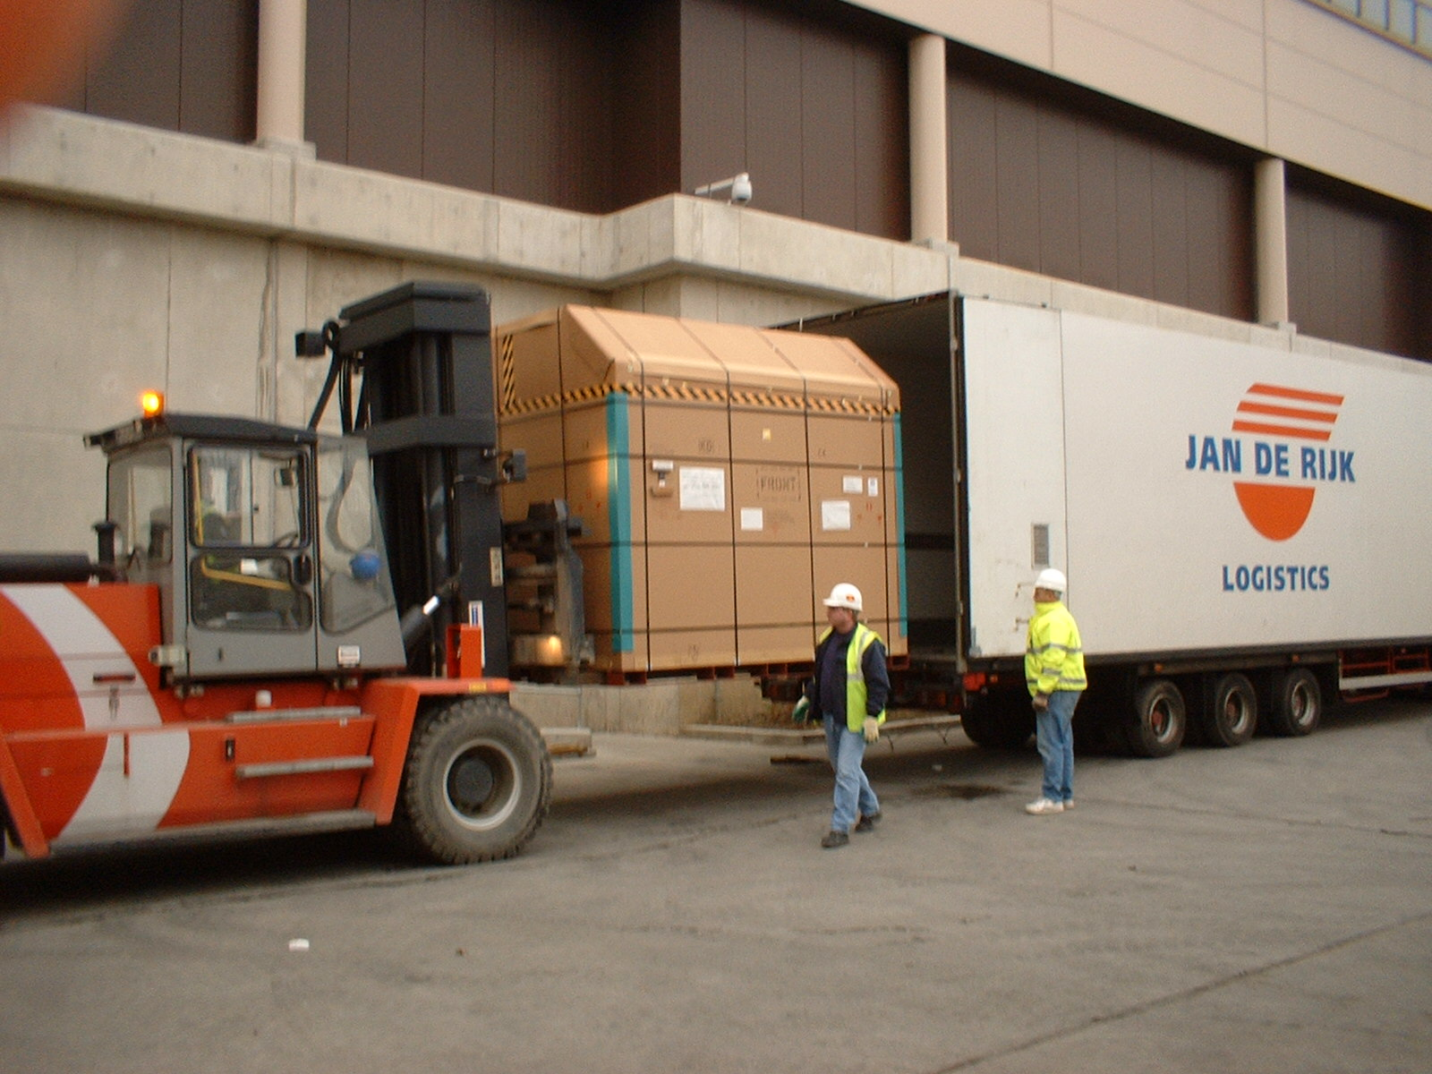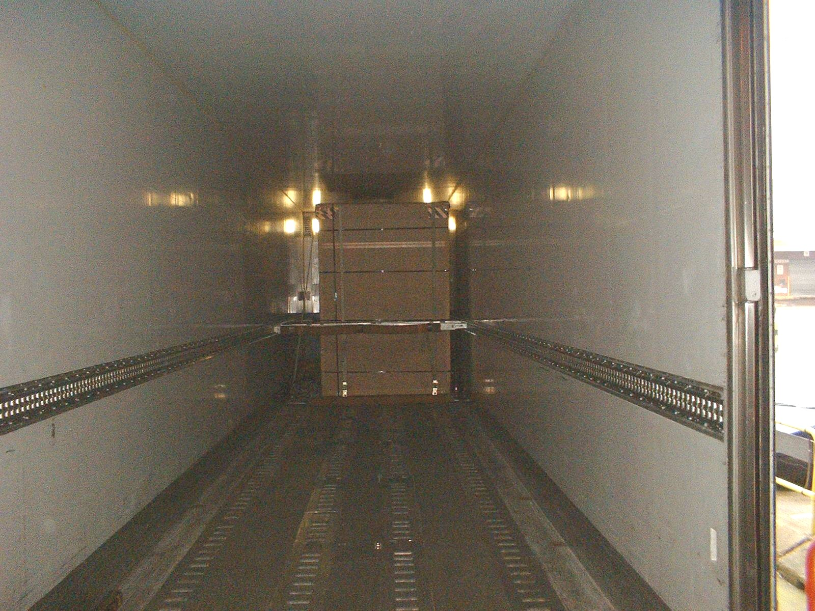
Request:
- Acceleration – < 3g
- Orientation – < 10º
- Temp – 20 ± 3ºC
- Humidity – < 80% RH, prefer ~40%

