Module assembly

This document will describe the assembly of two sensors on a hybrid, and the assembly of a hybrid on a pedestal.

The “Sensor on hybrid assembly” and “Hybrid on pedestal assembly” sections give step by step instructions for the assembly procedures. It is assumed that the operator knows how to use the glue dispenser. A more detailed description of how to use the software is given in the “Software” section.

Description of hardware

A window pc is used to control the alignment. The system of step-motor controlled stages moving the vacuum chunk for the sensor, and the aluminium structure it is mounted on is referred to as the alignment station. The alignment station is mounted on a long range linear stage defining the y-axis, and the camera is mounted on a long range linear stage defining the x-axis. The camera can also be moved in the z-direction for focusing. This way the camera can be moved over a wide area and allow for optical measurements. The alignment station also has got a z-stage for mounting the pedestal jig.

The jigging for the sensor on hybrid assembly consists of a turn-plate and two gluing jigs. The turn-plate serves two purposes:
- As a reference frame for the sensor alignment. It is mounted on the alignment station during the alignment. It has two cross-hair graticules defining the reference system for the alignment.
- As a mounting jig for the hybrid. The hybrid is mounted in the turn-plate for the gluing and assembly of the module.

There are two gluing jigs, one for the Phi-sensor (blue), and one for the R-sensor (red). A matching colour labelling scheme is used on the turn-plate to avoid confusion. The glue jigs have holes to match the steering pins on the turn-plate. This enables them to be lowered down on the turn-plate with high precision and repeatability. Vacuum is used to hold the sensors down on the jigs. A vacuum controller with three labelled switches is used for this:
  - The switch for the vacuum chunk on the alignment station.
  - The switch for the vacuum on the Phi-jig (blue).
  - The switch for the vacuum on the R-jig (red).

The jigging for the hybrid on pedestal assembly includes a hybrid jig and a pedestal jig. The pedestal jig is mounted on the z-drive on the alignment station and serves as a reference frame for the hybrid alignment and the mechanical mounting point for the pedestal. The hybrid jig is mounted on the vacuum chunk on the alignment station and is the mechanical mounting point for the hybrid. Vacuum is used to hold the hybrid down on the jig.

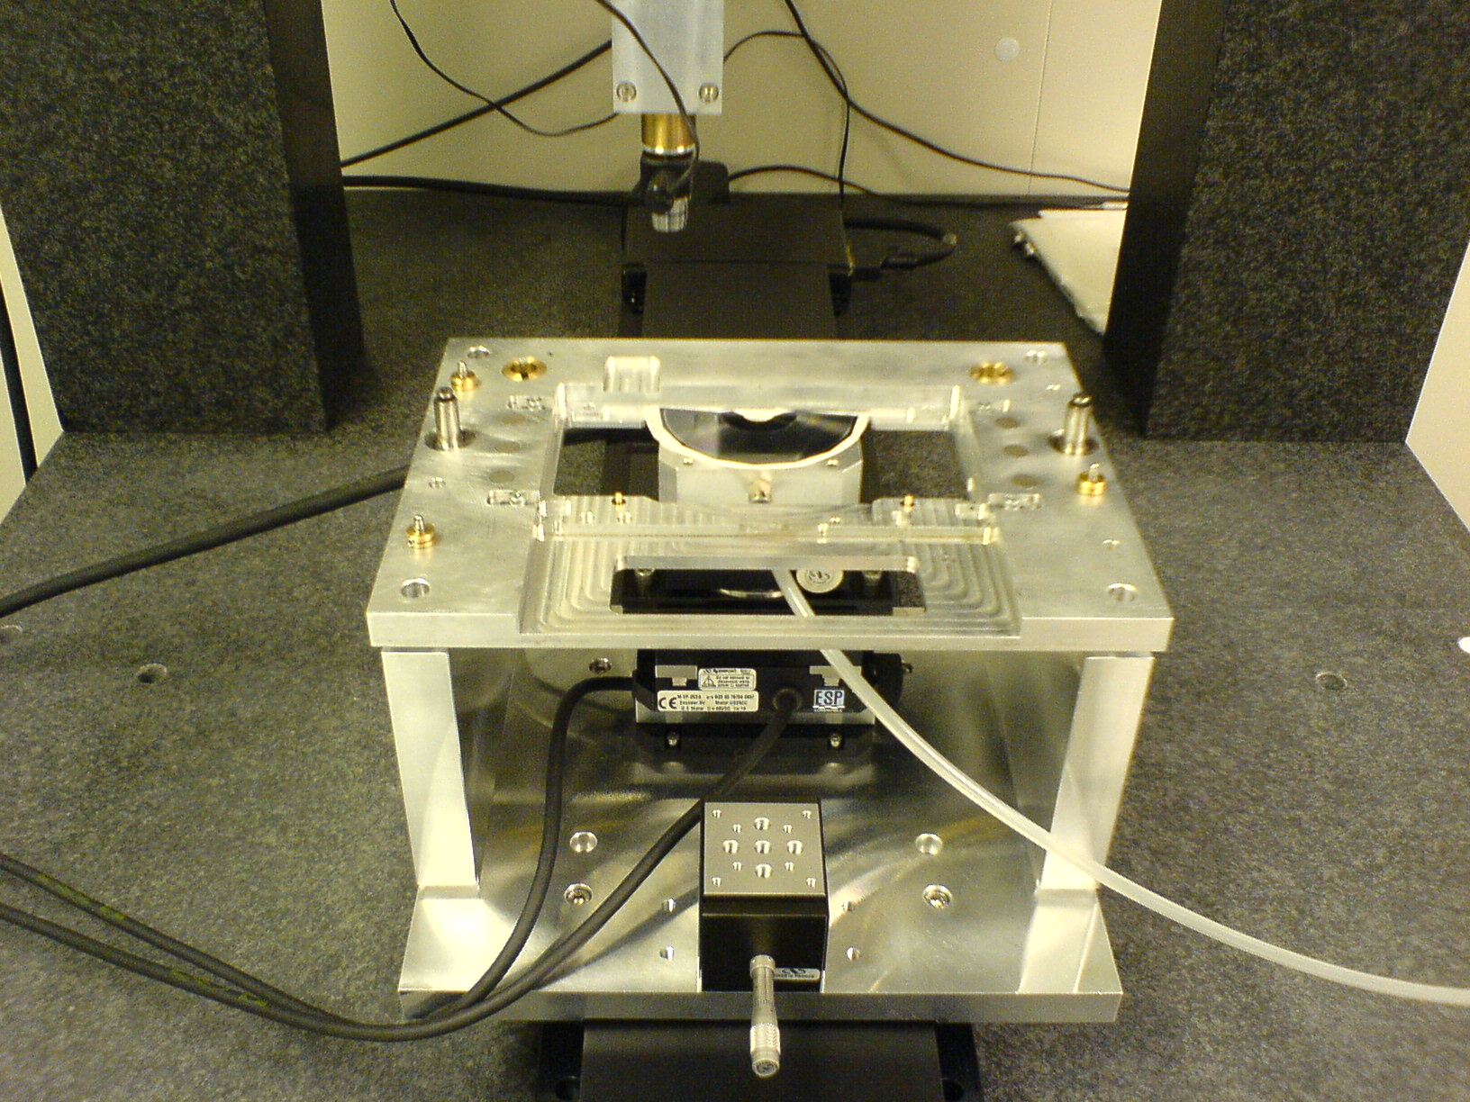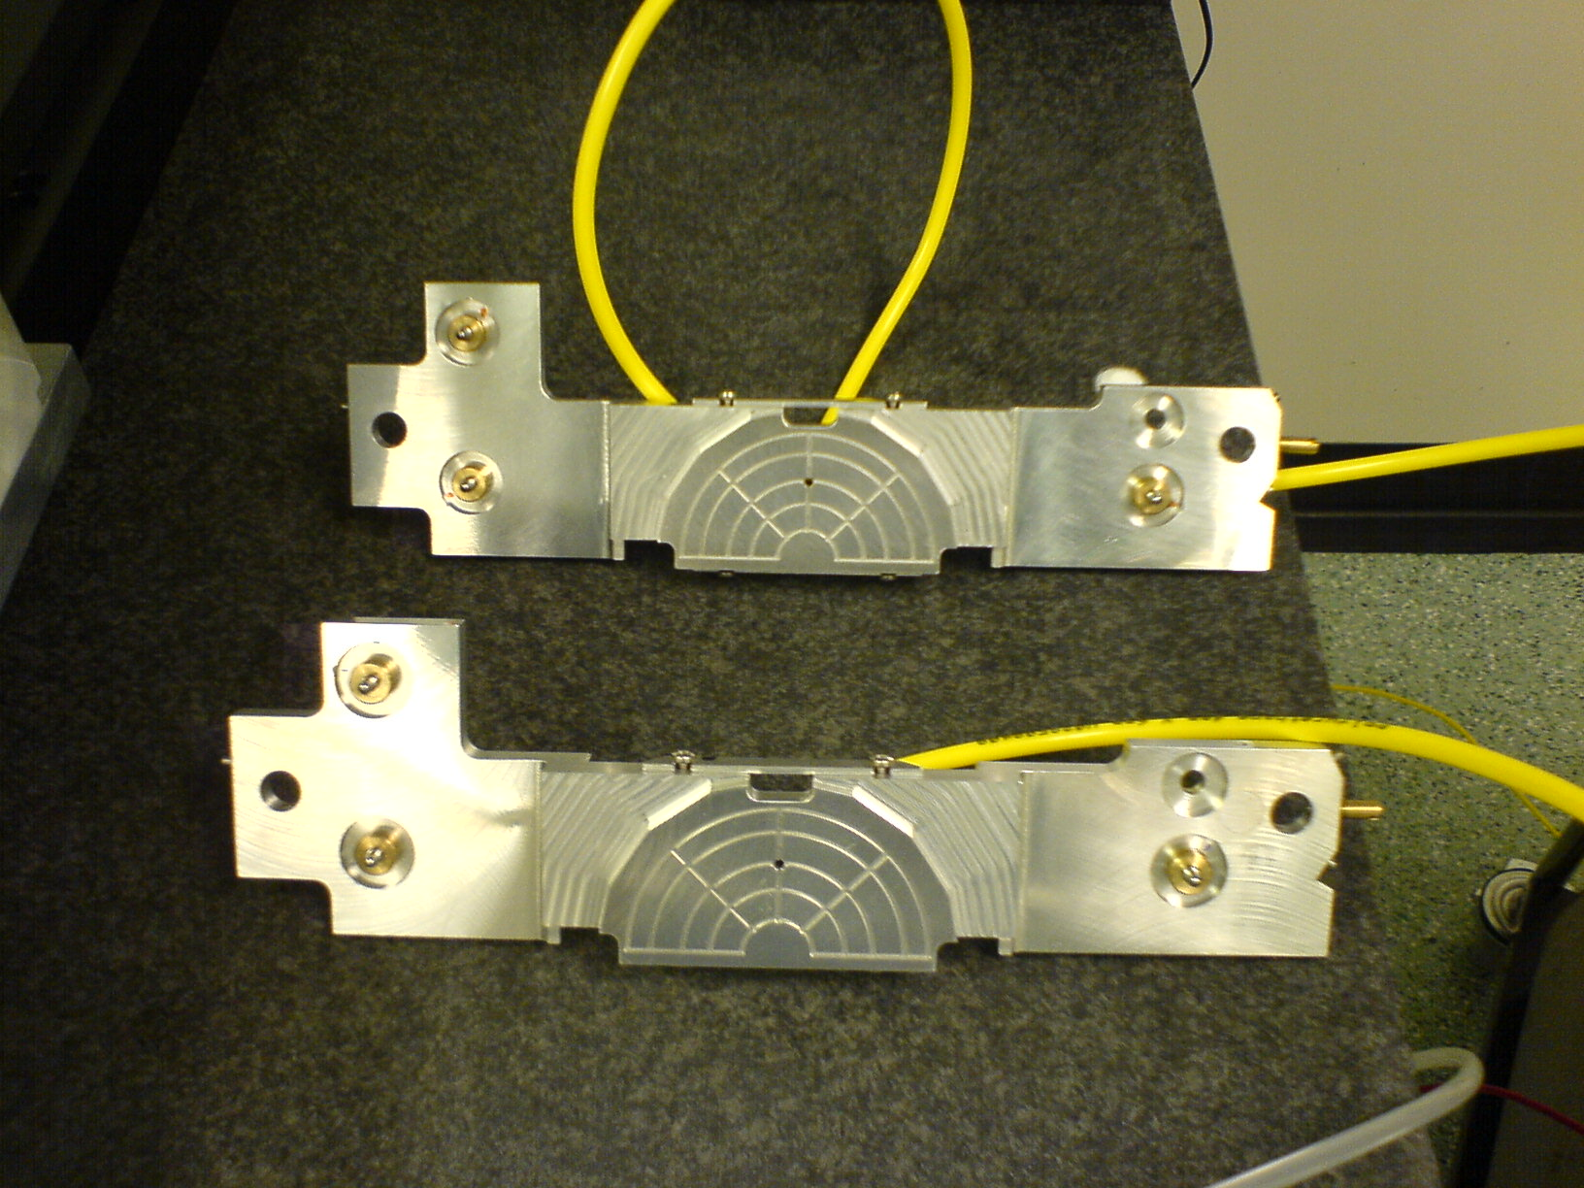
Figure 1: The alignment station with turn-plate to the left. A manual z-stage is mounted on the alignment station base plate. The pedestal jig is to be mounted on this z-stage for the hybrid on pedestal assembly. The two gluing jigs are shown to the right.

Sensor on hybrid assembly

Pick out a pair of sensors from the list of approved pairs (if in doubt contact Girish). Do a visual inspection of both sensors and hybrid before starting the procedure. Get a copy of the sensor-hybrid assembly spread sheet. Fill in your initials, date, hybrid and sensor numbers. Also write down any comments from the sensor inspection (this should also be logged in the database).

The following section will give a step by step instruction of the procedures. A more detailed description of the software is given at the end.

Pre-alignment and hybrid thickness test

If the hybrid is too thick, the glue could be smeared out too much and come out from under the sensors. The vacuum could then suck the glue onto the silicon surface. To avoid this, the spacing between the gluing jigs and the turn-plate must be adjusted. This procedure is to test the hybrid thickness.

- Put the Phi-sensor on the vacuum chunk of the alignment station. Use a vacuum pen to handle the sensor, and make sure there is a piece of clean room paper covering the vacuum chunk. Use the pre-positioning tool to get the sensor roughly in position. Switch vacuum 1 on.
- Put the turn-plate on the alignment station with the blue side up.
- On the Assembly program front-panel, choose Phi-side and insert the correct hybrid number and alignment parameters (use the default parameters unless other information is given).
- Start the alignment routine and align the Phi-sensor (as described in the Sensor alignment section).
- Put a piece of clean-room paper on the sensor surface and transfer the sensor to the blue gluing jig. Make sure the jig is resting on the turn-plate on all three spacers. Transfer the sensor by switching vacuum 1 off and vacuum 2 on.
- Repeat the alignment procedure with the R-sensor. Turn the turn-plate over to the red side and use the red gluing jig connected to vacuum 3.
- Move the turn-plate over to the glue dispenser and mount the hybrid (R-side corresponds to the red side).
- Put a piece of clean-room paper on the hybrid covering the sensor area to simulate the thickness of the glue. Put the R-side gluing jig down on the red side of the turn-plate, and clamp it down with the spring loaded bobbins. IMPORTANT: Put the bobbin on the side with two spacers first to avoid rotation of the glue jig on the turn-plate.
- Turn the turn-plate over. Put a piece of clean-room paper on the hybrid covering the sensor area. Mount the Phi-side gluing jig on the turn-plate. IMPORTANT: Put the bobbin on the side with two spacers first to avoid rotation of the glue jig on the turn-plate.
- Inspect the glue-jig spacers to see if they are touching down on the turn-plate. If there are gaps, measure it by inserting shims. Try the 38 micron shim and the 51 micron shim. If the gap is less than 38 micron no action is needed. If the gap is between 38 and 51 micron the R-side gluing jig must be lifted for the gluing (as described later). If the gap is more than 51 micron the assembly should be stopped. Consult with John.
- Un-mount the gluing jigs from the turn-plate. Take the hybrid out of the turn-plate and put it back in its frame.

Alignment and control of the sensors

- Put the turn-plate on the alignment station with the blue side up.
- Transfer the Phi-sensor to the vacuum chunk of the alignment station by lowering the gluing jig down on the turn-plate and swapping vacuum (2 off, 1 on). Remove the gluing jig.
- Align the Phi sensor (as described in the Sensor alignment section).
- Transfer the Phi-sensor to the blue gluing jig (vacuum 1 off, vacuum 2 on).
- Do a control measurement of the sensor on the gluing jig (as described in the Control measurement section). Make sure the sensor has not moved more than 3 microns from the target position. If the sensor has moved too much, do the alignment again.
- As a control of the mechanical precision of the system, lift the gluing jig off the turn-plate and put it back. Then do a control measurement of the sensor position. The sensor should not be more than three microns away from the target positions.
- Turn the turn-plate over to the red side and repeat the alignment and control procedure with the R-sensor.

Gluing procedure

- Mix the 2011 araldite, 5g of component A and 4-5g of component B. Transfer to a syringe. Use a pink needle for the sensor gluing.
- Mix the conductive glue.
- Place the turn-plate on the glue dispenser rack, red side up, and mount a dummy hybrid (aluminium). Select the “sensorRed” program and do a few test runs with the dispenser until the glue pattern looks ok. Clean and remove the dummy hybrid.
- Mount the hybrid in the turn-plate (R-side up).
- Apply the araldite 2011 on the hybrid R-side with the dispenser program “sensorRed”.
- Apply five dots of conductive glue by hand. Use a sharp ended q-tip.
- The glue must be inspected by a second person before the assembly of the R-sensor. The person doing the inspection must sign of on the sensor assembly spread sheet.
- Depending on the result of the hybrid thickness test, the R-side gluing jig might be lifted to adjust the glue thickness. If the gap was more than 38 microns, put two 38 micron shims on the turn-plate where the glue jig touches down.
- Mount the R-side gluing jig (red) on the turn-plate. Lower the jig down carefully until it touches down on the turn-plate with the spacers. Attach the two bobbins. IMPORTANT: Put the bobbin on the side with two spacers first to avoid rotation of the glue jig on the turn-plate.
- Inspect the assembly of the R-side, and sign the assembly sheet for inspected R-side assembly.
- Turn the turn-plate over with the blue side facing up.
- Change dispenser program to “sensorBlue”.
- Apply the araldite 2011 on the hybrid Phi-side.
- Apply five dots of conductive glue by hand.
- The glue must be inspected by a second person before the assembly of the Phi-sensor. The person doing the inspection must sign of on the sensor assembly spread sheet.
- Mount the Phi-side gluing jig (blue) on the turn-plate. Lower the jig down carefully until it touches down on the turn-plate with the spacers. Attach the two bobbins. IMPORTANT: Put the bobbin on the side with two spacers first to avoid rotation of the glue jig on the turn-plate.
- Inspect the assembly of the Phi-side, and sign the assembly sheet for inspected Phi-side assembly.
- This completes the sensor on hybrid assembly. Let the glue cure for 12 hours before removal of the bobbins.

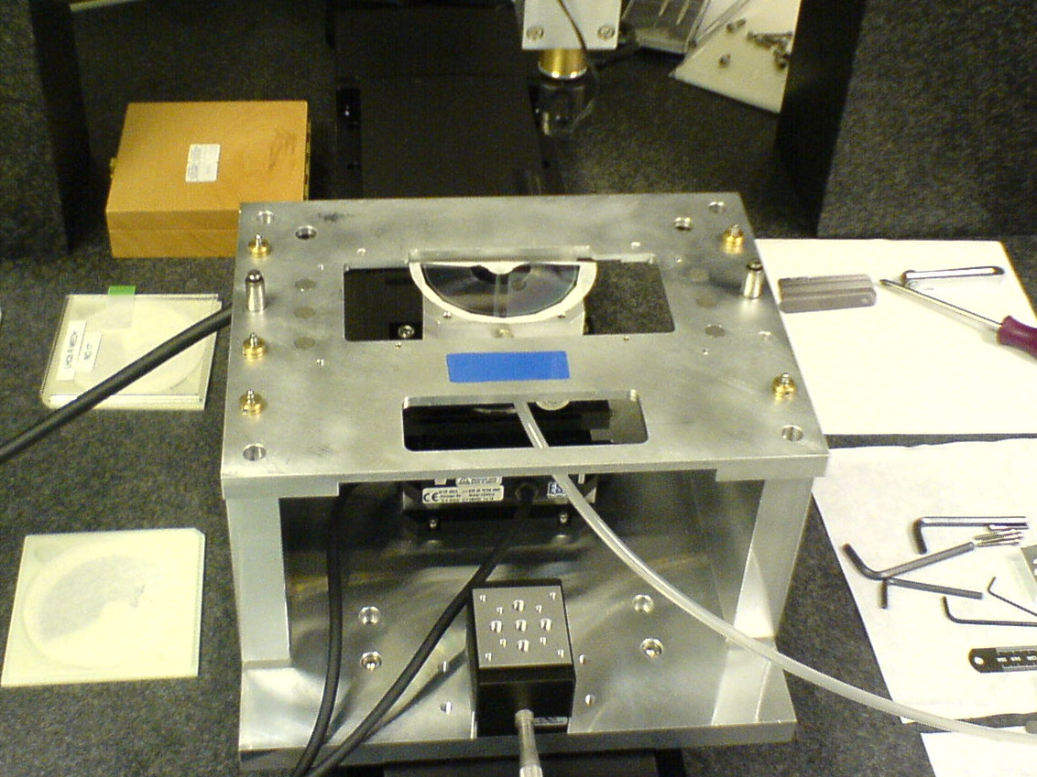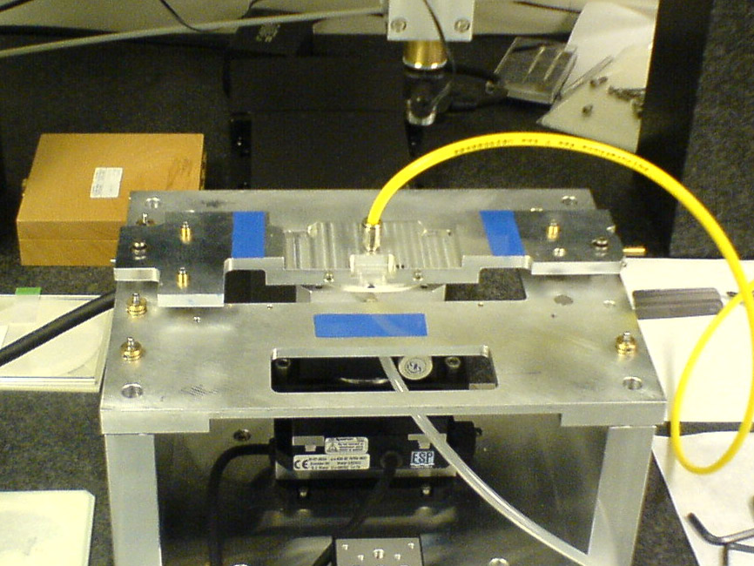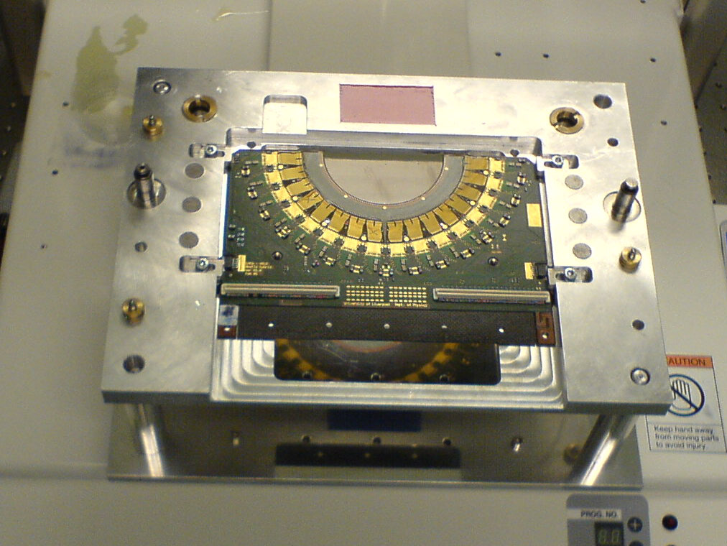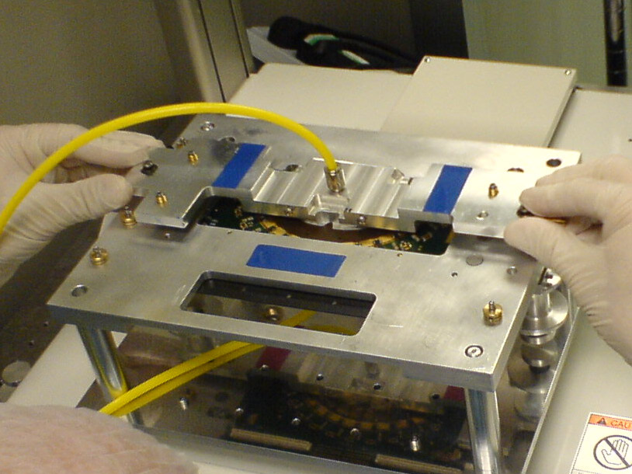
Align sensor
Transfer to glue jig
Glue on hybrid
Assembly
Figure 2: The sensor on hybrid assembly procedure.

Hybrid on pedestal assembly

This section gives a step by step guide to gluing a hybrid to a pedestal. A more detailed instruction of how to use the alignment software is given in the Software section. It is assumed that the operator knows how to use the glue dispenser.

Preparations

- Inspect the hybrid and pedestal. Make sure the hybrid is authorized for gluing, and that the pedestal has been grounded to match this hybrid.
- Mount the pedestal jig on the z-drive on the alignment station. Mount the hybrid jig on the vacuum chunk on the alignment station. Connect the vacuum to the hybrid jig.
- Drive the z-stage up until it reaches the stop position.
- Prepare three pieces of wire to be used for the gluing.
- Make sure the hybrid is mounted with the glue side up in the handling frame.

Pre-alignment and glue dispensing

- Put the hybrid on the hybrid jig. Switch the vacuum on.
- Choose R/Phi-side on the Assembly front-panel, and insert the hybrid number, pedestal number and alignment parameters.
- If it’s a Phi-glued hybrid, look up the sensor-sensor metrology data in the database and insert the numbers for the Phi-R offset.
- Align the hybrid relative to the pedestal jig as described in the pedestal alignment section. The hybrid jig is now roughly positioned for the hybrid-pedestal gluing.
- Mix the araldite 2011, 5g of component A and 5g of component B. Transfer to a syringe. Use the green needle for hybrid-pedestal gluing.
- Mount the gluing jig under the glue dispenser.
- Mount a mechanical hybrid on the glue jig (not aluminium hybrid). Use scrap hybrid number 32.
- Select program 15 (hybrid) on the glue dispenser and do a few test runs until the glue pattern is ok.
- Mount the real hybrid in the glue jig, with the correct side facing up (R-side for R-glued hybrid).
- Apply glue with the glue dispenser using program 15.

Alignment and assembly of the hybrid on the pedestal

- Move the hybrid to the hybrid jig on the alignment station. Switch vacuum on. Make sure the vacuum holds the hybrid down. Release the hybrid from its frame and let the frame rest on the jig.
- Clip the tags off the hybrid. Press the hybrid gently down while doing this (get help from a second person) to stop the hybrid from lifting off the jig.
- Put on the wires along the glue lines (must be two persons). Tape each wire to the walls of the alignment station.
- Mount the pedestal on the pedestal jig and attach a clock to feel the z-movement of the hybrid. Use a feeler gauge to check the response of the clock.
- Lower the pedestal down with the z-drive until it almost touches the glue (~0.5 mm above).
- Do a hybrid alignment.
- Lower the pedestal down until it touches down on the glue. The clock will start to move. Lower down until the clock has moved 15 microns.
- Do a hybrid alignment. Make sure the measured positions matches the target positions. If the deviations are more than 5 microns the hybrid should be re-aligned.
- This completes the hybrid-pedestal assembly. Let the glue harden for 12 hours.

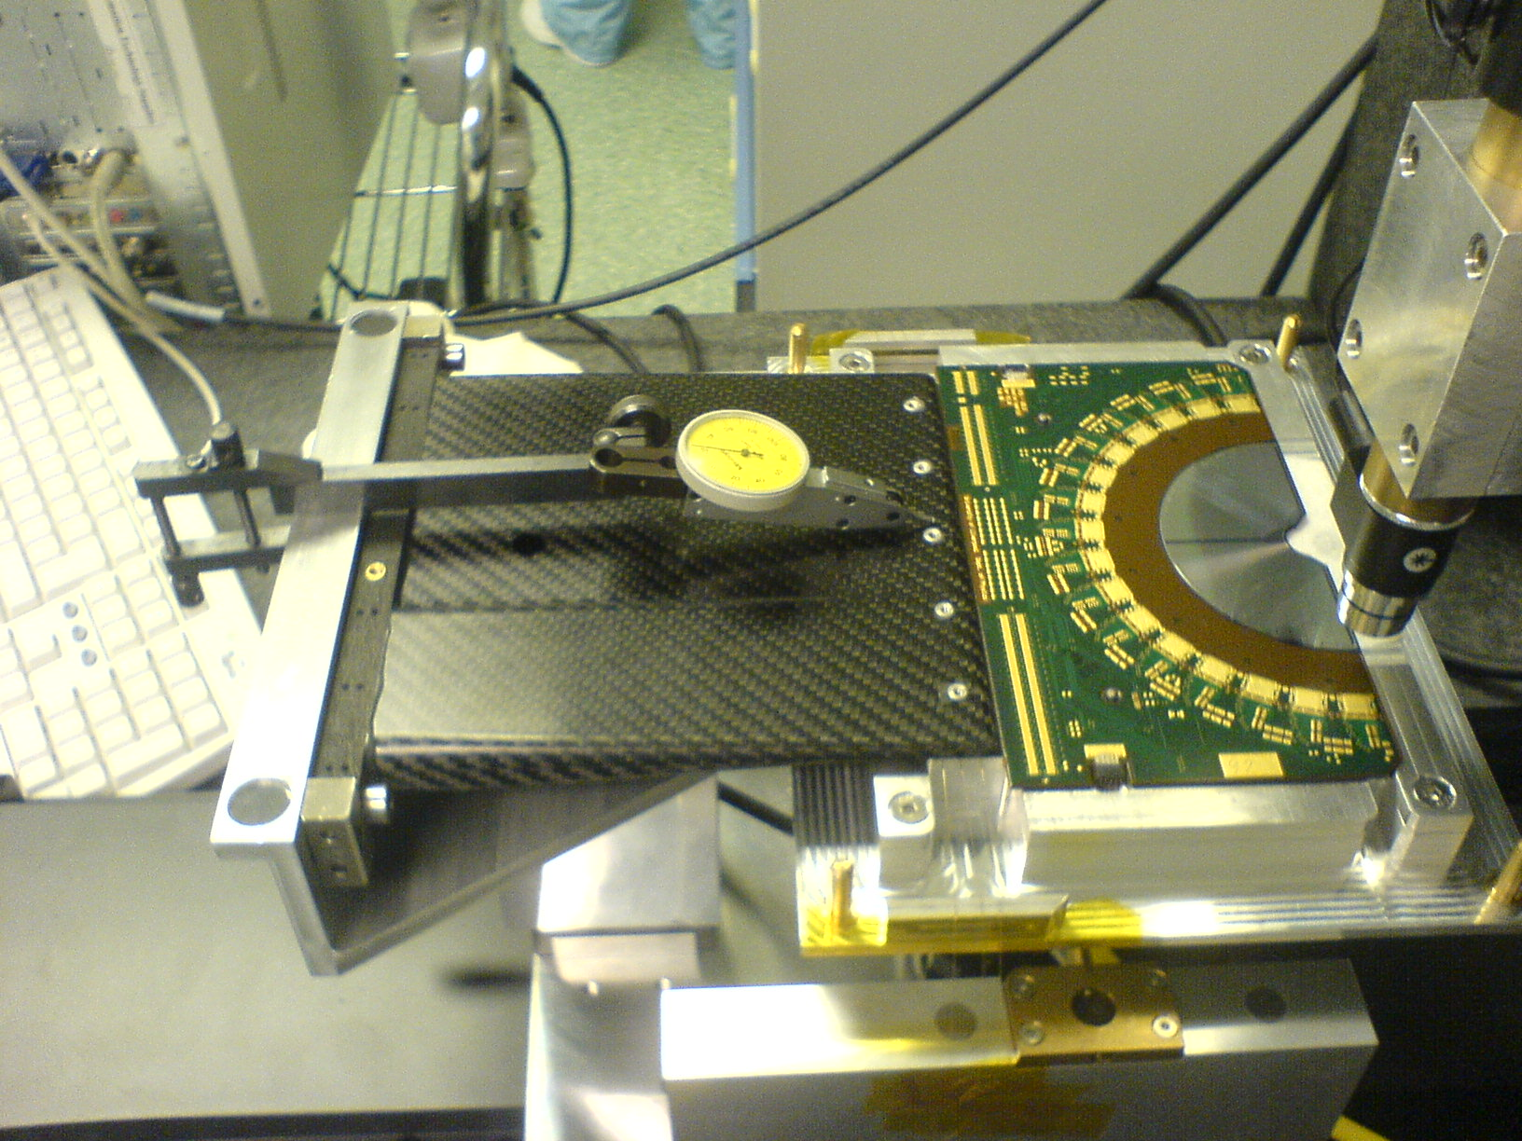
Figure 3: The hybrid to pedestal assembly.

The Assembly software

Use the LabVIEW program Assembly to do the sensor on hybrid assembly and the hybrid on pedestal assembly. It is located on the desktop as a shortcut. Start the LabVIEW program by clicking on the arrow on the tool bar.

The front panel

- Roll down menu containing the different functions of the program. Press the START button to start the selected function:
  - Sensor alignment.
  - Hybrid alignment
  - Control measurement
  - Go to pick-up position
  - Joystick
- Sensor type control to choose between R- and Phi-side.

The alignment routine

Choose “Sensor alignment” from the roll-down menu and press START.
- A joystick panel opens. Go manually to the left reference point on the turn-plate. Press SNAP to measure the position.
- The camera is driven to the second reference point. The joystick panel opens again. Press SNAP to measure the position.
- The camera is driven to the left fiducial mark on the sensor. The joystick panel opens. Locate and focus on the fiducial. Press SNAP to measure the position.
- The camera is driven to the right fiducial mark on the sensor. The joystick panel opens. Locate and focus on the fiducial. Press SNAP to measure the position.
- The sensor is now rotated. Press OK to continue.
- The measurements of the two fiducials are repeated. Use the joystick to locate, focus and measure the fiducial positions.
- The sensor is now shifted in the xy-plane. Press OK to continue.
- The measurements of the two fiducials are repeated. Use the joystick to locate, focus and measure the fiducial positions.
- The alignment is now completed. The results are written to a file (the name is given by the hybrid number) and displayed on the front panel. Check that the measured positions agree with the target positions.

The control measurement routine

Choose “Control alignment” from the roll down menu and press START.
- You are prompted if you want to go manually to the first reference point. If you press cancel, the stages are driven in a straight line to the last measured value of the left reference point. Press OK to go there manually if you are not sure about the last measured position.
- A joystick panel opens. Locate and focus the reference mark, and press SNAP to measure the position.
- The camera is driven to the second reference point on the turn-plate. The joystick panel opens. Locate and focus the reference mare, and press SNAP to measure the position.
- The camera will now be driven to the left fiducial mark on the sensor. Press OK to continue.
- The joystick panel opens. Locate and focus the fiducial. Press SNAP to measure the position.
- The camera will now be driven to the second fiducial mark on the sensor. Press OK to continue.
- The joystick panel opens. Locate and focus the fiducial. Press SNAP to measure the position.
- The camera is now driven to the first reference mark again.
- The control measurement is now completed. The results are written to file and displayed on the front panel.

The hybrid alignment routine

Choose “Hybrid alignment” from the roll down menu and press START.
- A joystick panel opens. Go to the left reference point on the pedestal jig manually. Press SNAP to measure the position.
- The camera is driven to the second reference point. Locate and focus the cross hair using the joystick panel. Press SNAP to measure the position.
- The camera is driven to the first sensor fiducial. Locate and focus the fiducial (the camera must be focused down several mm). Press SNAP to measure the position.
- The camera is driven to the second fiducial. Locate and focus the fiducial with the joystick panel. Press SNAP to measure.
- The hybrid will now be rotated.
- Repeat the measurements of the two fiducials.
- The hybrid will now be shifted in the xy-plane.
- Repeat the measurements of the two fiducials.
- Check the measured positions compared to the target positions. This is written to file, and displayed on the front panel.

Pattern recognition

Two types of fiducials are used for the alignment of the sensors and hybrid:
- Cross hair fiducial on the turn-plate and the pedestal jig. Two crossing lines of about 20 microns thickness.
- Sensor fiducials consisting of four circular spots in a square formation. The diameter of the spots is 25 micron and the sides of the square are 50 microns.

The sensor fiducials pattern recognition has got several parameters to adjust if the measurements fail. Adjust the parameters on the Pattern recognition page of the tab control.
- Upper and lower values of the area for the individual spots. Default values are 170 to 200 pixels.
- Upper and lower values for the length and width of the spots. Default values are 13 to 18 pixels.
- Threshold for the binary conversion. Default value is 190.
- Number of erosions. Erosions will remove small background particles. Big spots are more robust to erosions. Default value is three.

If the pattern recognition fails, try to relax the selection values for area, length and width. This could safely be done if there are no background particles.

