Matching Pedestal to Hybrid
1) On completion of pedestal construction and acceptance the part it is loaded on to a fixture and the hybrid to paddle interface is ground parallel to the central datum plane of the module. The surface is machined away just enough to give a flat and parallel face.
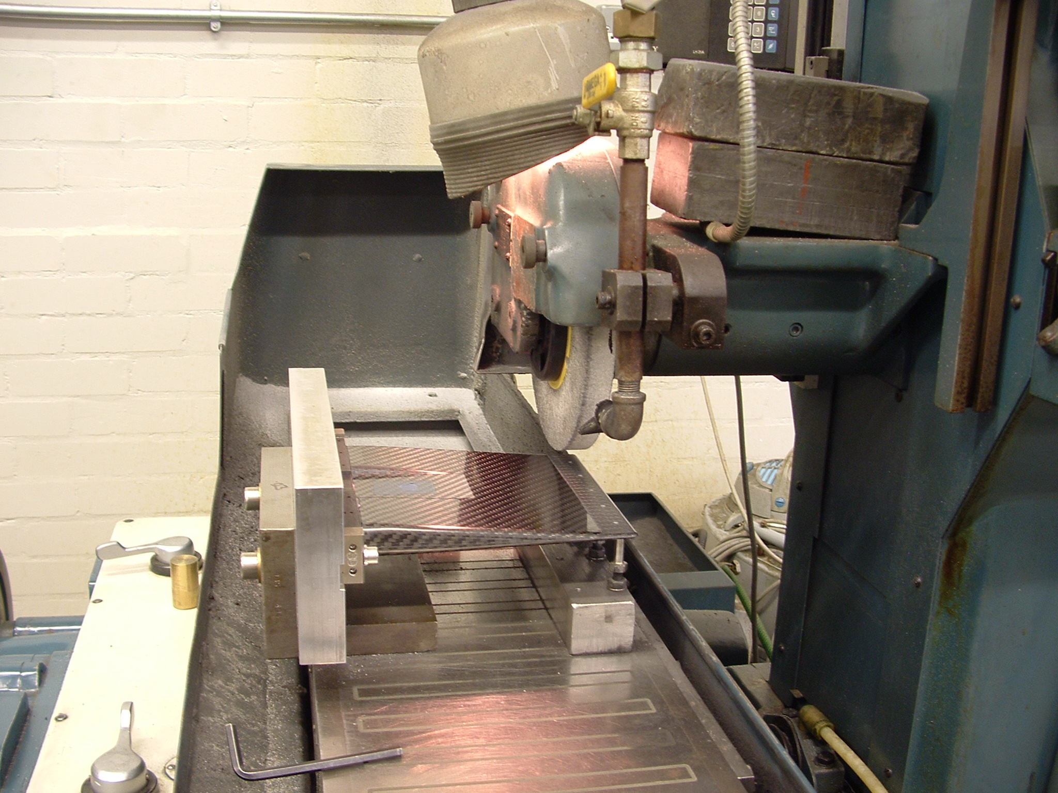

2) The pedestal is then cleaned and placed on the metrology stand of the CMM and a part inspection program is run. This measures the stand top plane, foot dowel hole and the face either side of the slot in the stand, these are used to sets up a coordinate system for the central datum plane of the module. A 12 point plane on the ground face of the pedestal is then measured to find the distance of this face from the datum. The 12 points of the plane are then uploaded to the DB as MET1.

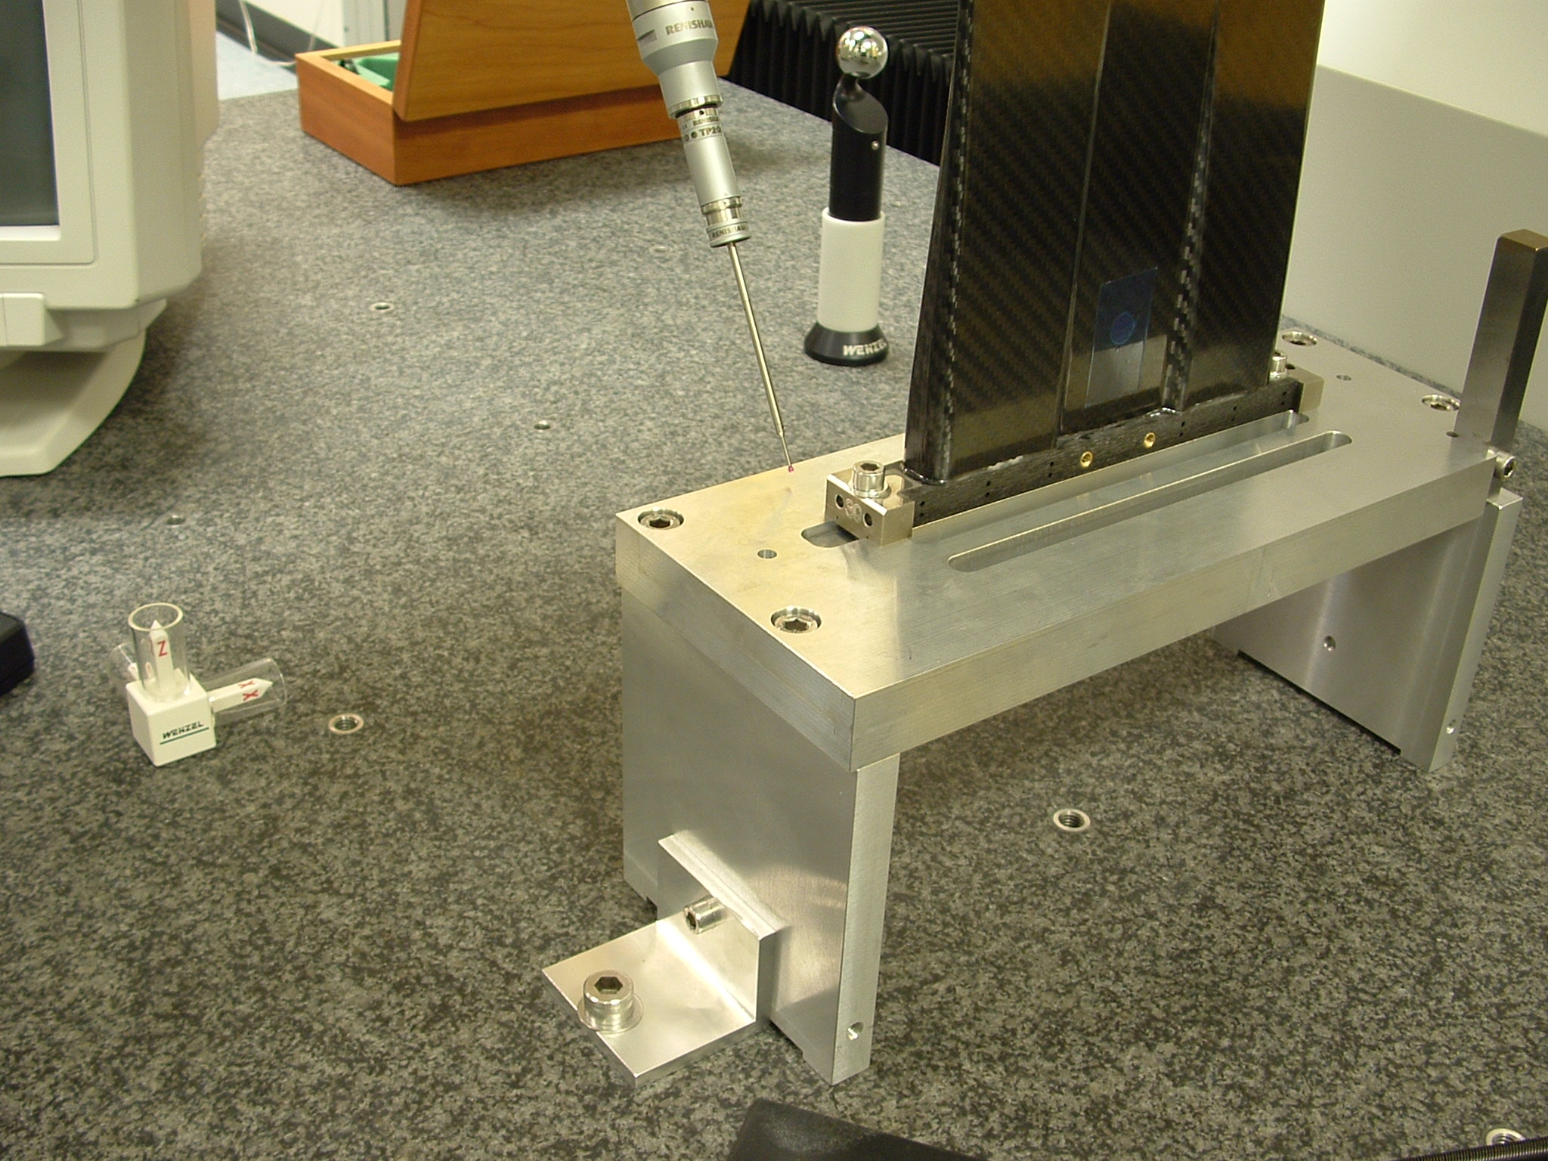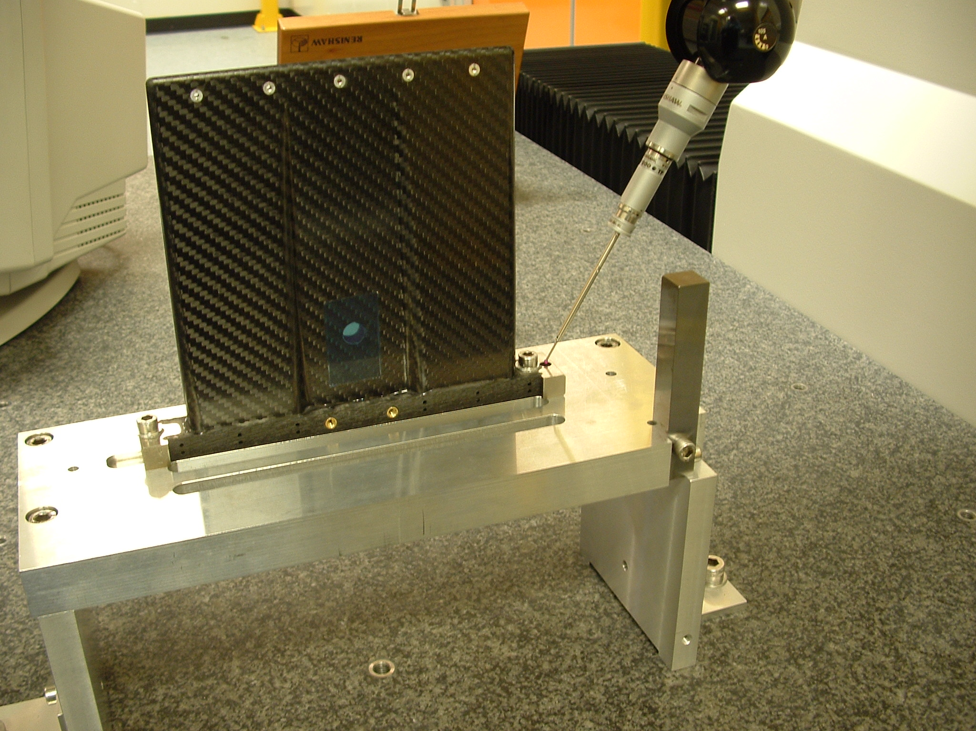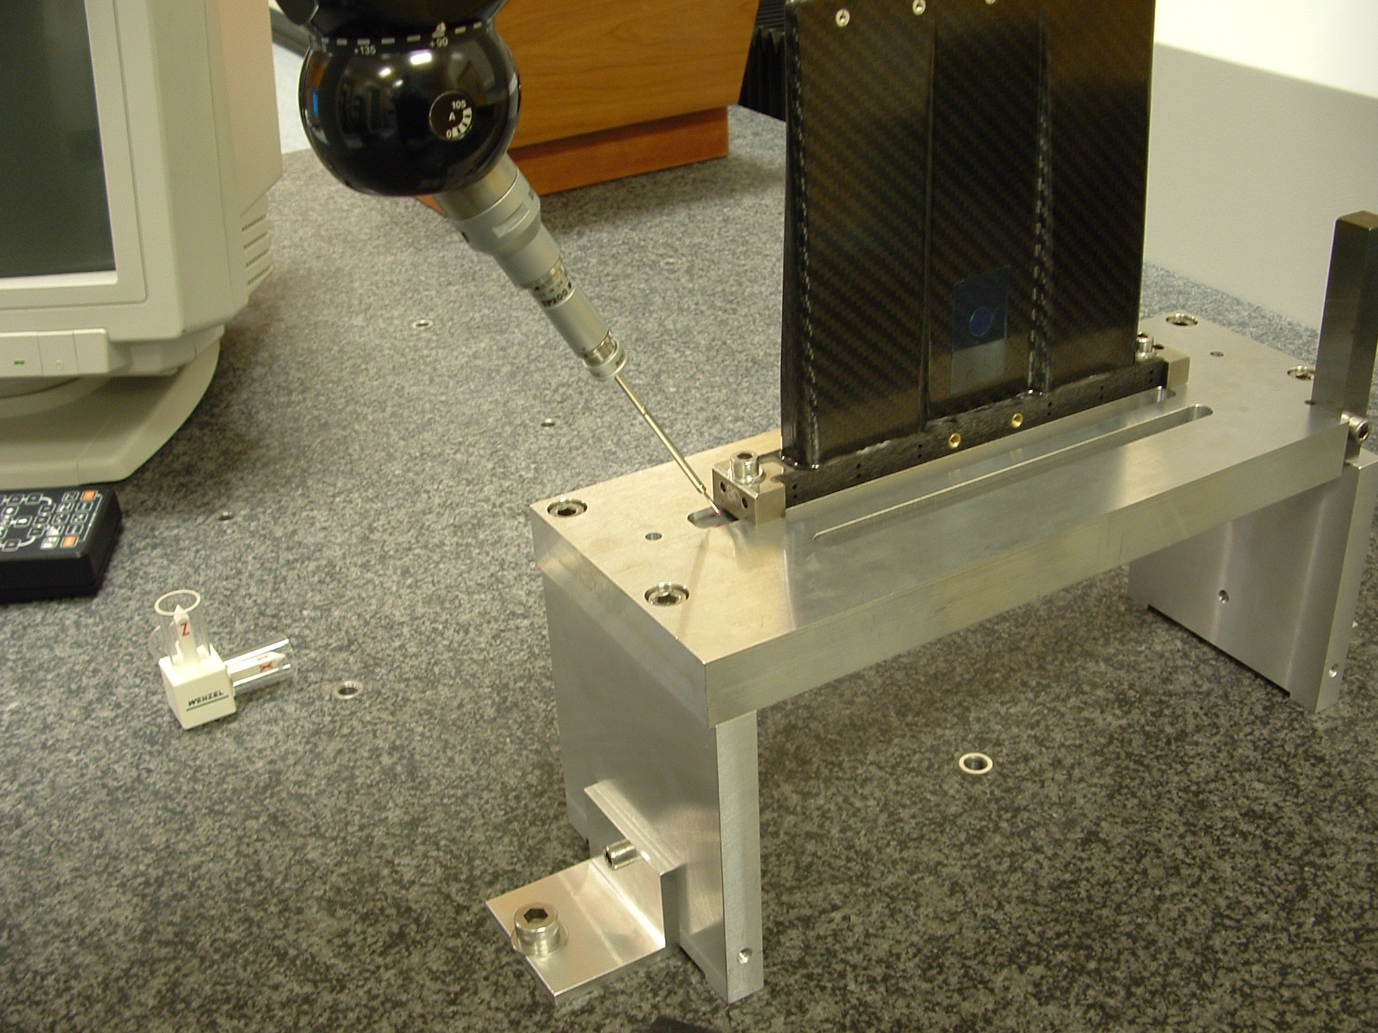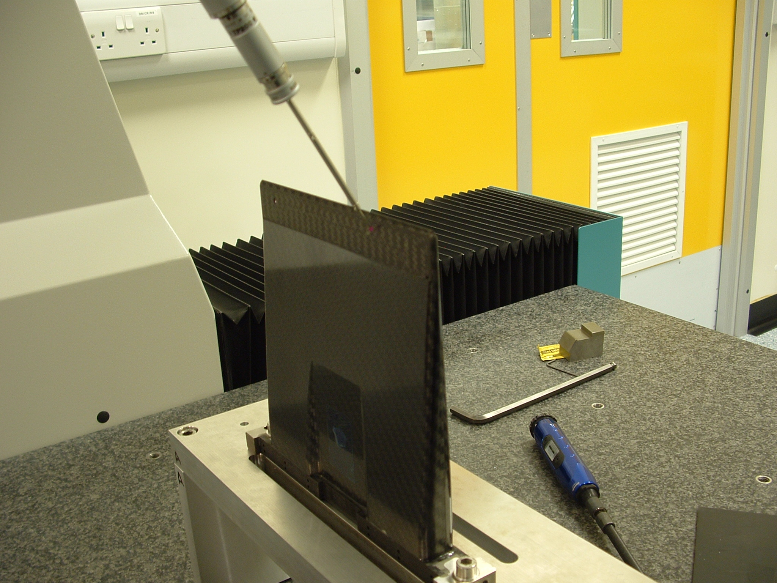

3) Each hybrid has the thickness of the cooling tongue measured at 9 points with a micrometer and loaded as a text file to the DB.
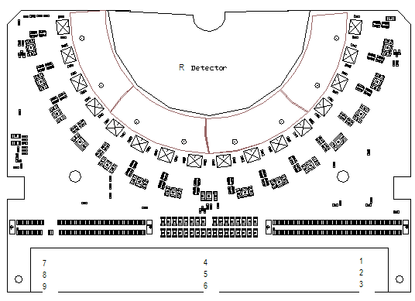 Spacing of points 1-9

4) To match a hybrid to a pedestal take the maximum thickness of the tongue and divide by 2, add the wire thickness (0.220mm) and this is the target offset for the pedestal face.
Subtract the mean of MET1 from the target thickness and round up to the nearest 2 d.p.
e.g. Hybrid82
Thickness of hybrid cooling tongue
1) 0.896
2) 0.885
3) 0.886
4) 0.922
5) 0.915
6) 0.917
7) 0.913
8) 0.935
9) 0.901

Pedestal 35 MET1
Minimum -0.474 ; Maximum -0.444 ; Mean -0.462 ; RMS 0.009
Pedestal 35 matched to Hybrid 82
Hyb 82 is 0.920/2=0.460
0.467+0.220 wire dia.= 0.680 Target offset
Target 0.680 – 0.462 Met1 = 0.218, round up = 0.220 to grind off

5) This dimension is passed to the workshop and the pedestal face reground to remove this material

6) Hybrid is then cleaned and replaced on the CMM metrology stand and the part inspection program is rerun. The resulting 12 points are loaded in to the DB as MET2
e.g.
Minimum -0.690 ; Maximum -0.668 ; Mean -0.680 ; RMS 0.008

7) If the mean of MET2 is within 0.01 mm of the target and the range within 0.01 mm the pedestal is forwarded to pedestal to hybrid gluing stage.
If oversize (excess material) the pedestal is reground and measured, if undersize it is set aside. If the range is outside 0.01 mm the contour of the pedestal is compared with the contour of the hybrid tongue and a as to there compatibility is made.

