Extraordinary X-rays
We’ve all seen them, the shadow-like pictures of bones, broken or otherwise, that genuine medics and their fictional counterparts in “ER” spend so much time looking at. They are a crucial diagnostic tool; screening for breast cancer has the potential to save many thousands of lives in the UK alone. But there is a problem; they are shadow pictures.
If you hold your hand up in front of the sun and look at it, you can see light getting through between your fingers where there isn’t much depth of tissue to block it. Where the fingers are at their thickest, all the light is absorbed. X-ray pictures are the same. When X-rays are shone through your body, objects such as bones absorb them and cast a shadow onto the film. Where they are not absorbed, the X-rays hit the film and expose it. It is then developed and, because it is a negative, the regions where the X-rays hit the film appear dark, whereas the shadows of the bones look light.
So what’s the problem? X-ray pictures taken like this only work because some of the X-rays are absorbed to create the shadows. And there’s the rub. The energy of these X-rays can “cook” the genetic material in the cells in which it is absorbed, some of which may later go haywire as a result. In fact, for every two hundred to one thousand breast cancers successfully detected in screening programmes, one is induced by the X-rays used in identifying the tumours. Obviously, screening programmes have an enormously beneficial effect overall, but there is room for improvement. So is there a way that pictures can be taken with fewer, or perhaps even no, X-rays being absorbed, some kind of extraordinary X-rays?
To answer this, we have to think about what happens when X-rays pass through the body. As we have just seen, some of them are absorbed. How many depends on their energy. The more energetic they are, the further they can go on average, so high energy X-rays tend to cause less damage than those at lower energy. But if all of them go straight through and none are absorbed, there are no shadows on the film and no picture! So what else happens? The X-rays can also be scattered. Instead of going through the body in a straight line, they are bent. The amount of bending varies because there are a number of ways that the X-rays can be scattered. Some of the X-rays are bent a lot and these make the shadow on the film look hazy. Other X-rays are bent only a small amount, in just the same way that light is bent in passing through a lens, by an effect called refraction. And just as in a lens, the amount of bending depends on the thickness and shape of the material. Can this fact be used to form pictures of the body without requiring that X-rays be absorbed?
Unfortunately, the amount of bending involved in the refraction of X-rays is tiny. The deviation from a straight line is about one millimetre over a distance of a kilometre. But maybe we shouldn’t give up just yet. After all, we do see “pictures” formed by the scattering of light through tiny angles. Find a room in your house that has a radiator under the window, and put the radiator on full blast on a winter’s day on which the sun is shining in through the window. Look at the sunlight hitting the opposite wall. What do you see? Faint shadows that look a bit like smoke rising up the wall. Pockets of air above the radiator are being warmed and are less dense than the surrounding air. These pockets form extremely weak lenses that cause the light going through them to bend slightly. You see the effects on the wall; more light is being focussed onto some parts of it than others. As the “lenses” are formed of hot air, they tend to rise, giving the smoke-like effect.
How do changes in density cause X-rays, or light, to be bent? When X-ray waves hit material, the waves cause the electrons in the atoms of the material to jiggle up and down like buoys in the ocean. But this jiggling motion causes the electrons to emit radiation, just as jiggling the buoys will make waves on the sea. If the jiggling is happening at X-ray frequencies, the waves that are emitted are more X-rays. These will jiggle electrons in further atoms, and so on. The X-rays are passed from atom to atom through the material and finally emerge at the other side. Now we can see that changes in the density, the concentration of atoms, will affect the way the X-rays are passed atom-to-atom through the material and may cause them to emerge at an angle.
So how can we detect the X-rays that have been bent by the changes in the density of tissue due to bones, cartilage or even cancer? We need to pick out the refracted rays and ignore the rest. If we could reflect rays that are at a slight angle to the straight-line path, but not the rest, we would be onto a winner. But is there a way of doing this? Yes there is, we can use diffraction.
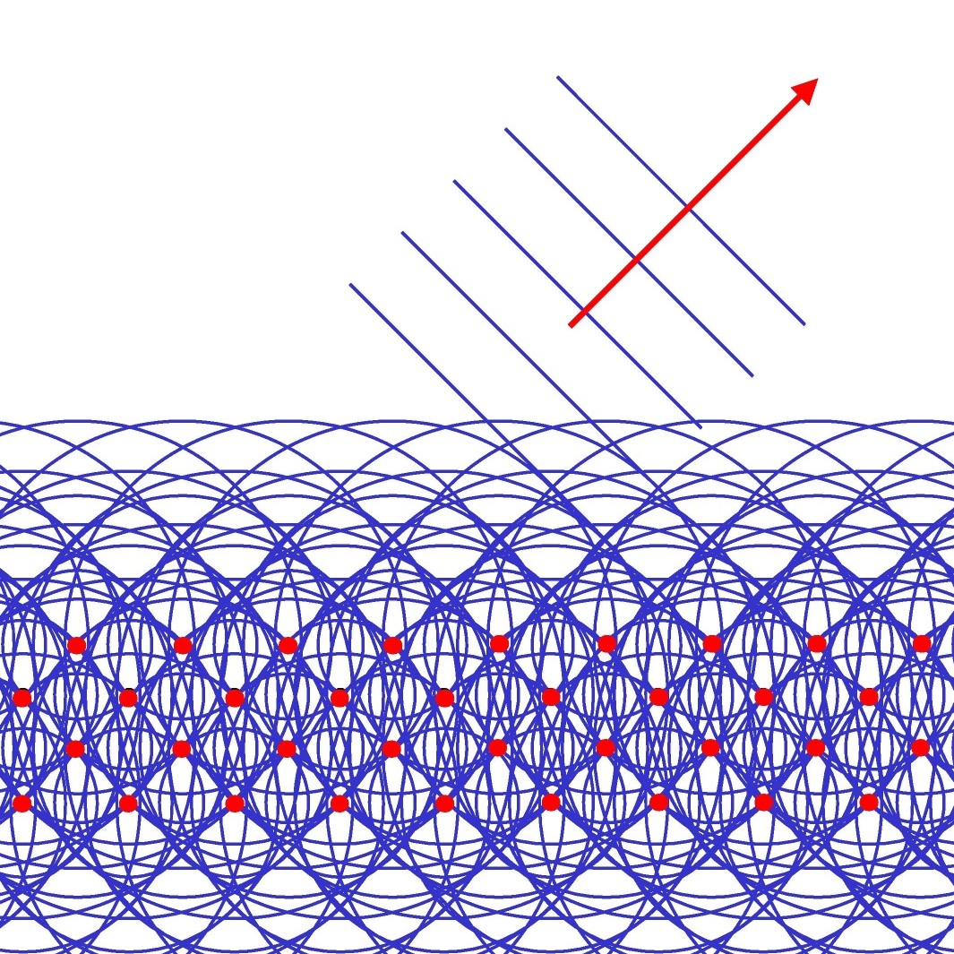
Figure 1: Red coloured buoys, bobbing up and down on the ocean, produce waves whose peaks are shown by the blue circles. Where peaks from one buoy meet peaks from another, the waves reinforce each other, where peaks meet troughs they cancel. The red arrow shows the direction of one of the resulting outgoing waves.
Suppose all those buoys in the ocean are being jiggled by incoming waves, and the jiggling motion is causing each of them to emit more waves. The emitted waves will spread out in a circular pattern around each buoy. If the buoys are randomly placed, wave troughs from one buoy will eventually meet peaks from another and the emitted waves will tend to cancel each other out. However, if the buoys are arranged in a regular pattern, as in figure 1, for incoming waves coming at the right direction, there will be some outgoing directions in which peaks from one buoy only meet peaks from another and troughs only meet troughs, reinforcing each other. Waves will travel in these outgoing directions, some of which are very different to the incoming direction. This phenomenon is called diffraction. For X-rays, we replace buoys with electrons arranged in the right pattern. As the electrons are fastened to atoms, this means we have to find materials in which the atoms are arranged in a regular way. Such materials do exist and we are all familiar with them; they are crystals, like diamond or ice. Thanks to the electronics industry we can get crystals that are cheaper than the former, and sturdier than the latter. The very large perfect crystals of silicon used for making chips are just what we need.
The next step in getting extraordinary X-rays is to place a silicon crystal in the beam of X-rays coming through the hand, leg or whatever it is that has to be examined. Careful orientation of the crystal ensures that the X-rays that have been bent off the straight-line path are diffracted. Effectively, the crystal acts like a mirror for the rays that have been scattered through a certain angle, but does not reflect the other rays. Catch the “reflected” X-rays on film, or better using a more sophisticated detector, and you are seeing only those that got scattered by bones etc. Eureka, we’ve done it!
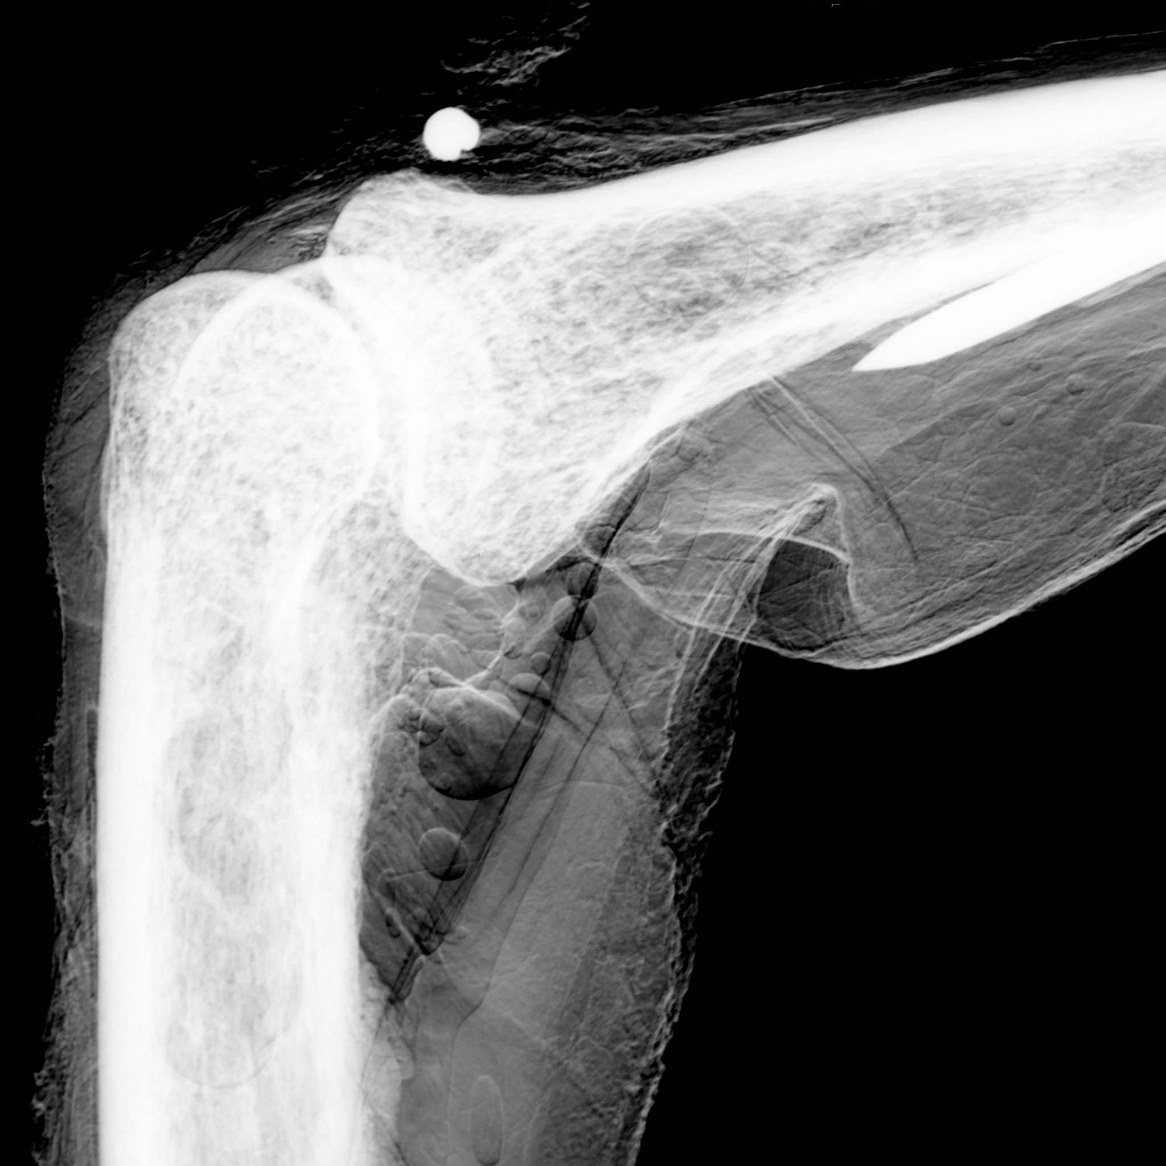
Figure 2: A picture of a finger joint.
The resulting pictures are very impressive, as shown in figure 2. This image is much better than a conventional X-ray because those X-rays that are bent through large angles are not reflected and so the haziness is eliminated. But this is not the end of the story. The picture we see is a mixture of the standard shadow picture and the new picture formed from the refracted X-rays. This happens because the difference in direction between the X-rays that have been refracted and those that came straight through is so small, that even our trick with the crystal can’t separate them completely. What we can do is to make a second exposure, shown in figure 3, immediately after the first, with the silicon crystal rotated ever so slightly. This means that X-rays scattered at a different angle are now diffracted onto the detector, but the shadow picture stays approximately the same. Identifying the differences between the two pictures with some sophisticated mathematics allows us to extract the pure refracted picture; we have our extraordinary X-ray.
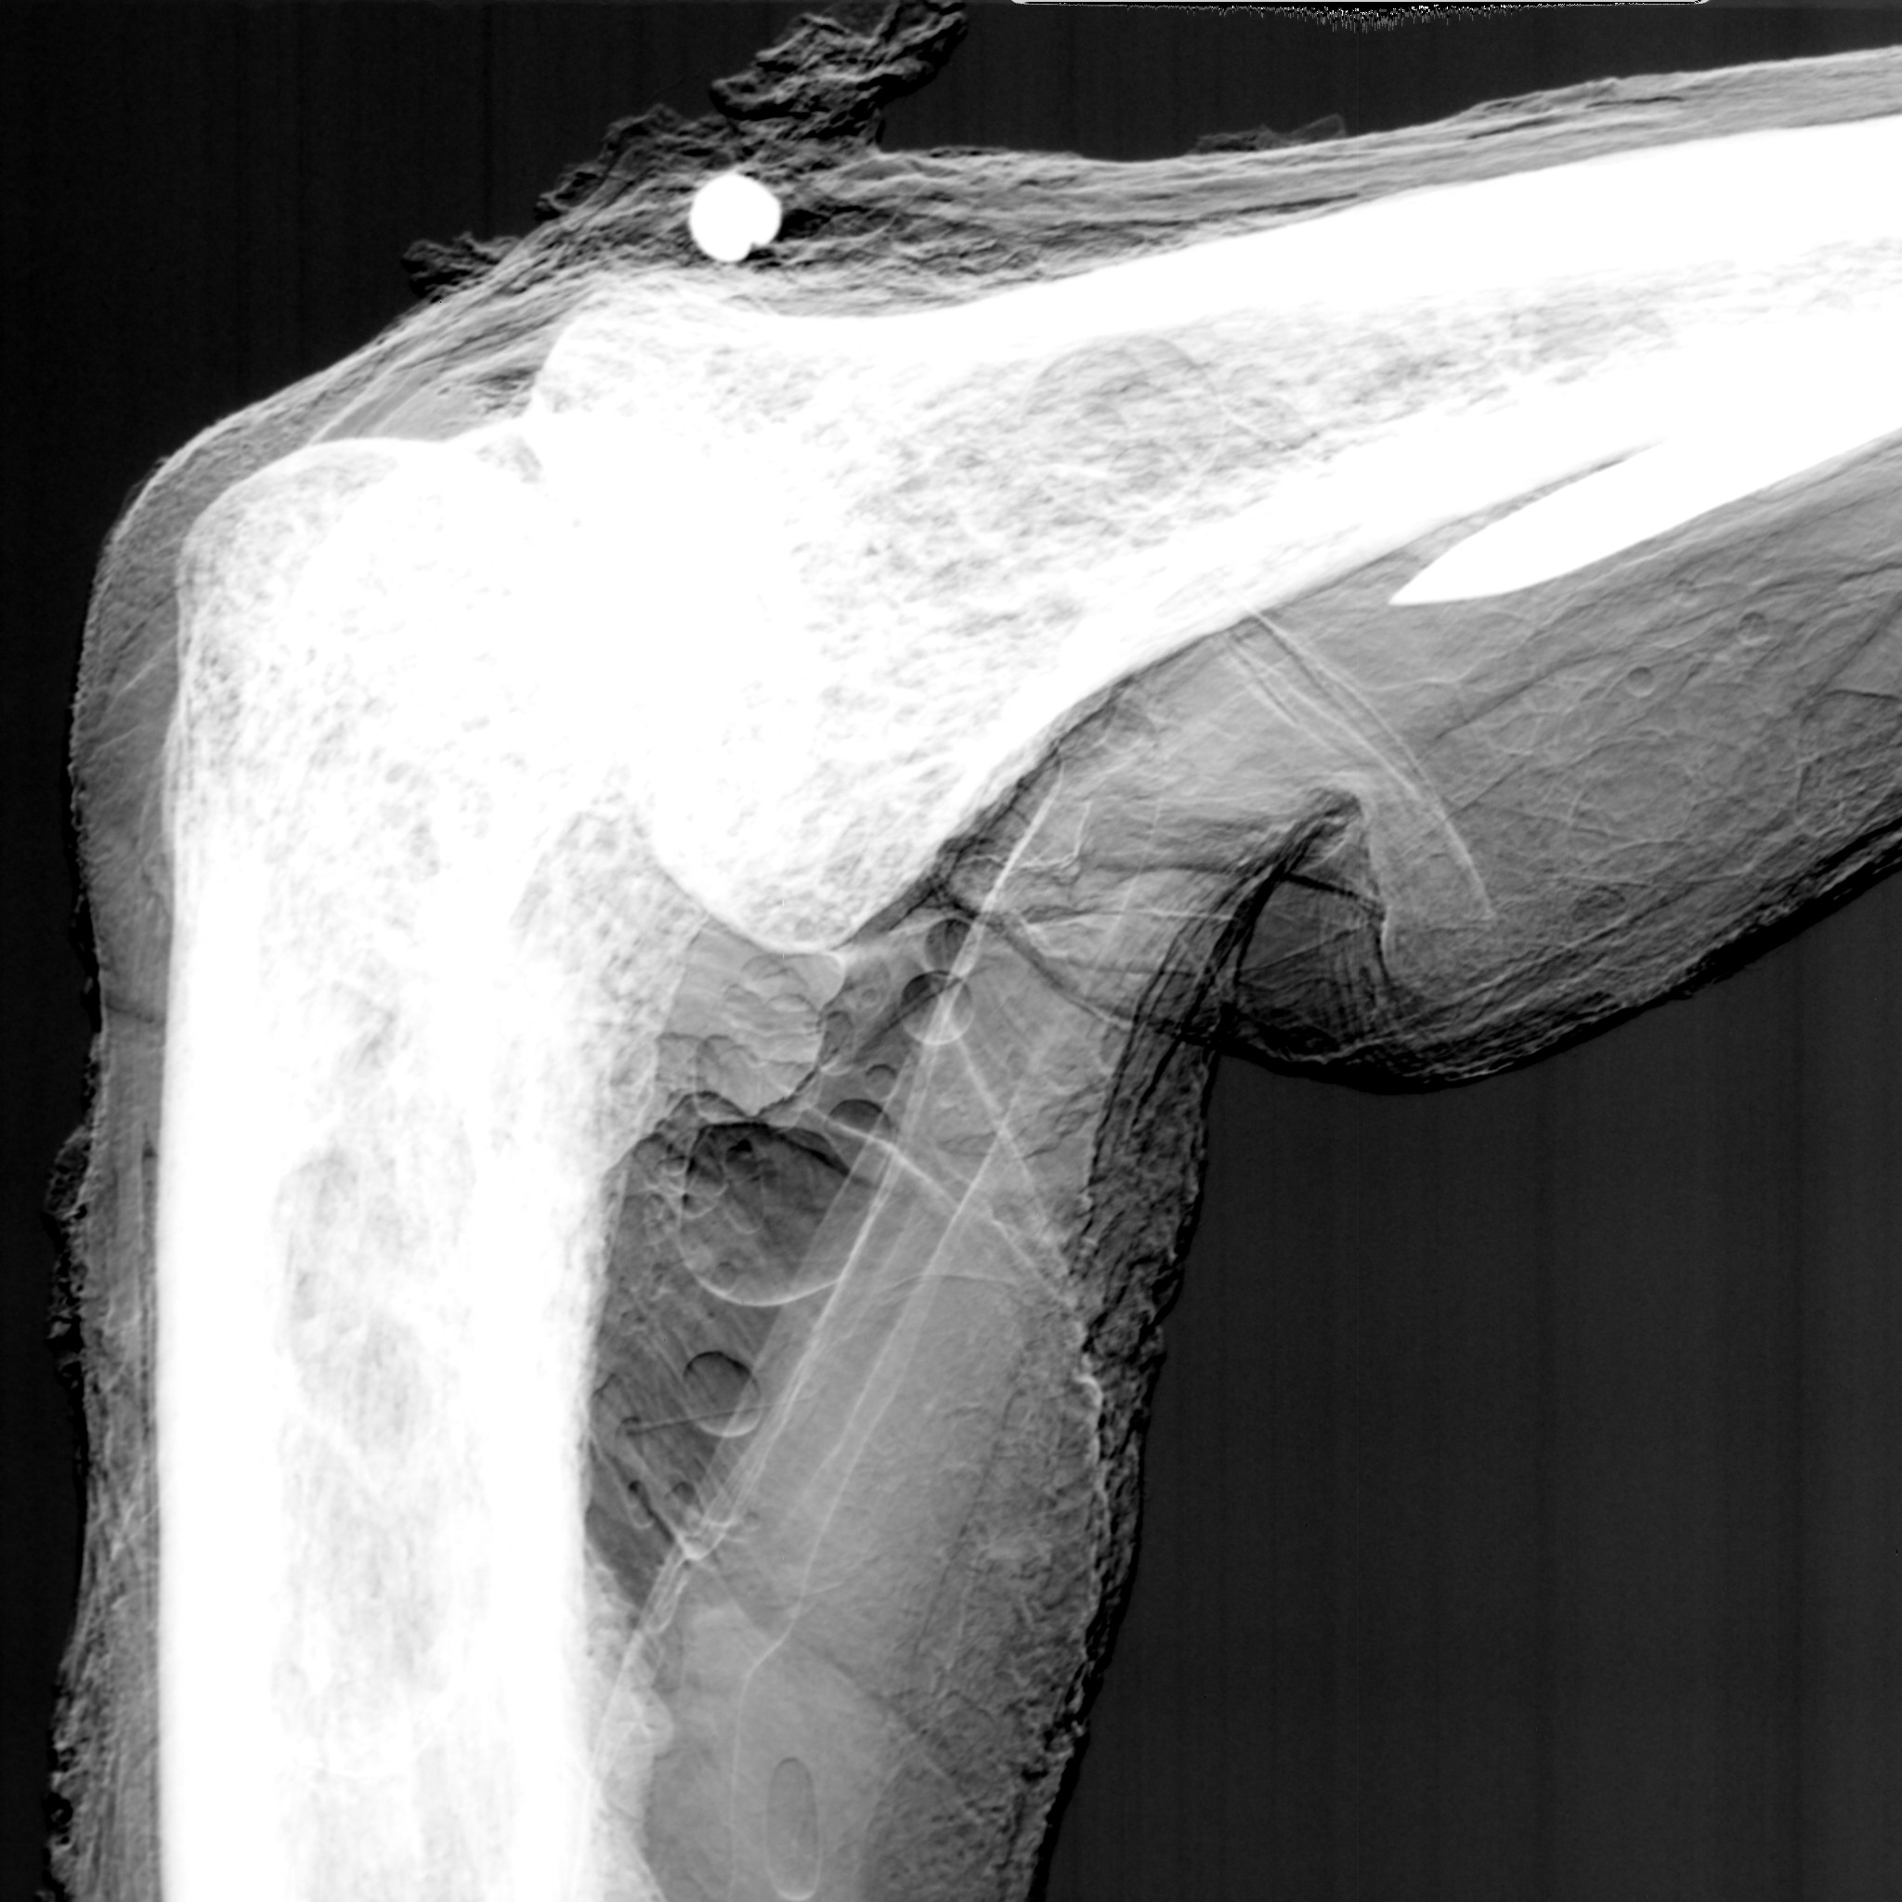
Figure 3: A second picture of the finger joint shown in figure 2.
An X-ray image of a finger joint, the result of “subtracting” the pictures shown in figures 2 and 3, can be seen in figure 4. The detail visible is astonishing. Because the amount the X-rays are scattered depends so strongly on how the electrons are distributed in the tissue, it is possible to see the differing electron patterns corresponding to cartilage and tendons in the picture as well as all the structure within the bones, impossible with conventional “shadow” X-rays. (You can also see a little lead ball used as a marker.) So is this the future of X-rays?
Some of us think the answer is “partly”. One problem is the requirement that two exposures be taken for each extraordinary X-ray picture. Any movement between the two exposures, due to breathing, beating of the heart or rumbling of the tummy, will spoil the picture. Work is going on at the Daresbury Laboratory near Warrington in Cheshire to tackle this problem. It is certainly surmountable.
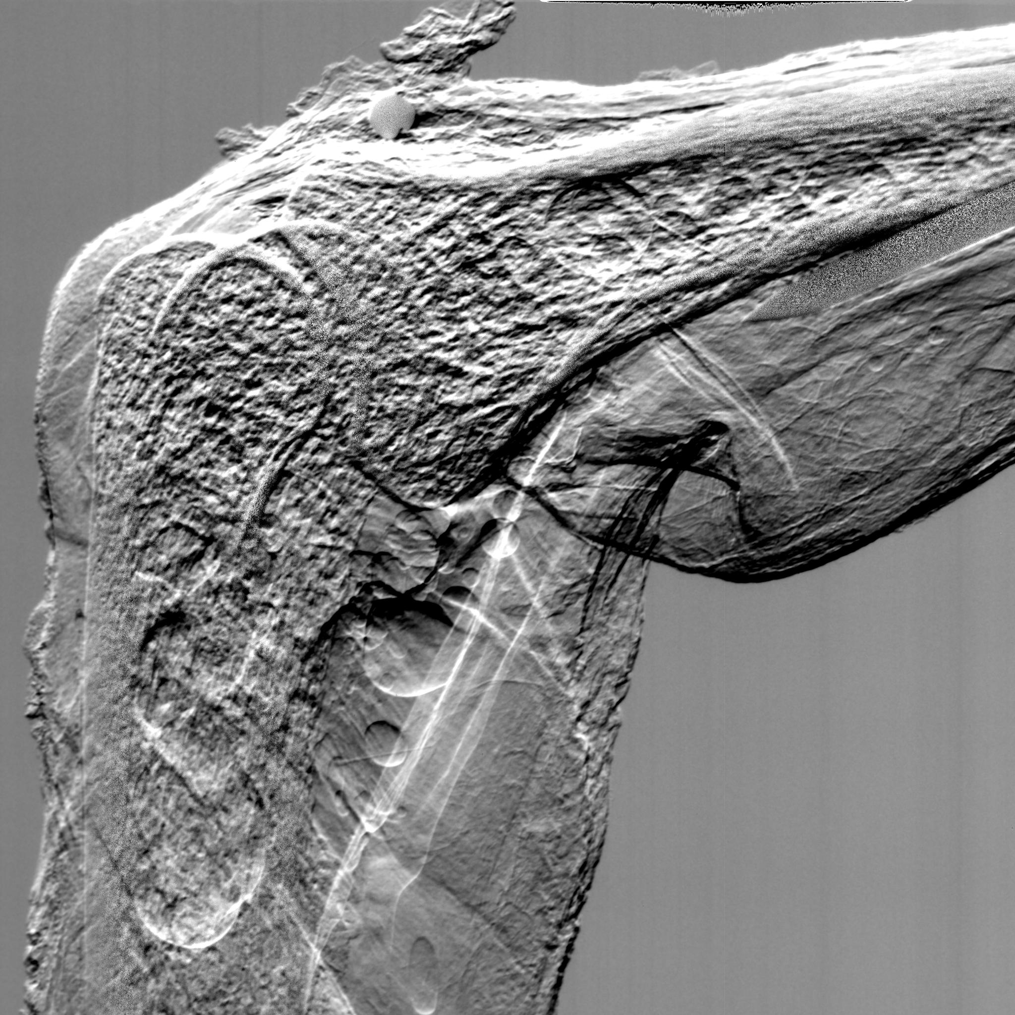
Figure 4: The “extraordinary X-ray” formed by removing the “shadow” picture from the images shown in figures 2 and 3.
The second problem is going to take longer to solve. In order to make the diffraction idea work, all the X-rays must be travelling in the same direction to a high degree of precision before they pass through the object to be examined. To reduce the dose below that of conventional X-rays, high energies are also required. Both of these facts make it necessary to use a synchrotron, a kind of particle accelerator, to produce the X-rays, rather than a conventional X-ray set. These X-rays, called synchrotron radiation, are produced when electrons are accelerated to nearly the speed of light and then pushed through a slalom course made of magnets. The magnets force the electrons to follow a wiggling path and as we know, wiggling electrons emit radiation. Choosing the dimensions of the slalom course correctly ensures the required high-energy X-rays are produced. Of course, the accelerator needed to do all this is large and expensive, which makes it unlikely that we will be able to site one in every hospital in the UK, or even in every region, in the near future.
So how can we put these ideas into practice so that we can all benefit from much better X-ray pictures? The government recently announced a £ 150 M package to establish a Centre for Accelerator Science, Imaging and Medicine (CASIM) at Daresbury, to help bring together all the people needed to make this new imaging technique work, and to investigate the possibility of designing and building much cheaper and more efficient accelerators with UK industry. This will establish a unique partnership between the Universities, hospitals and industry in the North West, quite different from scientific co-operations that have been tried before. CASIM will also make possible proton therapy for deep-seated tumours, see “Treating Cancer with Protons”, allow investigations of exotic nuclei important in the early universe and design and build a suite of Free Electron Lasers, which will enable us to study biological molecules useful for drugs.
And supposing we aren’t able to find cheaper ways of getting high-energy X-rays? Extraordinary X-rays will still be useful. The Daresbury synchrotron could be used to screen people who are genetically susceptible to breast cancer from an earlier age than is now possible, for example, and produce images of higher quality. The reduced dose would allow this to be done without the risks that would be associated with so many normal X-rays. But for now, lets keep our fingers crossed that CASIM can deliver what we want.

