AERO: Scurve Distortion and VDC Vled Control Voltage

Ashley Greenall & Scott Lindsay (August 2003)

When using AERO for the readout of SCT Endcap modules a discontinuity can be seen on the Noise Occupancy Scan. This is present no matter what readout mode is selected. This short document aims to explain why this phenomena is peculiar to the AERO readout and offers a simple solution to overcome this problem.

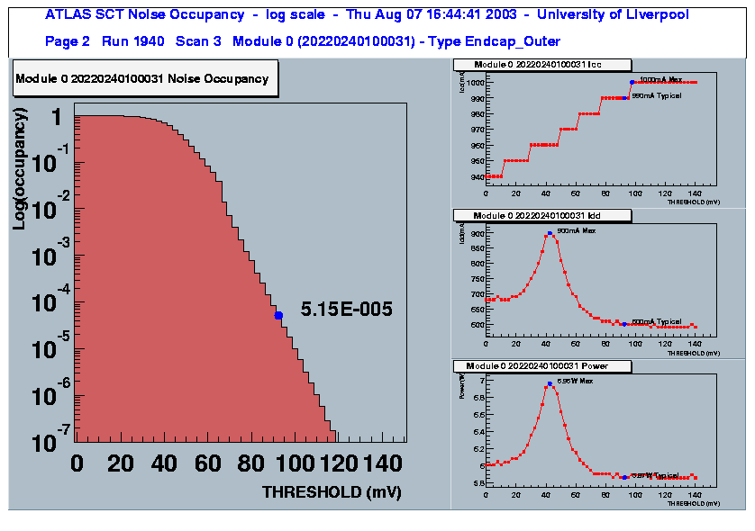
Discontinuity
AERO Pseudo-Optical Readout Mode Noise Occupancy Scan (VLED = 5.5V)

The plot above shows the Noise Occupancy Scan for an EndCap module readout using AERO in Pseudo-Optical Readout mode (Select = 0, SC_Mode = 0). The module was mounted onto the cooling block using a thermal pad (which is electrically conductive). It is clear from the plot that the module is either exhibiting some form of instability or there is an external influence which is affecting the module’s performance.

Typical Scurves for the above Noise Occupancy Scan are shown below:

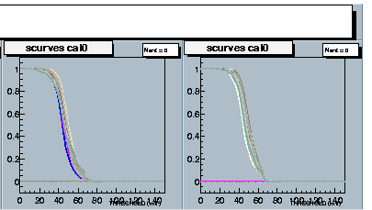
Some Scurves show a discontinuity at ~60mV threshold.
Scurves switch off much quicker than one would expect. Hence the discontinuity on the threshold scan.

AERO Pseudo-Optical Readout Mode Scurves (VLED = 5.5V)
Repeating the Noise Occupancy Scan but this time with the AERO readout changed to Redundant Mode, this should be the same as the Melbourne Support Card.
If one ignores the ‘higher’ Noise Occupancy value (the grounding scheme has been optimised for Pseuo-Optical readout) there is still a discontinuity clearly to be seen on the threshold scan.

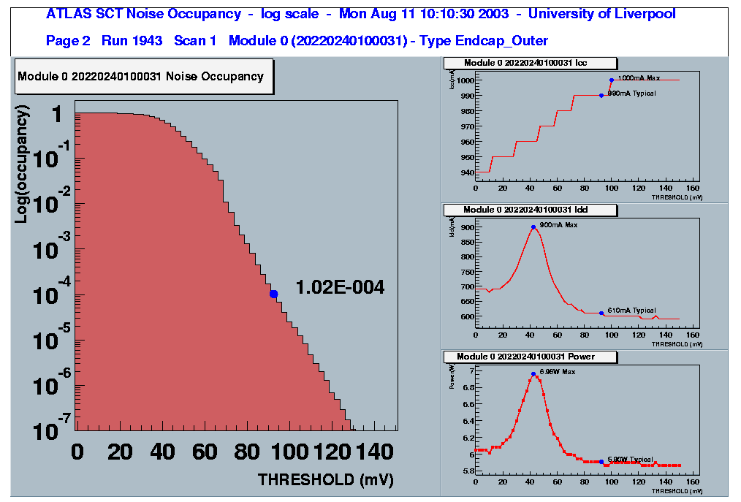
Discontinuity

AERO Redundant Readout Mode Noise Occupancy Scan (VLED = 5.5V)

For both the above Noise Occupancy Scans shown the VDC control voltage VLED was set to 5.5V (this sets the control current for the output drivers of the VDC, increasing this control current will increase the voltage swing of the output signal of the VDC).
For the Pseudo-Optical readout it is necessary that this be set such that data is actually transmitted from the VDC to AERO. But for the Redundant readout mode the VDC is not used hence VLED can be set to 0V.
Now repeating the Noise Occupancy scan with VLED set to 0V, in Redundant mode, the following plot is obtained:

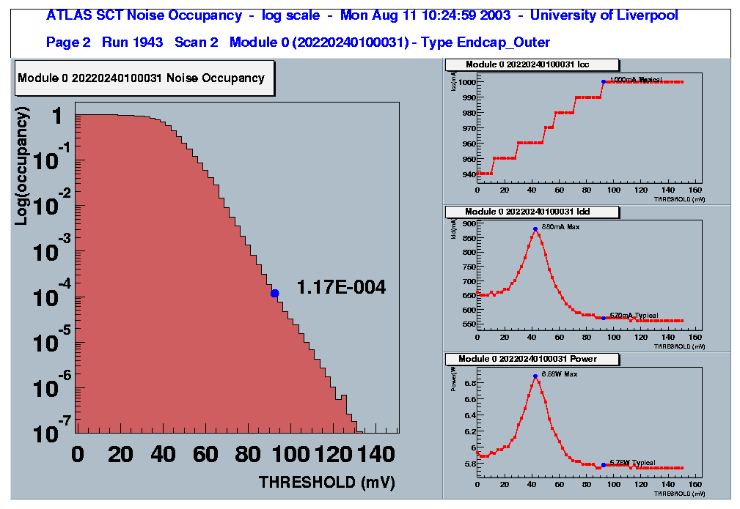
Discontinuity has reduced

AERO Redundant Readout Mode Noise Occupancy Scan (VLED = 0V)

It thus appears that with VLED set to 0V the discontinuity reduces.
Wiggly Kapton and Ethernet Cable to AERO

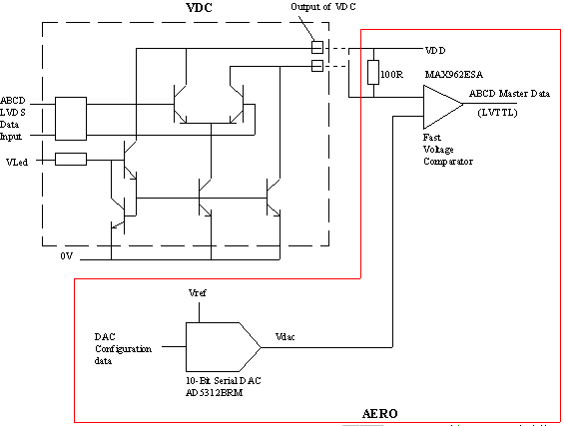

Schematic of VDC Electrical Readout (using AERO)

The schematic above shows that the VDC is a single-ended readout – whereas when using the Redundant readout (or the Melbourne Support Card for that matter) the data transmission is differential. Not only being single-ended the VDC output is sensed remotely from the hybrid, so one could infer that the problem could be due to either:

- The VDC output signal is being capacitively coupled back into the module via the Wiggly Kaptons and the Module Test Box.

- Changes in the digital power supply VDD are coupled back into the front-end of the ABCD. This could happen as the VDC output is sensed remotely on AERO – the output voltage signal is derived from adding a load resistor (which is mounted on AERO) across the VDC anode (which is actually VDD) and the VDC cathode. The use of ‘long’ cables, between AERO and the Patch Card, will introduce an impedance and therefore the VDD on AERO will actually be at a different potential to the VDD that is on the hybrid. As the VDC switches this could cause the VDD on the hybrid to change also.

So two solutions possibly exist:

- Electrically screen the Wiggly Kaptons so as to stop the VDC output being coupled back into the module.

- Reduce the magnitude of the VDC output signal i.e. reduce VLED. By doing this will reduce any changes seen on the VDD power supply.
As 1. appears to be non-realistic then option 2. maybe the only viable solution. Therefore repeating the Noise Occupancy Scan for various values of VLED (6V to 2V) using the SC_Mode 1(this mode uses the DORIC for data transmission to the module but data readout is via the ABCD SpyConnector and not the VDC). This readout mode was chosen for simplicity as it does not require the AERO to be reconfigured for data readout as VLED is modified. It is important to note that the VDC still transmits data back to AERO it is just that AERO disregards this data.

The Noise Occupancy plots for reducing VLED are shown below:

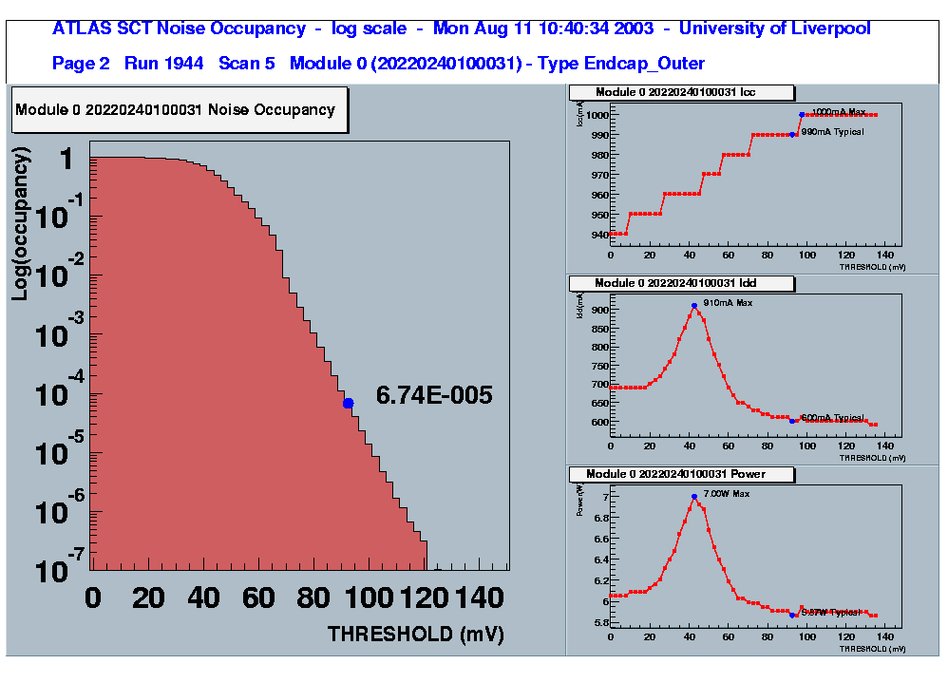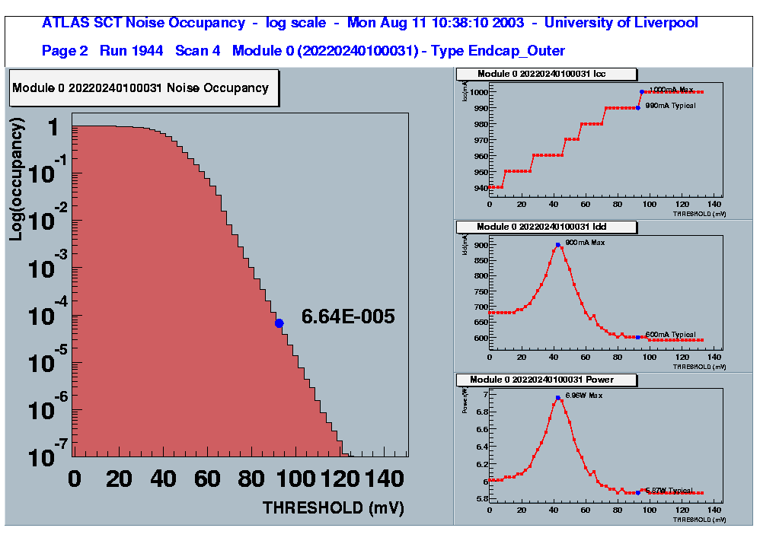
VLED = 6V VLED = 5V

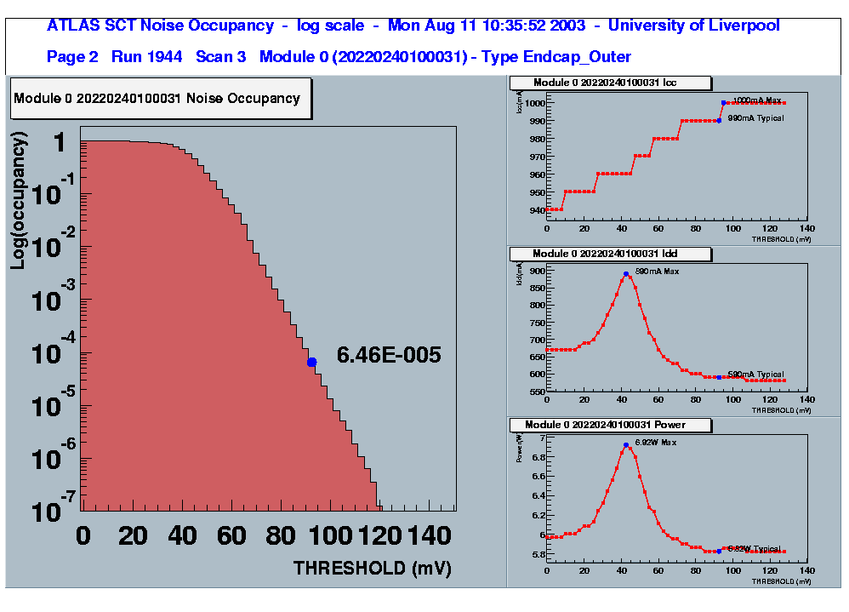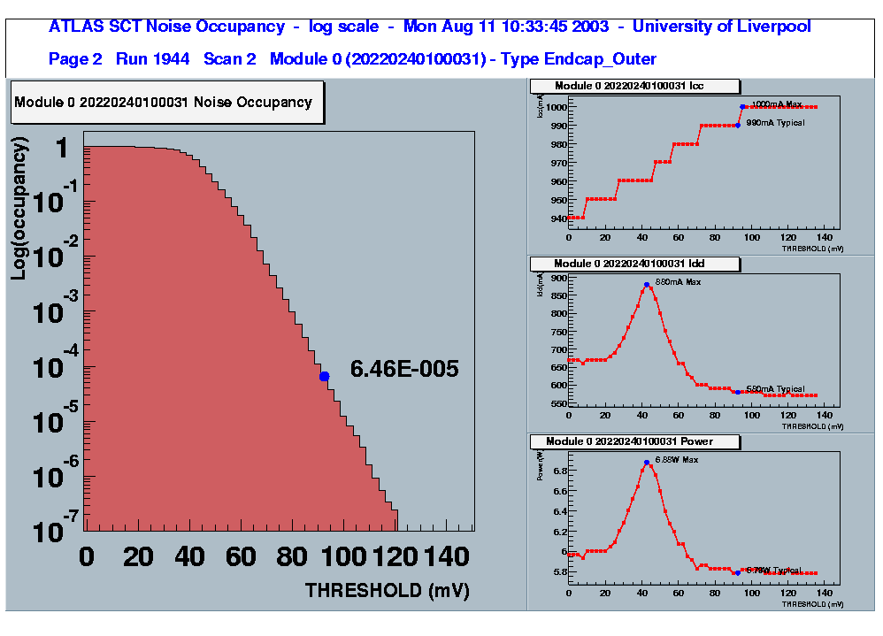
VLED = 4V VLED = 3V

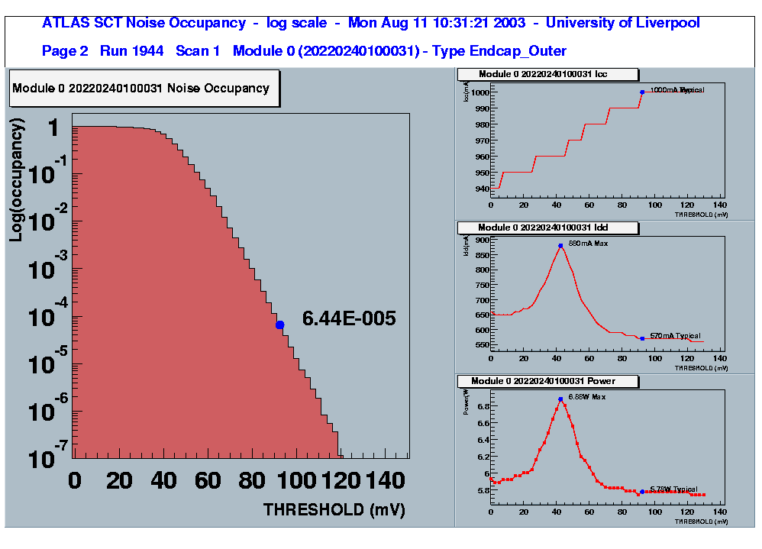
VLED = 2V

Clearly as VLED reduces so does the discontinuity. Therefore if one is able to run with reduced VLED whilst in Pseudo-Optical mode then it might be possible to obtain a Noise Occupancy Scan with little or no distortion. The following plot was obtained with VLED set to 2.8V and a 5m Ethernet cable linking AERO to the module Patch Card.

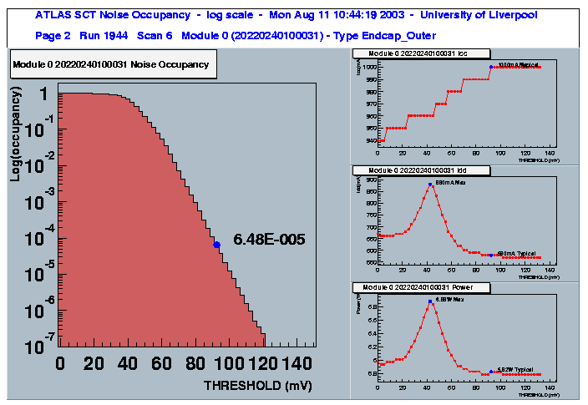

AERO Pseudo-Optical Readout Mode Noise Occupancy Scan (VLED = 2.8V)

The same channel Scurves, as presented at the beginning, are shown below but with VLED = 2.8V. There is still evidence of the Scurves still switching off at the same time BUT the affect has been significantly reduced.

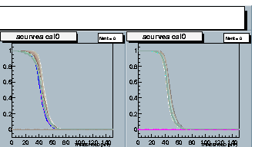
Scurves now show reduced discontinuity at ~60mV threshold.

AERO Pseudo-Optical Readout Mode Scurves (VLED = 2.8V)

Low Trigger Frequency Operation (No CLOAC)

So far all the tests have been done with SCTDAQ configured to use CLOAC for the module triggering – this uses a variable trigger rate which peaks at 100KHz. Using the same module and configuration(s) as before the Noise Occupancy Scan was repeated but this time using a non-CLOAC based system (this operates at a fixed trigger frequency of ~35KHz). Operating at a lower trigger frequency will have the benefit of reducing the presence of switching transients on the VDD power supply - assuming that this is the problem then one should be able to operate with a larger value of VLED and see a reduced presence of the discontinuity on the Noise Occupancy Scan.
The following Noise Occupancy Plots, for VLED set to 5.5V and 2.8V clearly confirm this:

VLED = 5.5V VLED = 2.8V
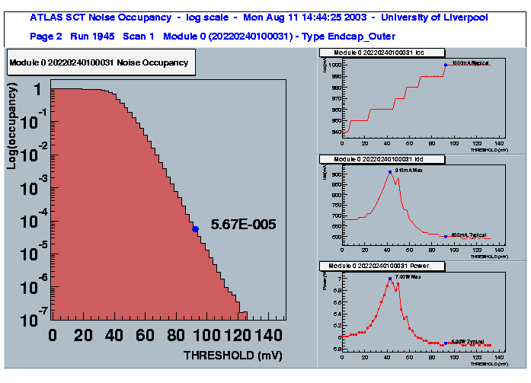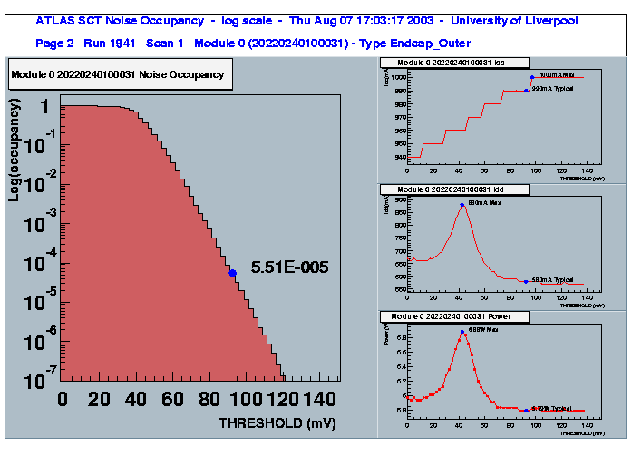

No CLOAC Pseudo-Optical Readout Mode Noise Occupancy Scans

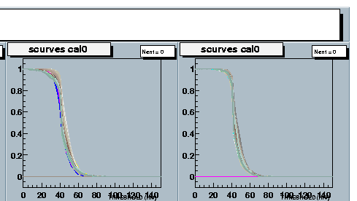
Scurves now show no discontinuity at ~60mV threshold.

AERO Pseudo-Optical Readout Mode Scurves (VLED = 2.8V) with No CLOAC

Conclusion

A correlation has been confirmed between the output switching voltage signal(s) of the optical VDC device and noise pick up by an SCT Endcap module. This noise pick up is directly related to the magnitude of the VDC output and also the trigger frequency – by reducing VLED one can significantly improve the module’s performance. Further improvement can be obtained by running at a reduced trigger rate but this will result in a ‘compromised’ Noise Occupancy Scan – as it does not meet the SCT requirement of a nominal trigger frequency of 100KHz.
For the actual experiment where ‘true’ optical readout will be used then one would not expect to encounter such problems as the VDC will be directly linked to an opto-plug-in which houses the optical components. The track lengths in this case will be of the order of mm and NOT metres as is the present case when using AERO.

