ATLAS SCT AERO (Version 1.2)

http://hep.ph.liv.ac.uk/~ashley/ATLAS_AERO.html

AERO Driver Board
The AERO is a 6U VME board which has been designed to interface (electrically) up to 6 Endcap modules to SCTDAQ. For each channel it provides:

- A pseudo-optical drive signal to the DORIC on the Endcap module (Select = 0).
The switching magnitude of this signal is fixed at ~120µA (the DORIC switching range is 60µA to 600µA).

- Data is read back from the module via the VDC opto device (Select = 0).

- The Redundant CLK1/COM1 signals and transmission route can be exercised with Select = 1.
A pseudo-optical CLK/COM is transmitted to the DORIC, with Select set to 1 the DORIC redundant outputs (CLK1/COM1) are routed off the module and then fedback into the module via the Wiggly Kapton Redundant connector.

Module data is readout via the VDC.

This emulates how the redundancy will be implemented in the experiment.

- Provision has also been provided so that the Redundant CLK1/COM1 can be sourced directly from SLOG and with data readout via the Master ABCD spydata connection.

This bypasses the Opto devices DORIC and VDC.

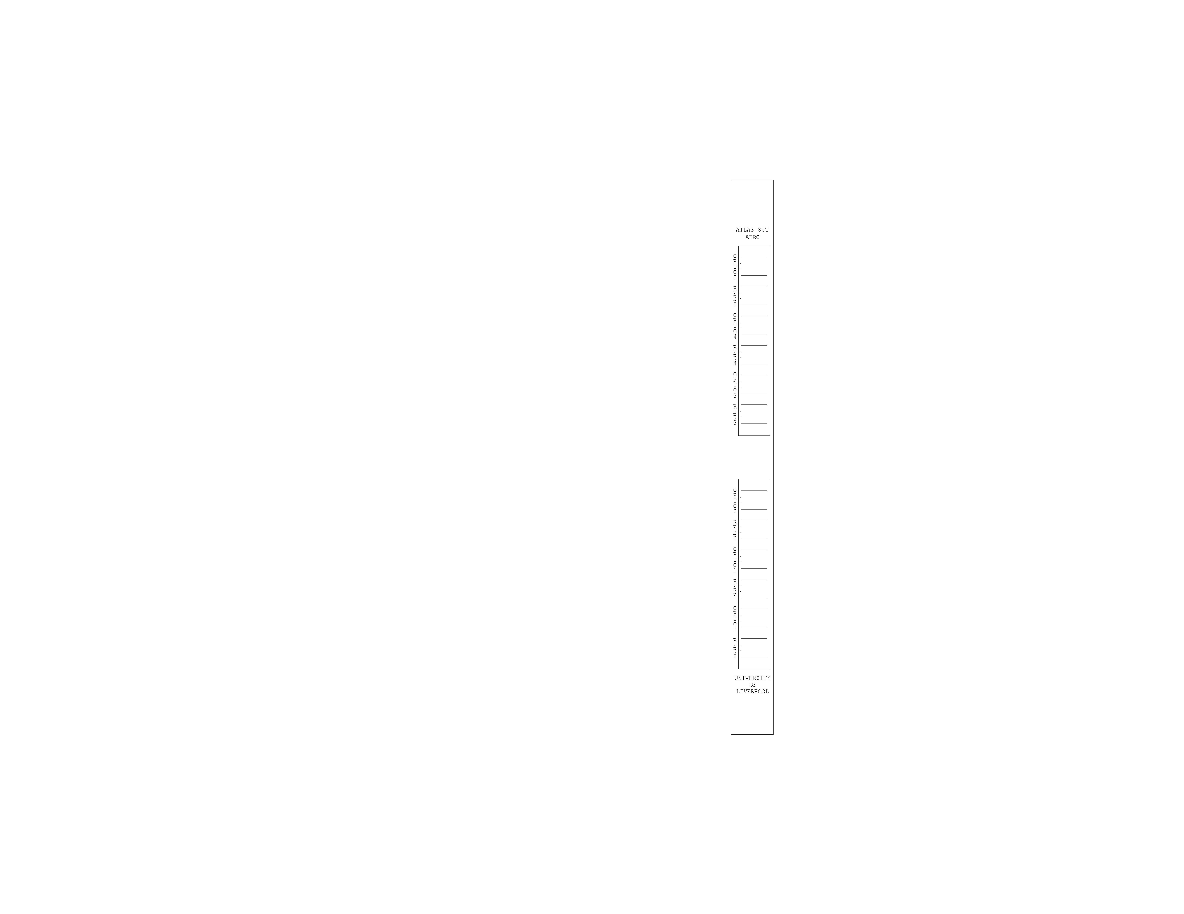
Pseudo-opto0
Pseudo-opt01
Pseudo-opto2
Pseudo-opto3
Pseudo-opto4
Pseudo-opto5

Connections

The Board slots into a standard 6U VME crate and requires +5V and +12V power.
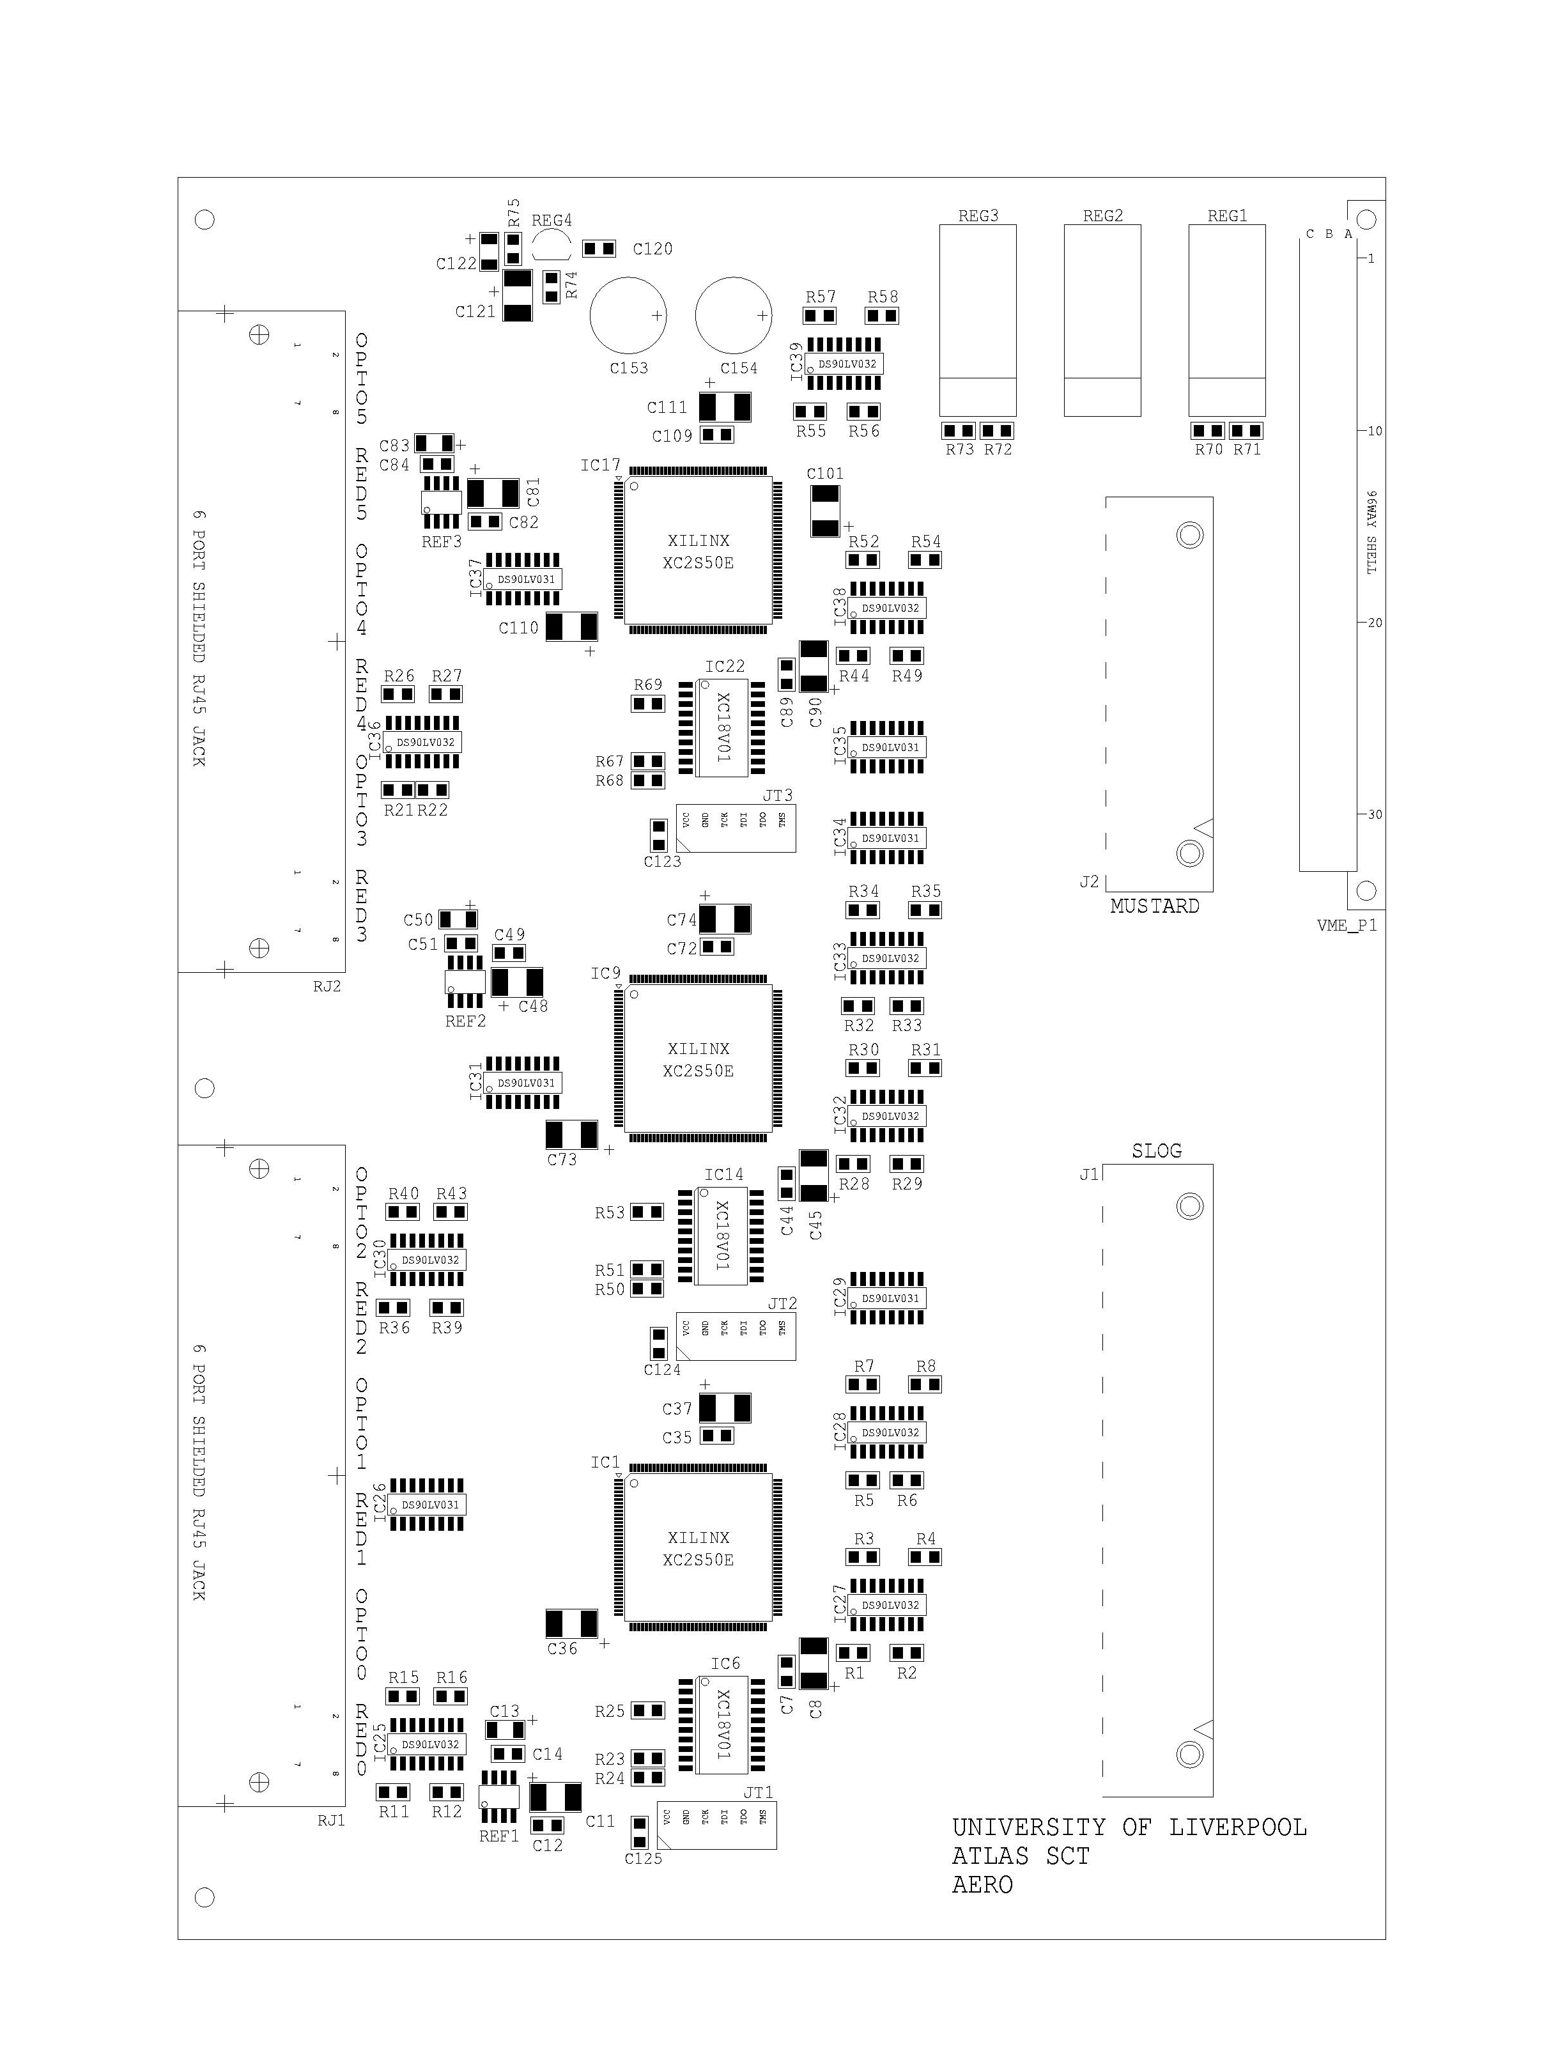
SLOG
MUSTARD
Redundant0
PseudoOptical0
Redundant5
PseudoOptical5
- The interconnects to the Patch Card(s) are made via Shielded Twisted Pair (STP) cables approved to Cat.5(E) - the E is optional. It is important that the cable is wired to 258A Specification (this can be used for 10-Base-T wiring).
For the Pseudo-optical channel the maximum (tested) cable length is 5m.

- Connections are also provided for SLOG and MUSTARD (for the transmitting and receiving of data to SCTDAQ).

For the Hybrid/Module QA only the Pseudo-Optical connection is required to be made from AERO to the Patch Card Opto connector

3 Readout modes:

- Primary Mode (Select = 0) SC_Mode = 0
Module is configured & Readout via the Opto devices DORIC/VDC using a pseudo-optical scheme.
Single Pseudo-Optical Ethernet connection required.

- Redundancy Test mode (Select = 1) SC_Mode = 0
Module is configured via the DORIC redundant CLK1/COM1 signals. These are fedback into the module via the Redundant connector. Module data is readout via the VDC. Again the pseudo-optical scheme is used.
Single Pseudo-Optical Ethernet connection required.

- Redundancy Mode (Select =1) SC_Mode = 2
Module is configured via the Redundant CLK1/COM1 signals provided from SLOG. Module data is readout via the Master ABCDs using the Spy connector.
Both the Redundant & Pseudo-Optical Ethernet connections are required.

For the Hybrid/Module QA only the Readout Modes 1. and 2. will be used i.e. the SC Mode = 0 with Select changing from 0 to 1 (to test the Redundant link).

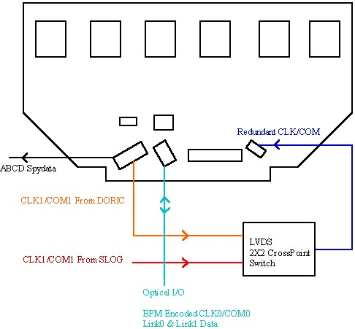

On Patch Card

Input/Output data routes to hybrid
SCTDAQ Integration and Operation

- Recent version(s) of SCTDAQ accommodate AERO configuration.

- Requires a modified module.det file with an additional line added.

- AERO configuration is achieved by a single command line entry in the ROOT window (Rint):

e->ExecuteSCConfigs(x) where x is module 0 -5

Typical AERO configuration sequence, assuming a single hybrid/module is being readout on channel 0 (using the pseudo-optical scheme):

- Make connection between Patch Card ‘Opto’ and AERO ‘OPTO0’.

- Invoke SCTDAQ – the assumption is made here that a modified module.det file is being used (Select = 0 and SC_Mode = 0).

- Once SCTDAQ has initialised (and the module is powered on) at the ROOT window (Rint) type the command line:

e->ExecuteSCConfigs(0)

Typing this command will configure AERO channel 0 – note that the hybrid/module has not yet been configured.

- From the main SCTDAQ menu select ‘Restart’ – this will now send the configuration data to the hybrid/module.

- At this stage AERO and the hybrid/module have been configured. SCTDAQ can now be used as per usual for the Confirmation or Characterisation of hybrid(s)/module(s).

Notes:

Pseudo-optical Readout

- For DORIC to work electrically it is necessary that 3 resistors are soldered to the signal ‘Wiggly Kapton’. Their placement and value/type is shown in the diagram below.
If these resistors are left off the DORIC will not work.

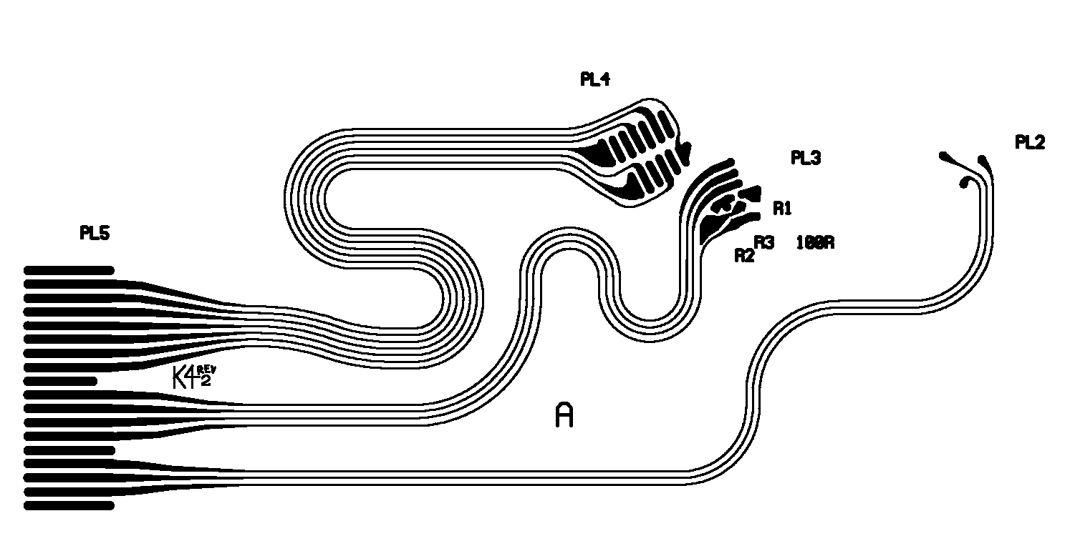
1 x 100Ω (0603 package)
2 x 4K7 (0603 package)

Diagram to show DORIC resistor placement on the Wiggly Kapton

VDC Operation

- When the Opto devices are being used for configuration and data readout it is important that the VDC parameters Vled0(1) and VDC_DAC0(1) are set correctly otherwise SCTDAQ will not decode the incoming data streams correctly. Their default values, when using 5m cable length, are presently :

Vled0(1) = 3.0
VDC_DAC0(1) = 750

Note: These parameters are temperature dependent. The above values are for a hybrid temperature of ~14°C

- If SCTDAQ does not decode the incoming data streams correctly the following should be done:

  - Using the above default values monitor the ABCD Header on an oscilloscope, via MUSTARD, with ‘Run’ set on the SCTDAQ menu.

  - The ABCD Header has a preamble which is composed of 5 bits (11101), where each bit is ~25ns wide. The first 3 bits should thus be ~75ns and the next 2 bits should be ~25ns respectively. This timing is critical for MUSTARD to decode the incoming data streams correctly.
The ‘scope trace below shows the ABCD Header when the module is being readout either via the SPYDATA route (Opto chips bypassed ) and the Opto route (using the VDC).

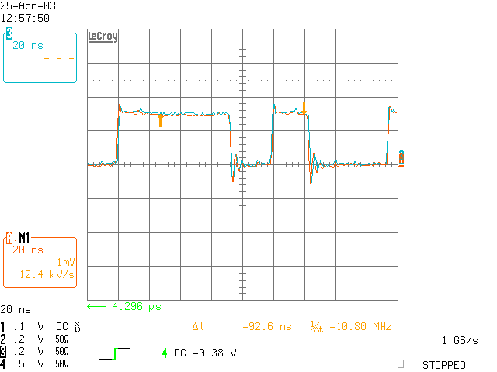

The timing can be modified by changing the value of Vled0(1) – this can be achieved in real time by selecting ChangeVariable from the SCTDAQ menu and then selecting ‘SetVLED’ to allow one to change Vled in 100mV steps.
In some cases it may also be necessary to modify the value of VDC_DAC0(1) as Vled is changed as well. As Vled is reduced the value of VDC_DAC should be increased (typically by no more than ±50 counts).

Remember that both data streams should be checked!

Cat.5 - 258A Specification, the pairs are bundled as follows: 1+2, 3+6, 4+5, 7+8 with no cross-over i.e. they wire straight through to the next connector (1 to 1, 2 to 2, 3 to 3 etc.).

