**Quad wafer and FE-I4 single chips 5 Quad and 8 Single chips:**

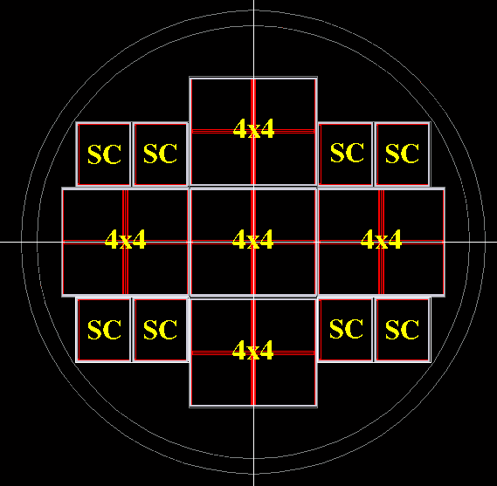

QUAD 5

QUAD 4

QUAD 3

QUAD 2

QUAD 1

SC8

SC7

SC6

SC5

SC4

SC3

SC1

SC2

Sensor type:

**SC1** – “test” (8 ganged pixels), 450 µm edge, vias under bond pads.

**SC2** – “production” (4 ganged pixels), 450 µm edge, vias under bond pads for ganged pixels only.

**SC3** – 500x25 pixels, 450 µm edge, punch through bias.

**SC4** – 500x25 pixels, 450 µm edge, punch through bias.

**SC5** – “test” (8 ganged pixels), 300 µm edge, vias under bond pads for ganged pixels only.

**SC6** – “production” (4 ganged pixels), 300 µm edge, vias under bond pads for ganged pixels only.

**SC7** – “production” (4 ganged pixels), 300 µm edge, single guard ring, vias under bond pads for ganged pixels only.

**SC8** – “test” (8 ganged pixels), 300 µm edge, single guard ring , vias under bond pads for ganged pixels only.

**QUAD1** – “production” (4 ganged pixels), 450 µm edge, vias under bond pads for ganged pixels only.

**QUAD2** – “test” (8 ganged pixels), 300 µm edge, vias under bond pads for ganged pixels only.

**QUAD3** – “test” (8 ganged pixels), 450 µm edge, vias under bond pads everywhere.

**QUAD4** – “test” (8 ganged pixels), 450 µm edge, vias under bond pads for ganged pixels only.

**QUAD5** – “production” (4 ganged pixels), 450 µm edge, vias under bond pads for ganged pixels only.