Motivation for different pixel geometries

The optimal pixel geometries for different locations of the ITk can be studied using their performance in simulations and ‘real-life’ conditions. One of the main issues of maintaining good tracker performance is to keep the cluster size at moderate/optimum levels even at high track incidence, which apart from poorer match between cluster size and pixel size may also cause the deposited charge not to reach set thresholds, particularly in entry and exit pixels. This of course becomes even more troublesome with higher radiation damage because the charge generated suffers from higher charge trapping which takes its toll on the sensor output signal, this inducing resolution distortion [G Casse*, Recent achievements of the ATLAS upgrade Planer Pixels Sensors R&D project,* 2014 *JINST* 9 C04006.].

A different geometry of the pixel cell could improve this, because of the large number of pixels per cluster, which do not contribute to determining the position can be reduced by trading the *r*/*z*-resolution for *ϕ*-resolution, which is both more useful for high *η* tracks and can potentially reduce the total number of hit pixels to readout. For this reason, the following alternative pixel geometries have been studied: 100×125 and 167×125 µm2 (squares) having 26880 and 15680 pixels respectively, 500×25 µm2 (elongated) with 26880 pixels and 2000×25 µm2, 2000×50 µm2 (strixel) pixel geometries, containing only 3660 and 6720 pixels respectively, apart from the 250×50 µm2 with standard 26880 pixels corresponding to the FE-I4 floor-plan and is the current baseline geometry for outer barrel pixel layers.

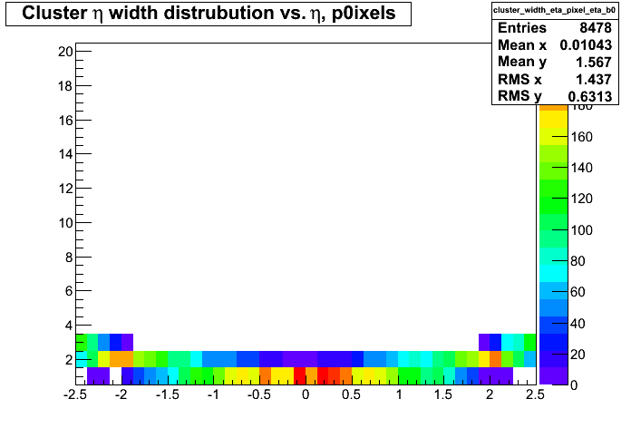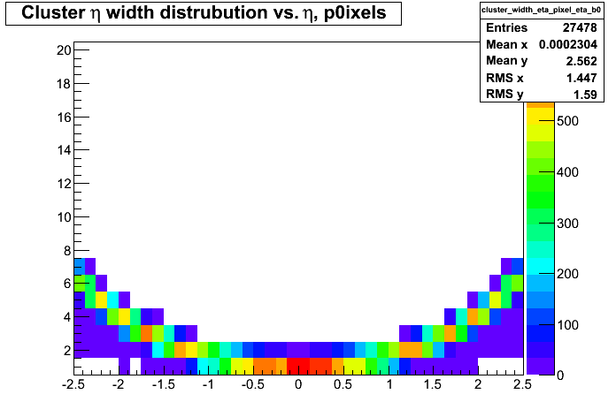

B0-layer

(a) (b)

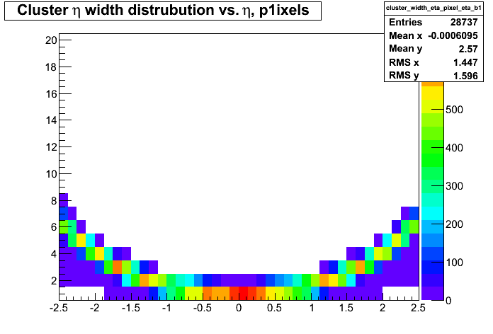 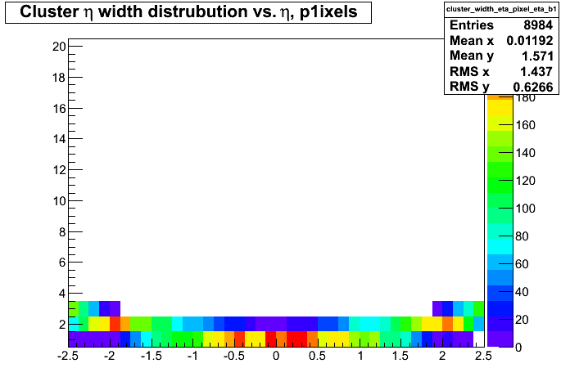

B1-layer

(c) (d)

**Figure 2**: Cluster width distribution versus *η* in the innermost barrel pixel layers; standard 250×50 µm2 geometry in a) B0-layer and c) B1-layer versus the alternative 500×25 µm2 geometry in the b) B0-layer and d) B1-layer.

Figure 2 shows some simulation results of cluster width distribution depending on *η* in the innermost barrel pixel layers using the alternative 500×25 µm2 pixel geometry and comparing to the standard (baseline) 250×50 µm2 geometry. The rising beneficial effect in cluster size for higher pseudorapidity regions (*η* >±1.5) can be clearly observed. Increased pixel dimension in *z*/*r*-direction does not degrade resolution for tracks with shallow angle, while increased granularity in *ϕ* direction improves the resolution in this dimension.

The baseline pixel geometry (250×50 µm2, *r*×*ϕ*) is optimized for the central barrel region. The tracking performance in the end-cap pixel disks can greatly benefit from enhanced resolution in r-direction, to improve z-resolution for tracks with both high momentum and pseudorapidity, which can help with fast association of tracks to appropriate vertices, making an essential input to Level-1 tracking. Thus, by combining alternative pixel geometries, the resolution of transverse and longitudinal impact parameters (*d0* and *z0*) can be improved, as well as the transverse momentum, *pT*. This can be done by trading the *d0* and *pT* resolution for the *z0* resolution and vice versa in the different ring radii. Hence, a new, alternative design is suggested for the pixel end-caps, so-called Open Ring Layout (see Figure 3). This layout both reduces area and is particularly cost effective to provide extension to higher *η*. This note will describe this layout in detail.

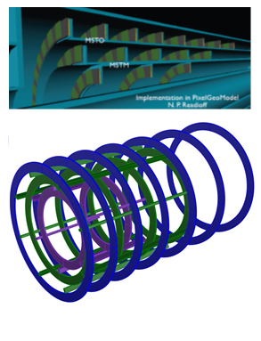

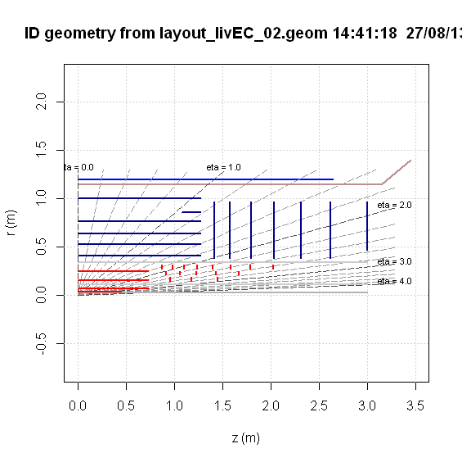

25x500 µm2



500x25 µm2

125x100 µm2

**Figure 3**: An alternative Open Ring Layout for Pixel end-caps

Due to highly inhomogeneous magnetic field, both in radial and azimuthal direction, numerical methods are needed for particle tracking in ATLAS. Although the magnitude of the magnetic field within the most of the barrel regions is fairly constant (around 2T), the pixel end-cap region is affected by the falling B-field [Andreas Salzburger, *Track Simulation and Reconstruction in the ATLAS Experiment,* PhD thesis page 110, Fakultaet fuer Mathematik, Informatik und Physik der Leopold-Franzens-Universitaet Innsbruck, March 2008.], which can have a negative impact on the tracking resolution, particularly for high *pT* tracks and hence a greater need for this improved pixel geometry. This is particularly crucial if tracking would be extended beyond η ≥ 3 in the innermost pixel layer, as in case of a potential New Concept for Forward Tracking [Sasha Pranko, Maurice Garcia-Sciveres, *New Concept for Forward Tracking in LHC Experiments*, LDRD FY15 Proposal Presentations, Lawrence Berkley National Laboratory, 31 March 2014, <https://indico.physics.lbl.gov/indico/getFile.py/access?contribId=0&resId=0&materialId=slides&confId=123>].

The ratio of *d0*, *z0* and *pT* resolutions between the baseline and this alternative pixel geometry for tracks with different momenta, is shown in Figure 4. These plots show a substantial increase in resolution for high *pT* tracks at high *η*, particularly for the *z0* impact parameter resolution. The ratio worsens only at very high η due to this specific forward disk geometry, however it is beneficial for most of the range. Potentially, there could be some combination or alternation of the pixel geometries that can help improve all the parameters at once, but it would require more studies.

  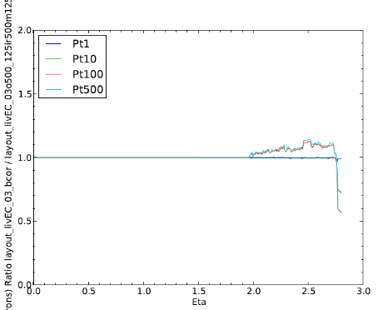

(a) (b) (c)

**Figure 4**: Baseline/alternative pixel geometry ratio of a) *z0*, b) *d0* and c) *pT* resolutions for different track momenta.

The study plan for alternative pixel geometries involves investigation of elongated (500×25 µm2) modules for use in high η regions of the outer barrel layers, where the increased incidence angle will increase the cluster size for the nominal 250×50 µm2 sensor. Square (100×125 / 167×125 µm2) modules are suggested and investigated for the end-cap, where the resolution demands of *ϕ* and *r* are very different from the barrel. The strixels (2000×25 µm2, 2000×50 µm2) are examined as a potential option for the 5th pixel layer in a modified layout tracker [The ATLAS Collaboration. *Letter of Intent for the Phase-II Upgrade of the ATLAS Experiment*. CERN-LHCC-2012-022. LHCC-I-023, CERN, Geneva 2012.].

This note will describe the use of the open ring structure that can also benefit from using different geometry pixels in different regions.