Quick Guide to Using HEP Video Conferencing Equipment

Turning on Video Conferencing system
Open TV cabinet and turn on TV using the remote (HDTV) standby button. TV front white LED should turn off.
TV source should be set to YPbPr.
Press any button on the Polycom (VC) remote to wake up the VC unit.
Optional: The VC output can also be displayed on the projector screen. Turn on the projector mounted next to the VC unit with its on/off button.

Controlling Video Conferencing system
The camera can be controlled from the Polycom remote (VC). Use the arrow buttons to move and +/- buttons to zoom.
There are a number of camera presets: press Preset and then a number from 0-9 to choose one of the typical setups.
Use the PIP button to change local/remote video display and positions.
There are two Polycom microphones. They can be (un)muted with their button. It shouldn’t be necessary to pull the microphones around too much.

Direct Video Conferencing
Ensure system is on and at the default Polycom home screen (use Home button).
Connect to another video conferencing system by entering the IP Address into the address bar, using the numbers on the VC remote. Then press the green Call button.
The video conferencing system will automatically accept external calls to the IP Address 138.253.48.77.

Linking Video Conferencing System to Vidyo Gateways
The Vidyo client cannot be connected directly to the Polycom system, but the Polycom system can dial in to a Vidyo Gateway to give the same result. On the Home page enter the gateway address then press the green Call button

CERN: vidyogw1.cern.ch (137.138.248.228)
Internet2 (Ann Harbour, US): cern-vidyo-gateway0.internet2.edu (207.75.165.80)

On the login screen press 1 to enter a conference, then enter the meeting room extension followed by the # key. For a typical Indico meeting the extension can be found as shown

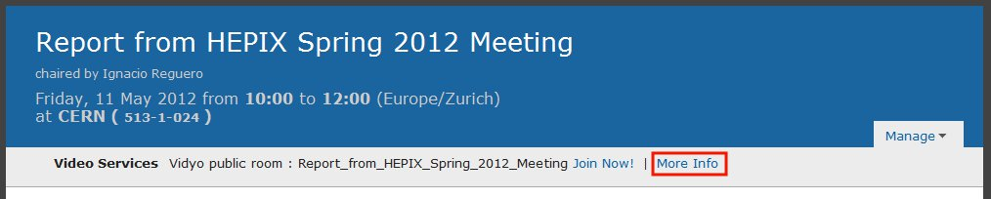
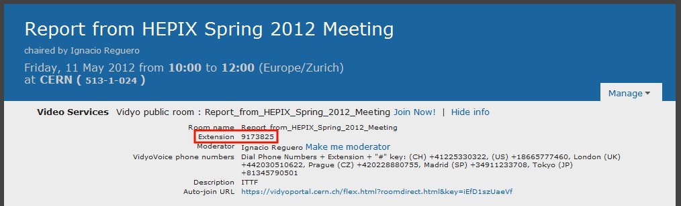
Other Vidyo users should inform you of the extension for their rooms.

Linking Video Conferencing system to EVO via H323
Ensure system is on and at the default Polycom home screen (use Home button).
Start an EVO session as normal (either on laptop or the VC room PC).
Log in to your EVO meeting.
Click on the phone icon and choose “Call H.323/SIP client”.
Enter the IP address 138.253.48.77 and click the green phone button to connect.

Turning off Video Conferencing system
Ensure the VC has no active connections (hang up). It will go to sleep automatically.
Switch off the TV with the remote (HDTV) standby button. LED should go white.
Close TV cabinet.

Using tabletop projector
By default the projector should be set up for use with the VC room PC using a 1080p HDMI connection. The PC is under the desk by the monitor/keyboard. Linux+MWS are available.
Turn on the projector with the Projector remote (or the projector power button). The lens door should open.
The projector should be available as the second display on the VC room PC.
Other equipment can be used via HDMI or VGA connections. Choose the source using the remote or projector Input buttons. Maximum resolution 1920x1080.
Turn off the projector by pressing the power button twice. The door should close.

Using the ceiling projector
Turn on the ceiling projector using the Ceiling Projector remote power button (it can take a while to start up so don’t press the button again).
Laptops can be connected using the VGA cable located by the projector screen. The cable plugs into the BNC connectors on the side. Be careful with these.
Maximum resolution 1024x768.
Turn off ceiling projector by pressing the remote power button twice.

Contacts and further information
In case of any problems with the equipment please contact the admins in room 220 (just past double doors past the lift) or send an email to helpdesk@hep.ph.liv.ac.uk.
Further information can be found online at the HEP TWiki
https://hep.ph.liv.ac.uk/twiki/bin/view/Computing/VideoConferenceRoom

Nov 2012

