CDF The CDF Experiment Proposal 305

University of Glasgow: Saverio d’Auria, William Bell, Peter Bussey, Sinead Farrington, Rick St. Denis, Stan Thompson, Brian Ward, Simon Waschke, Tatiana Unverhau.

University of Liverpool: Paul Booth, Anant Gajjar, Martin Griffith, Helen Hayward, Beate Heinemann, Mike Houlden, Barry King, Ronan McNulty, Tara Shears, Anyes Taffard, Martin Turner.

University College London: Ben Cooper, Mark Lancaster, Dustin McGivern, Rob Snihur, Dave Waters, Angela Wyatt.

University of Oxford: Farrukh Azfar, Todd Huffman, Jim Loken, Louis Lyons, Guilia Manca, Thilo Pauly, Nicola Pounder, Tracey Pratt, Jonas Rademacker, Armin Reichold, Peter Renton, Aidan Robson.

in collaboration with groups from: Academia Sinica; Argonne National Laboratory; University of Bologna; Brandeis University; University of Cantabria; University of Chicago; UC Davis; JINR Dubna; Duke University; Fermi National Accelerator Laboratory; University of Florida; INFN Frascati; University of Geneva; Harvard University; Hiroshima University; University of Illinois; McGill University; University of Toronto; ITEP Moscow; The Johns Hopkins University; Universitaet Karlsruhe; KEK Tsukuba; Korean Center for High Energy Physics; National University (Korea) & Seoul National University; Lawrence Berkeley National Laboratory; Massachusetts Institute of Technology; Michigan State University; University of Michigan; University of New Mexico; The Ohio State University; Osaka City University; Universita di Padova; University of Pennsylvania; University and Scuola Normale Superiore of Pisa; University of Pittsburgh; Purdue University; University of Rochester; University di Roma I; Rockefeller University; Rutgers University; Texas A&M University; Texas Tech University; INFN-Trieste & Universita di Udine; Tufts University; University of Tsukuba; University of California at Los Angeles; Waseda University Tokyo; University of Wisconsin; Yale University.

Introduction

In 1996 the first period of Tevatron data-taking, distinguished by the discovery of the top quark, ended. Since then, both the Tevatron and CDF have been upgraded and improved in order to extend their physics reach. Run IIa started in March 2001 and will deliver 2fb⁻¹ at an energy of 2 TeV. This represents a 10% increase in energy over Run I and a factor of 20 increase in luminosity. The Tevatron is the highest energy collider in the world, and will remain so until the advent of the LHC.

Tevatron Operations

By the end of 2002 a total integrated luminosity of about 150 pb⁻¹ was delivered and a peak luminosity of 3.8x10³¹ cm²/s was achieved by the Tevatron. This surpasses the best peak luminosity and exceeds the total integrated luminosity delivered at RunI.

The RunII physics programme depends on a significant luminosity being delivered by the Tevatron to the CDF and D0 experiments. Responding to a request from the machine physicists, the UK has invested effort in a project whose aim was to minimise the sources of machine-related background in the CDF detector. Such backgrounds arise typically from the beam halo (non-Gaussian tails to the circulating proton beam due to proton beam losses). Apart from shortening the beam lifetime, these losses can damage the silicon detectors and create a dirtier environment through which the physics of interest must be observed. Members of the UK groups have carried out detailed simulations of improved shielding. Their results in Figure 1 show background levels before and after the introduction of a new collimator and indicate that the backgrounds can be substantially reduced. This work is of particular importance for running with higher beam currents and luminosities in the coming years.
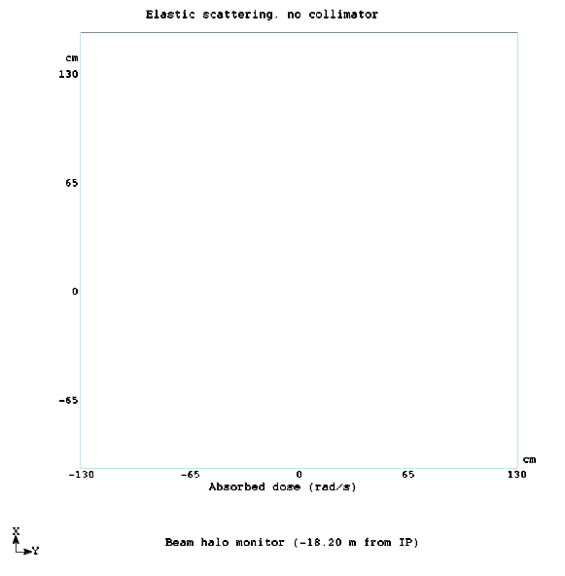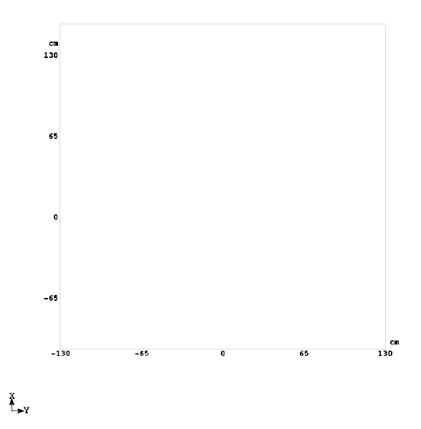
Figure 1: Simulated intensity levels due to proton beam halo at the entrance to CDF before (left) and after (right) insertion of the proposed new collimator upstream of CDF, showing a major reduction of the beam halo.

CDF Operations

The CDF Run II detector has been fully operating throughout the last year. Both the detector and the trigger have been working reliably and a data taking efficiency of 90% has been regularly achieved. The first physics results from CDF were presented at the 2002 summer conferences.

The UK group’s preparations for and involvement in data-taking have been in five broad areas: firstly with the silicon systems; secondly with the Level 3 triggering; thirdly with databases, fourthly with the offline reconstruction, and fifthly with the data distribution for the experiment through Grid technologies.

The Silicon Detectors

The Silicon Detectors have been built to achieve precise tracking as well as to allow the identification of short-lived particles, particularly those originating from the decay of B-mesons. It consists of three subsystems: Layer00, SVX and ISL. The SVX is the main silicon detector having five layers of silicon detectors between radii of 2cm and 10cm. Outside it is the ISL which is of particular importance in the forward region. Closest to, and mounted on, the beampipe is the Layer00 detector which provides a single high precision silicon hit close to the interaction region.
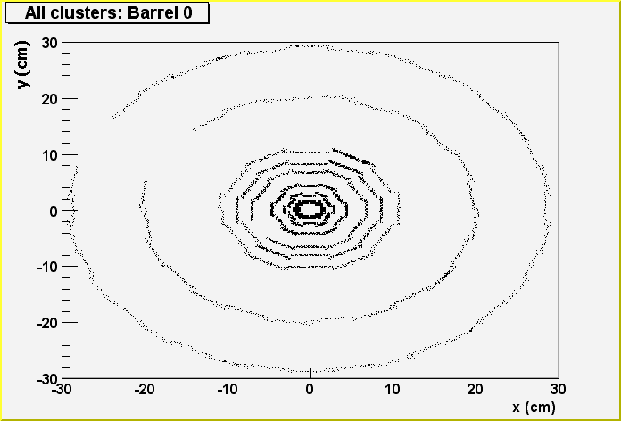
A hitmap of silicon clusters in the Silicon detector is shown in Figure 2 as viewed from the silicon monitoring software which has been designed and written by UK physicists. The innermost layer is Layer00, the next five layers are part of SVX and the two outermost layers are ISL.

Figure 2: Hitmap of silicon clusters as presented to the shift crew.

UK physicists have played a leading role in the construction and cooling of the Layer00 detector and have worked on a variety of aspects in the construction, commissioning and operation of Layer00, SVX and ISL. Apart from fulfilling our responsibilities to provide online and offline diagnostic histograms, the UK has also led and co-ordinated the silicon monitoring task. Over 90% of the silicon detectors are fully operational.

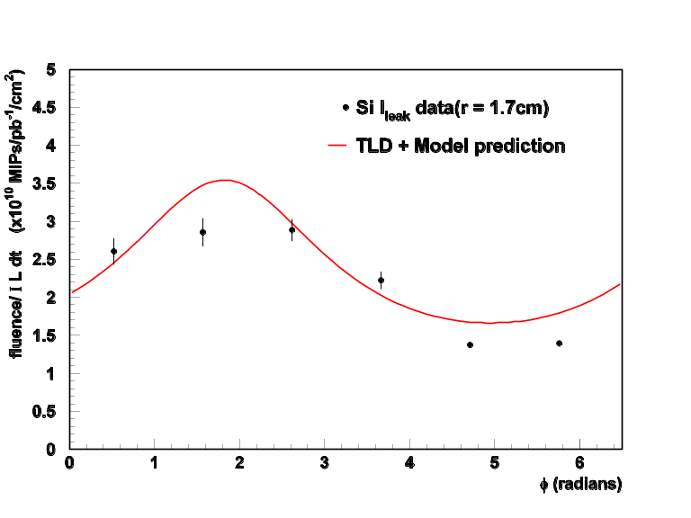
Understanding the radiation damage of the silicon is vital in predicting the longevity of the current detector. The UK groups have investigated this by recording the current on the bias lines which are proportional to the particle fluences. Figure 3 shows the fluence calculated from the current recorded in Layer00 as a function of azimuthal angle. The dependence on angle is a direct result of the fact that the beam is offset from the centre of the silicon; thus silicon on one side receives more radiation damage than on the other. The results are in qualitative agreement with dosimetry measurements indicating that the radiation and its impact on the currents in the Silicon is reasonably well understood.
Figure 3: Particle fluence per luminosity unit versus the azimuthal angle for Layer00

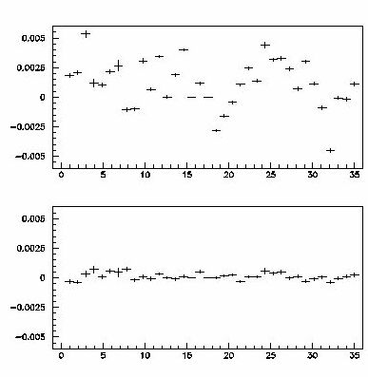
Each of Layer00, SVX and ISL have been constructed and surveyed separately. In order to ensure an optimal performance of the tracking system, the position of each of the wafers of silicon in each of the detectors must be known as accurately as possible. The UK groups have devised a software technique, which has been validated on simulation, and which is being used to determine the silicon alignment. Figure 4 shows the improvement in the impact parameter after this technique has been applied to the mechanical survey.

Figure 4: Mean impact parameter in cm versus wedge number before (above)
and after (below) a software alignment.

The Level-3 Trigger

One of the most challenging tasks at a hadron collider is the efficient triggering of events, i.e. the separation of the “interesting” events from a large “background”. Three distinct levels of trigger decisions are made in deciding whether or not to write out an event. The UK has had a wide range of responsibilities concerning the 3rd Level software trigger which consists of a farm of 126 dual processor Linux PCs that run executables that filter events coming from the Level-2 trigger upstream. The task of this trigger is to reduce an input rate of 500Hz to 75Hz.

In the past year we have continued our leading role in maintaining and validating the Level-3 code. This has been recognized by the appointment of a UK physicist to head the entire operations of the level-3 trigger. Two major projects have been completed on Level-3 in the past year. The process of code building, deployment and the distribution of calibration constants has been automated so that future UK physicists can continue to control the day-to-day operations of Level-3 without a large investment in training. In addition an automated system for the building and validation of the executables that run on the Level 3 PC farm has been developed and tested.

The Level-3 trigger changes and develops in response to machine conditions and the inputs of the physics analysis groups that develop trigger strategies for their particular field of interest.
To ensure the quality and reliability of the Level-3 trigger, a validation procedure was put in place that allows a thorough testing of any new trigger table. Tests include the comparison of the trigger rates of old and new tables on the same data sample and the testing of the trigger table on "golden samples" (where each event should pass). To allow for a rapid turn-around time for the Level3 development, it is essential that non-experts can validate their new contributions to the Level3 trigger themselves. UK physicists have put in place a framework that reduces the validation procedure to a few simple commands that are well documented and easily applied.

The Level-3 trigger consists of a total of about 150 decisions whose performance must constantly be monitored. To maintain the highest data taking efficiency and to have reconstruction and simulation code optimised for the best physics returns, the UK developed an online validation of the trigger rates which are monitored in real-time during data taking and compared to the expected rates as a function of the instantaneous luminosity. Alerts are raised if the rates are anomalous; peculiar trigger rates are often one of the first signs of a malfunctioning detector component.

Offline Databases

In 2002, the UK continued its involvement in the implementation and maintenance of the database systems used by CDF. The integrity and availability of the latest calibration constants is particularly important if the quality of the physics analyses is not to suffer. The UK is responsible for liaising with the detector experts and ensuring that the latest constants are correctly stored in the database and then catalogued in a transparent manner. A suite of utility routines allows physicists analysing the data to use the constants and define new ones without having any database expertise. Thanks to the work by UK physicists in the last year this process is now largely automated. Along with the validation work this has meant that data re-processing and new releases of the offline software now proceed quickly with minimal intervention. With a new detector accumulating data rapidly and with new ideas arising frequently on the best reconstruction strategies this has become an important aspect in ensuring that the highest quality physics results can be produced in a timely manner. In the past year, the majority of analyses have been conducted using the computing facilities at Fermilab. As the reconstruction and simulation code becomes more mature physicists are beginning to migrate their analyses to their home institutes. This requires the ability to replicate the Fermilab ORACLE databases to a large number of sites not running ORACLE but a freeware alternative (mSQL). The UK has continued to lead this effort and ran successful tests in 2002 in anticipation of a full scale deployment in 2003.

Offline Reconstruction

The trigger decisions at Level3 and the offline analyses depend on the reconstruction of objects in the event e.g. jets, electrons, muons, tracks etc. UK physicists have contributed significantly to the reconstruction of all these objects.

Calorimetry
The calibration of the electromagnetic and hadronic energy scales of the calorimeter is vital for both triggering and physics analyses. A UK physicist leads the team responsible for this work. The high quality of the reconstruction and calibration is illustrated in Figure 5 where the invariant mass of electron-positron pairs is plotted. A clear peak at the Z-boson mass value is seen and the data are well described by the simulation. UK physicists have made particular contributions to the understanding of the new forward (“Plug”) calorimeter which covers the range │η│>1.1.

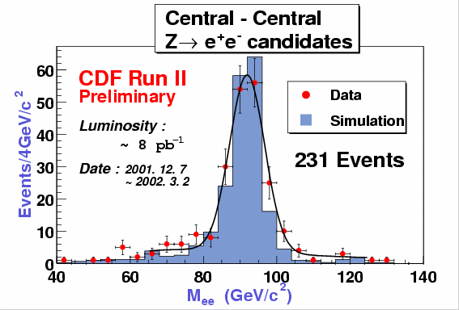. 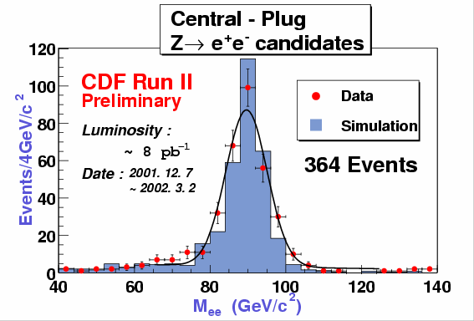
Figure 5: Invariant mass distribution of electron-positron pairs for data (red points) and simulation (blue histogram) for 8 pb-1of Run II CDF data. The left side plot shows the invariant mass where the electron and positron are both in the central calorimeter and the right hand side plot shows it for events where one is central and the other is forward.

Optimisation of electron/photon identification algorithms
The detection of electrons and photons over a wide range of energies with the highest possible efficiency and lowest background underpins the success of a significant fraction of CDF’s physics programme e.g. searches for physics beyond the Standard Model. The algorithms for finding electron and photons at a hadron collider are complicated by additional energy in the calorimeter cells from the underlying event and additional minimum bias events concurrent with the hard scatter. Jets, particularly those with a high π⁰ content, can mimic the calorimetric signature of an electron or photon. The commonest method to discriminate jets from photons and electrons is to employ an “isolation energy” cut, whereby the energy in the towers surrounding the electron/photon tower are compared to the energy of the tower containing the electron/photon. Background events are typically characterised by a significant fraction of additional energy in the neighbouring towers. However in order to maintain a high efficiency for a cut based on isolation energy it is necessary to understand and reliably simulate the “leakage energy” i.e. the fraction of energy from the electron/photon that leaks into the neighbouring towers e.g. when the electron is close to a calorimeter cell boundary. UK physicists have taken the mature electron algorithm from the first CDF run and further optimized it by taking into account the effects of the leakage energy and the contribution from additional minimum bias events. This has resulted in a new electron/photon identification algorithm which agrees much better with the simulation, has a superior efficiency above that of the previous algorithm, and possesses excellent efficiency up to the highest energies vital for new physics searches (see figure 6).

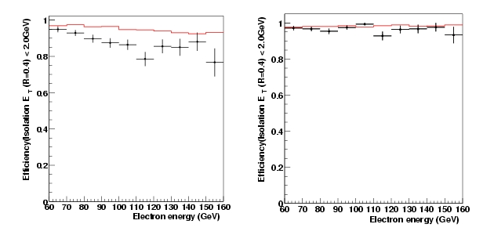
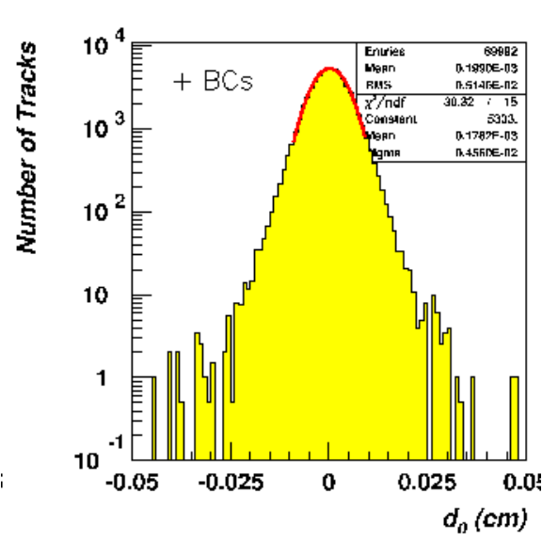
Figure 6: Efficiency for identification of photons in the Plug calorimeter before (left) and after (right) applying a correction for leakage energy for data (crosses) and simulation (histogram).

Tracking and Vertexing

Since much of our physics programme depends on the identification of short-lived decays, the understanding and performance of the tracking system is critical for success. The UK groups have expended considerable effort both to ensure an optimal reconstruction of tracks, and to devise algorithms which allow the primary vertex to be constructed. Figure 7 shows the track resolution which is obtained close to the interaction region for muons from J/ψ decays with a typical p_{T} of 2 GeV.
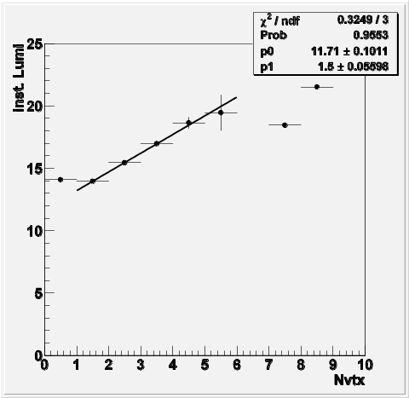
Figure 7: Impact parameter distribution for J/ψ decay muons.
In a significant portion of events in which a hard interaction takes place, another soft interaction occurs. The precise knowledge of the number of interactions is important since selection cuts and energy corrections depend on this. UK physicists have written a vertex finding algorithms which has an efficiency of more than 99% for most hard interactions and a fake rate of less than 2%. The performance of this algorithm is illustrated in Figure 8 where the average instantaneous luminosity is shown versus the number of identified vertices. As expected the number of interactions increases linearly with the instantaneous luminosity.
Figure 8: Mean instantaneous luminosity (in units of 10³¹ cm2/s) versus the number of vertices (Nvtx).
Muons
One of the major background sources for muon related analyses are cosmic rays and therefore efficient algorithms to identify and reject cosmic rays are needed. They make particular use of the timing information provided by the Time-Of-Flight system and the TDCs in the tracking chamber and the hadronic calorimeter. Since cosmic rays originate not from the centre of CDF but from outside the detector, there is a time difference for detections on opposite sides of CDF, where tracks coming from beam interactions are approximately coincident. These algorithms were developed by members of the CDF UK group. Figure 9 shows the invariant mass spectrum of dimuon events using raw tracking information before and after removing events tagged as cosmic rays. After cosmic ray removal the Z-boson mass peak is clearly seen.

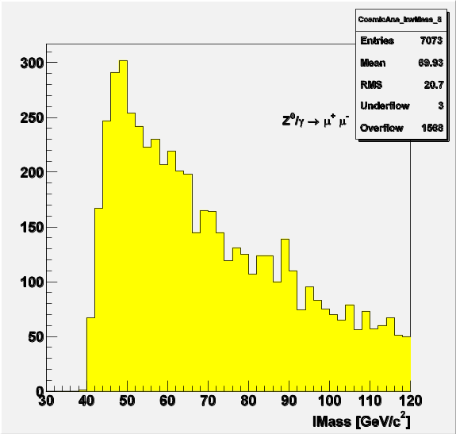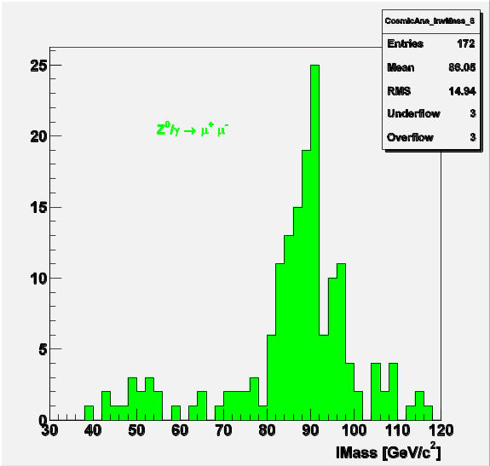
Figure 9: Di-muon invariant mass spectrum using raw tracking information a) before and b) after removal of events tagged as cosmic rays.

Data Validation
In the past year the quantity of data accumulated by CDF has increased significantly. In 2002 alone the amount of data taken surpassed that taken over a period of seven years with the previous CDF detector. This increase in the rate of data accumulation and the frequent updates to the reconstruction and simulation code, have placed a premium on data validation.
The UK have designed and implemented a quick, robust and responsive data validation suite consisting of many thousands of monitoring histograms. These histograms are compared to reference histograms and validated against histograms from the previous run. A summary is produced for each run on a dedicated web server which alerts the appropriate detector experts to short-term changes. Longer-term trends are catalogued by monitoring the mean and RMS of various salient histograms as a function of time e.g. the mean mass of the J/Ψ sample or the Z-boson mass, see figure 10.

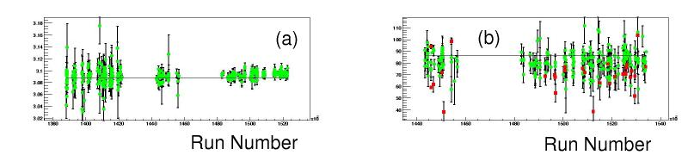
Figure 10: Validation histograms: invariant mass of J/Y-meson (a) and Z-boson (b) candidate events as a function of run number.

Computing and Grid

CDF is expected to obtain over 1 Petabyte of data stored to tape in RunIIa. The distribution and analysis of this data constitutes a particular challenge. CDF had originally envisaged a tape distribution mechanism but the recent emergence of Grid technologies has suggested a far more effective solution. Inspired by the GridPP initiative, all four UK institutes proposed to the CDF collaboration that Grid technology could and should be used for the data distribution of the experiment. The UK is now leading this effort on CDF working in collaboration with D0 and feeding back their experience to the LHC community, thus allowing the Tevatron experiments to act as real-data prototypes for the LHC, to which the Grid is essential for success.

The UK groups have spearheaded Grid efforts within CDF. The data file catalogue has been converted to use the same catalogue as D0 and integrated with Grid Tools. A successful demonstration of Grid-enabled installations for computing was deployed at RAL, in Korea, Toronto, Rutgers University, Texas, and Fermilab, and used to show a CDF analysis in real-time progress at the Global Grid Forum in Baltimore (SC2002). This demonstration was a major accomplishment of the year-old CDF-D0/SAM Grid effort which reflects the gathering together of a variety of resources with CDF and D0 at Fermilab, and within the DOE science Grid.

The UK CDF groups are benefiting from a £1.8M grant from the Joint Infrastructure Fund for computing equipment located in the UK and at the experimental site. Last year we purchased 10 TB of disk space and four 8-way SMP servers, one per UK institute. In 2002 each institution received a SCSI disk store of 7TB attached to a cluster of 10 dual 2.4GHz processors. In addition we have contributed 20TB to the storage facilities at the experiment and the JIF award allowed the UK to demonstrate its Grid applications at SC2002.

Physics Analyses

In 2002 the CDF experiment took nearly 115 pb-1 of data which is slightly more than that taken in the entire Run I. UK physicists have actively analysed the data and help make the first measurements in three broad areas of physics: B physics, electroweak physics and searches. First results were shown at the summer conferences.

B physics lifetime measurements:

The average B lifetime
Run II data was used to measure the lifetimes of B-mesons. While the precision on the B+ and B0 lifetimes can not compete with Babar, obtaining a consistent result is an important test of the detectors and analysis chain at CDF. These results prepare the ground for measurements of the lifetimes of B_{s}⁰ and Λ_{b}, where CDF will make a major impact, and for B_{d} and B_{s} mixing, as well as CP violation. Figure 11b shows the two dimensional decay length distribution for tracks coming from identified J/ψs (Figure 11a). Most of the contribution is from prompt J/ψ production but the tail to positive values is evidence for the production and decay of B mesons through B-> J/ψX. Using Monte Carlo simulation, the J/ψ transverse momentum and decay distance can be turned into an average proper lifetime cτ for B decays. A fit of these components taking into account the background yields a value of cτ = 458±10±11 μm. The background was estimated using the sidebands in the dimuon mass spectrum. The agreement of this measurement with the world average value demonstrates the excellent performance of the Silicon detector, alignment and tracking algorithms. 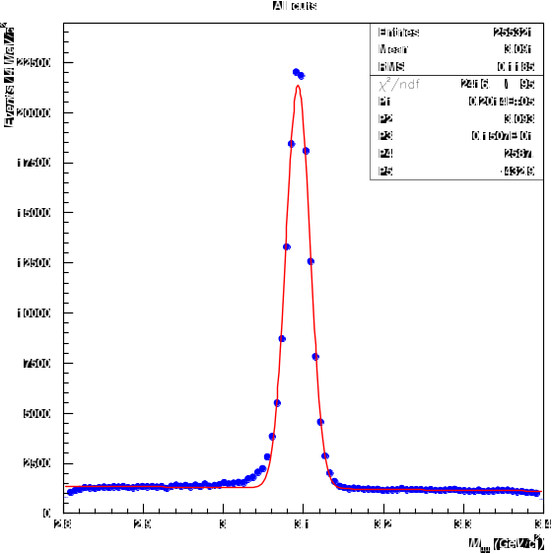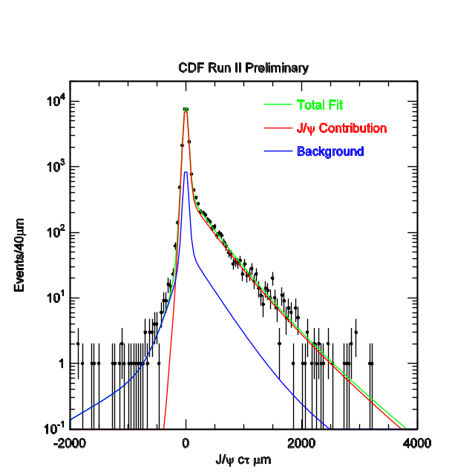
Figure 11: (a) Left: Di-muon invariant mass spectrum.
(b) Right: Pseudo-lifetime distribution of J/ψ candidates and a fit to those data.
The Λ_{b} lifetime
The Tevatron Collider at Fermilab is at present the only collider enabling us to study the properties of the Λ_{b} baryon. The UK groups are currently measuring its lifetime. In the spectator model of b quark decay, the B⁺ B⁰ B_{s}⁰ and Λ_{b} all have the same lifetimes. Heavy quark effective theory includes non-spectator effects and can be used to obtain predictions for a lifetime hierarchy: τ(B⁺ )/ τ (B⁰ )=1.05; τ( B_{s}⁰)/ τ (B⁰ )=1.00; τ( Λ_{b})/τ(B⁰)=0.9 to 1.0[1]. The current world average experimental value for τ( Λ_{b})/ τ (B⁰ ) is 0.78+-0.04 [2] a deviation of three sigma with the theoretical value, and is statistically limited. CDF, with its large sample of Λ_{b} should soon be able to supercede this value and test the predictions precisely.

The UK groups are concentrating on two complementary channels. In the “exclusive” channel the Λ_{b} is fully reconstructed in the decay Λ_{b}→Λ J/ψ but the branching ratio is only 4.7±2.8·10⁻⁴. The “semileptonic” channel Λ_{b}→Λ_{c} l ν with the subsequent decay Λ_{c}→ pKπ has a larger branching ratio of 7.7±5.5% but due to the neutrino not all the properties of the Λ_{b} can be fully reconstructed without model assumptions.

For the exclusive analysis there exists an excellent control sample in B₀→K_{s}J/ψ where the K_{s} decays into two pions compared to the Λ_{b} signal where a Λ decays into a proton and a pion. UK physicists have established a B₀ signal in this channel as seen in Figure 12 and have obtained first evidence for the Λ_{b}-meson in the corresponding signal channel.

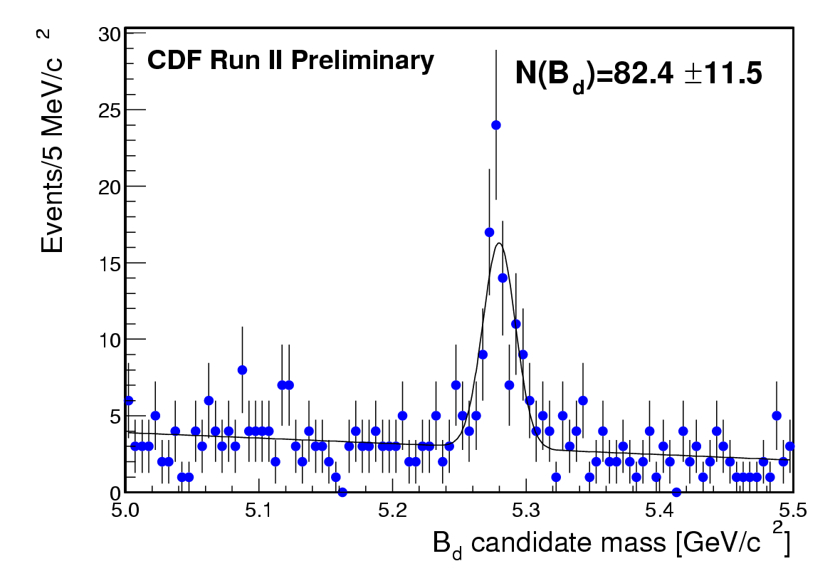
Figure 12: Invariant mass of K_{s}J/ψ candidates.

The analysis in the semileptonic channel exploits a new trigger at CDF that fires on the impact parameter of tracks thus enhancing the fraction of events that contain particles
with lifetime. Using that trigger however biases the lifetime measurement itself and
studying the effect of this bias is one of our main concerns. We have established a Λ_{c}→ pKπ signal and are working on deriving the energy corrections necessary due to the presence of the neutrino.

The decay B⁺ →J/ψK⁺ is an important sample for controlling the vertex reconstruction, calibration and determining biases introduced in the displaced vertex trigger. UK physicists have participated in the measurement of the lifetime of the B⁺ lifetime and found excellent agreement with the PDG values (cτ = 446±43±13 μm). The signal and the lifetime of the B⁺ sample are shown in Figure 13.

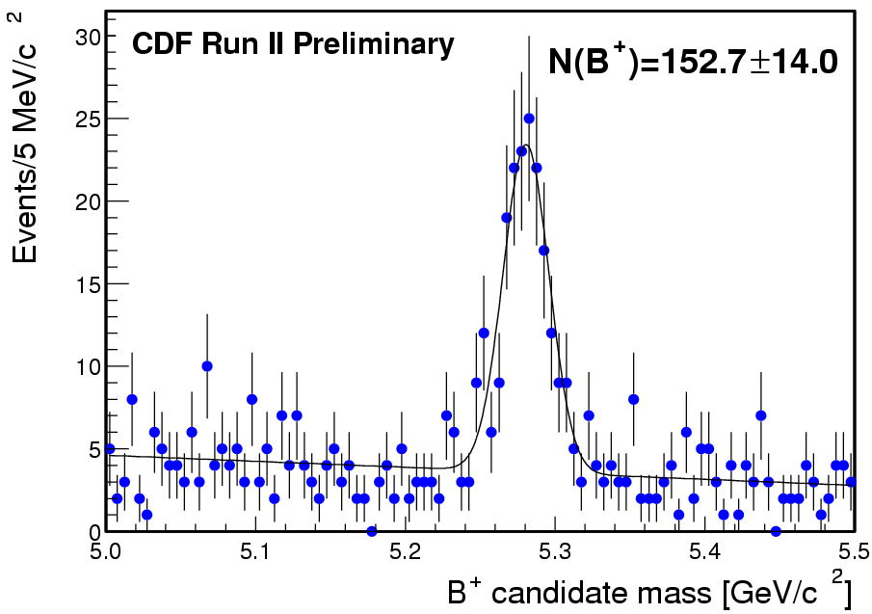
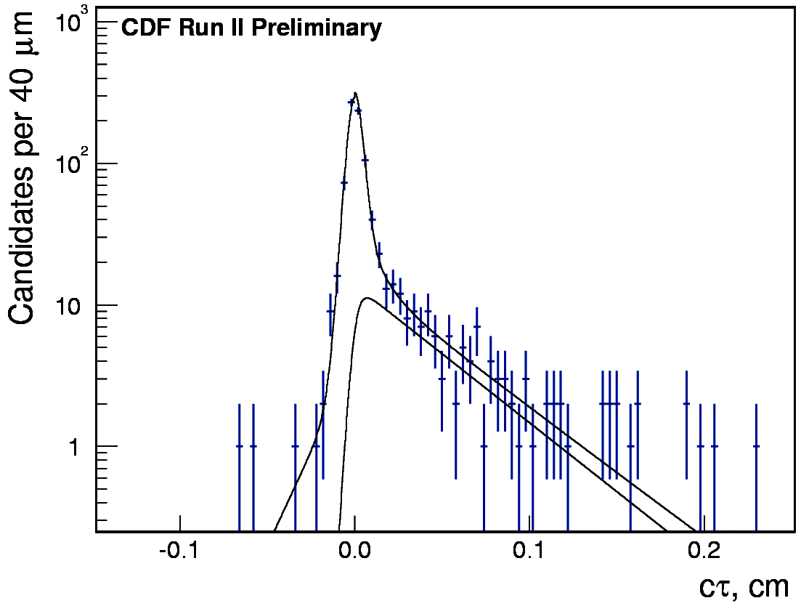
Figure 13: The invariant mass of J/ψK+ candidates and the pseudo proper time distributions.

B_{s} oscillations
The ability of CDF to make measurements in the B_{s} system is unique since the production of B_{s} mesons is beyond the reach of all current B factories. Although the B factories will make definitive measurements of the mixing parameter x_{d}, they can not measure x_{s}. The ‘standard’ method of measuring x_{s} is to observe the oscillation from B_{s} to B_{s}(bar) meson through the modulation of the normal exponential decay distribution. We have studied a different and complimentary technique.

The mass difference between the CP even and odd B_{s} states is related to the width difference [3] which in turn implies a lifetime difference. If either of the two eigenstates can be separated, a measurement of its lifetime compared to the average lifetime gives the width difference and thus the mass difference and x_{s}. Theoretical predictions suggest that the lifetime of either eigenstate could be 20% different from the average, currently measured to be 1.49+-.06 ps.[2]

UK physicists are working on the measurement of the width difference of the B_{s} meson CP-even and CP-odd species utilizing the decay B_{s} →J/ψ φ. We will utilize angular variables to separate the CP even and odd components of the decay in a comprehensive fit with two lifetimes and hence ΔΓ. The first evidence for the observation of the B_{s} in this channel using Run II data is shown in Figure 14.

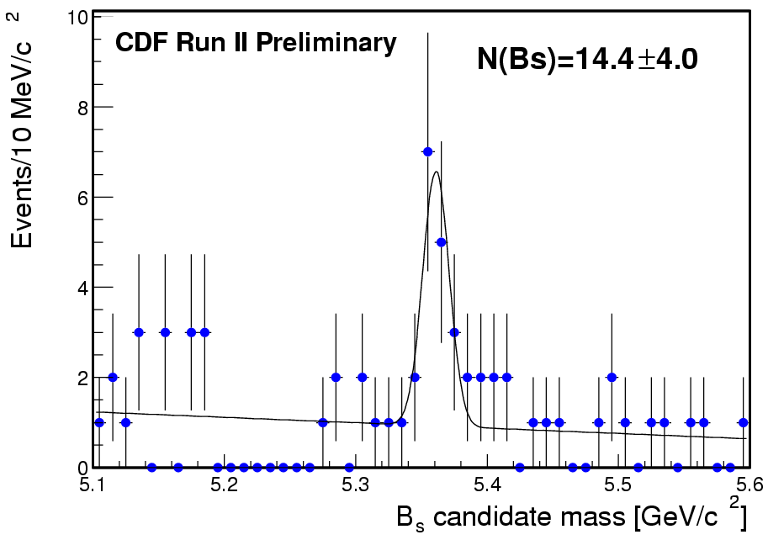
Figure 14: The invariant mass distribution of a sample of B_{s}->J/ψφ candidates from approximately 20pb⁻¹.An indication of the presence of the B_{s} meson can be seen.

UK physicists also determined an upper limit on the branching ratio for B_{s}→J/ψ η using Run I of BR(B_{s}→J/ψ η)<6.6 · 10⁻³ at 90% C.L.. There is hope that this decay can be observed in the Run II data. It is expected to have a very small CP violation in the Standard Model but new physics such as supersymmetry can lead to large CP violating effects.

For all B analyses, large Monte Carlo samples are critical. The CDF-UK group has become the main supplier of Monte Carlo for the B-physics group. With a high production cross section and a high bandwidth trigger the size of the data sample for the B group currently exceeds 30 TB. The Monte Carlo sample not only has to reach a comparable statistic, but also has to deal with issues related to the change in detector acceptance and trigger conditions. Due to its JIF funded hardware and the Grid involvement the CDF-UK-group were able to provide a sample of 15 million fully simulated and reconstructed bbbar-events.

Electroweak and Top Physics

Preparations for precision W-boson mass measurement
In the last run, CDF measured the mass of the W boson with a precision similar to any of the individual LEP2 experiments. In the present run, CDF is expected to reduce the error on the W mass by around a factor of three. Since the W mass depends logarithmically on the mass of the Higgs boson this measurement will provide an indirect constraint on the Higgs boson mass. In order to achieve this high precision a number of the systematic uncertainties which are not determined by the statistics of the control samples will have to be reduced. Key to attaining this goal is the development of a Monte-Carlo production model that correctly describes both the higher order QED and QCD corrections in a single program e.g. the effects of two photon emission from the final state lepton and the change in W polarization as a function of the transverse momentum of the W due to NLO QCD processes. UK physicists are playing a leading role in developing these more sophisticated Monte-Carlo models and tuning their parameters based on fits to the Run I CDF data.

Z and W boson production cross-sections
UK physicists are also measuring the ratio of Z boson to W boson production cross-sections. By doing this, most experimental and theoretical uncertainties on the individual cross-sections cancel (e.g. luminosity, parton density functions, electron energy scales, etc.) and the measurement is directly sensitive to the couplings of the electroweak gauge bosons.

Heavy di-boson cross-sections
The unique gauge structure of the electroweak interaction can be probed in detail by examining the production rates and angular distributions of diboson events (Wγ, Zγ, WW, WZ, and ZZ). These studies are potentially sensitive to physics beyond the Standard Model and enhancements in the WW production rate can also be used to indicate the existence of the Higgs boson. The associated production of two heavy bosons (WW,WZ,ZZ) also tends to be the commonest form of background event in searches for physics beyond the Standard Model and to other interesting Standard Model processes e.g. top quark production. The UK is taking a leading role in these analyses. The present analyses are based on integrated luminosities comparable with the previous run and efforts have concentrated on reproducing the previous results and further optimising the selection cuts, which is particularly important given the small number of events under investigation. In addition to the studies being undertaken with the latest data, a considerable amount of work has also been invested in finding the optimum Monte Carlo generator for describing WW events. Present leading-order plus parton shower Monte Carlos e.g. PYTHIA,HERWIG tend not to adequately simulate the width and full spin correlations of the Ws whilst the latest NLO Monte Carlos e.g. MCFM, MC@NLO, incorporating these effects generally need interfacing to a suitable parton shower and hadronisation model. The differences between the various Monte Carlos are generally apparent at the lowest and highest p_{T} values, see figure 15.
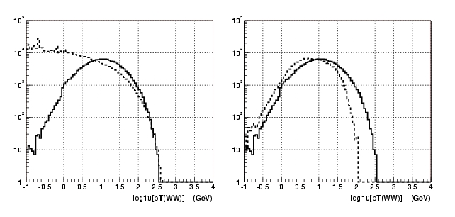
Figure 15: The transverse momentum of the WW pair for various generators. Left: MCFM(NLO)[dotted], MC@NLO[solid]. Right: MCFM(LO+PYTHIA(PS))[dotted], MC@NLO[solid].

Top Physics
The top quark is the heaviest fundamental particle observed as yet and the Tevatron is the only collider in the world where it can be produced and studied until the startup of the LHC. The precision on the mass is expected to be improved from about 5 GeV (Run I) to 2 GeV in Run II. Since the mass of the Higgs boson depends quadratically on the mass of the top quark the precise knowledge of the top quark mass indirectly constrains the Higgs boson mass. The top quark is the only quark which decays before it fragments into hadrons and thereby provides the unique possibility of studying the properties of a free quark. Additionally the increase in luminosity will allow a measurement of single top production to be made for the first time. This measurement is uniquely sensitive to the Kobayashi-Maskawa-Matrix element V_{tb}.

Since the cross section for top production is only about 1 pb the major task in the analysis is the suppression of background processes. The background can be efficiently suppressed e.g. by requiring two b-quarks in the final state and by measuring the number of jets accurately. Therefore UK-physicists are focusing on improving the efficiency and purity for the tagging of b-quarks using either displaced vertices or semi-leptonic decays. Additionally they are improving the jet energy resolution by combining tracking and calorimeter information, investigating different jet algorithms and analysing topological differences between top and background events. All those studies will lead to a better ratio of signal to background and/or a better precision on the top quark mass.

Searches for Physics beyond the Standard Model

The Standard Model of particle physics has been tremendously successful in describing all experimental observations at collider experiments in the past 30 years. However, there are reasons to believe that the Tevatron will observe physics beyond the Standard Model in the forthcoming years. Firstly, there are strong theoretical reasons to believe that the Standard Model will break down at an energy scale of about 1 TeV scale. Amongst the most popular models for new physics are Supersymmetry and Large Extra Dimensions. Both these theories would solve the major problem (“hierarchy problem”) of the Standard Model in complementary ways. Secondly, a number of Run I measurements show slight deviations from the Standard Model prediction and might with the higher statistics in Run II lead to a discovery. Highlights are an excess in the production rate of high mass di-jet events [4] and the observation of an event with two electrons, two photons and large imbalance in transverse momentum [5].

Di-Photon Production
UK physicists are measuring the production cross section of di-photon events. This is important for understanding the Higgs to γγ backgrounds at the LHC, and when the rate is measured at the highest energies it is potentially sensitive to physics beyond the Standard Model e.g. extra dimensions or Supersymmetry scenarios involving a bosophilic Higgs.

Recently elastic Higgs boson production has triggered a lot of interest as a potential discovery channel for the Higgs boson. Currently the cross sections predicted for the Tevatron are too low to be observable [6] but at the LHC this channel could be competitive with the other discovery channels [7]. The cross section predictions for this process are rather uncertain due to the presence of soft gluons and need to be tested experimentally. UK physicists are therefore measuring elastic di-photon and di-jet production in order to verify those theoretical predictions.

Large Extra Dimensions
Using 16.5 pb⁻¹ of Run II data, UK physicists have performed a search for resonances in dimuon events, either heavy neutral gauge bosons, Z', or gravitons (as suggested in Large Extra Dimensions Models (Randall-Sondrum)). The invariant mass of the two muons is shown in Figure 16 for data and simulation. Since the data are consistent with the Standard Model, limits can be placed on the existence of Z', or gravitons. A 95 % confidence level lower mass limit of 275 GeV/cc is set for a Z' boson with Standard Model coupling and lower mass limits of 220, 240 and 250 GeV/cc are set for the Randall-Sundrum model graviton for width parameter of 0.07,0.085 and 0.1 respectively.
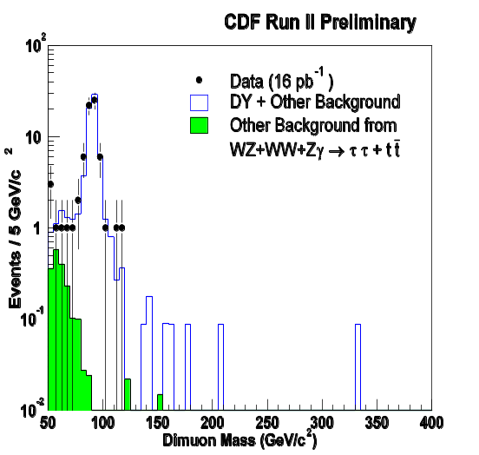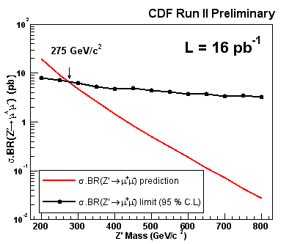
Figure 16: Left: Di-muon invariant mass spectrum for data, simulation and background. Right: limit on Z’ mass derived from the dimuon mass spectrum.

Photon + b quark Production
UK physicists are performing a search for physics beyond the Standard Model in events where a b quark jet and a photon are produced. This analysis was motivated by a stop search in Run 1, following the observation of an unusual event containing two photons, two electrons and missing transverse energy [5]. Both this and the photon+b jet topology can
be produced via the decay of pair produced chargino neutralino pairs. Many other supersymmetric and technicolour models also predict decays of non-standard model objects to photons and b jets. UK physicists are actively analysing Run II data to search for evidence of such decays and, given the luminosity currently available and the improved Run II tracking detectors, should soon improve on Run I results.

Jet Measurements
In the last CDF run, considerable interest was generated by an observed excess above the theoretical prediction for the number of jets produced at very high E_{T} values. Such an excess, if confirmed with higher statistics, would be a very significant result with possible interpretations ranging from the exotic (quark sub-structure) to the more prosaic (esoteric changes to the parton distribution functions). In the past year, UK physicists have been concentrating their efforts in three areas: optimising the online triggers for the selection of QCD events; understanding the jet energy scale; and investigating the predictions of the latest NLO theoretical calculations. Figure 17 shows the largest di-jet mass event ever recorded. It is these events at the highest E_{T} values which are of particular interest.
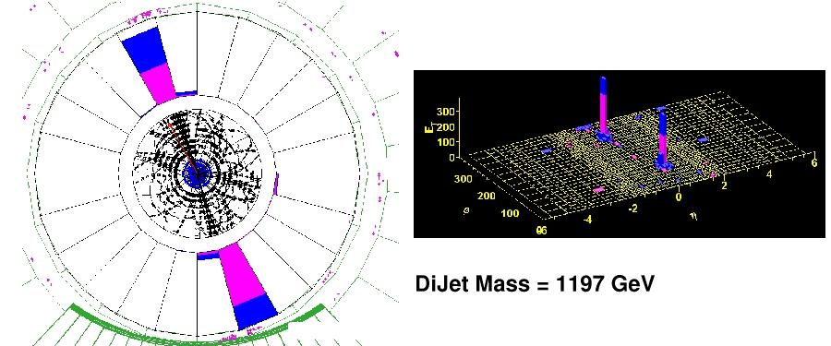
Figure 17: The highest ever di-jet mass event recorded. Left: r-ϕ view of tracking detectors and the calorimeter. Right: η−ϕ view of the transverse energy deposits in the CDF calorimeter,

Conclusions

The UK institutes have been members of CDF for just five years and have a relatively small number of physicists working full time on the experiment. Despite this, we have played a major role in the activities of CDF and are responsible for several key aspects of the experiment. We have designed, purchased and manufactured various parts of the Layer00 detector. We are in charge of the Level 3 trigger, the CDF database and the calorimeter reconstruction code. We are responsible for silicon monitoring and alignment. We have made significant contributions to the computing facilities by pioneering the usage of Grid technology for CDF. We have a broad and rich physics programme and have obtained first results on Run II data.

References:

[1] I.I. Bigi, Nuovo Cimento A109 (1996) 713.
M. Neubert and C.T.Sachrajda, Nucl. Phys. B483 (1997) 339.
[2] K. Hagiwara et al., ‘Review of Particle Physics’, Phys. Rev. D66 (2002) 010001.
[3] I. Dunietz, FERMILAB PUB-94/361-T
[4] T. Affolder et al., The CDF Collaboration, Phys. Rev. D64 (2001) 032001;Erratum-ibid.D65 (2002) 039903.
[5] F. Abe et al Phys. Rev. Lett. 81 (1998) 179; Phys. Rev. D59 (1999) 092002.
[6] V. A. Khoze, A. D. Martin, M.G.Ryskin, Eur. Phys. J. C14 (2000) 525; Erratum-ibid.C19 (2001) 477. B. E. Cox, J. Forshaw, B. Heinemann, Phys.Lett.B 540 (2002) 263-268.
[7]A. De Roeck, V.A. Khoze, A.D. Martin, R. Orava, M.G. Ryskin, Eur. Phys. J. C25 (2002) 391-403.

Appendix A: Journal publications in 2002
- CDF Collaboration, “Cross-section for forward J / psi production in p anti-p collisions at S = 1.8-TeV”, Phys.Rev.D66:092001,2002.
- CDF Collaboration, “Search for radiative b hadron decays in proton anti-proton collisions at s**(1/2) = 1.8-TeV”, Phys.Rev.D66:112002,2002.
- CDF Collaboration, “Measurement of the ratio of b quark production cross-sections in anti-p p collisions at s**(1/2) = 630GeV and 1800GeV”, Phys.Rev.D66:032002,2002.
- CDF Collaboration, “Branching ratio measurements of exclusive B+ decays to charmonium with the Collider Detector at Fermilab”, Phys.Rev.D66:052005,2002.
- CDF Collaboration, “Measurement of B meson lifetimes using fully reconstructed B decays produced in pp collisions at s = 1.8-TeV”, Phys.Rev.D65:092009,2002.
- CDF Collaboration, “Limits on extra dimensions and new particle production in the exclusive photon and missing energy signature in p anti-p collisions at s**(1/2) = 1.8-TeV”, Phys.Rev.Lett. 89:281801,2002.
- CDF Collaboration, “Charged jet evolution and the underlying event in proton anti-proton collisions at 1.8-TeV”, Phys.Rev.D65:092002,2002.
- CDF Collaboration, “Search for new physics in photon lepton events in p anti-p collisions at s**(1/2) = 1.8-TeV”, Phys.Rev.Lett .89:041802,2002.
- CDF Collaboration, “Comparison of the isolated direct photon cross-sections in p anti-p collisions at s**(1/2) = 1.8-TeV and s**(1/2) = 0.63-TeV”, Phys.Rev.D65:112003,2002.
- CDF Collaboration “A Study of B0 --> J/psi K(*)0 pi+pi- Decays with the Collider Detector at Fermilab”, Phys. Rev. Lett. 071801 (2002)
- CDF Collaboration, “Search for New Heavy Particles in the WZ0 Final State in p anti-p Collisions at s**(1/2) = 1.8 TeV”, Phys. Rev. Lett. 88, 071806 (2002).
- CDF Collaboration, “Search for Single-Top-Quark Production in p anti-p Collisions at s**(1/2) = 1.8 TeV”, Phys. Rev. D65, 091120 (2002).
- CDF Collaboration , “Search for the Decay B_s --> mu+ mu- phi in p anti-p Collisions at s**(1/2) = 1.8 TeV” Phys. Rev. D65, 111101 (2002).
- The CDF Collaboration, “Upsilon Production and Polarization in p anti-p Collisions at s**(1/2) = 1.8 TeV” Phys. Rev. Lett. 88, 161802 (2002)
- CDF Collaboration, “Diffractive Dijet Production at s**(1/2) = 630 and 1800 GeV at the Fermilab Tevatron” Phys. Rev. Lett. 88, 151802 (2002)
- CDF Collaboration, “Soft and Hard Interactions in p anti-p Collisions at s**(1/2) = 1800 and 630 GeV” Phys. Rev. D65, 072005 (2002).
- CDF Collaboration, “Measurement of the B+ Total Cross Section and B+ Differential Cross Section d sigma/dp(t) in p anti-p Collisions at s**(1/2) = 1.8 TeV”, Phys. Rev. D65, 052005 (2002)
- CDF Collaboration, “Searches for New Physics in Events with a Photon and b-quark Jet at CDF”, Phys. Rev. D65, 052006 (2002)
- CDF Collaboration “Measurement of the Strong Coupling Constant from Inclusive Jet Production at the Tevatron p anti-p Collider” Phys. Rev. Lett. 88, 042001 (2002)
- CDF Collaboration, “Search for Gluinos and Scalar Quarks in p anti-p Collisions at s**(1/2) = 1.8 TeV using the Missing Energy plus Multijets Signature” Phys. Rev. Lett. 88, 041801 (2002)
- B. E. Cox, J. Forshaw, B. Heinemann, Phys.Lett.B 540 (2002) 263-268.

Appendix B: Theses produced by UK CDF members in 2002

W.H. Bell, “Searching for B_{s}→J/ψ η with the Collider Detector at Fermilab” (Glasgow)

L. Cerrito, “Measurement of the Leptonic Angular Distribution in W-Boson Decay as a Function of the W Transverse-Momentum Using the CDF Detector at the Tevatron”, (University College London and Rutherford Laboratory)

A. Taffard, “Search for the stau slepton at DELPHI and muon identification and Z0 production at CDF’ (Liverpool)

