Bonding the 130nm SLHC Module

Using the H&K BJ820

Mike Wormald, 15th February 2012

Bonding a SLHC module

Definitions:
Back–End bonding:
Back-End bonding is all the bonds around the ASICs down to the hybrid circuit, and ASIC to ASIC bonds.

Front-End bonding:

Front –End bonding is all the bonds from the front end of the ASICs (channel amplifier section) to the silicon strips.

Hybrid: This is the kapton circuit board containing 1 row of 10 ASICs (see image 0.1)

Module: This is two hybrids glued to a silicon sensor (see image 0.2)

Image 0.1

HYBRID

Image 0.2
MODULE
Back–End bonding:
Mount the bonding jig to the base plate via the two locating 3mm bolts
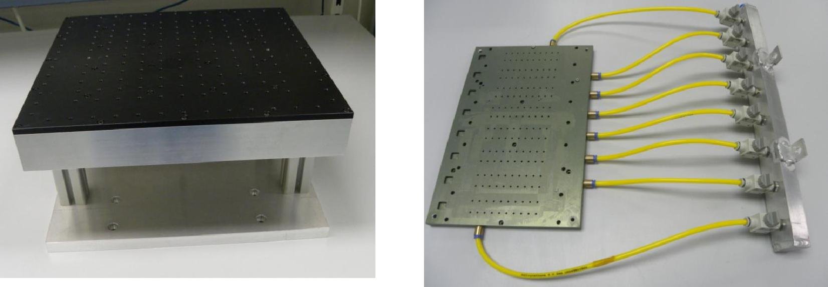

Mount the hybrid panel onto the jig and screw each corner down (4 screws). There should be an inline vacuum gauge to monitor leaks. Turn the vacuum on the hybrid to be bonded.
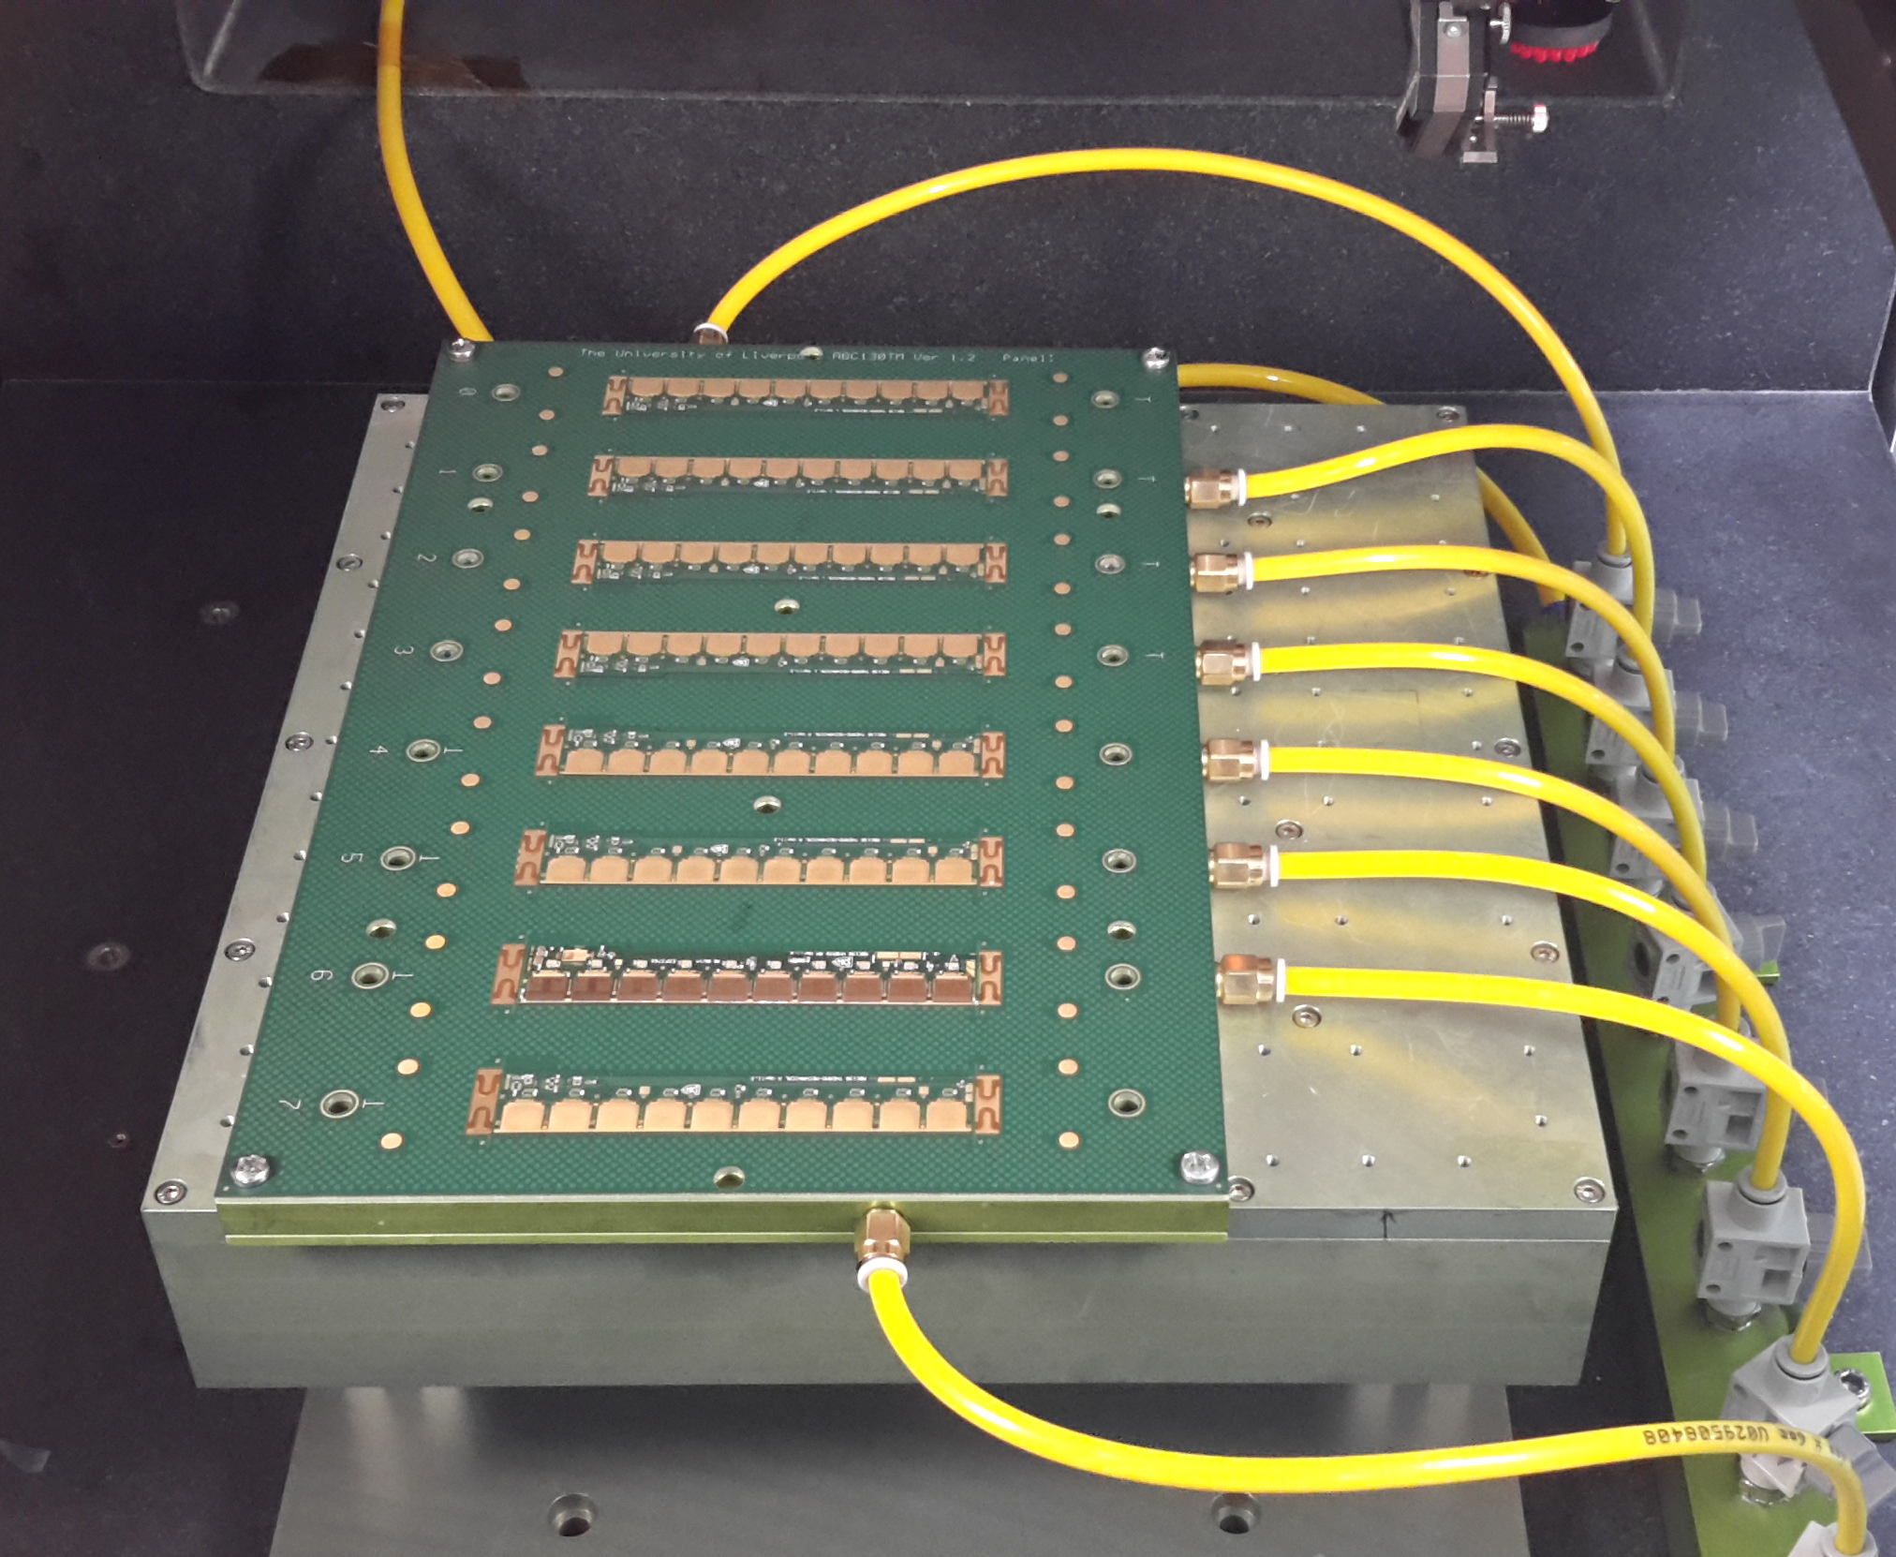

Mount the hybrid with the “T” to the left hand side so the front end is always facing you.

There are 20 reference systems to each hybrid. All Asics have numbering system 1 to 10 inclusive and the Hybrids surrounding each Asic have numbering systems from 11 to 20 inclusive.

Hybrid mounted for bonding

Load bonding program 130nm_beb_hybrid.bpx (Has 20 reference systems)

This program has all the bonding parameters required for this process, to allow a pull strength of around 10g. It contains 20 reference systems and 657wires.

Reference systems 1, 2, 3, 4, 5, 6, 7, 8, 9, and 10 all have the same reference points as shown below:

Ref system 1 point 1 (corner 4th row) Ref system 1 point 2

Because the hybrid is a kapton circuit there is a possibility of localised stretch and shrinking. I have broken the hybrid up into 10 reference systems 11, 12, 13, 14, 15, 16, 17, 18, 19 and 20.
The order of bonding is from Asic down to hybrid and the sequence is 1 to 11, 2 -12, 3 – 13 etc

Reference systems 11, 12, 13, 14, 15, 16, 17, 18 and 19 have the same reference points as shown below:
Please note there is no fiducial to the left of Asic 20 so see image for ref 20 point 2 below:

Ref system 11 point 1 Ref system 11 point 2

Corner of the fiducial left of Asic Corner of the fiducial right of Asic

Ref system 20 point 2 (Top corner of bond track)

Front-End bonding:
Mount the bonding jig to the base plate and secure using 3mm bolts

Bonding Jig mounted on base plate. Clean room paper placed on jig (diffuse vacuum).

Mount the Module in pcb handling frame onto the bonding jig using a lining of clean room paper to allow the vacuum to be diffused across the whole Module. Switch on the vacuum.

Load the program FEB1.BPX this is one of 4 programs to feb it has been broken into single rows feb1 denotes row 1, feb2 row 2 etc.
It forces the operator to visual inspect the row prior to loading next program. FEB2.BPX, FEB3.BPX and FEB4.BPX

All feb programs are made up of 11 reference systems and have 640 wires. Reference system 1 to 10 relates to the Asics and reference system 11 is the silicon.
All the programs have the same eye points

Load bonding program | FEB1.BPX

This program has all the bonding parameters required for the process to allow pull strengths around 10g. It contains 11 reference systems and 640 wires.

Reference systems 1, 2, 3, 4, 5, 6, 7, 8, 9, and 10 have the same reference points as shown below:

Ref system 1 point 1 Ref system 1 point 2

This is the corner of the pad on row 4 this is the same pattern as all the Asics in all of the rows

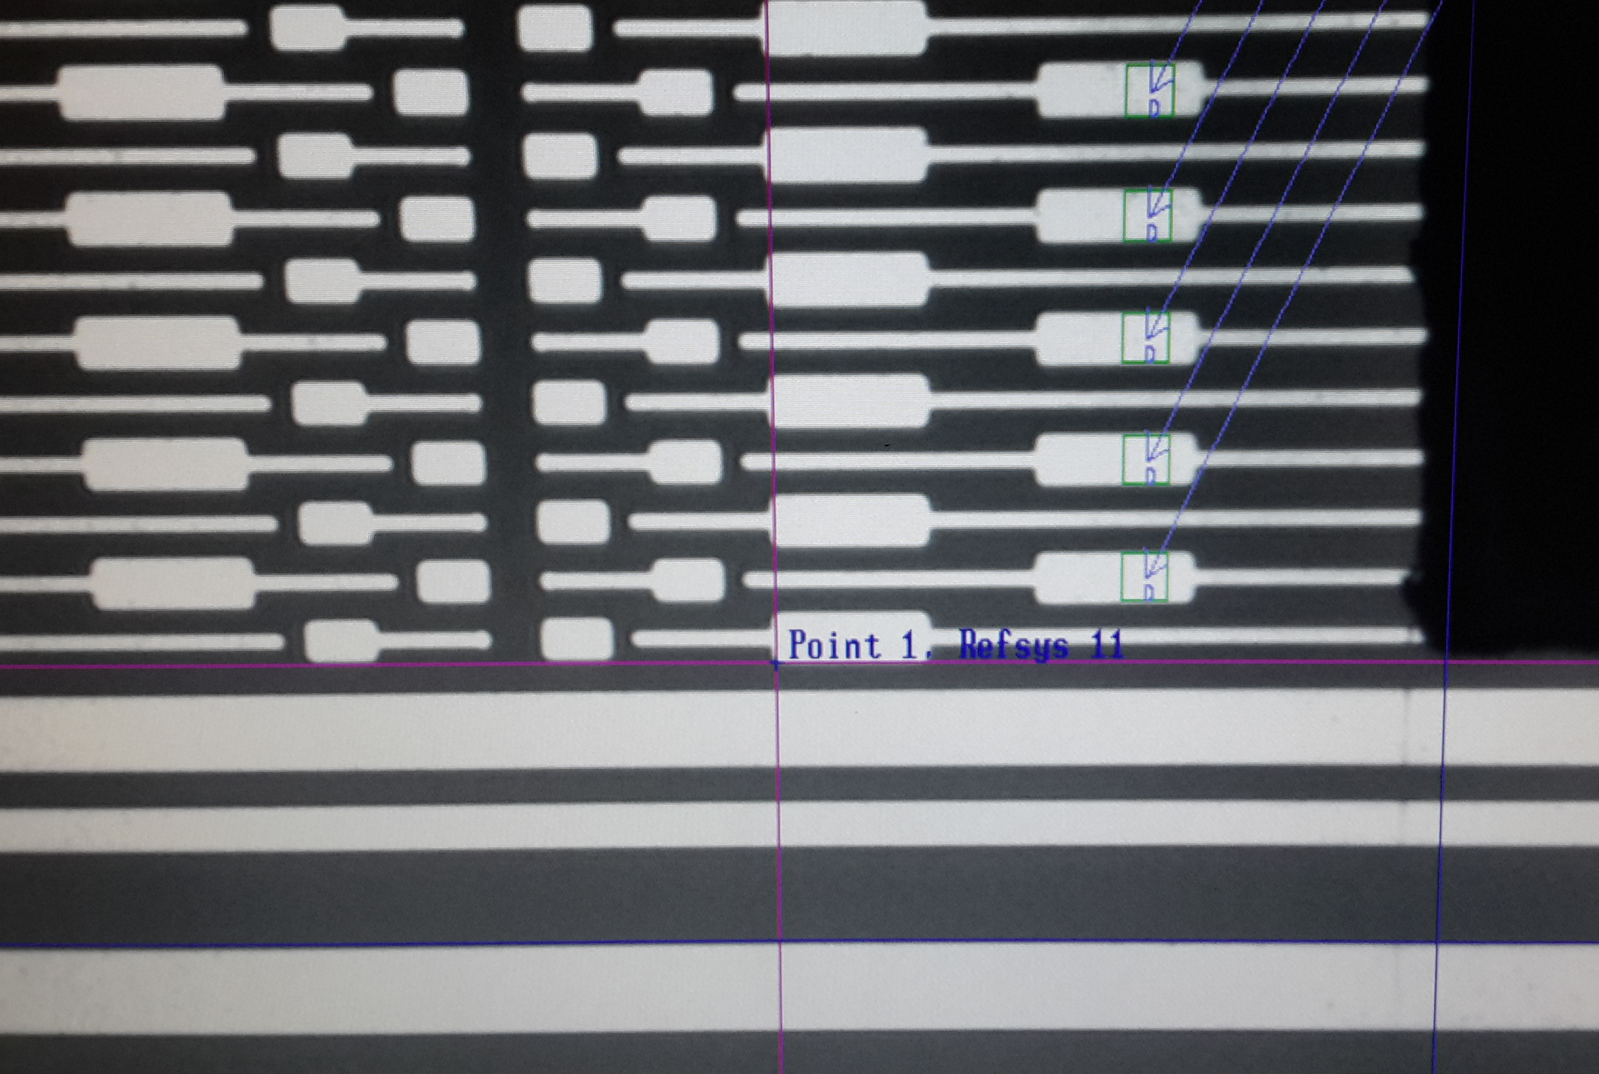
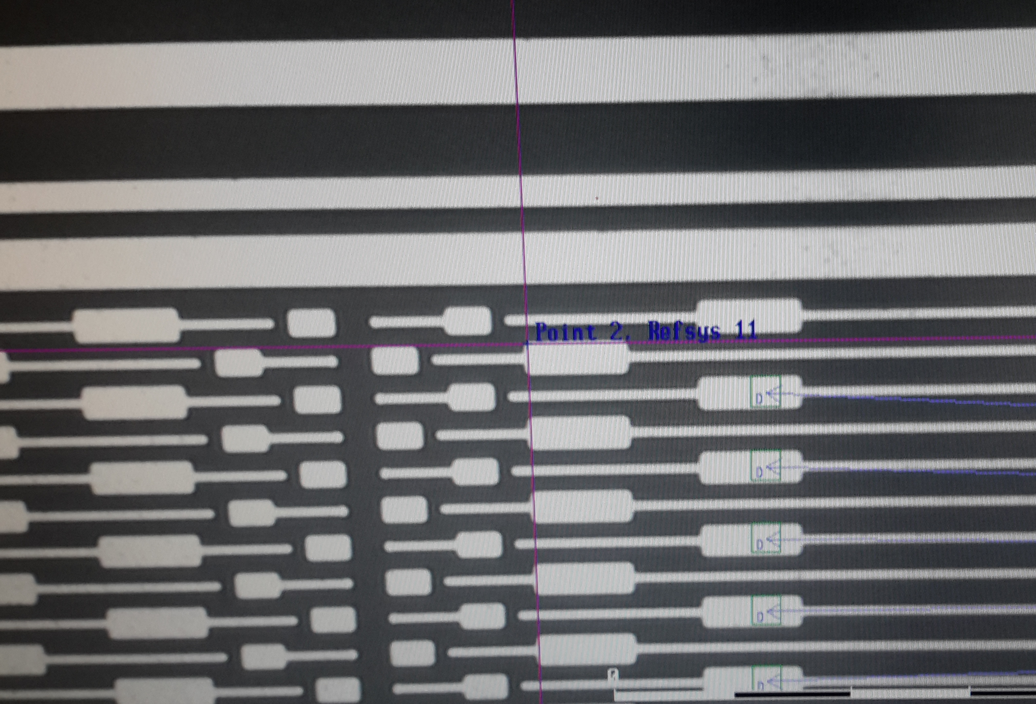

Ref system 11 point 1 Ref system 11 point 2

Reference system 11 has the same reference points for all the rows

Ias bons are only placed in FEB4.bpx

