NAME:................................................ GROUP:..................................



DEPARTMENT OF PHYSICS
2003-2004

MODULE PHYS111: Semester 2
YEAR 1 LABORATORY

PRACTICAL TECHNIQUES IN PHYSICS

MANUAL
OF
EXPERIMENTS

Index

Introduction 3

Introduction to Measuring Instruments and Data Analysis 10

A. Mechanical Instruments and Counter-Timer 13

B. Electrical Measurements 19

C. Distribution of Errors 24

D. Combination of Errors…………………………………………………..29

E. Graphical Data, Linefit 32

Spreadsheet Analysis, EXCEL 36

Data Analysis Summary 40

Revision Exercises 44

Foundation Experiments 46

1. Newton’s Rings 48

2. Hooke’s Law 48

3. Thermistor Experiment 48

4. LCR Circuit 48

5. Microwaves 49

6. Semiconduction Devices 50

7. Stefan’s Law…………………………………………………………….52

Sample Report 54

Long Experiments 56

1. Velocity of Sound 58

2. Liquid Nitrogen Experiment 61

3. Rectification Experiment 63

4. Polarised Light Experiment 68

5. Diffraction of Light…………………….………………………………...72

6. Low Temperature………………………………………………………..77

- Gamma Ray Absorption………………………………………………… 79

8. Refractive Index of Gases……………………………………………… 81
PHYS111: SEMESTER 2, PRACTICAL LABORATORY

NOTES ON THE ADMINISTRATION OF THE LABORATORY

INTRODUCTION

The Laboratory work consists of 18 afternoon periods of approximately 3 hours, starting at 14 00. The aim of the work is to give you the basic skill in and understanding of the techniques of physical measurement and the use of computer techniques for analysis. In Year 1 the work is designed to provide training in practical skills. In subsequent years practical work may provide understanding or practical experience of the lecture modules. Your work in the laboratory will be performed individually. The laboratories are situated in rooms T12 and T6 of the Chadwick Laboratory and have their own computing facilities. Further computing facilities are available in rooms T10 and T2 but these may involve some delay in access as these facilities are used by other classes. You will find it very useful to equip yourself with a floppy disc for data storage.

YOU ARE EXPECTED TO WORK ENTIRELY IN T6 AND T12.
The only exception occurs if all the computers in the T12 are in use when brief absences are allowed.

The work in this year will form the basis for work in subsequent years where you will apply the same methods, for example in error analysis. You are therefore encouraged to carry forward the notes, manuals and experience to other years.

SUPERVISION

Each demonstrator is responsible for a group of students allocated to him/her. He/she will give help with the experimental work, answer queries and assess your work. He/she will allocate experiments according to a schedule published in the laboratory and designed to accommodate the number of students to the facilities available. You should not start an experiment unless it is agreed with your demonstrator. If your allocated demonstrator is busy helping someone and you need help do not wait but ask any demonstrator who is free.

PROGRAMME OF WORK

The work is organised into the following 4 topics

1. Introduction to Measuring Instruments and Data Analysis

These four periods provide an introduction to the use of instruments, data analysis and general practical techniques. There are a series of exercises, with students working individually, following a schedule of work.

A. Mechanical Instruments and the Digital Counter
B. Electrical Instruments
C. Distribution of Errors
D. Combination of Errors
E. Analysis of Graphical Data
Sessions C, D, and E are accompanied by an introductory lecture.

In addition there are instructions on the use of the spreadsheet EXCEL in the analysis of experiments. This builds on the experience gained in the module PHYS113.

2. Foundation Experiments

You are asked to carry out four simple experiments, which take one period each, and which are designed to illustrate the material covered in the introduction.
You will be allocated to a demonstrator for the Introduction and the Foundation Experiments, to whom you should take your work-book at the end of each exercise or experiment. You are encouraged to make good use of EXCEL spreadsheets as it offers advantages in laying out data and making the repetitive calculations required for the error analysis. If your demonstrator is satisfied with your experiment you can proceed to the next one. You can, however, approach any demonstrator for assistance during an exercise or experiment.

3. Long Experiments

You are asked to carry out and write up three longer experiments. These are allocated three periods each, and must be completed (including write-up and marking) within the allocated three-day period. You are not allowed to carry over an experiment into the next three-day period.

During the experiment you must enter your measurements into your work-book. You should also write comments about the experiment in the work-books as you proceed.
4. Revision and Class Test

A compulsory class test will be held for an assessment of your progress. The test will be based on what you have learned in the Introduction to Measuring Instruments and Data Analysis.
Laboratory Work-Books

You will be provided with a work book: (1) to make notes, (2) to write up the foundation experiments, and (3) to enter your measurements as you carry out the long experiments. If you need graph paper it is included at the back of the work-book and each graph should be numbered so you can refer to it in your working. All observations made during an experiment should be written in your work-book. Each afternoon period should have the date followed by a brief neat record of what you are doing and the data together with the appropriate calculations, graphs and computer supported analysis where required. You should glue or staple your computer output in the work-book at the appropriate place in the analysis.

Organise your write-up in an orderly fashion so that the description of your work is very clear. If your have made any mistakes or retaken data which you do not wish to be considered, cross it out and do not remove pages. Try to be as neat as possible but DO NOT write notes on paper and then try to produce a fair copy. You are producing experimental work-books containing the details of the measurement procedure, the data and the analysis with the conclusions and not a paper for a learned journal.

Your report should be hand written and your graphs should be hand drawn. Do NOT use a word processing package. The only computer outputs allowed are tables from EXCEL (BUT NOT GRAPHS!) and results from LINEFIT.

The work book must not leave the laboratory, for any reason.

If a workbook is found to be absent from the laboratory, marks may be taken off.

On completion hand your work-book to your Demonstrator. To help you ensure that your write-up is complete there is a check-list below.

CHECK LIST

- Measurements are tabulated neatly and wherever possible are presented graphically with their errors.
- The computer output is attached to the work book.
- Error analysis has been carried out where required and examined for reasonableness (including the % error).
- Line fitting has been carried out where required and the result, including chi-squared considered critically.
- The magnitudes of measured quantities have been quoted taking into account the values of their error uncertainties, i.e. the number of significant figures.
- The units of all quantities are given, including the errors.
- The conclusions about the work have been considered and written in the report.

ASSESSMENT OF PRACTICAL WORK

You are responsible for presenting your work to a demonstrator at the correct time for assessment and failure to do so without reason will usually mean your work will be marked but a mark of zero will be recorded. The only exception to this rule is for illness and/or as outlined below.

The module mark is made up as follows:-
(i) 10% comes from active participation in exercises A to E
(i) 20% comes from completion of the 4 Foundation Experiments.
(ii) 10% comes from the class test to be held at a convenient time and which will be announced on notice boards.
(iii) 60% comes from assessment of the 3 Long Experiments.

Each mark for a foundation experiment will be awarded out of 5. The assessment of these will be on a simple three grade scale:- Excellent (5 marks), Pass (2.5 marks) and Fail (0 marks).

Each mark for a long experiment will be awarded out of 10 in accordance with progress achieved in the scheme below and appropriate to the work being carried out:
1. taking a few preliminary readings
2. understanding the apparatus
3. understanding the basic physics involved
4. taking a viable set of data
5. making some sensible error estimates---satisfactory level
6. comparing data with theory---a good level of understanding
7. writing a clear description of the work carried out---significance of work understood
8. relating theory and experiment in the context of the equipment used
9. taking more advanced data for a deeper understanding
10. excellent high quality work

Absences

If it is known in advance that you will be unavoidably absent from laboratory classes with a valid reason discuss it with your demonstrator. If it is approved a “reason for absence” form must be completed by the student, approved and signed by a staff demonstrator, and handed in to the department Student Office before the absence. If the student is absent for medical reasons then a self-certificate or doctor’s note must be submitted to the Student Records office, and you should inform your demonstrator on return to the laboratory. In this case only any marks which have to be awarded will be at the pass level only, e.g. 40%. If the student cannot complete a long experiment because of unavoidable absence, partial credit can be given if there is evidence for deserving such e.g. work-book entries, familiarity with experiment, etc. Note: the Board of Examiners has the final discretion in awarding marks for the laboratory component of this module, and account will only be taken of absences if the above procedure is followed.

COMPUTING INFORMATION

Facilities
The computers in laboratory T2 are available for use of students taking physics modules. They are stand-alone machines and are not connected to the University PC Managed Network. The computers in Laboratory T10 are a part of the University PC Managed Network and may be used when not booked for classes (consult the notice on the door).

Computer Viruses
Computer viruses can cause severe damage to your work. Do read the notices concerning viruses on the notice board next to Laboratory T1. They list suggestions on how to organise your working practices to reduce damage to your work from viruses. There is more information about viruses on the Computer Services Web pages under Documentation/Miscellaneous. A User Note about viruses can also be obtained (free!) from Computer Services on Brownlow Hill.

SAFETY IN THE LABORATORIES

The following points supplement the general information about Safety and Fire Precautions in the Physics Department Handbook, which was given to you when you registered. It is your responsibility to read these regulations and those below.

Your should exercise particular care with experiments involving cryogenic liquids, lasers and radioactive materials and take note of any local rules posted near such experiments.
- It is your responsibility to work at all times in a way that ensures your own safety and that of other persons in the laboratory.
- None of the experiments in the laboratories are dangerous provided that normal practices are followed.
- The treatment of serious injuries must take precedence over all other actions, including the containment or cleaning up of radioactive materials.
- If you are uncertain about any safety matter for any experiment, you must consult a demonstrator. This includes any health condition which you think may be affected by any of the techniques you are expected to use.
- All accidents must be reported to the laboratory supervisor or technician who will take the necessary action.
- After an accident, a report form, which can be obtained from the technician must be completed and given to the laboratory supervisor.

Particular Hazards
Liquid Nitrogen:
- Use the goggles provided when pouring.
- Great care should be taken when transfering liquid nitrogen as contact with skin can cause “cold burns”.
- Do not confine the liquid in an enclosed vessel without some means of venting the gas.
Lasers:
- Never look directly into a laser beam.
- Experiments are arranged to minimise the use of reflected beams. Care should be taken with any operation that could reflect the beam into your own eyes or those of others nearby.
Vacuum equipment:
- Use needle valves and all pumping equipment with care.
Personal belongings:
- Please do not place coats or clothing on the benches.
- Please do not obstruct the aisles with bags.
- Do not bring food or drink into the laboratories.
Lead
- In some experiments lead bricks and sheets are used. Wash your hands after handling, and certainly before you next handle food. Lead also rubs off onto benches and other parts of the equipment.

FACULTY OF SCIENCE REGULATIONS

The Regulations of the Faculty of Science as outlined in the Handbook apply to this module.

INTRODUCTION TO
MEASURING INSTRUMENTS
AND
DATA ANALYSIS
INTRODUCTION: GUIDELINES FOR LABORATORY WORK

Some general guidelines for the successful completion of laboratory experiments are given below. The instructions for individual experiments may offer more detailed advice.

A useful reference book is Practical Physics by E Squires. There are several copies in the Year 1 Laboratory.

Finding out about the experiment
- Read the instructions through once. Do not worry if you do not understand every aspect initially.
- Identify the pieces of apparatus to be used.
- Try some test measurements to familiarise yourself with the apparatus.
- If there are still points you feel you need to understand more clearly before taking the data, ask a demonstrator.

Asking a demonstrator should not be a substitute for thought!
The demonstrator will expect you to have thought about your problem.

Taking the data
- Establish the range and number of the readings to be taken.
- Before starting to take a series of measurements, it is worth spending a few minutes to lay out the apparatus in an orderly way and to tidy any wiring or cables so that you can read and record the instruments efficiently and comfortably.
- Record the raw measurements with their units directly into your work book, not on scraps of paper. The raw measurements should always be included in your report.
- Check your observations as you proceed, looking out for any measurements that are out of line with the rest. Plotting a graph as you take the data is often the simplest way to identify rogue measurements.
- You may need to repeat some measurements to determine the random error associated with the measurement. (See the section on errors later.)

Doing the analysis
- Write the analysis directly in your work book, not on scraps of paper.
- Show the key intermediate arithmetic steps of your calculation in your report. This will help both you and the demonstrator who assesses the work if you make a mistake in the calculation.
- Consider the experimental errors in the measured quantities and estimate the error in any derived quantity. This may require repeating measurements to estimate the spread in the readings. (See the guide to errors in the following section.)
Plotting graphs
- When investigating the relation between two measured quantities, always plot the data on a graph preferably as you take the data. It is the easiest way to judge the consistency of the data.
- Label the axes of the graph clearly, including the units of the quantities plotted.
- Make the graph large enough to illustrate the quality of the data. As a rule of thumb, graphs with real data points should be at least half an A4 page. It is increasingly common to see small graphs in word processed reports. While these are adequate as illustrations, they are a poor visual indication to the assessor of how well you have taken the data.
- Match the scale to the graph paper to aid plotting the points and interpolating from the graph. For example, do not set 1 unit on the scale of the graph (paper or computer display) equal to 3 units of the quantity you are plotting.
- As a general rule, choose the range of the scale on the graph to match the range of the data. Including zero on one or both axis often helps the visual interpretation of the graph, but not usually at the expense of large areas of unused graph paper. Common sense and experience are the best guides!
- When using the EXCEL spreadsheet (see section E) to plot a graph, the two previous bullet points may require you to override the programme defaults and set the scale and the grid intervals manually.
- You should use the XY Scatter option to plot a graph with EXCEL. The Line option expects simply a list of y data and plots the points at equal intervals on the x-axis.

Presenting your work
- Your report should have a Title and date and should include:
- An introduction stating the aim of the experiment
- A brief outline of the method in your own words. Do not reproduce the instructions in this Manual.
- The raw data and any derived data, suitably tabulated.
- Any calculations laid out in a way that can be followed.
- Graph(s) of the data.
Even if the final result of the experiment is derived from the slope or intercept of a straight line fitted to the data using the computer, your report should always show a graph of the data.
- The conclusion, including any derived numbers quoted to a sensible number of decimal places.
A `sensible number of decimal places’ will be determined by the error on the number. Your calculator may well indicate that the density of liquid nitrogen is 811.24352 kg m⁻³, but if the error is  2 kg m⁻³ the figures after the decimal place do not make a significant contribution to your knowledge of the density. The result should be quoted as (811  2) kg m⁻³. See the section on quoting results for more details.
(A) MECHANICAL INSTRUMENTS AND THE COUNTER-TIMER

The ability to use a large range of laboratory measuring instruments is an important skill for any physicist. This involves: knowing which instrument is appropriate for the required measurement; knowing how to use the instrument correctly; considering the accuracy of the measurement; considering whether the instrument is correctly calibrated, etc.

Many of these ideas are brought out in the measurements of length, mass, temperature, pressure, time and frequency in the following exercises. Record all measurements in your work book with all lengths expressed in millimetres. It is important when making a measurement that you also record at the same time the correct units of the value. Since it is normal practice to use SI units any values not originally in SI units should be converted.

Your demonstrator will show you how the instruments work if you have not used them before. There are also notes in this Manual which you should read.

MECHANICAL INSTRUMENTS

Errors in Reading Instruments
The error in reading a scale, for example on a rule or an analogue meter, can arise from a number of sources:
(a) Parallax error. If the line of sight is not at right angles to the scale, a gap between the object being measured (the pointer in the case of a meter) and the scale will cause an error. This can be reduced by careful alignment of the eye, a process aided in better quality meters by a mirror built into the scale so that the pointer and its image can be lined up to ensure the scale is viewed at right angles.
(b) Zero error. Most instruments have the provision to set the reading to zero when zero input is present. If the instrument is not correctly zeroed, actual readings will be offset by the offset of the zero. This offset can be measured and a correction applied but it is good practice to always zero the instrument so that the readings can be used without correction.

(c) Scale reading errors. The scale can only be read to some accuracy which depends on how finely the scale is engraved. A conservative rule-of-thumb is to assume that the scale can be read to a half of the smallest division. However a fifth of the smallest interval can often be achieved. In practice, you make a judgement based on your use of the particular instrument tempered with experience and common sense.
A digital scale can be read to  1 in the least significant digit displayed provided the reading is stable. As for an analogue instrument, there will be a zero error.

A vernier scale can never be read to better than one unit of the smallest division. Usually the accuracy is printed on the instrument.

Calibration Errors

The accuracy of the reading of every instrument, analogue or digital, will depend on the calibration. Manufacturers will usually supply details of the accuracy of the calibration of the instruments at the point of manufacture. A data sheet from the manufacturer with this information should be available close to the equipment in the laboratory. Unless told otherwise in the instructions, you can assume the calibration is correct. However, possible calibration errors should not be ignored if you have to do any trouble-shooting on the data.

Calibration errors may take the form of an overall multiplicative constant. Instruments will often have some internal adjustment to set this. More commonly, calibration errors will manifest themselves as small deviations around the marked scale due, for example, to the quality of construction of the instrument. These can be accounted for by calibrating the scale against an (expensive) standard instrument. If this is advisable, the instructions will tell you.

Often uncertainties on digital multimeters are given as +/-(2 + 3). The first number is the uncertainty in the calibration of the instrument, in percent. The second number is associated with the granularity of a digital scale and therefore the uncertainty in displaying a measured value. The 3 in this example means that one component of the uncertainty is 3 times the smallest digit displayed on the scale. E.g.: A multimieter reads U=7.34 V. The error according to the manual is (2 + 3) i.e 2% and 3 times the smallest digit (in this case the second digit after the decimal point). Since both errors are independent, they are added in quadrature. The total error is:

ΔU = [(7.34 V * 2/100)² + (3*0.01 V)²]^{1/2} = 0.15 V
Calibration Scale

And the result must be quoted as: U = (7.34 +/- 0.15) V

For values much greater than the smallest division the scale error is usually negligible, whereas for small values both errors contribute.

Quoting Results

Whenever you report a physical quantity it must be quoted in a standard form. This form contains either 5 or 6 mandatory elements.
- A sentence describing the result
- The name of the measured quantity
- The measured value, rounded according to the error
- The uncertainty, given to at most 2 significant digits
- If applicable, a global order of magnitude
- The unit

E.g.: A volume of a box was measured to be 294.58344 cm³. The error analysis shows that the uncertainty of the result is 0.5664 cm³. The result should be rounded to 1 significant figure and presented as:

The volume of the box is V = (294.6 +/- 0.6) cm³

If the result is a very large or very small number, it is convenient to explicitly give the order of magnitude for both the measured value and the uncertainty. If we wanted to show the volume of the same box in m³, we could either do it as
V= (0.0002946 +/- 0.0000006) m³,
which is difficult to read. It is much more convenient to quote it as
V = (294.6 +/- 0.6) x 10⁻⁶ m³.

One often finds great uncertainty whether to quote one or two significant figures. As a general rule of thumb any error beginning with 3 or greater should be rounded and only be quoted to one significant figure. The only exception are values 14 15 16 and possibly 24 25 26, these can be left in their present form, rounded to two significant figures.

Examples: L = (7.3789 +/- 0.0453) m is shown as L = (7.38 +/- 0.05) m
T = (25687 +/- 1424) s is shown as T = (25700 +/- 1400) s
ρ = (0.00005489 +/- 3.79x10⁻⁶) kg/m³ as ρ = (5.5 +/- 0.4)x10⁻⁵ kg/m³
v = (344.347 +/- 0.152) m/s is shown as v = (344.35 +/- 0.15) m/s

VERNIER INSTRUMENTS

To read a vernier caliper take the reading of the mark on the main scale immediately preceding the zero on the vernier scale. The vernier scale is a shortened scale of 0.9 cm with the ten equal divisions so that each division is 0.01 cm short of 1 cm. The position of the vernier scale where the vernier scale coincides with the main scale to form a continuous line gives the number of 0.01 cm’s to add to the main scale reading. Other variations on this principle in the vernier microscope have the main scale in 0.05 cm divisions and a vernier scale of 4.9 mm divided into 50 divisions so that each division of 0.05 cm is subdivided into 0.05/50 = 0.001 cm parts. This principle is also used in the micrometer screw and spherometer gauge. To obtain a correct micrometer scale reading the spindle should be closed on to the anvil to a repeatable tightness as allowed by the rachet both for checking the zero error and final reading. Refer to the drawings in the laboratory for further information.

1. Steel Rule
Measure the outside diameter, inside diameter and depth of the brass beaker provided, using the steel rule.

2. Vernier Callipers
Make the same measurements as in 1 using the vernier callipers. (N.B. these have three modes of use for outside diameter, inside diameter and depth).

3. Repeat Measurements
Taking repeat measurements is always good practice, both to eliminate mistakes and to obtain information on the accuracy of a measurement. Repeat exercises 1 and 2.

Calculate the volume of the beaker. Compare with the water volume from the measuring cylinder used to fill the brass beaker.

Are there any differences comparable with the smallest reading you can make (i.e. 0.5 mm for the steel rule and 0.05 mm for the vernier callipers)? How do the readings taken with the different instruments compare?

4. Steel Tape
Do you understand the function of the loose end piece on the tape? Make the three measurements on the brass beaker using the steel tape.

5. Micrometer
Make sure you check the zero, and use the ratchet mechanism to give the correct reading.
a) Measure the distance across the flats of the nut using the micrometer, repeat this for all the flats.
b) Measure the diameter of the rod provided in 5 different positions. Are any differences comparable to the smallest reading you can make (0.01 mm)?

6. Travelling Microscope
Use the travelling microscope to measure the internal and external diameter of the washer.

7. Simple Balance
Weigh the aluminium cylinder on the simple balance. (Set the zero first with the screw on the right-hand side).

8. Precision Balance
Weigh the aluminium cylinder on the precision balance situated in T6. Compare with the value obtained with the simple balance.

9. Laboratory Temperature
Measure this with the thermometer provided. Convert this to Kelvin.

10. Laboratory Pressure
Measure the athmospheric pressure (in mm Hg) using the barometer, situated at the back of laboratory T12. Convert this to Pascals.

COUNTER-TIMER

The following sections are designed to acquaint you with the use of electrical instruments for measurement of circuit values and in the next section B the techniques of fault finding in circuits.

1. Controls Identification

Study the counter-timer and make sure you understand the functions controlled by the knobs.

2. Frequency Mode (Freq A)

The status and settings are indicated by red LED’s above each control button.
Connect the oscillator output (red to red, black to black) to A INPUT of the counter-timer and switch both units on (Mains, ON/OFF).
Set the oscillator controls to square wave, 1 kHz, 1V (pk to pk).
Press the counter-timer control Freq A button. Measure the frequency on all range settings of the counter-timer by repeatedly pressing the Freq A button. As the counter-timer is an auto ranging instrument it changes automatically to always give the best resolution. To hold a value on another range press the HOLD button. The MIN/MAX button allows you to see the variation of the oscillator frequency which varies a small amount with temperature and time.

3. Frequency Calibration

The counter-timer is very accurate and can be used to check the oscillator frequency. Set the oscillator in turn to 50 Hz, 500 Hz, 5 kHz and 500 kHz and each time measure the frequency with the counter-timer which will use the auto ranging facility to indicate the frequency.

Use the counter-timer to take repeated readings (with the HOLD button in and out) to observe the drift of the oscillator frequency with time. The digital counter has at its heart a 10 MHz, quartz crystal controlled oscillator. This is accurate to 1 part in 10⁶ or ± 0.0001%. Any particular measurement is further subject to a possible uncertainty or resolution of 7 ± 2 digits on the display (see next section).

4. Period Mode (Period A)

Keep the oscillator control set to square wave. Set the counter-timer control to period mode (Period A). Measure the period in seconds for the following settings of the oscillator; 50Hz, 500Hz, 5kHz and 500kHz.

This mode indicates how the instrument works. The internal oscillator is counted for a given number of cycles which then becomes a time period (0.1, 1, 10 s). During these times input AC voltages (e.g. INPUT A) are counted to give their frequency or period. The resolution of this counting process is 7  2 digits.

Compare with the direct frequency measurement (previous section), by calculating the reciprocal of the measured value.
(B) ELECTRICAL MEASUREMENTS

If you have not used a CRO before your demonstrator will help you. The notes below will help you understand how the CRO works.

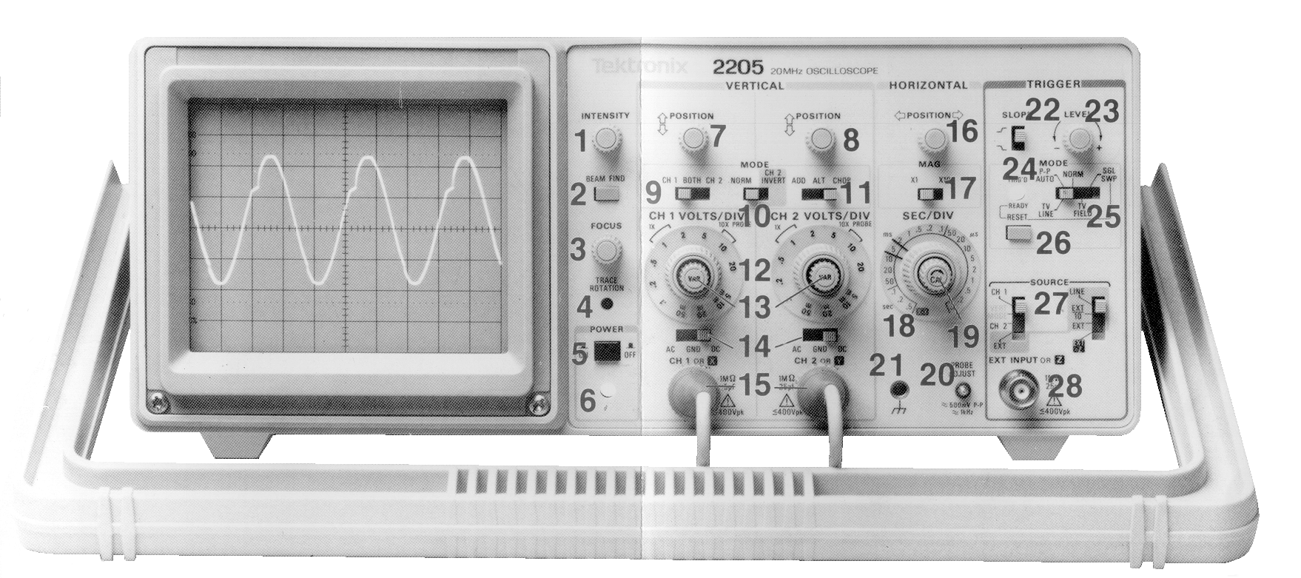

THE OSCILLOSCOPE (CRO)

There are 4 major SECTIONS which control the display of a voltage signal as a function of time.

The DISPLAY section controls (1-6) affect only the brightness (1), focus of the trace (3), alignment of the trace to the graticule (4), assist you to find off-screen signals (2) and switch the instrument on (5, 6).

The VERTICAL section (7-15) contains 2 sets of controls to display the vertical (or voltage) axis of the display and the input connectors (15) through which to apply the signals to be viewed and selected (9, 11). The vertical position (7, 8) adjustment and sensitivity (12) are used to position the signal for measurement. Ensure that the centre knobs (13) are in the fully clockwise position to give the correct volts/cm reading from the graticule. According to the nature of the signal, you can find it with 2, and adjust it to give the largest vertical trace with 12 and 14. This control (14) allows you to set the zero voltage position (GND) on the graticule using 7, 8. The normal position of this switch should be to DC when the input is directly connected to the vertical input amplifiers of the CRO. In the AC position, the input and amplifier are separated by a capacitor which blocks any DC voltage but passes AC and this facility is useful for the display of small ripple voltages superimposed on larger DC voltages. Note that the red terminal is the signal and black is the earth or ground.

The HORIZONTAL section (16-20) set the speed (18) and move (16) the horizontal (or time) axis for the displayed traces. The centre knob 19 should be in the fully clockwise position to give the correct seconds/cm reading from the graticule.

The TRIGGER section (22-28) defines the conditions to initiate (or trigger) a steady trace on the screen of either (27) or the inputs at 15. The normal display conditions will use the auto (25) position and 22 and 23 can be used to steady the trace if required.

FAULT FINDING

If a circuit does not perform as you would expect you should always try to solve the problem yourself by systematic checks as this is the best way to learn the art of fault finding. If you are unable to proceed after a reasonable effort you should then call for assistance from a demonstrator.

A visual check will usually reveal the absence of a complete circuit or omission of a power supply. Less frequently, there may be failure of a component or a broken lead hidden from view which can be investigated by substitution of a known working item. The following check procedure can be useful:

1. Make sure you understand the test equipment you are using and check to see that any power supplies you intend to use are switched on.

2. Compare the circuit you have built with the one in the Manual you think you have made and see if you have any omissions or short-circuits.

3. Use a multimeter or CRO to check the voltages in the circuit starting with any power supply to see, for example, if it has the correct polarity.

4. Check the earthing remembering that you can only have one common earth point.

5. If you find a fault in a piece of mains powered equipment report it to a demonstrator immediately and ask for a replacement.

DIRECT CURRENT

1. Voltage Measurement
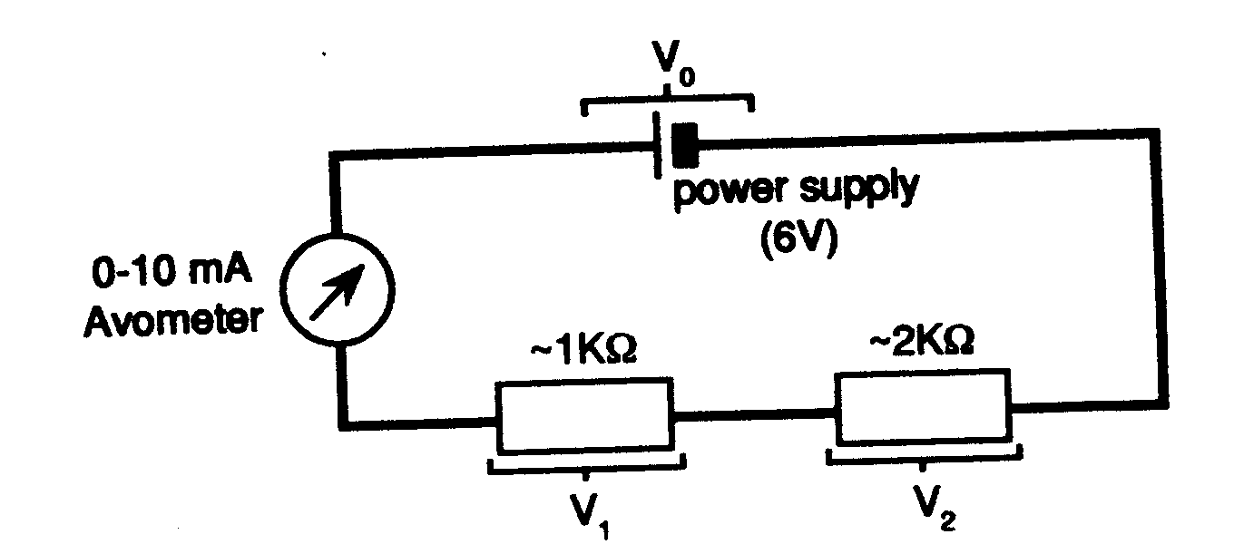
Measure V₀, V₁ and V₂ with the other digital multimeter. See if the current changes when the meter is connected. What does this imply for the resistance of the voltmeter? Look up the instruction manual and find out the error on these values.

2. Resistance Measurement

Measure the decade box resistance at various values with the multimeter. Does the multimeter give the correct value within its quoted accuracy?

3. Current Measurement

Replace the 1 kΩ resistor in the above circuit by the decade box resistance set to 1000 Ω. Measure the voltage across the decade box. Does the value of current obtained using I = V/R agree with the reading of the avometer?

ALTERNATING CURRENT

With alternating current (AC) it is necessary to know not only the voltage (or current) but also how it varies with time. Because of this, the term voltage is not unique (as it is with direct current). There is the instantaneous voltage (V), the voltage amplitude (V₀), the peak to peak voltage (V_{pp}) and the root mean square voltage (V_{rms}). Copy this diagram into your work book and write down the relations linking V₀, V_{pp} and V_{rms}.
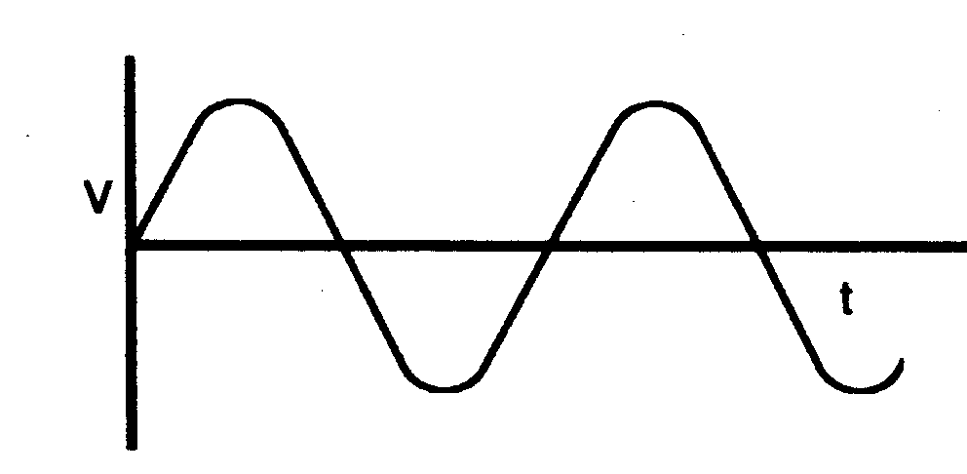
The oscilloscope is the ideal instrument for investigating AC circuits as it displays voltage as a function of time. In the diagram above the convention is time increasing from left to right.
4. Voltage and Frequency Measurement

Connect the oscillator to channel 1 of the oscilloscope and apply sinusoidal signals of the following voltages and frequencies: 2V, 1MHz; 1V, 40kHz; 0.1V, 100Hz. In each case obtain a conveniently sized stationary trace (ask a demonstrator for help with triggering). Make sure you understand what all the controls do and use the oscilloscope to measure the voltage and frequency in each case. If correctly set up, oscilloscopes should typically measure voltages and frequencies to within ± 5%. This can often be checked by using an internal or external standard.

5. Current Measurement

The oscilloscope is basically a voltage measuring device, but by measuring the voltage across a known resistance, the current through the circuit can be obtained. With the circuit shown measure the voltage across R₁ with the oscilloscope and hence derive the current through the circuit.
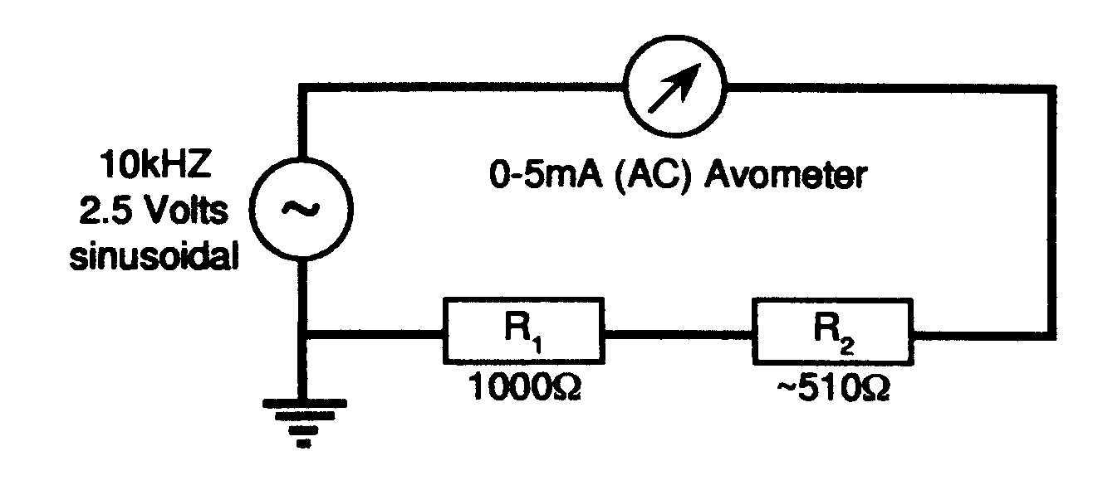
(i) Is the value of the current obtained consistent with that given by the ammeter?

(ii) Was there any change in the current on connecting the oscilloscope across R₁? What does this imply about the effective resistance of the oscilloscope?

6. Earthing Problems

In the circuit of (5) one of the output terminals (black) of the oscillator is shown earthed. One of the connections to the oscilloscope (black) is also earthed.
(a) How does this dictate the way in which the oscilloscope must be connected across R₁.
(b) Can the oscilloscope measure directly the voltage across R₂? Try it.

7. AC/DC Oscilloscope Connections

An alternating voltage may vary about zero or about some DC voltage level. The latter situation can be produced by connecting the oscillator, with a 2V 1kHz sine-wave output, in series with the 9V battery. This gives a voltage signal:
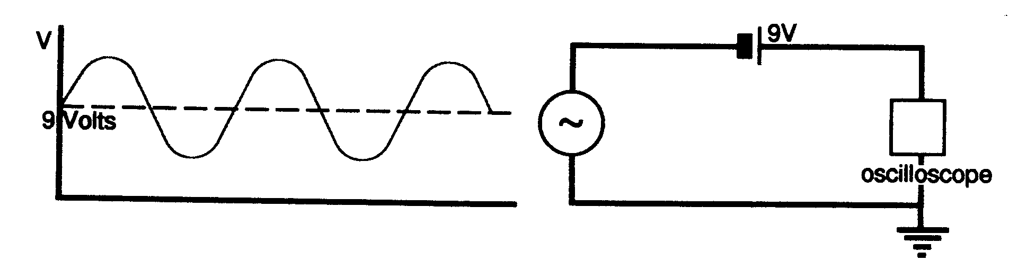

Display this signal on the oscilloscope and observe the change in the display with the AC/DC/Ground switch in the various positions. Explain what the various positions do.

8. Phase Measurements

By using both channels of the oscilloscope you can compare the relative phase of the voltage across a circuit and the current through it. The phase difference is usually expressed as a lag or lead of φ (360° = 2 π radians = one complete cycle). Measure the phase difference between current (put one channel of the oscilloscope across the resistance R₁ and trigger the oscilloscope from this channel) and voltage (put the other channel of the oscilloscope across the whole circuit) in the following circuits. Use a frequency of 1 kHz. (Ask a demonstrator for help if you don’t understand how to calculate the phase difference).
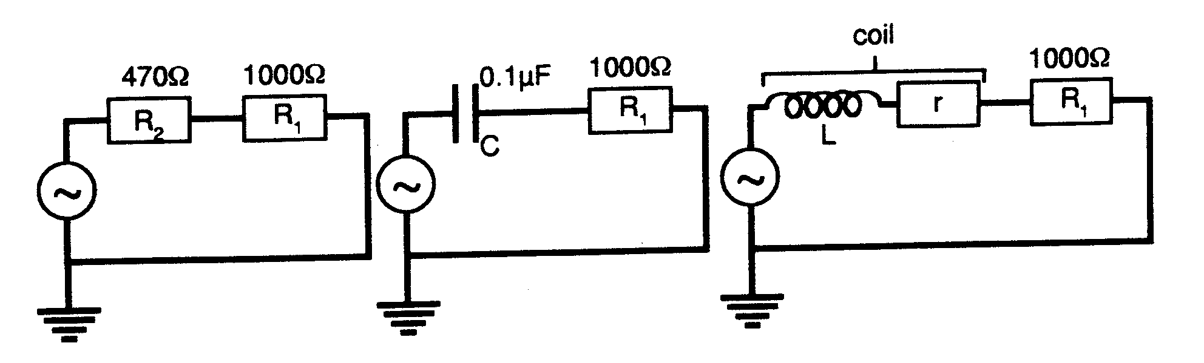

(C) THE DISTRIBUTION OF ERRORS

This section will begin with a short lecture introducing the material below.

Why estimate errors?

A measurement of a physical quantity is unlikely to yield exactly the true value. An estimate of the size of the likely difference between the true and measured value is important if significant conclusions are to be drawn from the results. Since the true value is not known, the most likely size of the error on the measured value must be estimated and quoted along with the result.

Random and Systematic Errors
A random error occurs when repeated measurements vary around the mean value without any pattern. For example, reading the position of a pointer on the scale of a meter has a random error associated with it. Random errors can usually be estimated from the spread in repeated measurements.

Systematic errors are usually more difficult to estimate and must be identified by consideration of the experimental method. A simple example of a systematic error is one which is the same throughout a set of readings. For example if a meter is not zeroed correctly, all the readings taken with it will be offset by the same amount. More subtly, a systematic error can vary during an experiment due to, say, drift in the calibration of an instrument. See Chapter 8 of Squires book for a useful discussion of systematic errors.

At the research level, rigorous error analysis can be difficult and sometimes impossible. It is however important to attempt an error analysis and to state clearly in any report of an experiment how the error has been estimated so that the reader can understand the significance of the result and compare it with results from other experiments. This is why it is important to develop an understanding of error analysis and why you will always be expected to perform an error analysis of experiments.

Estimating errors in practice.
- In experiments in the undergraduate laboratories, you should identify possible sources of systematic errors and eliminate or reduce them by correct use and calibration of the instruments. An estimate of remaining systematic errors should be made by considering operation of the instruments. For example the zero of a scale can be set to within, say  0.2 of the smallest division.
- Random errors can be estimated from the spread in repeated readings.
- All the errors can then be combined to determine the error on the final result using the rules given later in this document.
- Estimates of error are liable to have errors themselves! As a rule-of-thumb it is usually adequate to determine the errors themselves to within about 10%. In consequence, error calculations can often be simplified by ignoring errors that are small compared with other errors. Some care is needed here as the analysis may be more sensitive to erros in particular quantities than others.

1. Length Measurement with Steel Rule

Make 5 measurements of the length of the aluminium cylinder using the steel rule. You will probably find that the measurements are the same. In this situation the measurement process is very simple and the error or uncertainty in the measurement arises from the size of the division on the steel rule and is usually taken to be ± half the smallest division. To eliminate mistakes you should still take more than one reading.

2. Timing using digital stopwatch
In this exercise you will measure the time period for the flashes from a “lighthouse” for which this is a precise but unknown value. The timing will be carried out using a digital stopwatch.

(i) Take 5 readings with the timing in milliseconds. The variation you see is a consequence of the nature of the measurement process rather than the size of the smallest reading (which is usually ± last digit for a digital device).

(ii) In order to explore this further take 30 more readings (in 6 groups of 5) to provide enough data to analyse.

(iii) Draw a histogram of the 30 readings (for guidance on how to do this ask a demonstrator).

(iv) It is probably obvious to you that the best estimate of the true value is the mean of these readings. Work this out for the 30 readings sample and draw it in on the histogram. If the individual readings are x_{i} then the mean is = ∑x_{i}/N where N is the total number of readings. (N.B. this function is on a calculator). Also calculate the mean for the initial 5 readings sample.

(v) The spread of the readings gives information on the error. The Standard Error on a single reading is a measure of this spread, it is given by
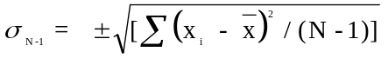

where N is the number of readings

Calculate the Standard Error on a single reading (usually σ_{n-1} on a calculator) for the 5 and 30 readings separately and indicate - σ_{N-1}and + σ_{N-1} on your histogram for the 30 readings.

(vi) The Standard Error on a single reading remains essentially the same, irrespective of the number of measurements taken. However it is obvious that the uncertainty in the mean value must get less as more individual readings contribute to this mean value. This concept is embodied in the quantity Standard Error in the Mean Δx = σ_{N-1}/√N which is used as the error in a measurement of this type. Thus the result would be quoted as ± Δx.

(vii) Calculate the means for the 6 groups of 5 readings making up the 30 reading
sample. Including the initial 5 reading sample you should now have 7
independent means for 7 samples of 5 readings. Plot a histogram for these 7
means and calculate σ_{N-1} for this sample. This distribution should be narrower
than that for the 30 individual readings and the σ_{N-1} value should be comparable
with the Δx value calculated in (vi) above. THIS ILLUSTRATES THE
DIFFERENCE BETWEEN THE CONCEPTS OF STANDARD ERROR
FOR A SINGLE READING AND THE STANDARD ERROR ON THE
MEAN WHICH SHOULD BE USED WHEN A MEAN IS TAKEN.

(viii) The histogram obtained in (iii) above approximates to a normal or gaussian distribution for which 68% of the readings lie within ± σ_{N-1}, 95% within ± 2σ_{N-1} and 99.73% within ± 3σ_{N-1}. What are the actual percentages of the total number of your readings within these limits?

3. Consistency

In sections 2(i) and 2(ii) you have obtained two independent measurements of the same quantity. These should be consistent i.e. the same within the errors. A reasonable criterion for the consistency of two independent measurements of the same quantity x₁ ± Δx₁ and x₂ ± Δx₂ is that
⎢x₁ - x ₂ ⎢< 3 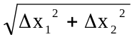
Check your two measurements against this criterion.

4. Systematic Errors

So far we have been considering Random Errors, which cause the measured values to spread around the true value and only affect the precision of the determination. If the instrument used has adequate sensitivity the random error can be reduced by taking more readings. However there may also be Systematic Errors which shift all the readings in one direction away from the true value, as for example when a manufacturer quotes the accuracy of an instrument as being ± 1%, in this situation any measurement made with a particular instrument would be subject to a systematic error of 1% and this will affect the accuracy of the result. This could not be reduced by taking multiple readings with the same instrument. Alternatively the experimenter may introduce a systematic error into a measurement by poor technique. There is no general rule for dealing with systematic errors; you should try and be aware of possible systematic errors and eliminate or reduce them if possible, and then make an estimate of their contribution.

5. Significant Figures

It is standard practice to give some indication of how close to the true value is the mean value obtained by measurement. Because of their very nature errors cannot be precisely quantified. While an error should always be included with a measurement you should accept that its value is only approximate. For this reason a result like 2.732 ± 0.312 is inappropriate and this should be quoted as (2.7 ± 0.3) using brackets and followed by the common powers of 10 and units. Use 1 (or possibly 2) significant figures for the error and round up the measured quantity appropriately as outlined in section A.

The above ideas on how to deal with errors are repeated in the “Data Analysis” summary after section E. These ideas become more familiar as you gain experience in applying them in a variety of real experimental situations.

6. ESTIMATING ERRORS

Here are some examples of common measurements that you will come across in your laboratory work.

a) Apparatus A

Measuring the angle of the analyser to obtain a minimum intensity from two ‘crossed’ Polaroid filters.

What determines the error? Is it a scale reading error or something else?
How would you estimate it in practice?
Is it worth taking a mean of several readings?

b) Apparatus B

Measuring the diameter of Newton’s Rings using a travelling microscope.

What determines the error? Is it a scale reading error or something else?
How would you estimate it in practice?
Will multiple readings help?

c) Apparatus C

Measuring the amplitude and frequency of an AC signal with an oscilloscope.

What determines the errors? Are there scale reading errors or something else?
Is it worth taking a mean of several readings?
What systematic errors could be present?

d) Apparatus D

Measuring the density of air by using a precision balance to weigh a vessel of known volume when filled with air and when evacuated.

What determines the errors? Are there scale reading errors or something else?
Is it worth taking a mean of several readings?
What systematic effects would you worry about?
If the vessel evacuated weighs 0.152 kg what would you expect it to weigh when full of air of density 1.2 kg m⁻³? Take the internal dimensions of the cylindrical vessel to be 6 cm diameter and 15 cm in length.

(D) COMBINATION OF ERRORS

This section will begin with a short lecture on the material below.

The final result of an experiment is often obtained by combining various measured values, or it may be some function of those values. There are certain procedures for obtaining the error in the final result from the errors in the individual measured quantities, and these are given in the Data Analysis summary after section E. The theoretical justifications for these procedures are given briefly below. Before stating these, it is useful to note other alternative ways of specifying the error δx in a value x such as the fractional error δx / x and the percentage error [(100 δx) / x ]% as these values are often used in the derivation of combined errors. So if z is a function of two quantities A and B, usually written z = f(A,B), then a small error δz in z is related to small errors δA and δB in A and B. If A and B are independent of each other and their errors δA and δB are random then the error in z, δz is obtained by adding the individual contributions to δz in quadrature (squaring) to avoid the situation of a smaller error resulting if the individual parts have opposite signs, so that
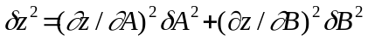 All the combined errors needed can be derived from this formula and are given in the Data Analysis Summary Sheets after Section E. For example, the refractive index n, of the glass of a prism can be found from measurements made with a spectrometer and use of the formula, 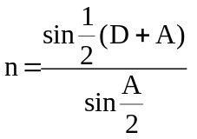 using and 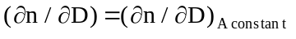 and 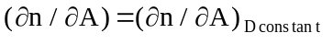. In order to get practice in using the rules for combining errors a number of problems are given below to evaluate in your work-book. Give all answers to a sensible number of significant figures. Make sure you check your answers with a demonstrator.

a) Z = A+B. If A = 9387 ± 1 and B = 97 ± 5 calculate Z and its error.

b) Z = A-B. If A = 99 ± 2 and B = 95 ± 2 calculate Z and its error.

c) A block of material has a mass of (4.26 ± 0.04) kg and a volume of (4.52 ± 0.08) x 10⁻⁴m³. Calculate the density of the material.

d) If we know the diameter of a sphere to within 2%, how accurately do we know its volume and its surface area?

e) If x = 0.33 ± 0.02 (a 6% error) calculate the value and the error of: x², 2x², x³, 1/x, 1/x², e^{x}, log_{e}x. What is the percentage error in each case?

f) How much power is dissipated in a resistor of (10.3 ± 0.4)Ω, through which a steady current of (2.2 ± 0.1)A flows?

g) Two measurements of a particular physical quantity gives values of 101.6 ± 1.7 and 104.3 ± 1.3; are these consistent? Two measurements of another quantity give values of 93.8 ± 0.1 and 94.7 ± 0.2; are these consistent?

h) θ = (20 ± 5)° and ψ = (80 ± 5)°.
Calculate the value and the error of cos θ and tan ψ.

i) A cylindrical annulus has an external diameter (215.0 ± 0.5)mm, internal diameter (183.0 ± 0.5)mm and length (107 ± 0.5)mm. What is its volume?
Hint:
Use the formula V = π(R₁²-R₂²)L and NOT V = πLR₁²- πLR₂²
WHY??
Do the calculation in stages :- a) error in R₁² , b) error in R₂² ,
c) error in R₁²-R₂² , d) error in π(R₁²-R₂²)L

Use of the spreadsheet EXCEL

The labour of performing repeated error calculations can be greatly reduced by using the EXCEL spreadsheet.

The following data was taken from the experiment to verify Stefan’s Law that the heat radiated from a black body at temperature T K is = σT⁴ W m⁻² where σ is Stefan’s Constant. In the experiment the voltage V across a light bulb and the current I flowing through it are measured. The temperature T is calculated from the formula
T = 293 + ((R / 8.11) -1) / 0.0048
where R is the resistance of the bulb = V/I. The power radiated P = IV. To prove the law a plot of Ln P v Ln T should give a straight line with a gradient equal to 4.
The table below gives the raw data for I and V and sets out a spreadsheet format to give the final data points for the graph together with the necessary errors.

Produce an EXCEL spreadsheet based on this model and perform the necessary calculations to fill in the spreadsheet.

I ma | error | V volts | error | IV | error | V/I ohm | error | ln(IV) | error | T | error | ln(T) | error
142 | 1 | 5.88 | 0.01
124 | 1 | 4.64 | 0.01
109 | 1 | 3.71 | 0.01
97 | 1 | 2.99 | 0.01
86 | 0.9 | 2.44 | 0.01
78 | 0.8 | 2.01 | 0.01
70 | 0.7 | 1.68 | 0.01
64 | 0.6 | 1.42 | 0.01
59 | 0.6 | 1.21 | 0.01
54 | 0.5 | 1.03 | 0.01
49.2 | 0.5 | 0.856 | 0.01

(E) ANALYSIS OF GRAPHICAL DATA

This section will begin with a short lecture discussing the material below.

A frequent experimental situation is that we have two quantities x and y that have some functional relationship to each other y = f(x), and we take pairs of measurements of x and y in order to find what that function is. We do this by plotting the points on a graph and then try to find some curve that passes as closely as possible to the points. In order to decide whether a function corresponds to the experimental points it is essential to include with the points some information on the possible uncertainty in the points. This is usually done by plotting “error bars” with the measured values of x ± Δx and y ± Δy plotted as two lines of length 2Δx and 2Δy centred on the point (x,y) and the curve should then pass through these error bars. (In many cases the errors on either x or y may be zero or negligible).

Remember to label the units on each axis. When extracting information from the fitted curve to the points, it is much better to convert values to SI units before plotting them so that the derived gradient is then in SI units.

Mass/Length Experiment

In order to have a simple experimental situation to explore graphical data, you will determine the relationship between the mass (dependent variable, y) and the length (independent variable, x) of the ribbon cable provided.

a) Use six lengths of the ribbon cable between 10 and 125 mm long, measure the length of each and weigh each piece (use simple balance).

b) Draw up a table of the values of the lengths and their errors and the masses and their errors (i.e. x, Δx, y, Δy).

c) Plot these points (with error bars as described above) on a suitable graph.

A great deal of information can be obtained by a careful scrutiny of the graph with just the points and error bars plotted.
DO NOT draw any line through the points.
Possible conclusions that might be drawn at this stage are:
(i) It is reasonable to assume that there is a linear relationship between y and x, i.e. the function is of the form y = mx + c.
(ii) There is clearly not a linear relationship between y and x.
(iii) Because of the size of the errors it is going to be very difficult to decide between various possibilities for the function.
(iv) One point seems to be inconsistent with the others.

Consider your graph in the light of these possibilities. Hopefully situation (i) applies and it is realistic to proceed to fitting the best straight line to the experimental points. If not, further attention must be given to the data. (If necessary discuss this with the demonstrator).

d) With help from your demonstrator put your data into the Line Fit computer program for least squares fitting, and get a print-out of the output. Draw the best straight line given by the computer output on your graph. There is a description of Least Squares Fitting at the end of this section.

e) What is your value for the mass per unit length of the cable quoted, with its error, and units to a sensible number of significant figures?

f) For this experimental situation it is reasonable to expect that the graph should go through the origin. Is your value of the intercept consistent with this?

g) The computer output gives both the chi-squared for each point and the chi-squared per degree of freedom (CSPD). The former is large (>>1) for a point that is suspect. The latter should be around 1 for a good fit. However, because of the difficulty of estimating the errors on the points, values of between 0.1 and 5 may not be unreasonable. If your value of CSPD lies outside this range consult a demonstrator, but first check the values you have used.

h) Carry out the same experiment with one of either the coaxial cable, the copper wire or the aluminium wire.

Least Squares Fitting

The experiment has given n pairs of measurements of x and y which it is reasonable to believe are related by the linear function y = mx + c. The problem now is to find the best (most probable) values of m and c and some estimate of the errors in these quantities. An objective criterion for the “best” straight line is needed. The deviation of the ith point (x_{i}, y_{i}) from a particular straight line is given by y_{i} - mx_{i} - c. If Δy_{i} is the error on the ith point and it is assumed that any error is only in the y values, the best straight line is that for which ∑[y_{i} - mx_{i} -c)/Δy_{i}]² is minimised. This quantity is known as chi-squared. This result can be generalised to take into account errors on both x and y values.

The actual minimisation requires the use of a computer and gives errors on the best values of the gradient m and the intercept c. If the relationship between x and y is a straight line one might expect the experimental points to be scattered about the best straight line by an amount roughly equal to their error, giving a value of chi-squared of approximately one for each point. Such a value of chi-squared can be taken as an indication that a reasonable fit has been obtained.

If the CSPD value is reasonable, Line Fit has the added advantage of giving the best gradient and intercept with their errors and since these often relate to the desired quantities in the experiment, Line Fit can also be seen to simplify the job of error analysis.

EXERCISES

1) PLOT THE FOLLOWING DATA
X | DX | Y | DY
2.793 | 0.004 | 4.73 | 0.09
2.833 | 0.004 | 4.98 | 0.07
2.874 | 0.004 | 5.38 | 0.06
2.915 | 0.004 | 5.31 | 0.05
2.958 | 0.005 | 5.39 | 0.05
3.003 | 0.005 | 5.53 | 0.04
3.049 | 0.005 | 5.77 | 0.03
Comment on the data.Are the errorbars appropriate? What kind of relationship do you expect to find between X and Y?

2) FIT THE FOLLOWING DATA
X | DX | Y | dY
4.19 | 0.006 | 7.16 | 0.01
4.25 | 0.006 | 7.31 | 0.01
4.311 | 0.006 | 7.73 | 0.01
4.373 | 0.006 | 7.91 | 0.01
4.437 | 0.008 | 8.04 | 0.01
4.505 | 0.008 | 8.36 | 0.01
4.574 | 0.008 | 8.75 | 0.01
Attach the LINEFIT printout to your work-book. Comment on the fit.

3) FIT THE FOLLOWING DATA (Only the errors have changed from the previous set, do not retype all data)
X | dX | Y | dY
4.19 | 0.006 | 7.16 | 0.15
4.25 | 0.006 | 7.31 | 0.15
4.311 | 0.006 | 7.73 | 0.15
4.373 | 0.006 | 7.91 | 0.15
4.437 | 0.008 | 8.04 | 0.2
4.505 | 0.008 | 8.36 | 0.2
4.574 | 0.008 | 8.75 | 0.2

Attach the LINEFIT printout to your work-book. Comment on the fit.

4) Compare the gradients for the fits in exercises 2) and 3).
Comment on the errors on the gradients found in the two fits.
Which do you have confidence in??
If you do not have confidence in either how would you proceed??

5) PLOT THE FOLLOWING DATA

X | dX | Y | dY
4.19 | 0.006 | 7.1 | 0.1
4.25 | 0.006 | 7.3 | 0.1
4.311 | 0.006 | 7.4 | 0.2
4.373 | 0.006 | 7.9 | 0.2
4.437 | 0.008 | 8.4 | 0.3
4.505 | 0.008 | 9.2 | 0.3
4.574 | 0.008 | 10.5 | 0.3

Comment on the data. Are the errorbars appropriate? What kind of relationship do you expect between X and Y?
SPREADSHEET ANALYSIS

The repetitious (and tedious) nature of evaluating errors for many data points cries out for use of a computer based technique, and the spreadsheet is ideal for this purpose. The following exercise is designed to familiarise you to a particular variation of spreadsheet software called EXCEL. You are encouraged to apply EXCEL to data from any of the foundation experiments. You should already be familiar with EXCEL from the module PHYS113. The notes below are a reminder.

INTRODUCTION TO EXCEL

The Excel icon is in the Microsoft Office Window. Double click on it to start the program.

The screen will display the sheet with columns labelled by letters and from rows labelled by numbers. The active cell address will initially be column A, row 1 and the boundary of this cell will be in bold. You can change this cell using the arrow keys (the group of four between the main keys and the numeric pad) or the mouse.

HELP You can get instant help at any time in Excel by selecting the Help item from the main menu or by pressing the F1 key. If a menu option is highlighted, you will get a window of text about that option. Otherwise you will get the Excel Help Menu; simply highlight whatever topic you need to know about using the mouse. Some topics have sub-windows of help (these are shown as underlined green text); simply use the mouse to select subsequent pages of help.

How to Input Data to the Straight Line Fitting Programme

Many laboratory experiments will require you to fit a straight line to your data as in Section D. Data can be entered directly into the fitting programme following the on-screen instructions. When the raw data has to be manipulated into the correct form, it is usually quicker, particularly with large data sets, to enter the raw data on an EXCEL spreadsheet, calculate the data to be fitted on the spreadsheet and write a file that the line fitting programme can read. The important steps in the procedure as described below.

Setting up the spreadsheet:
- In order to write the file of data for the fitting program correctly, it is essential that the numbers for the fit be entered in four adjacent columns in the order:
x Error in x y Error in y
and that each set of readings be on successive lines. The block must contain only numbers if the fitting routine is to read the data correctly.

Writing the file:
- Select just the block containing the values of x, the error in x, y and the error in y.
- Copy the block, i.e. put it on the Windows clipboard.
- Click on New in the File menu and select Paste Special. In the dialogue box, check Values so that just the numerical values are pasted into the spreadsheet. Put nothing else in this spreadsheet apart from the block of data.
- Click on Save as... in the File menu and from the Save file as Type option at the bottom of the dialogue box, select CSV (Comma delimited). This will save just the numbers as you see them on the screen separated (i.e. delimited) by a space which the line fitting routine can understand. EXCEL will add the extension .CSV. When you click on OK in the Save As... box, EXCEL will display a warning message “Selected file type will save only the active sheet”. This is what you want, so click on OK.
- Close the CSV file in EXCEL, otherwise you will not be able to open the file in the linefit program.

Running the fitting programme
- The fitting programme is menu driven with options shown on the bottom of the screen:
- Press L on the keyboard to load data and select the option required. Use <F1> to view your files if you have forgotten the name.
- Check the numbers appear correctly in the table and press <F1> to ask the program to do the fit. S followed by f will save the results of the fit to a file. Change the default filename if you do not want to overwrite your data file and give the file the extension .CSV, which EXCEL will recognise.

Importing the results of the fitting programme to a spreadsheet
- To import the results of the fit into the spreadsheet, you can reverse the exporting procedure. The output from the linefit program is also written as a comma delimited file.
- If you have given the file the extension .CSV, EXCEL will treat it as a comman delimited file and import it directly into a new spreadsheet.
- If you have not included the extension .CSV, when you attempt to open the file, EXCEL will recognise it is not a standard EXCEL file and will display the Text Import Wizard.
- Check the box `Delimited’ and click on Next.
- Check Comma as a delimiter and “(Double quotes) as the Text Qualifier (this should be set already). The window should display the results, with the slope and intercept and text in separate cells.
- Click on Finish to load the spreadsheet. The values can now be pasted into any other spreadsheet via the Windows clipboard.

APPLICATION TO THERMISTOR EXPERIMENT DATA

In this exercise you are asked to enter experimental data into Excel and manipulate it into a given form which can be fitted to a straight line. To run the least squares fit program, you will have to exit from Excel, taking the data you have prepared to the new program by means of a file written on your disk. The output from the least squares fit program can be imported back into Excel. You may not wish to do this step until you have more experience. Otherwise retype the output from the first stage into the least squares fit program.

Set up a spreadsheet using the thermistor data (see last pages in Foundation Experiments section or use your own data) and the quantities required for the straight line fit.

N.B. In order to write the file of data for the fitting program correctly, it is ESSENTIAL that the numbers for the fit appear in successive columns in the order: x, error in x, y, error in y and that each set of readings be on successive lines. The block must contain only numbers if the fitting routine is to read the data correctly.

In this case the suggested columns contain the fixed error in T (one value), and the values of T, R, error in R, 1/T, error in 1/T, 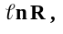 error in so that only the last four columns will be printed to a file (see later).

Hint:
Keep the first row for labels.
Enter the fixed error for T as numerical datum into cell A2.
Enter the values of T, R and error in R into cells C2, C3, ... D2, D3 ... and E2, E3 ... respectively.
Into F2 enter the formulae +1/C2, and copy it to cells F3F4 ...
Into G2 enter the formula + $A$2.(C2*C2) (Why?) and copy it.
Into H2 ... work it out yourself!

To save the data for the fitting program:
- Select just the block containing the values of x, the error in x, y and the error in y.
- Copy the block i.e. put it on the Windows clipboard.
- Start the Notepad program in the Accessories window. There is no need to exit from Excel, but do be sure you have saved the latest version of your Excel file. If you have the Microsoft Office toolbar set up at the top right of the screen you can access the Program Manager directly to run Notepad, otherwise you will probably have to minimise the Excel window to see the Program Manager.

Use the File in the Notepad menu to write a file of the data in a form the fitting program can read on your A drive. Give your file an extension so that you can recognise that it is just a file of the ASCII characters. The extension .prn is often used for this sort of file (prn indicates printer because the most common use of these files was for sending to simple printers), but the Notepad default extension of .txt is equally satisfactory.
To start the line fitting program on the machines in T2, click on Linefit in the Applications window. On the Managed Network it is available on the L drive in the directory Physics. You can run it via the File Manager by highlighting it with the mouse and then selecting Run ... from the File menu in the File Manager. If you wish to you can drag the file into your New Applications menu and Windows will set up an icon for accessing the program directly. This will then be available to you in future sessions on the Managed System.
The fitting programme is menu driven with options shown on the bottom of the screen. Press L on the keyboard to Load data from the A: drive (the file with .PRN, not XLS!) and answer the questions.
The file of results can be loaded into a new EXCEL worksheet. Select Open from the File menu. To list your file you will find it useful to select All Files using the List Files of Type button at the bottom of the dialogue box. EXCEL will recognise that your file is not in the standard format and will display the Text Import Wizard. Choose Delimited and click on Next. Select the Comma delimiter and check that the text and numbers are in separate cells. Click on Finish to load the file into a new spreadsheet. Copy the results you require to the Clipboard and Paste into the spreadsheet with your data.
Use the spreadsheet to calculate the constant A.

DATA ANALYSIS SUMMARY SHEETS

Errors

The result of every physical measurement should be accompanied by an error (or uncertainty) i.e. x ± Δx where Δx is typically given by:
(i) the standard error in the mean of a set of N measurements of which x would then be the mean (see below).

(ii) half the smallest reading we can take on the instrument used in the measurement (or 1 digit for a digital instrument).

(iii) an estimate of the possible systematic error (e.g. from the manufacturers specification of the accuracy of the instrument).

Strictly the contributions to Δx from i, ii and iii should be combined, but usually we take whichever is the largest.

The distribution of measurements

A set of measurements of the same quantity free of systematic errors will typically show a distribution centred about the true value. The best estimate of the true value of the quantity will be given by the mean of these readings:

Mean 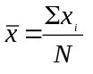

where N is the number of readings and x₁, x₂......x_{i}.....x_{N} are the N values of x.

The error on a single reading is related to the spread of the distribution. The appropriate estimate of the spread of the distribution for N readings is given by:

Standard error on a single reading 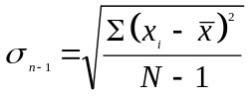

Note: This can be obtained using the button labelled _{n-1} on a calculator. This should be used rather than the button labelled _{n} which is a different measure of the spread, called the standard deviation.

Multiple readings reduce the error on the mean by the factor 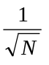:

Standard error on the mean: 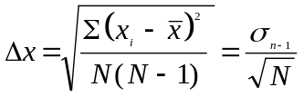

Quoting results

Whenever you report a physical quantity it must be quoted in a standard form. This form contains either 5 or 6 mandatory elements.
- A sentence describing the result
- The name of the measured quantity
- The measured value, rounded according to the error
- The uncertainty, given to at most 2 significant digits
- If applicable, a global order of magnitude
- The unit

E.g.: A volume of a box was measured to be 294.58344 cm³. The error analysis shows that the uncertainty of the result is 0.5664 cm³. The result should be rounded to 1 significant figure and presented as:

The volume of the box is V = (294.6 +/- 0.6) cm³

If the result is a very large or very small number, it is convenient to explicitly give the order of magnitude for both the measured value and the uncertainty. If we wanted to show the volume of the same box in m³, we could either do it as
V= (0.0002946 +/- 0.0000006) m³,
which is difficult to read. It is much more convenient to quote it as
V = (294.6 +/- 0.6) x 10⁻⁶ m³.

One often finds great uncertainty whether to quote one or two significant figures. As a general rule of thumb any error beginning with 3 or greater should be rounded and only be quoted to one significant figure. The only exception are values 14 15 16 and possibly 24 25 26, these can be left in their present form, rounded to two significant figures.

Examples: L = (7.3789 +/- 0.0453) m is shown as L = (7.38 +/- 0.05) m
T = (25687 +/- 1424) s is shown as T = (25700 +/- 1400) s
ρ = (0.00005489 +/- 3.79x10⁻⁶) kg/m³ as ρ = (5.5 +/- 0.4)x10⁻⁵ kg/m³
v = (344.347 +/- 0.152) m/s is shown as v = (344.35 +/- 0.15) m/s

.....and once more: do not forget to include the units!

Consistency

Two independent measurements of the same quantity x₁ ± Δx₁ and x₂ ± Δx₂ are consistent if
⎜x₁ - x₂ ⎜ < 3

Rules for Combining Errors

The rules below show how an error in a measured quantity propagates into an error in a derived quantity. ΔA refers to the error in A and is assumed small compared with A.

1. Z = A + B or Z = A - B
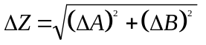  Add the errors in quadrature

2. Z = k A
ΔZ = k ΔA  Multiply the actual error by k
or
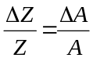  The fractional errors of A and Z are equal

3. Z = k A x B or Z = 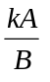
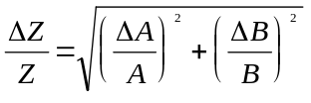  Add the fractional errors in quadrature

4. Z = kA^{n} where n is a constant
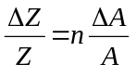  Multiply the fractional error by n, independent of k

5. Z = f(A) where f is a function
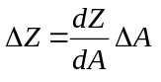  where 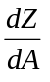 can be expressed analytically

For example, if Z = log_{e}A, then 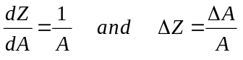

Also remember d(sinθ) = cosθ dθ (etc) and that the error dθ in θ is in radians.

For more complicated functions, the above rules must be applied in sequence.

Care must be taken if a quantity appears more than once in the calculation to avoid the effects of correlated errors. You will not meet this problem in Year 1.
Mathematical Basis of the Rules for Combining Errors

Using mathematics you will cover in Year 1, the rules described above for combining errors can be derived from a single equation:

If z = f(x,y), then a small error z in z is related to small errors x in x and y in y by:

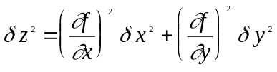

Examples

i) z = A + B  Example of rule 1
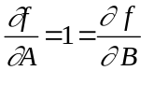  δz² = δA² + δB²

ii) z = k A^{n}  Example of rule 4

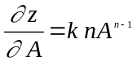

δz = k nA^{n-1} δA  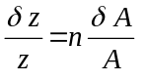

iii) z = k sinθ  Example of the use of rule 5

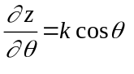  δz = k cosθ δθ (θ in radians)

iv) z = cA + k B  Combination of rules 1 and 2

⇒ δz² = c² δA² + k² δB²

v) z = k AB  Example of rule 3

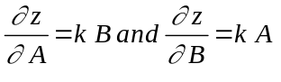 

δz² = k²y²δA² + k²x²δB²  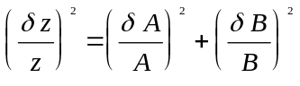

REVISION EXERCISES

These exercises are intended to help you revise the various elements of the practical course. They are similar to the questions contained in the Practical Techniques Class Test, which will be held during the revision afternoon.

1. A quantity is measured to be 10 ± 1. What is the value of the uncertainty of
a) 6x b) x³ c) 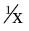 d) e^{x} ?

2. A certain length is measured 9 times independently and the values obtained are 8.61, 8.72, 8.65, 8.67, 8.62, 8.80, 8.58, 8.66, 8.65, all in cm.

Write down a) the best estimate, b) the standard error in a single reading, c) the error in the mean, d) the final result.

A different method gives a result of 8.90 ± 0.10 cm. Is this consistent with the above result?

3. Describe how you would measure:
a) the r.m.s. voltage of an a.c. signal;
b) the peak-to-peak voltage of an a.c. signal;
c) the frequency of an a.c. signal;
d) the phase difference between two a.c. signals of the same frequency.

4. The current in an a.c. circuit is monitored using both an ammeter (reading r.m.s. values), and an oscilloscope which measures the peak-to-peak voltage across a (200 ± 1) Ω resistor. The values obtained are (7.3 ± 0.1) mA and (4.0 ± 0.2) V. Are these consistent?

5. An inductance L, capacitance C and resistance R are connected in series to an oscillator, one side of which is earthed. Draw diagrams to show how to measure using the oscilloscope:
a) the total voltage across the LCR combination;
b) the current through the LCR combination;
c) the voltage across the capacitor C;
d) the current through the inductance L.

6. If i = (45 ± 2)º and r = (35 ± 3)º what is μ = sin i/sin r and the uncertainty in μ?

7. The length of a cylinder is measured to be 219.325 ± .002 mm. The diameter of the cylinder is approximately 200 mm. What is the largest error in the diameter measurement to give an error in the volume measurement of 10⁻⁵m³? What instrument should you use?

8. The total impedance of an LCR circuit is given by

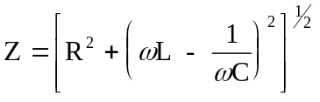

The following quantities are measured:
R = (1001.6 ± 0.5) Ω
L = (127.2 ± 0.2) mH
f = (562.57 ± 0.03) Hz
C = (0.565 ± 0.016) μF
What is Z, its error and in what units is it expressed?

FOUNDATION
EXPERIMENTS

FOUNDATION EXPERIMENTS

These are a series of short experiments designed to give you a chance to use a wide range of laboratory equipment. You have four periods to complete these experiments.

You should write a short factual report on each experiment. This should include (where appropriate):

(i) The method you used - BRIEFLY

(ii) All results - in table form if there are a large number

(iii) The error analysis

(iv) Graphs numbered so that you can refer to them in your working, plus computer fits

(v) The quantity which you have been asked to determine with its error

(vi) A BRIEF conclusion

When you have finished your report each experiment must be discussed with a demonstrator. No formal assessment is carried out on individual experiments, but you will be asked to correct any error you make. Do not move to a new experiment until given permission by a demonstrator.

You should complete three experiments out of the following 6 experiments within the four periods.

A sample report is given after the descriptions of the experiments.

When you have finished all 3 experiments you should summarise the SKILLS you have acquired using the Summary Sheet and hand it to your Demonstrator.

Do not take your work book outside the laboratory.

F1. Newton’s Rings

The diameter of D of the n^{th} ring is given by D² = 4Rλn where λ is the wavelength of the light (589.3nm for the sodium light) and R is the radius of curvature of the lens. Verify this relationship by measuring the values of D for different values of n, plot a suitable graph with error bars, see if it looks linear and if so use the computer to obtain the best straight line and hence from the gradient obtain a value of R. Check to see if this is consistent with the value of R measured directly using a spherometer.

F2. Hooke’s Law

With a load, m, measure the extension, e, set the load into small vertical oscillations and measure the period T. Repeat for a number of values of m (making sure that the oscillations remain small and that the extension is less than the original length of the spring). Plot e against m and T² against m. The graphs should be linear. Determine the acceleration due to gravity, g, from:

g = 4π² x gradient of extension graph
gradient of period graph

F3. Thermistor Experiment

A thermistor has a resistance R which varies with temperature T (in Kelvin) according to the relationship.
R = Ae^{B/T}
Measure the resistance as a function of temperature between 90 and 50ºC (363 and 323K) using boiling water. By plotting a suitable graph verify the above relationship and obtain values for A and B.

F4. LCR Circuit
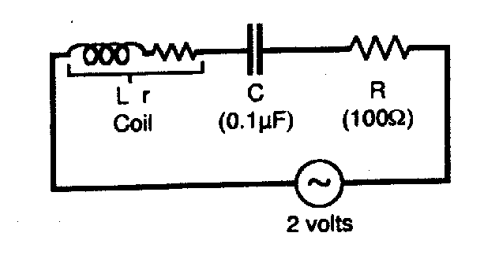

Approximate values are given for C and R. Your components may vary from these values. Using the oscilloscope (remember to connect the earth of the oscilloscope and the oscillator to the same point in the circuit - ask a demonstrator if in doubt).

(i) Measure the voltage (whole circuit) and current (from voltage across R) in the circuit at 500Hz and 5kHz.

(ii) Measure the phase difference between current and voltage at these frequencies.

(iii) Compare with theory V = IZ (Magnitudes)
Z = [R² + 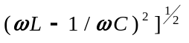

ψ = tan⁻¹ 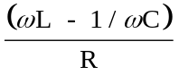

(iv) Draw resonance curves in the range 500Hz to 5kHz (take a number of points near the resonance)
I vs.
ψ vs.
Does the experimental resonance frequency equal the theoretical value of _{res} = (1/LC)^{½} ?

F5. Microwaves

Two interference situations are investigated using microwave radiation with a wavelength of the order of 3cm. The first case is “Thin Film Interference” which has important applications in the blooming of lenses used in optical equipment in order to reduce unwanted reflections. The other is the “Michelson Interferometer” which is of practical importance in measuring the wavelength of electromagnetic radiation. Both experiments will be used to measure the wavelength of the microwaves, and should give consistent results.

a) Thin Film Interference
With the set up shown in the diagram there is interference between microwaves which are reflected at the front and back of the “thin-film” produced by the gap between the perspex plate and the aluminium plate.
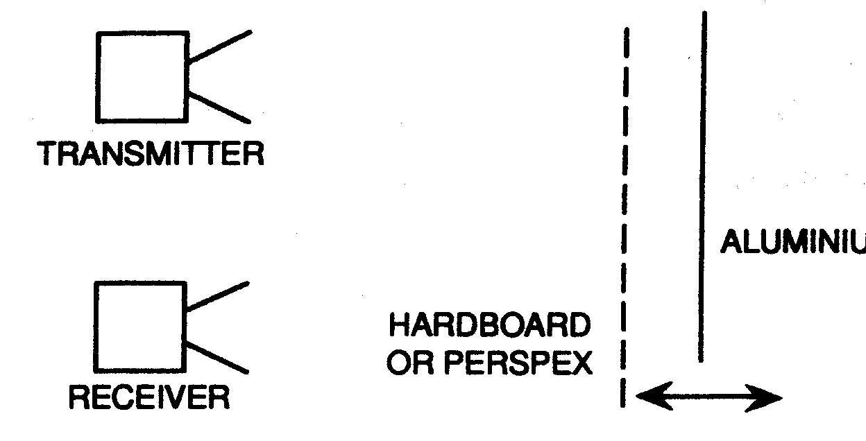
Varying the separation of the two plates produces maxima and minima. The distance moved by the metal plate between successive maxima (or minima) is one half wavelength. Use a graphical method to find a value for the wavelength.
b) Michelson Interferometer
The Michelson interferometer is shown schematically in the diagram. Radiation from the transmitter falls on the “half-silvered mirror” which is mounted at 45° to the direction of the incident beam.
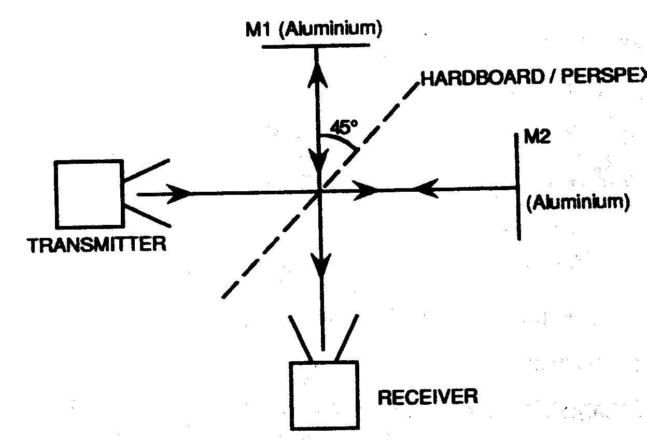

The incident beam is split into two parts, one travelling out to mirror M₁ and the other M₂. If the mirrors M₁ and M₂ are respectively parallel and perpendicular to the initial beam direction the radiation will return to the half-reflecting mirror and some part of both beams will recombine as they travel towards the detector. These two beams of radiation will be in phase if the distances of M₁ and M₂ from the half-reflecting mirror are the same, or a whole number of half wavelengths different. This is the condition for constructive interference, and the detector will then show a maximum in intensity. If, however, the two waves are not in phase the intensity will be less and will be a minimum when the phase difference is 180°. So if the mirror M₂ is moved parallel to the incident beam direction a series maxima or minima of intensity will be observed. The distance moved between successive maxima (or minima) is again one half wavelength. Use this to find a value for the wavelength.

F6. Semiconductor Devices

Introduction

Most materials can be classified as either conductors of electricity or insulators. The difference in conductivity between these groups is very large (∼10²⁰). However, certain materials, such as silicon, have an electrical conductivity ∼10⁻⁶ x copper and are given the name semiconductors.

The addition of controlled amounts of either trivalent or pentavalent materials to pure silicon significantly increases the conductivity resulting in P-type or N-type silicon respectively. (In P-type silicon the increased conductivity is due to extra positive carriers; in N-type silicon extra negative carriers). A PN junction can be used to produce a two terminal device, a solid state diode, which conducts preferentially in one direction. A NPN transistor is a three terminal device which behaves like two PN junctions. In addition current flowing from the power supply into one transistor terminal can be controlled by a smaller current flowing into a different terminal. This control of a large current by a smaller current is called current amplification.

Individual transistors are rarely used in modern electronic circuits. Instead several transistors, resistors and capacitors are packaged, with all internal connections, inside an encapsulated integrated circuit (IC). This reduces wiring effort and overall cost with improved reliability.

EXPERIMENTS

a) Use a digital multimeter (DM) on the diode setting to check that the NPN transistor BFY51 behaves like two diodes connected as below.
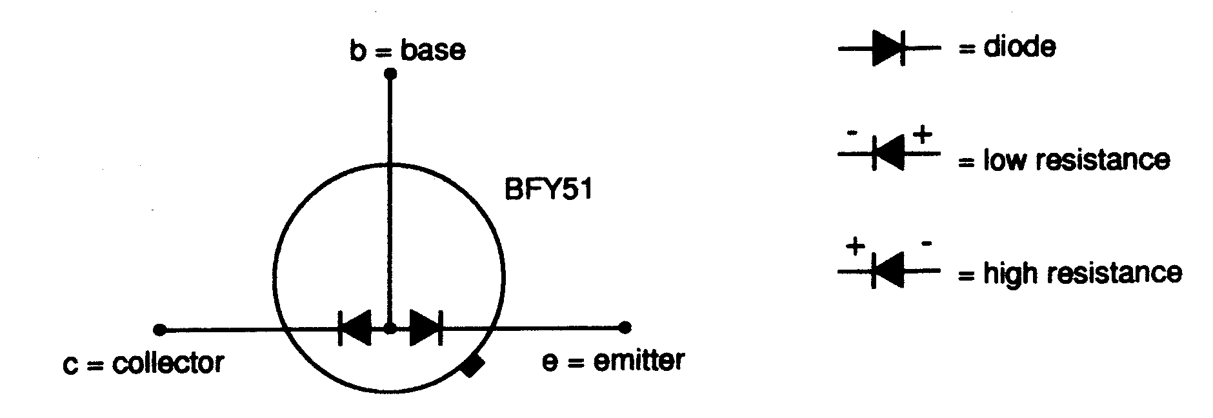

b) Connect the circuit with R_{b} set to 1000kΩ and the DM on the 20mA setting. Measure I_{c} for various values of R_{b}. Do not allow I_{c} to exceed ∼10mA. Calculate I_{b} for each reading [I_{b} = (V_{s} - 0.65)/(R_{b} + 39000)] and plot a graph of I_{c}(mA) against I_{b}(μA). Measure the slope to obtain the current gain of the transistor.

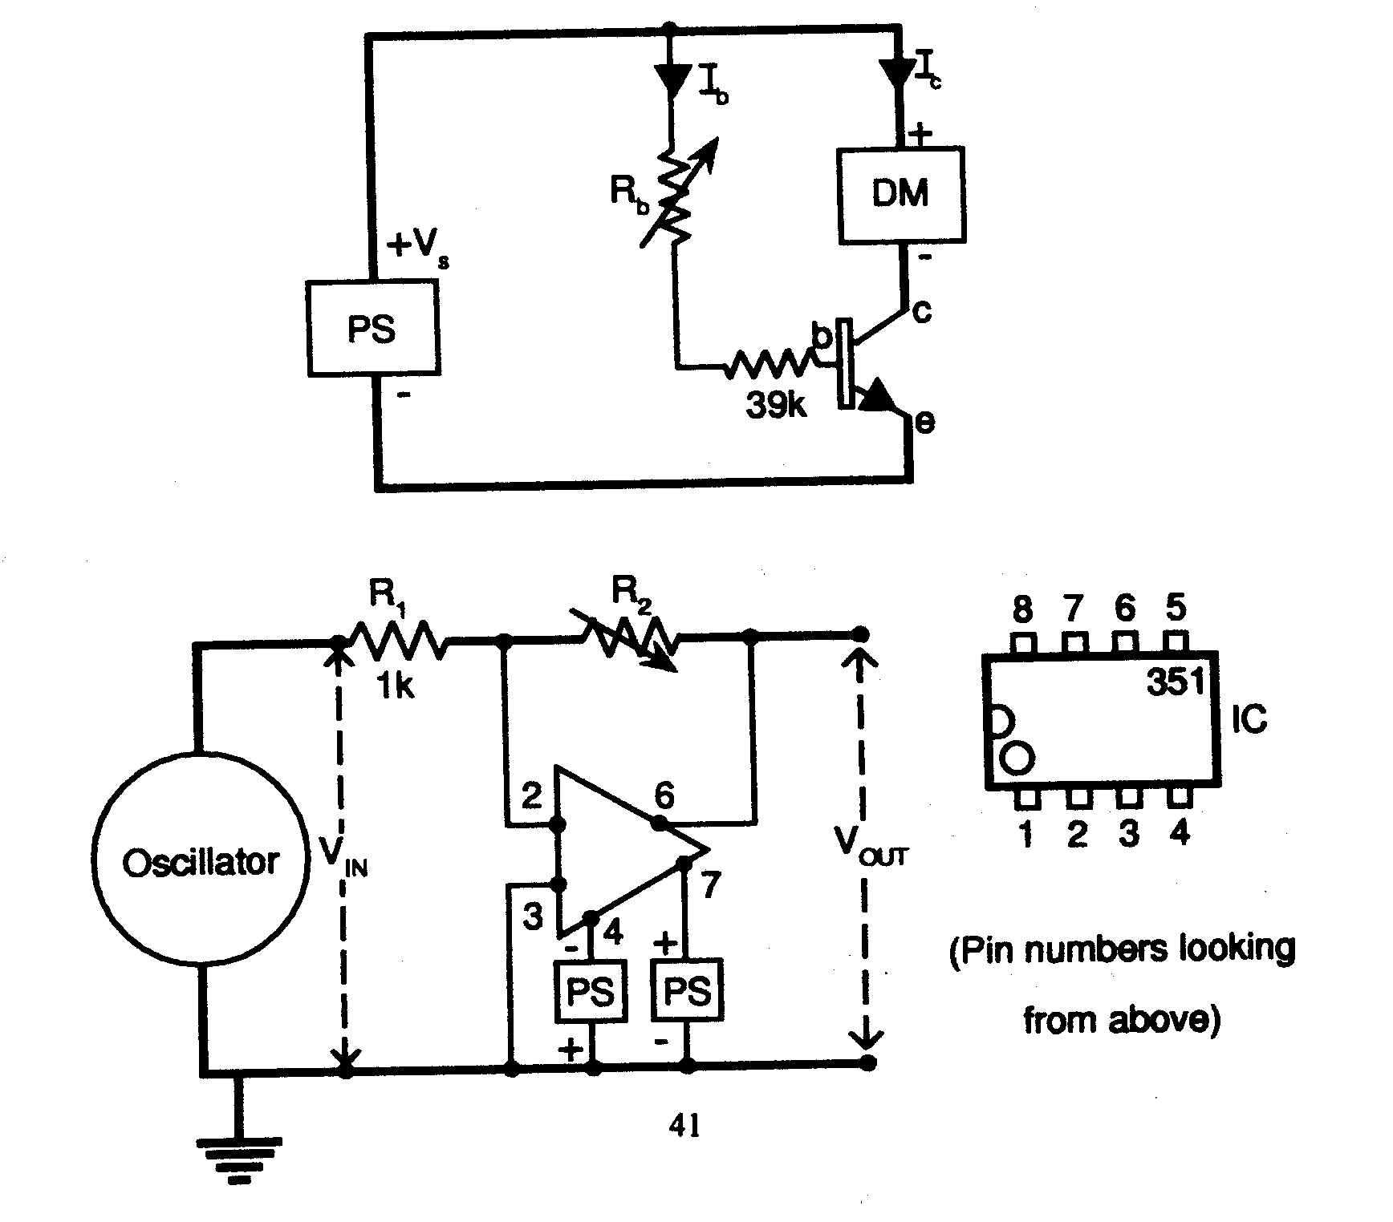

Connect the above circuit noting that two power supplies are used to provide both +6V and -6V. The triangle represents IC operational amplifier type 351 and the numbers alongside are the pin connections. Use a double beam oscilloscope to display V_{IN} and V_{OUT} simultaneously. With R₁ = 1kΩ and V_{IN} = ±10mV at 1kHz on the oscilloscope, measure V_{OUT} for R₂ = 5kΩ, 10kΩ, 50kΩ, and 100kΩ. In each case compare V_{OUT}/V_{IN} with R₂/R₁.

F7 STEFAN’S LAW

Experimental observations of the rate of emission of radiant energy Q per m⁻² s⁻¹ from the surfaces of different materials at temperatures T K led to the formulation of STEFAN’S LAW

Q = ε σ T⁴

where ε is the EMISSIVITY of the surface and σ is STEFAN’S CONSTANT.
The value of ε varies between 0 and 1 depending on the nature of the surface. Polished metals have small values of ε while black materials have values close to 1.
An ideal surface with ε = 1 is called a BLACK BODY.

The experiment is to test the validity of this law using a simple light bulb.

The simple arrangement below allows you to vary the power radiated from the light bulb.
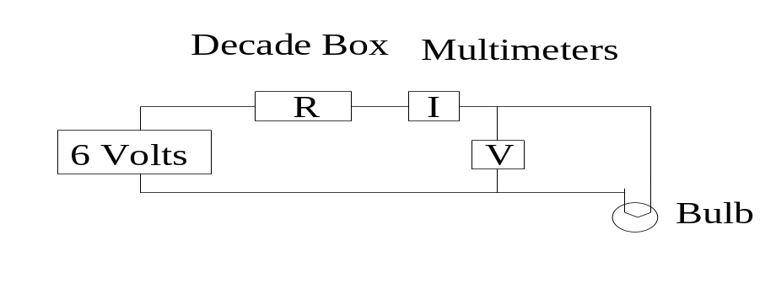.
The power is varied by introducing a series resistance using the decade box provided. Measurements of the current I and voltage V allow the power to be calculated
(P = I V) and the resistance of the bulb to be determined (R_{b} = V/I). The temperature of the bulb filament can then be calculated if the behaviour of the bulb resistance with temperature is known.

The Experiment.

Connect up the circuit and begin by setting the value of R = 200 Ohms. Measure V and I . Hence determine the resistance of the bulb R₀ at room temperature. Note that only a low power is applied to the bulb for this measurement to restrict the heating effect.

Now vary the value of R between 100 Ohms and 0 Ohms noting the values of I and V for each case.
The temperature of the bulb may be determined using the formula

R_{b} = R₀ ( 1 + α (T - T_{ROOM})) where the coefficient α = 0.0048 K⁻¹ for the tungsten filament.

Plot Ln ( P ) v Ln (T).

Measure the gradient of the graph and compare with theory.
You are recommended to do a spreadsheet analysis for this experiment.

SAMPLE REPORT

THERMISTOR EXPERIMENT

Aim:-
To investigate the relationship between resistance and temperature for a thermistor.

Apparatus:-
A beaker, kettle, mercury thermometer, thermistor and a multimeter.

Method:-
The beaker was filled with hot water from the kettle and readings were taken of the resistance of the thermistor and the temperature. The water was stirred to provide a uniform temperature. The estimated error on reading the temperature wastaken as a scale reading error of +- 0.5 degrees. The error in the resistance was assumed to be +-1 digit or +-0.2%. The experiment was repeated to confirm the data.

Measurements and Analysis
R = Ae^{B/T}
n R = n A + 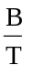

Plot n R against (1/T) [in Kelvin]

T  (°C) | R  (kΩ) | T⁻¹ x 10⁻³  (K⁻¹) | nR
85 | 0.114 | 2.793 ± 0.004 | 4.736 ± 0.009
80 | 0.136 | 2.833 ± 0.004 | 4.913 ± 0.007
75 | 0.162 | 2.874 ± 0.004 | 5.087 ± 0.006
70 | 0.191 | 2.915 ± 0.004 | 5.252 ± 0.005
65 | 0.226 | 2.958 ± 0.005 | 5.420 ± 0.005
60 | 0.273 | 3.003 ± 0.005 | 5.609 ± 0.004
55 | 0.319 | 3.049 ± 0.005 | 5.765 ± 0.003
±0.5°C | ±0.2%  (or 1 digit)

The gradient is B = (4.04 ± 0.08) x 10³K
From intercept A = (1.4 ± 0.4) x 10⁻³Ω

Conclusion:-
The data are consistent with a straight line confirming the relationship.
N.B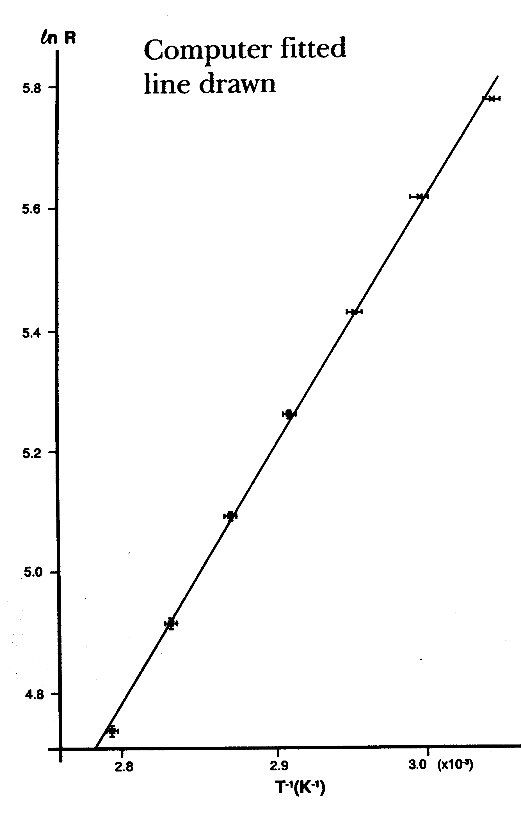
N.B. This is just an illustration.

ALL GRAPHS MUST BE DRAWN BY HAND

LONG
EXPERIMENTS

LONG EXPERIMENTS

There are four experiments available and you should aim to complete three. For each experiment there is a description in this Manual which gives instructions of what is to be done. You will work individually and remember that the demonstrators are there to help.

You should write down your measurements, rough notes and graphs as you are doing the experiment using your work book for this purpose. At the conclusion of the analysis you should produce a neat report, following the data and working and having the same structure as that used for the Foundation Experiments, but with a little more detail. DO NOT copy large parts of this manual. The report should summarise your work and state the results of the measurements requested together with your conclusions. Number the graph sheets used at the end of the book and refer to these in your report. At the end of each experiment hand your workbook in in one of the trays in T12 or to your Demonstrator. Do not put your finished work in your pidgeonhole, or it will not get marked!

You must finish each experiment and hand it in within the allocated three day period.

Do not take your work book outside the laboratory.

L1. VELOCITY OF SOUND

Introduction

The velocity of sound in gases, liquids and solids is an important physical quantity because it is the velocity at which any mechanical disturbance is propagated through the material. In many circumstances it can also give valuable information on the atomic or molecular structure of the material. As an example of this, kinetic theory predicts that in a gas the velocity of sound (v) is given by:-

V² = γP
ρ
where γ = ratio of the specific heats C_{p}C_{v}
P = pressure
ρ = density

Hence if ρ, P and v can be measured a value of γ can be found.

In this experiment, ρ, P and v are measured for both air and argon and hence the value of γ for these gases can be deduced.

1. Velocity of Sound Measurement

a) Method

This measurement can be most conveniently carried out at ultrasonic frequencies, (i.e. above 20kHz) for two main reasons. The wavelength is relatively short so that the apparatus is small, and there are no environmental pollution problems! The simplest method of measuring velocity is to measure wavelength λ and frequency f and use the relation v = fλ.

Quartz crystal transducers are used to produce and detect the ultrasonic longitudinal waves used in the experiment. These transducers are mechanically resonant at a frequency in the region of 40kHz and as a result they are relatively insensitive to sound at any other frequency so external interference effects are minimised. The operating frequency can be measured precisely by measuring the frequency of the electrical output from the transmitter with a digital frequency meter.

There are a number of ways of measuring the wavelength. the simplest is to place a receiver in front of a transmitter and observe the behaviour of the waves produced as the distance between the two is varied. The amplitude of the received wave should not change if the wave is a plane wave but the phase difference between changes by 2nπ if the transmitter to receiver distance is changed by nλ. Hence the wavelength and its error can be determined.

b) Apparatus

The transducers are mounted in a Perspex tube which allows different gases to be used. One of the transducers is arranged so that it can be moved through precisely measurable distances using a travelling microscope base. The foam plastic inserts are present to reduce unwanted waves due to reflections from the ends and sides of the tube.

The phase difference can be measured using a two channel oscilloscope. The time base should run at a convenient speed for measuring this phase difference and is best triggered with the transmitter signal as this is likely to be the most constant.

2. Pressure Measurement

The pressure of the gas in the system will be atmospheric, so its value can be obtained from the barometric pressure. There is a barometer at the end of laboratory T12.

3. Density Measurement

The density of the gas can be measured by weighing a vessel of known volume firstly containing the gas and secondly when evacuated. There is a special piece of apparatus for evacuating and sealing the vessel provided. Follow the instructions carefully otherwise the vessel may be destroyed. To minimise its mass it is made of only 0.2 mm thick stainless steel and is very fragile. It should be noted that the density must either be measured at the same pressure as the velocity measurement, or a correction must be made. CONSIDER CAREFULLY WHETHER REPEATED MEASUREMENTS NEED TO BE MADE. There are at least two ways of finding the volume of the vessel.
a) Measure the dimensions and calculate volume.
b) Measure the volume of liquid of known density which just fills the vessel.
(consider carefully which method is best).

4. Procedure

Do the experiment for both air and argon. You should flush the perspex tube with air before taking the air reading. When filling the perspex tube with argon ensure that when you have finished the argon is at atmospheric pressure.

5. Results

You should have the following results (values and errors) for each of air and argon (answer to be expressed at the same pressure)
(i) velocity of sound
(ii) density
(iii) a deduced value of γ.

The expected values of γ (for an ideal gas at atmospheric pressure) are 1.4 (for a diatomic molecule, e.g. N₂) and 1.67 (for a monotonic molecule, e.g. Ar). How do your values of γ compare with these values?

L2. LIQUID NITROGEN EXPERIMENT

Introduction

In this experiment you are asked to determine two of the three quantities density, molar mass and latent heat of vaporisation, of liquid nitrogen (LN₂) at its normal boiling point (under atmospheric pressure) of 77K (-196°C).

The apparatus used is very simple, but nevertheless it is possible to determine the latent heat to within 10%, while the density and molar mass can be found considerably more accurately.

Because of its low boiling point and latent heat, LN₂ is stored in dewar vessels of low thermal conductivity (expanded polystyrene buckets) to minimise the heat leaks into it from outside.

Care should be exercised when handling LN₂ as it can cause low temperature burns if contact with the skin is prolonged. Never seal off the liquid. If the bung is frozen DO NOT try to force it into the glass dewar flask. Consult a demonstrator or the technician.

Throughout this experiment you MUST consider whether it is appropriate to make repeated measurements.

Remember, choose to do two of the three following measurements:

1. Density

The density is measured using the experimental dewar flask as a specific gravity bottle, with a rubber band around the neck indicating the reference level. Fill the LN₂ to the reference level. Afterwards, warm up the flask and fill with water to measure the volume. You should calculate the effect of cooling on the volume of the flask and also estimate the volume occupied by the bubble.

2. Molar Mass

The well known result, following from Avogardro’s law, that a mole of any gas at s.t.p. (273K and 760mm Hg) occupies 22.4 x 10⁻³m³, can be used to find the molar mass of LN₂ by determining the volume of gas produced when a given mass of the liquid evaporates.

The dewar flask containing LN₂ is weighed and then connected to the gas meter so that the volume of gas evaporating over a suitable period can be measured. The dewar flask (and LN₂) is weighed again. Thus the volume of gas (corrected to s.t.p.) corresponding to a certain mass of liquid can be found, and hence the molar mass can be calculated.
The long length of tubing connecting the dewar to the gas meter is to ensure that gas is at room temperature on arrival at the meter. The time between weighing and connection to the meter must be minimised. Why?
The gasmeter used is of the standard domestic type and is therefore calibrated in cubic feet (1 cu.ft. = 28.3 x 10⁻³m³). The small dial which reads 2 cubic feet for one revolution is used in this experiment and is accurate to ± 3%.
3. Latent Heat of Vaporisation
The latent heat of vaporisation is measured by dissipating a known quantity of heat electrically in the LN₂, and measuring the rate of boil off in excess of the normal boil off with no electric heat input. To do this the power supply is connected across the normal 10Ω resistor which is immersed in the LN₂. From the current through the resistor and its resistance (measured with a meter) the electrical power input is calculated. This should be set to approximately 10 watts. Measure the boil-off from the change in mass.
The natural boil off is dependent on the level of the LN₂ and you should take account of this when making measurements. An estimate should also be made of the natural heat leak into the LN₂.
(N.B. The reading on the power supply meter is correct as it stands on all ranges - do not multiply by any factors).

L3. RECTIFICATION EXPERIMENT
INTRODUCTION
Electrical power is normally distributed as an alternating voltage 230V 50Hz for standard mains supply), but for many purposes a voltage which does not vary with time is required. A typical example of this is the power supply for a piece of electronic equipment. This experiment is to examine the process of rectification using semi-conductor diodes, and smoothing using capacitors, which is the most common way of obtaining a unidirectional source of power from an alternating supply. A simple analysis of the rectification process may be made if the diode is assumed to have an infinite resistance when voltage is applied in one direction and zero resistance when applied in the other.
In this experiment you have to perform a large number of small subexperiments. It is usually easier to write your final report including all error analyses as you perform each measurement.
THEORY
Full Wave Rectifier
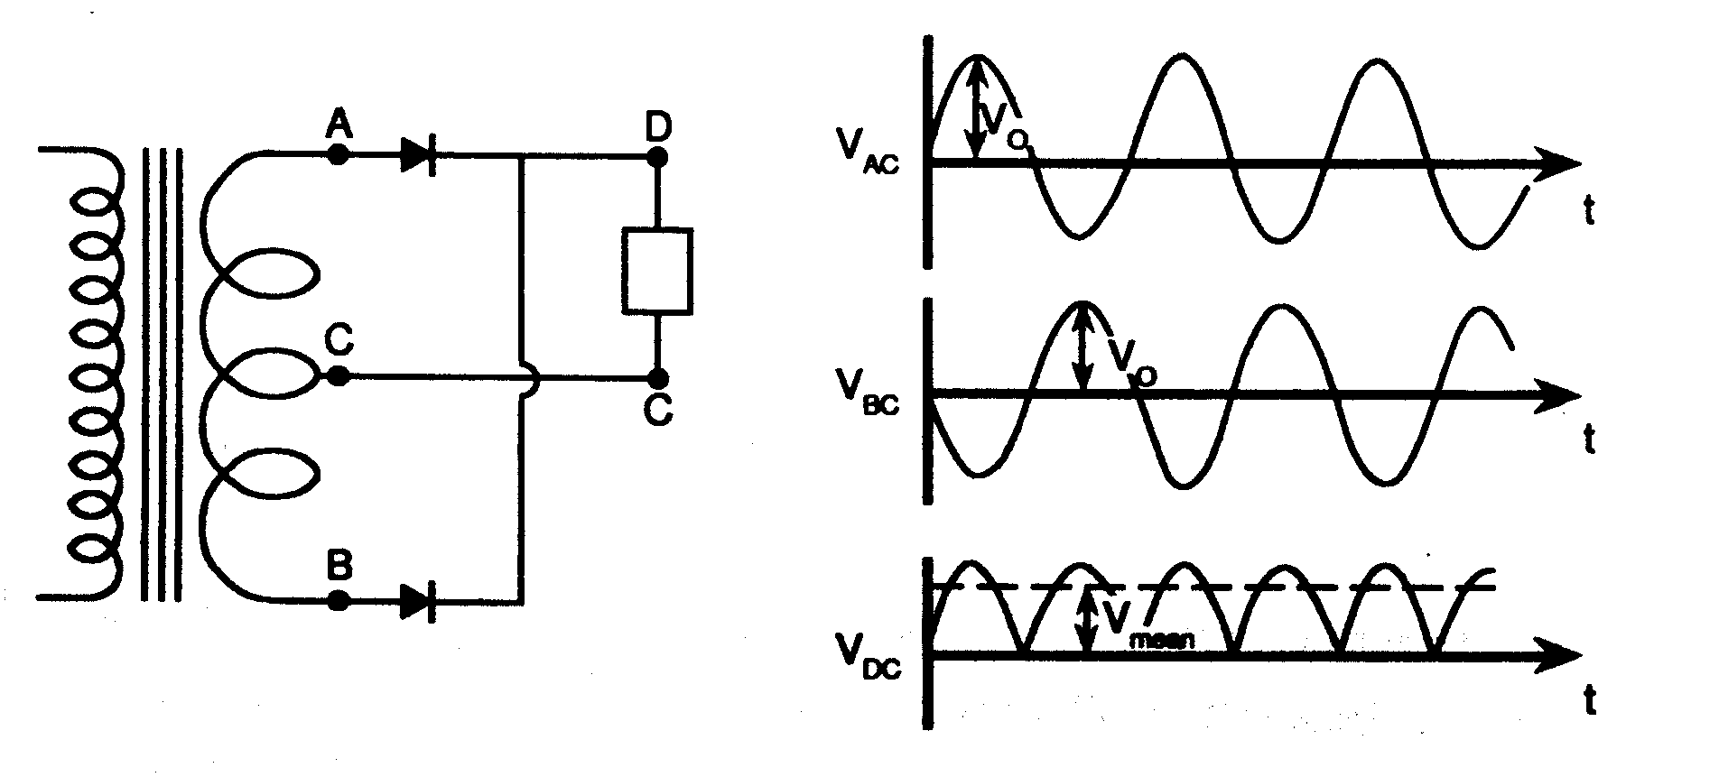
This circuit requires the alternating voltages applied to points A and B to be 180° out of phase. A transformer which has a connection to the centre of the secondary winding can be used to provide this. The voltage across AC has a 180° phase difference with respect to the voltage across BC.
This circuit gives
V_{mean} = 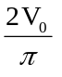
Although the voltage is unidirectional it is supplied to the load as a series of pulses. This may not matter under certain conditions such as battery charging, but for most purposes the wide variation of voltage with time cannot be tolerated.
The variation in output voltage is generally known as the ripple voltage and in this case the peak to peak ripple voltage is equal to V₀.

Full Wave Rectifier with Smoothing Capacitor
A large value capacitor can be used to store energy and hence provide a more continuous supply.
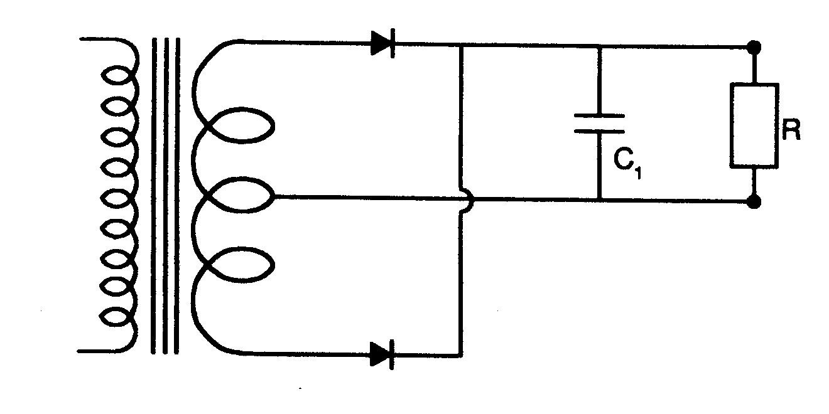
If the output current is zero (infinite load resistance) the capacitor will charge up to V₀ and the ripple voltage will be zero. When a current flows into the load the capacitor will discharge through the load resistor when the diode voltage is below V₀. If the time constant of the capacitor and load resistor is long compared with half the supply period, the change in output voltage will be small compared with V₀ and hence the ripple voltage will be greatly reduced.
An approximate value of the ripple voltage can be calculated, if it is assumed that the capacitor discharges for ~3/4 of time T/2 (where T is the period of supply) and the average discharge current is 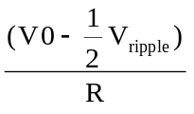. Therefore in this time the change in the charge on the capacitor is given by ΔQ = i t = (V₀ - ½ V_{ripple})/ R x 3T/8, and the corresponding change in voltage, which is the ripple voltage, is given by solving for V_{ripple} giving
Vripple = 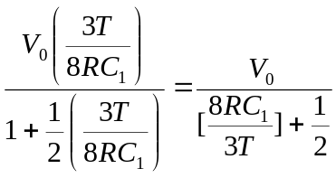
The output voltage is given by
V_{mean} = V₀ - ½V_{ripple}
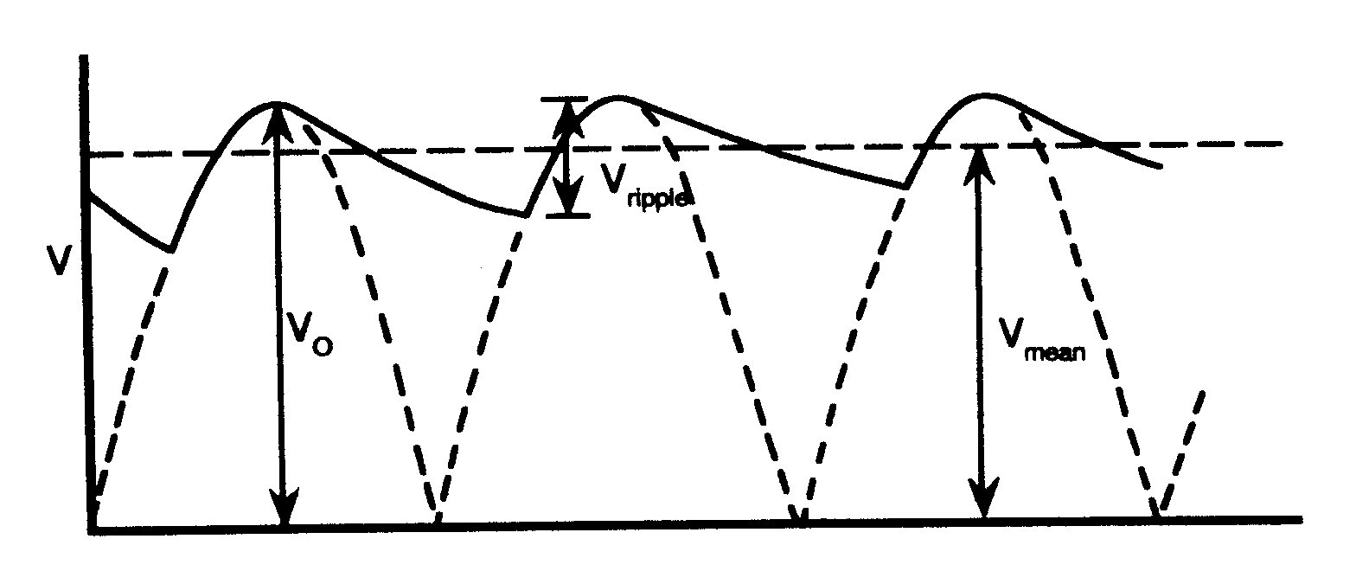
Full Wave Rectifier with Smoothing Capacitor and Low Pass Filter
A further reduction in ripple voltage can be obtained by the addition of a low pass filter circuit (shown between the dotted lines in the diagram) after the smoothing capacitor and before the load resistor.
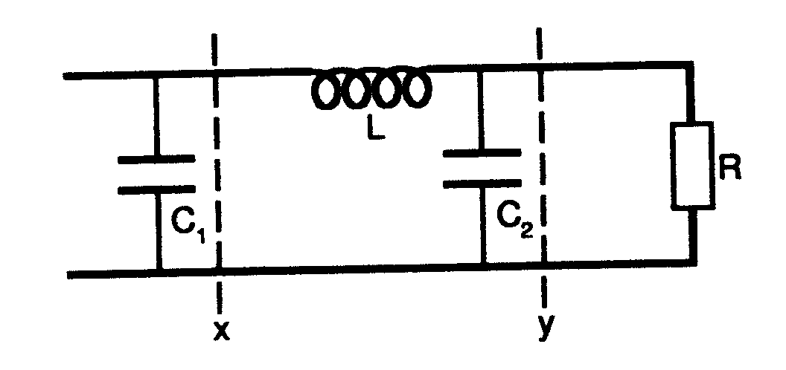
The low pass filter acts as a potential divider for the alternating component (ripple) of the voltage. If the inductor (L) has no resistance it has no effect on the DC component of the voltage across the capacitor C₁. In practice the inductor does have a small resistance which will cause a small voltage drop. The effects of the filter on the ripple voltage can be calculated approximately as follows:
Assume that the ripple is sinusoidal with a frequency of 2f where f is the original supply frequency (i.e. 50Hz). Assume also that R is large compared with 1/ωC₂ and that the resistance of the inductor is small compared with ωL. Then the input ripple voltage is across the impedance jωL-j/ωC₂ which arises from L and C₂ in series, while the output ripple voltage is across the impedance - j/ωC₂ which arises from C₂.
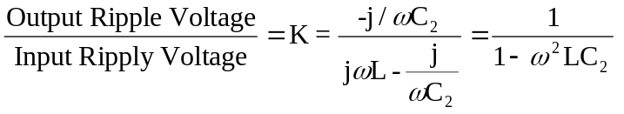

EXPERIMENTS
1. Full Wave Rectifier
Connect a full wave rectifier circuit to the transformer.
(i) With a 1kΩ load resistor sketch the waveforms produced at AC, BC and DC.
(ii) Measure the transformer supply voltage amplitude V₀ (across AC) with the oscilloscope.
(iii) Measure the rectifier output voltage V_{mean} across the load with a digital multimeter (on a dc setting).
(iv) Measure V_{rms} for the transformer (across AC) with the digital multimeter (on an ac setting). Compare the value of V₀ calculated using V₀=√2 V_{rms} with that obtained in (ii) above. Which is the more precise value?
From the value of V₀ calculate V_{mean} (=2V₀/π) and compare it with the value obtained in (iii). Are they consistent? In order to make this comparison you will need to consider the errors on the measured quantities.

2. Full Wave Rectifier with Smoothing Capacitor
Connect (a) a 20μF and (b) a 470μF reservoir capacitor in parallel with the load. (N.B. the 470μF capacitor is an electrolytic type and must be connected with the positive terminal connected to the positive side of the rectifier output or the capacitor will be destroyed).
(i) Sketch the output waveform across the load resistor.
(ii) Measure the output voltage V_{mean} with a digital meter (on a dc setting).
(iii) Measure V_{ripple} using the oscilloscope.
(iv) Calculate the value of V_{ripple} expected from the approximate theory and compare it with the measured value, for each capacitor (the capacitor values should be measured with the capacitance meter). Explain any discrepancy you observe. Again it will be necessary to estimate the errors.

3. Full Wave Rectifier with Smoothing Capacitor and Low Pass Filter
Set up the circuit with the 20μF capacitor as the smoothing capacitor C₁, a low pass filter made up with the 0.5H inductor and the 470μF capacitor, and with a 1kΩ load resistor.
(i) measure the ripple voltages at the input (x) and output (y) of the low pass filter.
(ii) obtain an experimental value for K and compare this with the theoretical one. What is the significance of the sign K?

L4. POLARISED LIGHT EXPERIMENT
The purpose of this experiment is to investigate some of the properties of polarised light.
Polarisation
Light may be considered as a transverse wave motion. In fact it is a transverse wave motion in the electromagnetic field with a wavelength (∼450 to ∼650nm) characteristic of that part of the electromagnetic spectrum which we call light. The direction of the vibration for a particular wave can be represented by a vector drawn normal to the direction of the propagation of the wave. This direction plus the direction of propagation actually specifies a plane, so that we often refer to such light as plane polarised and often talk of its plane of polarisation (figure 1). In this way the amplitude of a light wave is a vector along a particular direction, the square of which is proportional to the intensity, just as in interference and diffraction phenomena. With most sources of light, all possible directions of vibration occur at random and the light is said to be unpolarised. All these vibrations may be resolved into two components at right angles to each other.
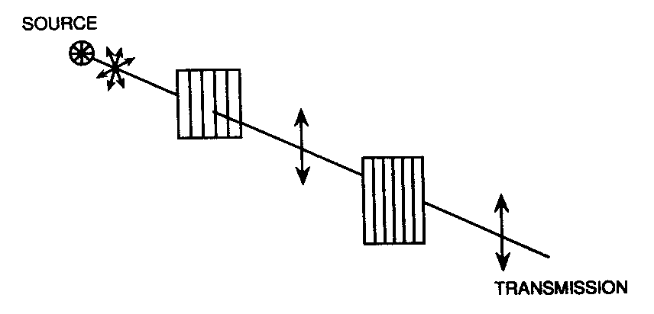
Figure 1: Schematic of unpolarised light emitted from a source passing through a polariser and analyser with their axes parallel.
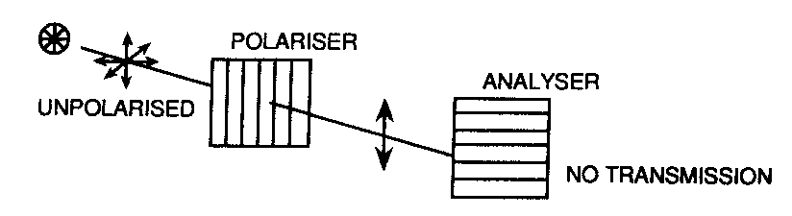
Figure 2: Schematic of unpolarised light emitted from a source passing through a polariser and then being blocked by an analyser when the axes of each are mutually perpendicular, that is are crossed.
There are optical devices which have the property of transmitting light only when the direction of its vibration vector is parallel to a particular direction in the device. Otherwise they effectively absorb it. These are known as polarisers. Consequently if a polariser is placed in a beam of unpolarised light the emergent light will contain only those components of the vectors of vibration which are parallel to the particular direction, and the light is said to be plane polarised (figure 1). If a second polariser (known as an analyser) is placed in the beam with its particular direction perpendicular to that of the first, no light at all will be transmitted (figure 2). The polariser and analyser are then said to be crossed.

Polarisation by Reflection
When unpolarised light falls onto the surface of a transparent material, the reflected and refracted beam are in general partially plane polarised. At a particular angle of incidence, known as the polarising or Brewster angle, the reflected light is completely plane polarised. It can be shown, using the theory appropriate for electromagnetic waves, that this occurs when the angle between the reflected and refracted beams is 90°. As usual the angles of incidence, reflection and refraction are defined with respect to the normal to the surface.
Sketch the ray optics corresponding to refraction and reflection at an angle of incidence equal to the Brewster angle. Assuming Snell’s Law of Refraction
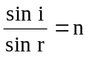
relating the angles of incidence i and refraction r to the refractive index n of the transparent material, calculate Brewster’s angle of incidence for light incident on a smooth surface of water with a refractive index of 1.33.
Optical Activity
Certain transparent materials have the property that they can rotate the direction of polarisation. These materials generally have a structure, either molecular or crystalline, which does not have complete rotational symmetry. The magnitude of the rotation depends both on the wavelength and the thickness of the material.
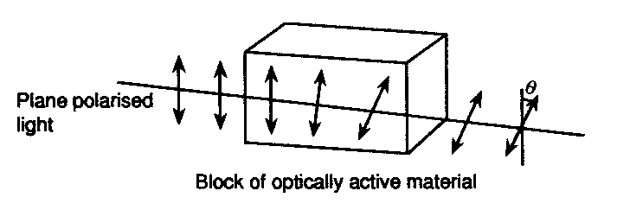
Figure 3: Schematic of the rotation of the plane of polarisation of plane polarised light when traversing an optically active material
Experiments
The equipment includes a light source (a conventional desk lamp) and a simple clamp system for supporting polariser, analyser and any additional optical components necessary. In addition there is a set of filters (one set to be shared by all sets of apparatus for this experiment) which transmit in only a small range of wavelength marked on their holders. Take care - under no circumstances handle the faces of these filters, and after use return them to their box for safe keeping. They are expensive and their effectiveness deteriorates if handled carelessly. Table 1 below summarises the range of transmitted wavelengths for each filter.

mean wavelength (nm) | width of transmission  profile (½ height) nm
700 | 694.4 - 706.5
656.3 | 650.6 - 663.4
650 | 644.3 - 655.4
632.8 | 627.2 - 638.6
600 | 596.4 - 606.7
589.6 | 585.8 - 595
550 | 546 - 554
530 | 525.1 - 532.5
500 | 497.8 - 505
480 | 486.8 - 493.2
Table 1
1. Preliminaries
Do the preliminary checks (i) and (ii) below with the equipment. There is no need to take many detailed measurements - just satisfy yourself that the stated phenomena are confirmed experimentally and note the fact.
(i) Set up the (white) light source and polariser and verify that no change in intensity occurs when the polariser is rotated. Then add an analyser and verify that there are two angular positions of the analyser for which no light is transmitted. Investigate whether there is any dependence of these positions on wavelength of the light.
(ii) Examine the reflection of a suitably illuminated object at a flat transparent surface and confirm that at a particular angle of incidence the reflected light is completely plane polarised. If possible determine an estimate of this angle of incidence and thereby extract an estimate of the refractive index of your transparent material.

2. Optical Activity of Quartz
Use the 4mm thick piece of quartz mounted in a holder. Verify that this material is optically active and investigate how the rotation θ of the plane of polarisation varies with wavelength (λ). Check to see that your results follow Biot’s Law.
θ = A + B/λ²
where A and B are constants, and determine A and B for your piece of quartz.
Explain why the direction and magnitude of the rotation is not determined uniquely from your data.

3. Optical Activity of Turpentine
Turpentine, a liquid, is optically active (see Longhurst’s book “Geometrical and Physical Optics” Chapter XXIII). Using light from a sodium source (589nm) determine the angle of rotation per cm length of turpentine. You are provided with two containers of different length both of which contain turpentine plus samples of glass disks which are identical to the end walls of the containers. Show that in this experiment the angle of rotation can be uniquely determined provided your errors of measurement are small.
Take care - the glass containers are fragile.

4. Optical Activity of Sugar Solution
Aqueous solutions of sugar are optically active. Using light from a sodium source measure the angle of rotation as a function of the sugar concentration expressed as a fraction of the concentration of a saturated solution. The quickest way of doing this is to use a saturated solution, measure its rotation angle, and then dilute it by adding known volumes of water for each subsequent measurement. Check that your result extrapolates to zero concentration as expected.
Once again take care - the glass containers are fragile.

L5 DIFFRACTION OF LIGHT

Please observe the local rules for the use of lasers in this experiment.

Introduction

Electromagnetic radiation has a very wide range of wavelengths, from gamma radiation with typical wavelengths of the order of 10⁻¹²m, through visible light, with wavelengths in the very narrow band between 4 x 10⁻⁷m, to microwaves of the order of 10⁻²m, to radio waves with wavelengths of 10³m or more. Electromagnetic radiation has certain properties which are common to all wavelengths. One or these properties (which is also shared with other types of wave) is the ability to produce interference and diffraction effects.

The term interference refers to any situation in which two or more waves overlap in space. The addition of amplitudes that results when waves from two or more sources arrive at a point in phase (out of phase) is called constructive (destructive) interference. In the microwave interferometer the interference from two sources (formed from splitting the radiation from a single monochromatic source) is used to determine the wavelength of radiation; Newton’s rings are circular interference fringes caused by the interference of two waves of monochromatic light reflected from different surfaces.

Diffraction phenomena occur when radiation from a single source propagates past an object/objects; for example the shadow of an object cast on a screen by a small source of light contains banded patterns near the edges of the shadow. Diffraction phenomena associated with a point source of light which produces curved wavefronts are classed as Fresnel diffraction; plane wavefronts of a parallel beam of radiation produce Fraunhofer diffraction. These effects are largest when the size of the obstacle is the same order of magnitude as the wavelength of the radiation.

In this experiment monochromatic radiation from a Helium-Neon laser is used to study diffraction effects from two arrangements of diffracting objects:-

(a) a large number of parallel lines ruled on glass (called a diffraction grating).
(b) a series of millimetre lines on a plastic ruler.

(a) The diffraction grating

This is a device for producing spectra of white radiation or for measuring the wavelength of monochromatic radiation. It consists of a large number of equidistant parallel lines ruled with a diamond point on glass. When the radiation is incident normally then diffracted light produces maxima of illumination when

d.sinθ = nλ .......... (1)

where d is the spacing of the ruled lines, n is an integer (fig 1).

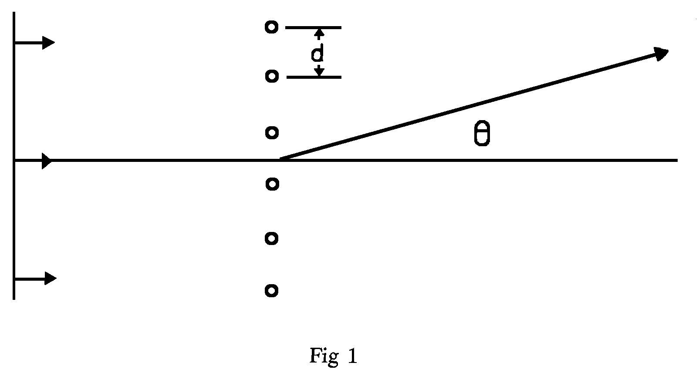

You should arrange the apparatus as shown in figure 2.

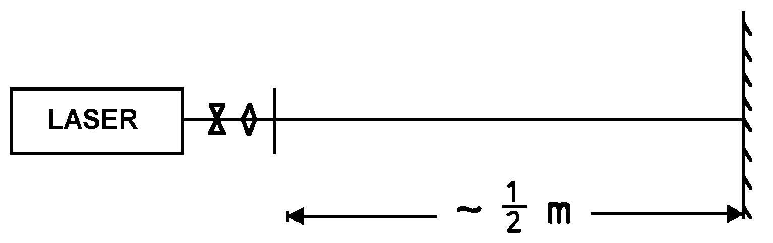

Fig 2
Experiments

(a) Diffraction from a grating

You are given three gratings, one of which has a known spacing of 300 lines per mm. Use this grating to measure the wavelength of the laser light (use a graphical method to determine λ from the position of the nth bright spot , n = -2, 1, 0, 1, 2). From qualitative observation, is the density of lines on the other gratings larger or smaller? Use your value of λ to determine the number of lines per mm on the grating with the smaller number of lines/mm.

(b) Diffraction from a ruled scale

If light is incident on a ruled scale as shown in fig 3 then a
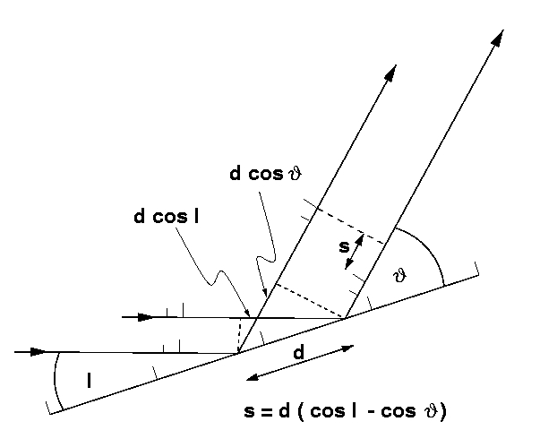

Fig 3

diffraction pattern will be seen on reflection. The condition for bright spots to be seen is

d (cos I - cos θ) = Nλ .......... (2)

The apparatus should be arranged as follows:
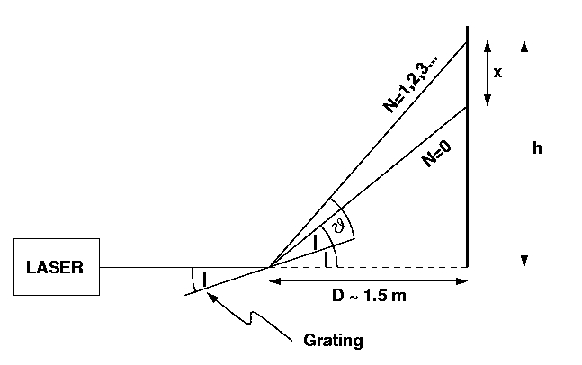

Fig 4 (not to scale)

The laser should be arranged as shown. The angle of incidence is about 5º and the spacing d is 1mm.

Experiment

Determine the position of at least five bright spots, other than θ = I, the reflected direct beam. Use a graphical method to determine the wavelength of the light. To do this you will find it useful to expand equation (2) using the relation cos A = 1 - (A²/2) where the angle A is measured in radians. This small angle approximation is valid in this experiment. From equation (2) show that

d( + I)( - I) = 2n .......... (3)

The angles (θ + I) and (θ - I) can be related to the distances x and h given in fig 4.
Using small angle approximations we have :-

h/D = tan ( + I) ~  + I --------(4)

and (h - x)/D = tan (2 I) ~ 2 I ---------(5)

Eliminating h from (4) and (5) yields

x = D ( - I) -------------------(6)

Substituting (4) and (6) in (3) gives

x h = D²( + I)( - I) = 2 D² N λ / d ------------(7)

A plot of xh against N should then be used to find a value of λ (remember to estimate an errors in d, the average spacing between graduations on the ruler, and D as defined in Fig 4).

Further questions for discussion and answers in your report

(i) How do the two determinations of λ compare? Are they consistent? Which is the better method and why? (The known value of λ is 632.8nm).

(ii) Is the diffraction from the grating or scale best described as Fresnel or Fraunhofer diffraction? Why?

(iii) In the interference experiment known as ‘Young’s slits’ two slits typically 0.5mm apart are illuminated from a single coherent source and then serve as two coherent sources according to Huygens principle (every point of a wave-front may be considered the source of secondary wavelets which spread out in all directions with a speed equal to the speed of propagation of the waves). Interference fringes are observed when dsinθ = nλ where d is the separation of the slits. Would any modification be necessary in the above experimental arrangement to measure λ using Young’s slits?

(iv) The Law of reflection states that the angle of incidence = angle of reflection. Use Huygen’s Principle to briefly explain why bright spots may be observed at angles different from the angle of incidence in part (b)

L6 LOW TEMPERATURE EXPERIMENT

Introduction
The temperature at which a liquefied gas boils can be lowered by using a vacuum pump to reduce the vapour pressure over it. This principle is used extensively in Low Temperature Physics; reducing the pressure by pumping on liquid ⁴He can give a temperature below 1.0K. In the present experiments pumping on liquid nitrogen, which boils at 77.4K under atmospheric pressure, produces a reduction in temperature, with solidification occurring at 63.1K. Due to the high vapour pressure of the solid further pumping yields temperatures below 60K.

The liquid nitrogen is contained in a small dewar vessel and by attaching a pumping tube from the vacuum pump the pressure above it can be reduced. Never seal off the liquid. The nitrogen can be warmed up by switching off the pump and opening the valve to let in air, this causes some contamination of the liquid and the dewar should be cleaned out occasionally and refilled.

An important aspect of low temperature experimentation is the measurement of temperature. In order to measure temperature we require a property which varies with temperature and is conveniently measurable. The resistance of many materials shows a marked temperature dependence. The magnitude and sign of this temperature dependence are related to the nature of the conduction processes in the particular material. This property can be used to measure low temperatures, as certain materials have significant variations of resistance with temperature in the low temperature region. For use as a thermometer the resistance variation with temperature should be stable with time and thermal cycling, as well as reproducible. In the first experiment you will measure the resistance variation with temperature of a pure metal, an alloy and a semiconductor, and calibrate one of these for use as a thermometer.

The variation of the vapour pressure of liquid nitrogen with temperature is the property which leads to the reduction in temperature following pumping on the liquid. This can be related to the difference in energy between a molecule in the liquid and a molecule in the vapour. A very simple calculation, which relates this energy difference to the molar heat capacity L₀, and involves the Boltzmann Law for the probability of a molecule being in the liquid or the gas at a particular temperature, gives an approximate relationship between vapour pressure P and temperature T

P = Ae^{-L0/RT}

where R is the gas constant. In the second experiment you will use your resistance thermometer to check how well this relation holds.
Experiments

1. Temperature Variation of Resistance

You are provided with samples of copper (pure metal), constantan (metallic alloy) and carbon (semiconductor). For each sample measure the resistance at room temperature; ice temperature; 195K, the temperature of solid CO₂ (if available) using acetone to give good thermal contact; 77.4K, the temperature of liquid nitrogen boiling under atmospheric pressure; 63.1K the solidification temperature of nitrogen. Plot the change of resistance with absolute temperature in a way which most clearly illustrates the behaviour of the different materials. Think why they behave differently.

For the second experiment the copper sample will be used as a thermometer. It can be assumed that in the small interval between 77.4K and 63.1K its variation of resistance with temperature is linear. Using these two temperatures as fixed calibration points work out an equation to convert the resistance into a temperature.

In this experiment the appropriate errors to use are not the systematic errors corresponding to the absolute accuracy of the instruments but the random errors corresponding to the variation between different readings. In the case of the resistance measurement this error is ± 1 digit. In the case of the pressure gauge a value of ± 10mb is probably reasonable.

2. Variation of Vapour Pressure with Temperature

Put clean liquid nitrogen into the dewar and pump slowly on it (you can throttle the pumping with a valve) taking measurements of pressure and temperature until solidification is reached. By plotting a suitable graph determine whether the relation given in the introduction describes the variation of vapour pressure with temperature. Determine L₀ from this graph and compare it with the experimental value of 5852 Joules per mole.

3. Ultimate Low Temperature

By continued pumping on the solid nitrogen determine the ultimate low temperature obtainable with this system. Think about what limits this and put your ideas in your report.

L7 GAMMA-RAY ABSORPTION

There are notes about the equipment with the apparatus. Please read them. They describe the Gamma Ray Detection equipment and how you collect data from it using the computer which is shared. Before starting the experiment please read the safety instructions describing the local rules for the use of radioactive sources.

Introduction

All forms of radiation are absorbed by matter, but to a varying degree, depending on the density and atomic number of the absorbing material. Gamma-radiation is very penetrating and can pass through a considerable thickness of material. The relationship between the count rate obtained for a fixed distance between the source and the detector with no material in between (count rate r₀) and with a certain thickness (x) of material in between (count rate r) is given by r = r₀e^{-x/λ} where λ is the mean free path for γ-rays in the material (the absorption due to the intervening air is neglected). In this way the absorption properties of various materials can be determined, and this information can be used to determine the internal composition of structures inaccessible by other means. This technique is commonly used in industry to look for flaws in metal e.g. aircraft engines.

Counting Statistics

The rate at which nuclei in a large assembly decay is dictated by the half-life of the isotope concerned. However the decay of each individual nucleus occurs completely at random. As each decay leads to a single count the number of counts obtained in a set interval of time exhibits the statistics dictated by the random decay process (known as counting or Poisson statistics) rather than the statistics associated with random errors in the measurement process (which approximate to Gaussian statistics). For counting statistics the standard error in a single measurement of N counts is approximately given by (N)^{½}.

Measurements

- First, convince yourself that the standard error on a single measurement of N counts is indeed given by (N)^{½}. To do this, use a detector which is connected to the computer based counter system. Instructions are available with the apparatus. Collect at least 1000 readings for 0.1s time intervals which are then binned into a histogram. Compare the standard error value

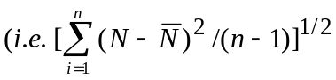

calculated by the computer, with the value (N—)^{½}.

ii) In order to measure λ a holder enables varying numbers of plates of different materials to be placed in between the counter and the source. Measure the count rate using the digital counter (corrected for the background count rate) with varying thicknesses of material. Think CAREFULLY about the best way to measure the count rate, bearing in mind the uncertainties due to counting statistics. You should aim to measure the count rate accurately in a reasonable time. Bear in mind that it is simpler to measure for a long time than to measure for many shorter periods and take the mean (convince yourself that the two techniques should be equivalent). Verify the relationship given above by drawing a suitable graph and obtain a value for λ. (Remember to subtract the background count rate). You should obtain values of λ for lead, copper and aluminium.

Then carry out the following analysis and include the answers in your report:

a) Determine the absorption cross-section σ for each material. This is another way of quantifying the absorption process whereby each atom is assigned an absorption "cross-section" σ. It is related to λ by the relationship λ = ¹/_{nσ}, where n is the number of atoms per unit volume.

b) The "classical electron radius", r_{e}, was introduced in early atomic models to explain how electrons interacted with, and radiated, electromagnetic waves. Its value can be calculated from
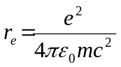

where m is the electron mass.

You should calculate the cross-sectional area of electrons in the three materials (different numbers of electrons per atom) and compare the values obtained to the values of σ deduced above.

c) The physical cross-sectional area of lead atoms should be calculated as a final comparison.

L8 REFRACTIVE INDEX OF GASES

Please observe the local rules for the use of lasers in this experiment.

Introduction

Interference effects can be used to measure very accurately, small path differences or small changes in the wavelength or velocity of light. In this experiment Young’s fringes are used to measure the refractive index of gases. The velocity of light in any homogeneous medium is c/n where c is the velocity of light in vacuum and n is the refractive index of the medium. The velocity of light is compared in the gas and in vacuum by measuring the small optical path difference (which is the product n., refractive index times geometrical path difference  and the change in the Young’s fringe pattern.

In general the refractive index n of a medium depends not only on the physical properties of the medium, but also on the wavelength of light. In this experiment the wavelength λ is fixed at that of a helium-neon laser, namely λ = 632.8 nm. The medium is taken to be a gas whose density changes with applied pressure P and temperature T, thereby varying the refractive index. The value of n(T,P) measured at temperature T and pressure P can be related to the standard value at STP, n_{o}, by the formula

n (T,P) - 1 = [n_{o} - 1].F

where F is the correction factor given by
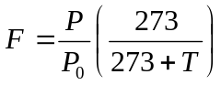
T is the temperature (°C), P is pressure. If the pressure is read in mbar you must use P₀=1013 mbar. If the pressure is shown in mmHg, P₀ becomes P₀=760 mmHg.

Principle of the Method

The layout of the apparatus is as in figure 1. Using the light from the laser and the diverging (concave) and converging (convex) lenses, a beam of coherent light is incident on the beam splitter. One part of the beam is then passed through the cell containing the gas at a fixed T and P and the other part by-passes the cell. The two parts are again coincident on the screen where the resulting fringe pattern due to interference between them is viewed with a microscope.

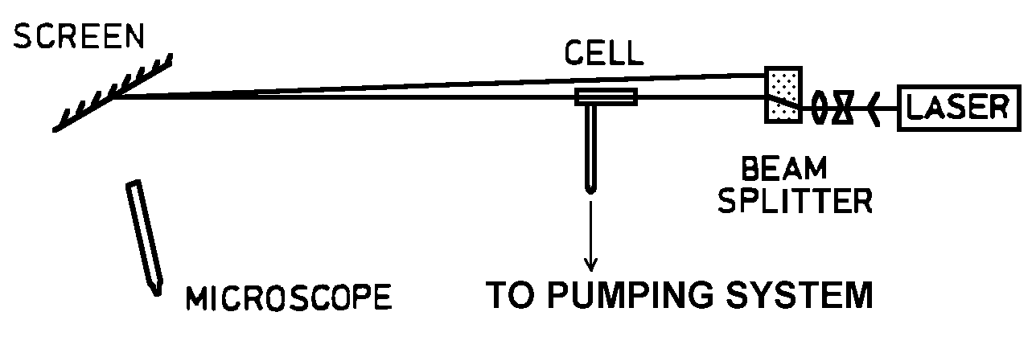

Do you understand what is meant by "coherent light"? Write down in your lab book a concise statement of what makes light coherent as part of your report.

There is an optical path difference between the two parts of the split beam due to the difference between wave propagation along the path through the cell and along the path past the cell. As the filling in the cell changes the optical path difference (n.) changes because the refractive index of the medium changes. Each time this optical path difference changes by one wavelength there is a shift of one fringe in the Young’s fringe pattern - why? The optical path difference for a particular filling is [n(t,P)-1]. so that when we count a shift of m fringes we can write

[n(T,P)-1]. = mλ
Hence
n(t,P)-1 = mλ/

Thus a measurement of m amounts to a measurement of n(t,P)-1.

You need to plot m vs P and extract n₀ from the gradient.

Experimental Procedure

It is important in this experiment to ensure that you understand the apparatus and its function. The apparatus is delicate and easily damaged. If in doubt consult a demonstrator. Please read the whole script all the way through, looking at the apparatus and identifying the pieces, before you start to do anything else.

Place the laser as far from the screen as possible and use the diverging lens to give a spot on the screen 3 to 4 cm in diameter. Now use the converging lens to give a spot on the screen approximately 1.5 cm in diameter. Now ensure the beam passes through the glass cell. Introduce the beam splitter positioned about 10 cm from the convex lens so that the beam enters through the centre of the round hole (on the side where there is only a hole and not a slit). Two beams should be visible. Adjust the side control and the top control nearest to it to ensure that the beams are at the same height. The knob above the round hole controls the beam convergence and should be adjusted until the two beams overlap on the screen. The screen should now be positioned at an angle to the beam as shown in the figure and the microscope used (about 10 cm from the screen) to view Young’s fringes. These are vertical stripes and can be made to appear larger and further separated by adjusting the angle of the screen to the beam. If you have set up the apparatus correctly one beam passes through the glass cell and the other does not. Check this!

Measurement of the Refractive Index

Carry out the following series of measurements to establish first that the arrangement behaves as it should and then measure the refractive index of nitrous oxide (N₂O) and methane (CH₄). Assume the length of the glass cell  is 75 mm and the helium neon laser emits at wavelength λ = 632.8 nm. In adjusting the pressure in the cell with the control valve use great care when rotating the control valve as it is a very delicate piece of equipment.

1. Plot a graph of the fringe shift against pressure in the cell to show how the former depends on the optical path length, which is proportional to pressure. Do this with air in the glass cell.

2. Count the number of fringes corresponding to filling the glass cell with air. Repeat the measurement for evacuation of air from the glass cell. Hence determine the refractive index of air n₀ at STP. Be careful to think carefully how to express your result with its error in a usefully meaningful way. Ask a demonstrator if you are in doubt.

3. Measure the refractive index of N₂ by counting the number of fringes as a function of the pressure in the glass cell as it is evacuated. Express the answer at STP.

4. Measure the refractive index of CH₄ in the same way.

Determination of the Dielectric Constant of a Gas

One of the great triumphs of physics in the 19th century was the formulation by James Clerk Maxwell of the unified theory of electricity and magnetism called electromagnetism. You already have some knowledge of electromagnetism, in particular how magnetic fields are generated when electric charges of electrostatics move. Maxwell was able to write down the four (coupled differential) equations which describe all the electromagnetism. Though they may not yet mean much to you, it is worth quoting them just to illustrate their concise beauty:

Gauss’ Law (E electric field, ρ charge density): div E = ρ/ε_{o}
No free magnetic monopoles (B magnetic field): div B = 0
Faraday’s Law of electromagnetic induction: curl E = -∂B/∂t
Ampere’s Law (J is current density): curl B = μ_{o}J + μ_{o}ε_{o}∂E/∂t

μ_{o} and ε_{o} are constants which take account of the fact that we choose units of V m⁻¹ for E and Coulombs for charge - SI units. Then μ_{o} = 4π x 10⁻⁷ Hm⁻¹ and ε_{o} = 8.854 x 10⁻¹² Fm⁻¹. And if that isn’t enough to impress you, they are also found (unknown to Maxwell at the time) to be consistent with, i.e. to include, Einstein’s Laws of Special Relativity, which were only discovered many years after Maxwell’s work (but that is not relevant here).

A direct consequence of these equations is that in free space (vacuum) the electric and magnetic fields E and B satisfy a wave equation. What is more, the phase velocity of these waves is predicted in terms of the constants μ_{o} and ε_{o} to be c where

c = (μ_{o}ε_{o})^{-1/2}

which evaluates to be . . . . . work it out yourself in m s⁻¹. In other words the simple and beautiful equations of all the electromagnetism predict the existence of electromagnetic wave motion in free space with a phase velocity equal to that of light. Light is an electromagnetic wave phenomenon.

In a homogeneous (that is uniform) medium (e.g. a gas), Maxwell’s equations can be very simply modified: everywhere μ₀ and ε₀ are replaced by μμ₀ and εε₀ respectively, where μ and ε are called the relative permeability and relative permittivity (sometimes the dielectric constant) of the medium. They are both ⟩ 1. Now we find that the phase velocity v of the electromagnetic wave motion is

v = (μμ₀εε₀)^{-1/2}
= c/n

when n is the refractive index of the medium. Thus

n = (με)^{1/2}

and the refractive index, which describes the effect of the homogeneous medium on the transmission of light, is related to the electromagnetic relative permeability and permittivity of the medium.

Calculate values of the relative permittivity for each gas (with an error) from the measurement of n. The relative permeabilities of air, N₂O and CH₄ are all 1 to within 1 part of 10⁸. Again be careful to express your result with its error in a usefully meaningful way in your report.

