Modules on Disk 9 with Redundancy Links

Results are presented for four modules mounted on Disk 9 with and without their redundancy links present.

The modules are mounted as neighbours with an anchor hybrid at each end. This is shown schematically below, Figure 1.
The Disk is mounted within a test box inside an environment chamber. The chamber temperature is set to -5°C. The modules are furthermore cooled by forced air, typically the hybrid thermistor temperatures vary between 14°C to 25°C.

Hybrid
Module 132
Module 45

Module 52

Module 221

Hybrid
Redundancy Links between modules (showing direction of data flow)
Low
High
Low
High
Low
High
Position on Disk

Figure 1. Schematic of Module Layout on Disk

Module Readout, Chip orientation

6
3
4

7
10
9
Redundancy Input from neighbouring module
Redundancy Output to neighbouring module
12
12
1

Figure 2, Chip Orientation and Redundancy data flow

Chips 1 to 6 are on the top of the hybrid, chips 7 to 12 are on the underside.

Power Supplies and Grounding
The power supplies used are LV0 types, with updated firmware, these are then interconnected to a temporary patch panel (PP1FD) via 18m screened power cables. The connections to PPF0 from PPF1D are made by unscreened 1m ribbon cables. No common-mode chokes or filters are used.
The grounding philosophy adopted is where one is trying to minimise the voltage difference between modules, so as to reduce any inter-module noise injection. This has been achieved by tying the module grounds together with a low impedance connection:

- All modules are connected at the cooling block area via a ground ‘finger’ from the Power tape. The ‘finger’ on the Power tape is from AGND.

- All cooling blocks on the Disk are tied together electrically via their cooling pipes and also by Copper foils, laid on the Disk, between the cooling blocks.

Results
All results obtained are for the Input Noise extracted from a Noise Occupancy threshold scan, the only results being shown are for the modules and not hybrids.

As a reference the Redundancy links between modules was left disconnected between the modules, see Figure 3 below. The noise profile across the 4 modules of interest shows no structure and is within the specification of ≈1500e ENC.

Figure 3, Input Noise across the 4 modules without Redundancy Connections

The threshold scan was repeated but this time with the Redundancy connections made between all modules and hybrids, Figure 4.

Figure 4, Input Noise with the Redundant Connections made
Clearly the noise structure across all 4 modules changes dramatically. All modules show increasing noise across chips 4 to 9 and a reduction in chips 1 to 3 and 10 to 12 (see explanation later on, Input Noise Reduction). Furthermore the 2 ‘Inner’ modules, whose Silicon sensors are overlapped on both sides (modules 45 and 52), show a greater increase in their input noise. Whereas the ‘Outer’ modules, whose sensors are only overlapped to one side, as they neighbour hybrids, do not show a larger increase. This noise structure is asymmetric with very high noise to one side of the module, the Redundancy Input connection side.

Figure 5, below, shows schematically the Redundancy interconnection between modules. The interconnect is made up of 2 differential LVDS signals (CLK1 and COM1), a single-ended control line (SELECTR) and a DGND return line between the 2 modules. For the LVDS signals, the signal current that flows in one conductor will flow back through the other conductor, thus completing the current loop. For real high speed signals, which will have common-mode noise current present as well, a short ground return path is also required between the driver and receiver. If this ground line did not exist this return current will find its own route back, for example by being capacitively coupled into the receiver modules ground plane and returning via the cooling pipes/Cu foils on the disk to the transmitting DORIC. This will involve a large loop area with increased inductance hence generating a voltage difference between the module grounds i.e. it will be injecting a noise voltage into the module.

By adding a 5K1 resistor in series with the DGND return line one is in effect forcing the common-mode return current to flow back along the path of least ‘resistance’ i.e. instead of returning across the redundancy interconnect it will return as suggested above (as if there was no ground line present). Which involves a larger loop area for the return path with increased inductance.
Only by making the resistor in the return path to 0ohms will the return current flow back along a much shorter route and corresponding smaller loop. This will result in a lower loop inductance and hence the voltage difference between the module grounds is reduced and thereby minimising any noise injection.

CLK1
COM1
SELECTR
DGND
RCLK1
ROCM1
RSELECTR
DGND
5K1
Redundant Output
Redundant Input on neighbouring module

Redundancy Interconnect

Figure 5, Schematic of the Redundancy Connection between 2 modules
If, as suggested above, that the noise mechanism is due to the 5K1 resistor in the DGND return path on the module receiving the redundant signals then changing this to 0ohms should result in reduced noise. The 5K1 was hence changed to 0ohms on all modules and hybrids. The results are shown below in Figure 6.

Figure 6, Input Noise with Redundant Connections and 0ohm module resistor
The plot shown above clearly shows that by improving the common-mode currents’ return path has the affect of reducing the input noise. But it still does not recover it back to when there was no redundant link present.

To test to see if the increased noise is due to common-mode noise injection originating from the signal traces on the neighbouring module the redundancy interconnect was modified such that only the ground connection is made between the modules (whilst retaining the 0ohms link on the module).
By making only a ground connection between the modules their performance recovers to that without the redundant connections being made, see Figure 7. This implies that there must be a common-mode signal present on either the DORICs redundant output traces or the SELECTR line (which originates from LV0). But for the Redundant links to function we require all these signals to be present.

Figure 7, Input Noise with Ground connection only on the Redundancy Link
The results so far presented indicate that there is a common-mode noise problem between modules with the redundant link in place. Furthermore the modules’ input noise, with the links present, can be improved by changing the 5K1 resistor to 0ohms.
But, as indicated above, the modules never fully recover back to their original state when the links where not in place. The plot in Figure 6 suggests that there is still a residual impedance in the return path which is causing common-mode noise injection into the modules. Visual inspection of the redundancy links show that their physical makeup is made of small diameter (<0.3mm diameter) single conductors. It could be that the return path on the link still does not have sufficiently low impedance. For optimum performance differential signals should be routed above a continuous ground plane, this presents the shortest route possible for any common-mode switching currents to return and means that the loop area is minimised. This was implemented by adding a Cu foil to the redundant links and then connecting the foil to the Dgnd return pin at each connector end.

Figure 8, Input Noise with the modified Redundant Connections and 0ohm module resistor
These results (Figure. 8) indicate that one can nearly fully recover the module’s input noise performance by simply improving the common-mode currents return path present on the redundancy links.

An alternative solution would be to try and use common-mode chokes instead. To test this solution out, a common-mode choke (Ferrite bead) was attached to each of the redundancy links of module 45. All other links were left unmodified.

Figure 9, Input Noise with ferrite beads on Module 45 redundancy links and 0ohm module resistors
The addition of the ferrite beads gives the best results (Figure. 9), in terms of recovering the module’s input noise. BUT as the modules will be operating within a magnetic field one cannot use such devices unless they are of an air core type. There is also the problem of how one would incorporate these components into the redundancy scheme, a choke is required on 5 of the signal traces. A choke should not be introduced into the ground return path as one would simply increase the inductance of this path thereby forcing the high frequency switching noise to return via another lower inductance path (which could result in increased noise).

Input Noise reduction
One observed anomaly, when the Redundancy link is made between the modules, is that there is not only an increase in the input noise to one side of the module but also a reduction in the noise on the other side.
The problem we believe is due to the S-curves being distorted on one side of the module. The calculated input noise is extracted from a straight line fit to the Log Occupancy vs Threshold², any discontinuity on this plot can result in a ‘bad’ fit’, see the plots below. But this can also be a good indicator of the quality of the S-curves and the presence of any common-mode (non-Gaussian) noise.

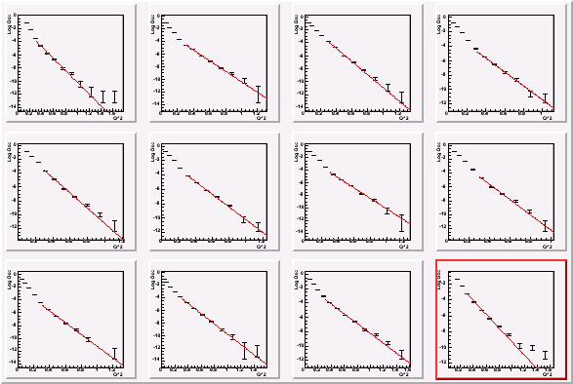

Figure 10, Log Occupancy vs Threshold², No Redundant Link Present

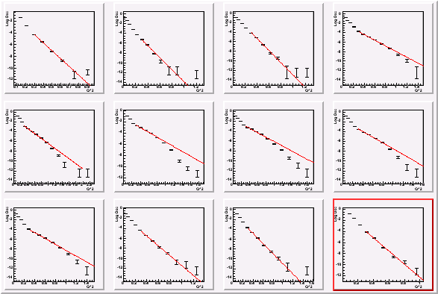

Figure 11, Log Occupancy vs Threshold², with Redundant Link Present
Event Count and Triggering
Presently with the ROD system being used here in Liverpool there are 2 important caveats to be aware of:

- Only 1000 events per threshold step is taken. This will produce anomalous results where a large number of statistics is required i.e. at increasing threshold where the occupancy is reducing. The quoted values for the Noise Occupancy at 1fC are probably incorrect (or at least have a large error associated with the measurement).

- Only single trigger readout has been implemented i.e. reading out and then sending another trigger. During readout when the ABCDs receive a trigger the Master output drivers switch on to output their data, this action results in there being a large switching current pulse on the VDD digital supply line. As the hybrid traces and power cables have a finite impedance there is a corresponding voltage drop on the VDD line. This only occurs after receipt of the trigger. As the ABCDs incorporate pipeline architecture and for single trigger readout, present data collection occurs before the dip in the VDD line i.e. the VDD line is nominally ‘static’.
A direct consequence of this is that the results presented are probably ‘ideal’ and are not truly representative of what will happen in reality when data collection will occur when the power supplies are moving. IT COULD GET WORSE.

Conclusion
To summarise the results presented above:

- Without the redundancy links present the modules achieve their design specification of 1500e ENC for their input noise, Figure 3.

- Once the redundant link is made between modules their noise profile becomes asymmetric with greatly increased input noise for those chips adjacent to the redundancy input connector (both top and bottom of the module), Figure 4.

- By simply changing the value of a single resistor, on the module, helps to recover their input noise performance, Figure 6.

- Further improvement can be achieved by adding a ‘ground’ plane in parallel to the redundant signals present on the redundancy interconnect, Figure 8.

- An alternative solution would be to use common-mode chokes integrated into the redundancy links, Figure 9. But as the modules will be required to operate within a magnetic field this is clearly not feasible.

