Liquid argon photomultiplier base PCB (largon.pcb)
PCB TOP SIDE AS SEEN LOOKING AT THE BOTTOM OF THE PMT

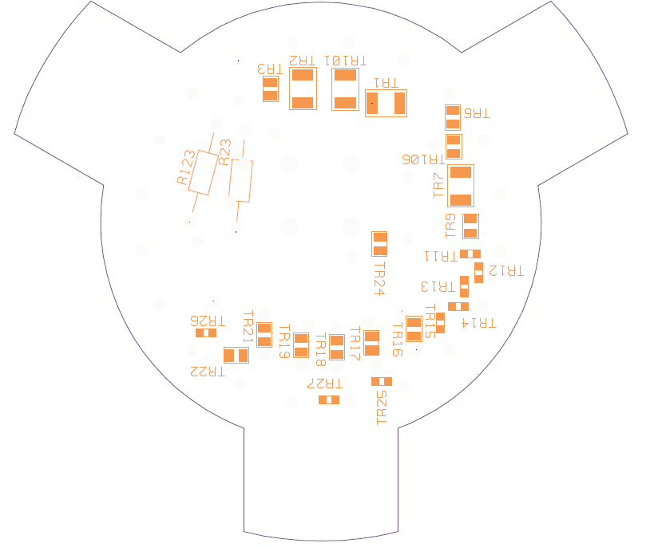

PCB BOTTOM SIDE as seen from the PMT

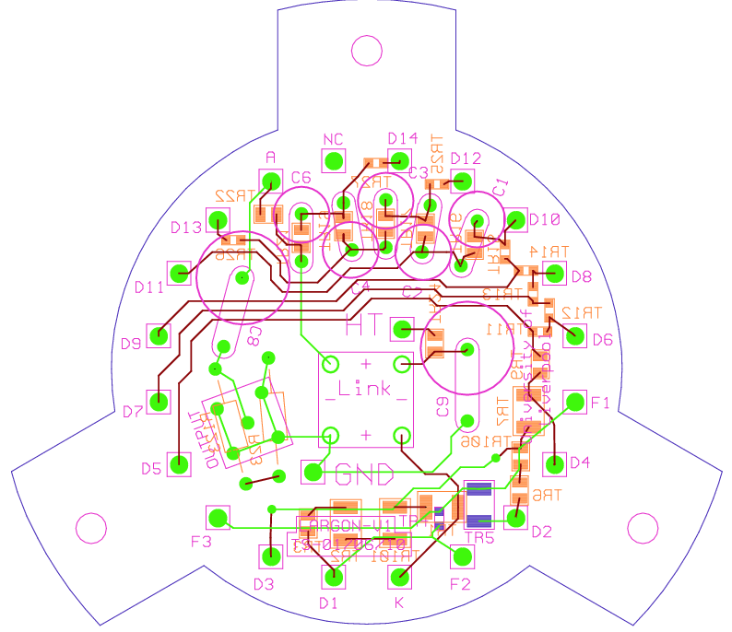PCB THROUGH VIEW SHOWING TRACES

Parts list
 | anode voltage 2KV |  |  |  | VDiff from
 |  | PIN no |  | Vmod | original | vdrop | power | package |  | Farnell no | qty
 | component |  | value (K) |  | percent |  | (watts) | required
Cathode |  | 20 |  | 0
 | R1 |  | 1000 | 163.2653 | 34 | 163 | 0.03 | 1206 |  | 139-9992 | 30
 | R101 |  | 1000 | 326.5306 | -33 | 163 | 0.03 | 1206 |  | 139-9992
 | R2 |  | 1000 | 489.7959 | 1 | 163 | 0.03 | 1206 |  | 139-9992
 | R3 |  | 390 | 553.4694 | 1 | 64 | 0.01 | 0805 |  | 140-0255 | 10
DYNODE1 |  | 1 |  | 553.4694 | 1 | 0 | 0.00
F2 |  | 19 |  | 553.4694 | 1 | 0 | 0.00
 | R4 |  | 180 | 582.8571 | 1 | 29 | 0.00 | 0603 |  | 140-0110 | 10
F1 |  | 16 |  | 582.8571 | 1 | 0 | 0.00
F3 |  | 3 |  | 582.8571 | 1 | 0 | 0.00
 | R5 |  | 1000 | 746.1224 | 1 | 163 | 0.03 | 1206 |  | 139-9992
DYNODE2 |  | 18 |  | 746.1224 | 1 | 0 | 0.00
 | R6 |  | 750 | 868.5714 | 13 | 122 | 0.02 | 0805 |  | 140-0262 | 20
 | R106 |  | 750 | 991.0204 | 1 | 122 | 0.02 | 0805 |  | 140-0262
DYNODE3 |  | 2 |  | 991.0204 | 1 | 0 | 0.00
 | R7 |  | 1000 | 1154.286 | -5 | 163 | 0.03 | 1206 |  | 139-9992
 | R8 |  |  | 1154.286 | 1 | 0 | 0.00
DYNODE4 |  | 17 |  | 1154.286 | 1 | 0 | 0.00
 | R9 |  | 510 | 1237.551 | -3 | 83 | 0.01 | 0805 |  | 140-0258 | 10
 | R10 |  |  | 1237.551 | 1 | 0 | 0.00 | not used
DYNODE5 |  | 4 |  | 1237.551 | 1 | 0 | 0.00
 | R11 |  | 300 | 1286.531 | 1 | 49 | 0.01 | 0603 |  | 140-0116 | 30
DYNODE6 |  | 15 |  | 1286.531 | 1 | 0 | 0.00
 | R12 |  | 300 | 1335.51 | 1 | 49 | 0.01 | 0603 |  | 140-0116
DYNODE7 |  | 5 |  | 1335.51 | 1 | 0 | 0.00
 | R13 |  | 300 | 1384.49 | 1 | 49 | 0.01 | 0603 |  | 140-0116
DYNODE8 |  | 14 |  | 1384.49 | 1 | 0 | 0.00
 | R14 |  | 300 | 1433.469 | 1 | 49 | 0.01 | 0603 |  | 140-0116
DYNODE9 |  | 6 |  | 1433.469 | 1 | 0 | 0.00
 | R15 |  | 300 | 1482.449 | 1 | 49 | 0.01 | 0603 |  | 140-0116
DYNODE10 |  | 13 |  | 1482.449 | 1 | 0 | 0.00
 | R16 / C1 |  | 360 | 1541.224 | 1 | 59 | 0.01 | 0805 |  | 140-0254 | 10
 | C1 |  |  |  |  |  |  | 20nF | 200v | 116-6835 | 20
DYNODE11 |  | 7 |  | 1541.224 | 1 | 0 | 0.00
 | R17 / C2 |  | 470 | 1617.959 | 0 | 77 | 0.01 | 0805 |  | 140-0257 | 10
 | C2 |  |  |  |  |  |  | 20nF | 200v | 116-6835
DYNODE12 |  | 12 |  | 1617.959 | 0 | 0 | 0.00
 | R18 /C3 |  | 680 | 1728.98 | 0 | 111 | 0.02 | 0805 |  | 140-0261 | 10
 | C3 |  |  |  |  |  |  | 20nF | 200v | 116-6835
DYNODE13 |  | 8 |  | 1728.98 | 0 | 0 | 0.00
 | R19 |  | 910 | 1877.551 | -2 | 149 | 0.02 | 0805 |  | 140-0264 | 10
 | R20 |  |  | 1877.551 | 0 | 0 | 0.00 | not used
 | //c4 |  |  | 1877.551 | 0 | 0 | 0.00 | 47nF | 200v | 116-6836 | 10
 | //C5 |  |  | 1877.551 | 0 | 0 | 0.00 | not used
Dynode14 |  | 11 |  | 1877.551 | 0 | 0 | 0.00
 | R21 |  | 750 | 2000 | 0 | 122 | 0.02 | 0805 |  | 140-0262
 | //C6 |  |  | 2000 |  |  | 0.00 | 47nF | 200v | 116-6836
 | //C7 |  |  | 2000 |  |  | 0.00 | not used
 | R22 |  | 200 |  |  |  |  | 0805 |  | 140-0247 | 10
Anode |  | 9 |  | 2000 | Power total |  | 0.326531
unused |  | 10
 | total chain RES |  | 12250
 | Current (mA) |  | 0.16327
other components
 | R23 |  |  | 1M0 |  | HV |  | wire-end | 1.6kv | 110-0281 | 20
 | R123 |  |  | 1M0 |  |  |  | wire-end | 1.6kv | 110-0281
 | R24 |  |  | 10K |  | pulse proof |  | 0805 |  | 140-0212 | 10
 | R25 |  |  | 51R |  | pulse proof |  | 0603 |  | 140-0013 | 20
 | R26 |  |  | 51R |  | pulse proof |  | 0603 |  | 140-0013
 | R27 |  |  | 51R |  | pulse proof |  | 0603 |  | 140-0013
 | C8 |  |  |  |  |  |  | 10nF | 2KV | 141-3940 | 10
 | C9 |  |  |  |  |  |  | 10nF | 2KV | 141-3940
link pins |  |  |  |  |  |  |  |  |  | 149-319 | 25
links |  |  |  |  |  |  |  |  |  | 149-313 | 20
red loops |  |  |  |  |  |  |  |  |  | 873-1209 | 1
green loops |  |  |  |  |  |  |  |  |  | 873-1217 | 1

