VELO Hardware interlock unit

LHCB Technical Note

Issue: Draft
Revision: 1
Reference: LHCb 2007-0XX
Created: 20th October 2007
Last modified: 20th October 2007
Author: N.A.Smith

Abstract
This note describes the design, and functionality of the LHCb VELO Hardware interlock unit.

Document Status Sheet
1. Document Title: VELO Hardware interlock unit
2. Document Reference Number: LHCb-2007-0XX
3. Issue | 4. Revision | 5. Date | 6. Reason for change
Draft | 1 | 20th October 2006 | First version

Table of Contents

LHCB Technical Note i
Issue: Draft i
Abstract i
Document Status Sheet i
Table of Contents i
1. Introduction 3
2. Front and back panel layout and functions 4
2.1. Front panel 4
2.2. Back panel 4
3. Internal layout 5
3.1. Mainboard 5
3.2. Power supply and conditioning 7
3.2.1. PSU 7
3.2.2. Power Filter PCB 7
3.2.3. Dummy load resistors 7
3.3. Front panel PCBs 8
3.3.1. Switch contact and temperature Input PCB 8
3.3.2. HV output PCB 8
3.3.3. LV and relay output PCB 8
4. References 11

Introduction
This note describes the design, and functionality of the LHCb VELO Hardware interlock unit. The unit is designed to receive input signals from temperature monitoring cards, the vacuum system, cooling system and beam condition monitor (BCM) of the VELO detector. Signals from both the Aside and C side of the detector and some common signals are brought to this unit but each side of the VELO is handled as a separate entity, except for the common signals. These signals are interfaced to a field programmable gate array (FPGA) and logic in the FPGA conditions the signals and combines them to produce outputs to enable the high and low voltage detector power supplies, allow the cooling system to be operated and to allow the detector to close (move into the operating position close to the beam). Switches on the mainboard PCB allow individual inputs to be overridden and outputs to be forced off during commissioning. The unit therefore provides a basic interlock function which is a first line of defence against incorrect detector operation and which is independent of any software. The unit is designed to be FAIL SAFE such that any disconnection of any input or output will result in an error condition.
The unit is implemented in a rack mountable 6U fully screened ventilated case with a hinged front panel to allow access to the internal switches. To further facilitate access and allow reprogramming of the FPGA the main PCB can be slid forward when the panel is opened whilst in situ in the rack.
The unit is shown, as seen from the front, in Figure 1 below
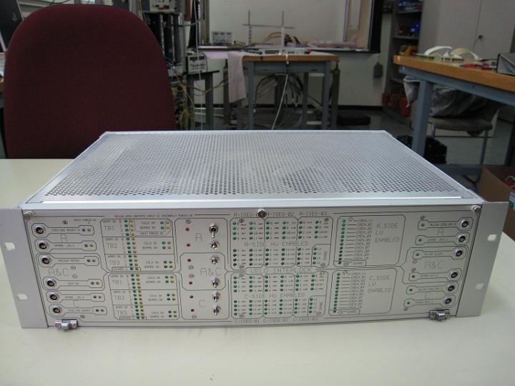
Figure 1 VELO Hardware interlock unit

Front and back panel layout and functions

Front panel
The front panel of the unit is shown in Figure 1(above). The top half of the panel has inputs and shows the status of the input and output signals with LEDS for the A side of the detector. The bottom half of the front panel contains the same functionality for the C side of the VELO. The signals which are common to both halves are placed around the centre line of the panel. The input signal green LEDs show the status of the actual input signals whilst the yellow LEDs indicate that an internal switch has forced the signal to the FPGA to the asserted condition. On the left side of the panel there are 6 x 2pin LEMO connectors which transmit an asserted level to the FPGA when the two lines are shorted together facilitating input from relay contacts or switches. Moving to the right are two columns of green and Yellow LED’s indicating the status of the inputs and if any of these inputs have been forced true. To the right of these are two columns of LED’s showing the input and forced status of the inputs from the 3 temperature monitoring boards for each side of the detector. These are marked WARM OK meaning that the higher level temperature limit has not been exceeded (see note 1 below). The next two columns indicate the status of the cold limit not being exceeded (COLD OK) and board OK inputs (see note 1 below). Moving right again there is a row of red LED’s and associated switches. These are spare inputs and status indicators with no assigned function in this first revision of the unit. The next six columns of LEDS show the output status of the High Voltage Power Supply interlock signals and a lit green LED indicates that the associated interlock is supplied with power and is therefore enabled. Moving further right a single column of LEDS indicates the status of the Low Voltage power supply interlock outputs and again a lit LED indicates that the interlock is supplied with power and therefore enabled. Finally on the extreme right there is a column of green LED’s showing the output status of the signals on the last column of 2 Pin LEMO outputs. These outputs are isolated relay contacts which are closed when active.
NOTE 1 The use of LEDS to indicate an OK status rather than an alarm status is because of the requirement that faults such as open circuit inputs must be treated as an error condition.

Back panel
The back panel is pictured in Figure 2 (below) On the extreme left of the panel is the IEC power input connector and On/Off switch. Moving right the two 37way Dsub connectors provide interlock signals to the Low Voltage power supplies, the top connector for side A and the lower for side C. The top 6 X 9pin Dsub connectors provide interlock enable signals to the A side High Voltage power supplies and the lower six to the C side. The top 37 Dsub connector on the right provides differential inputs for the warm OK signals from the A side of the detector. The middle of these provides inputs from the A and C side COLD OK and BOARD OK signals and the lower one carries the inputs from the WARM OK signals from the C side.
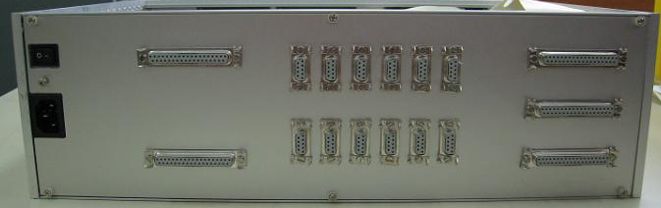
Figure 2 VELO hardware interlock unit back panel

Internal layout

Mainboard
The mainboard is a four layer PCB horizontally mounted between card guides and can be slid forward once the front panel is hinged down to allow access to onboard switches and allow reprogramming of the FPGA without removing the unit from the rack. The top and bottom sides of the board can be seen in figures 3 and 4 below.
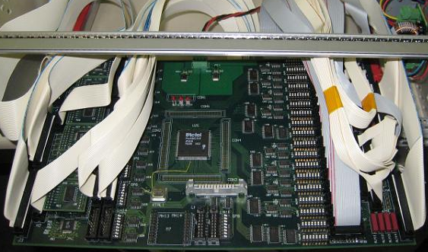
Figure 3 Mainboard seen from the top
Figure three highlights the main features of the Mainboard:
- MEZZANINES
Ringed in green on the right are the input signal mezzanine cards. These are of two types; a 9 channel differential card which converts from the differential LVDS signals from the temperature cards and; an 8 channel single ended card which handles the relay or switch contact inputs from the front panel.
- INPUT OVERRIDE SWITCHES
Ringed in turquoise are the input override switches which force the state of a particular input to the FPGA to be OK and light the corresponding LED on the front panel
- POWER REGULATORS
Ringed in blue are the power supply regulators Power input connector and power supply LEDS. The regulators drop down the 5V input voltage to 3.3V and 2.5 V and the three red LEDS indicate that each supply is present.
- FPGA
Ringed in grey in the centre is the FPGA which is an Actel APA150
- PROGRAMMING CONNECTOR
Ringed in purple is the FPGA programming connector. Note that due to a PCB Error the 2.5V supply to the programmer was wrongly connected and these pins are bent up and not connected. The programmer used at CERN fortunately does not use the 2.5V from the connector so this does not present a problem. If another programmer that needed to use the 2.5V as a power source then these two pins could be connected to the 2.5V supply at the regulator.
- OUTPUT DISABLE SWITCHES
Ringed in red towards the right hand side are the switches used to force any of the outputs to a disabled state.
- REED RELAYS
Ringed in orange ar the lower right are some of the reed relays used to provide isolated outputs to the front panel LEMOs
- SPARE INPUTS
Ringed in yellow are some of the spare input channels, at the extreme left is a hard wired (not on a mezzanine) set of 9 differential converters and to the right an unoccupied mezzanine slot which can take either a differential or switch input mezzanine. None of these spare channels are used in the first implementation of the unit.

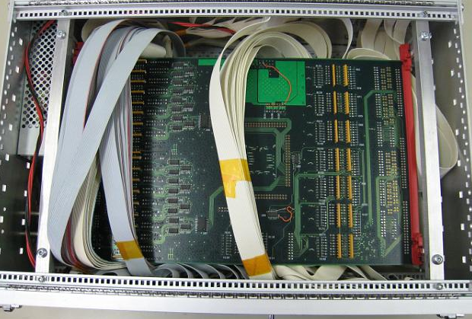
Figure 4 Mainboard underside

Power supply and conditioning

PSU
Power to the unit is provided by a commercial PC server type supply (TYPE) which provides +5Volts and +/- 12V however only the 5V output is actually fed to, and used by, the mainboard. The PSU is mounted on two lugs at the left hand side of the unit and held in position by a single screw through the back panel between the on off switch and the IEC mains socket. The original “as supplied” connector is removed and replaced with 6 pin connector which mates with a 6pin connector on the power supply PCB.
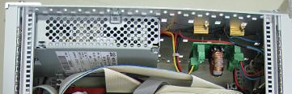
Figure 5 Power supply, filter PCB and dummy load resistors

Power Filter PCB
A small power filter PCB is bolted to the side panel of the unit with a number of connectors and provides filtering for the 5V supply to the mainboard using a common mode choke. Two locations are provided for capacitors to decouple the 0V to ground before and after the choke. In the initial implementation the capacitors are not present and the 0V on the output side after the choke is shorted to ground via the mounting posts. A number of connectors are mounted on this board, each with a different number of pins to avoid incorrect connections. The input connector from the power supply has 6 pins. The 5V output to the mainboard has 4 pins and the 3 pin connector connects to the dummy load resistors. A 2 pin connector is provided to allow connection to a 12V fan but is not used in the initial implementation of the unit and it is likely that the rack cooling will always be sufficient.

Dummy load resistors
The PSU specification requires that there be a minimum load on the 5V output of 1 amp and on the +12V output of 100mA but as the unit can take much less than this from the 5V supply if none of the front panel LEDs are lit, and no power at all from the 12V, two high wattage resistors are bolted to the side of the case to give these minimum loads. The resistors are connected via a 3 pin connector to the filter PCB.

Front panel PCBs
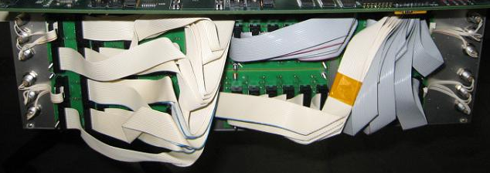
Figure 6 Front panel PCBs

Switch contact and temperature Input PCB
Figure 6 shows the rear of the front panel and the areas ringed in red indicate the position of the switch contact and temperature input PCBs. These cards also provide connections to the spare switches and red LEDs on the front panel. These are two identical cards, one each for the A and C sides.

HV output PCB
Figure 6 shows the HV output PCBs ringed in yellow. Again these are two identical cards one each for the two sides.

LV and relay output PCB
Figure 6 indicates the position of the LV and relay output PCBs which are mostly hidden behind the cabling. Again these are two identical cards.

PCB Faults
There are a number of minor faults on some of the PCBs which were easily rectified and these are listed here.

Mainboard Resistor packs RP21 to RP38
Pin 9 on each of these resistor packs is wrongly connected to the power plane. This cannot be corrected so the short trace between the resistor pack pin 9 and the adjacent connector pin needs to be cut at all locations and a discrete resistor soldered directly to the connector pin and to the nearest +5V supply. Figure 7 shows where the PCB traces should be cut on all the resistor packs ( note that this is a view from the top side but the traces to be cut are on the underside
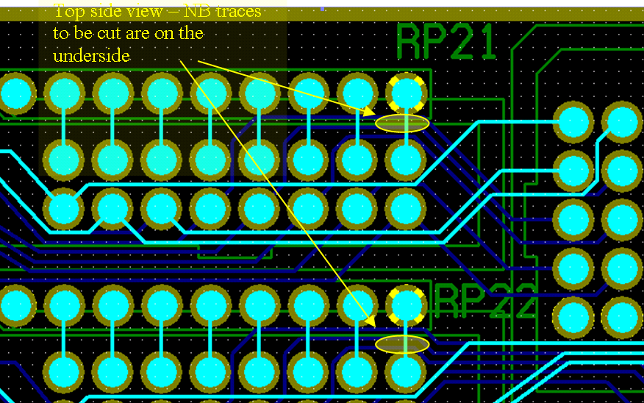
Figure 7 Resistor pack location showing traces to be cut

Open circuit to FPGA
One input line to the FPGA is open circuit before it reaches the breakout header. This is a CAD fault not a manufacturing fault. Fig. 8 below shows the problem which is on the top side of the PCb and the fix can be seen as the yellow wire in the photo of the board in Figure 3
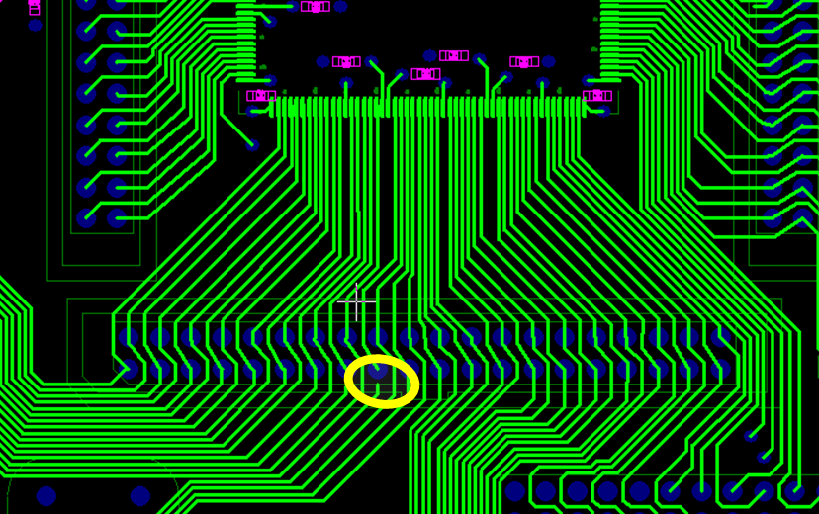
Figure 8 Location of open circuit trace to FPGA

Incorrect pin-out of crystal oscillator

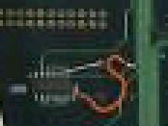
Figure 9 Crystal fix on rear of mainboard
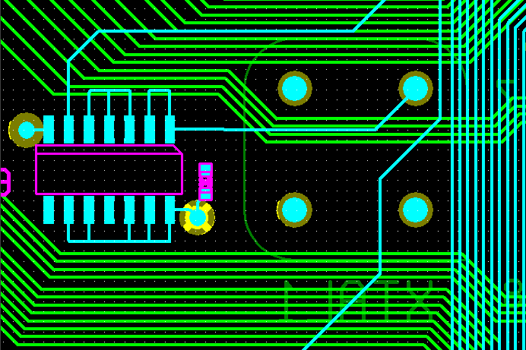
Figure 10 Crystal fix shown from rear - cut blue trace and insert red wires

References

