The Large Hadron-Electron Collider (LHeC)

Written for NuPECC’s Long Range Report by Max Klein. 26.4.2010

The current status of the LHeC is that of a joint CERN-ECFA-NuPECC project, in which a conceptual design report (CDR) is being worked out for delivery by the end of 2010. The CDR is devoted to the accelerator, the interaction region, the detector and to the main physics topics: high precision QCD and electroweak interactions, new physics beyond the standard model and physics at high parton densities. After an evaluation of the CDR, a Technical Design Report (TDR) may follow. Operation of an LHeC, possibly synchronous to the LHC, may thus commence by 2020.

The LHeC represents an update project for the LHC, in which ep and eA collisions are realised with a polarised electron/positron beam (Figure 0) at or above 1 TeV energy in the electron-quark centre of mass system. This is almost four orders of magnitude in excess for Q2 and 1/x of what was achieved in former lepton-nuclear scattering experiments, see Figure 1. The LHeC may thus become the world’s highest resolution microscope of proton and nuclear structure in making efficient use of the large investments in the LHC.

The CDR will present two versions of the electron beam: i) A ring accelerator, positioned on top of the LHC using new dipole magnets under design at BINP Novosibirsk, providing a maximum considered energy of about 70 GeV at luminosities of order 1033cm-2s-1, which is 100 times larger than HERA. ii) A linac, tangential to the LHC, which with ILC type cavities in pulsed mode may provide energies of up to 140 GeV at luminosities of about 1032cm-2s-1. With energy recovery techniques this luminosity limit may be overcome by about an order of magnitude. The electron beam is foreseen to be coupled with various ion beams, D, Ca, Pb (being part of the LHC programme already).

For the LHeC a new detector is under design, see Figure 2. Its dimensions are determined by the high p/A beam energy and the requirement of large acceptance coverage close to the beam pipe in forward and backward directions. Its technology choices are based on high accuracy demands in terms of the alignment, calibration and resolution requirements.

The physics programme of the LHeC specific to ions may be briefly summarised in the following points: a) The extension of the knowledge of the nuclear parton distributions by four orders of magnitude in kinematic range; b) The exploration of QCD parton dynamics in semi-inclusiev eA scattering as diffraction or vector meson production; c) The discovery of saturation phenomena in ep and eA from the tamed rise of the gluon density towards low x beyond the unitarity limit; d) The investigation of the initial state in heavy-ion collisions leading to the formation of the quark-gluon plasma state; e) Stringent tests of parton fragmentation and hadronisation inside nuclei. In eA mode the LHeC is therefore not just the extension of the former deep inelastic scattering programme with nuclei but as well the ideal and necessary supplement and continuation of the AA (and pA) programme of the LHC.

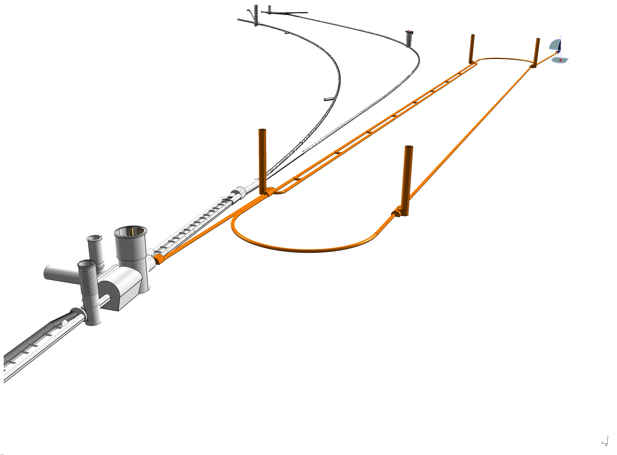

*Figure 0: Sketch of an electron linac with racetrack layout (brown) tangential to the LHC (grey) at the ALICE interaction point. [I would not show this as we have no final layout yet which would be described in the CDR.]*

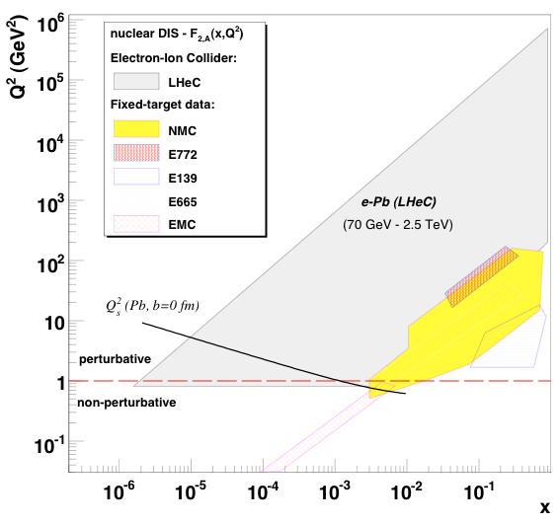

*Figure 1: Kinematic range of previous fixed target muon-nucleon scattering experiments. Extending the range by nearly four orders of magnitude, the LHeC collider is expected to radically alter the present view on strong interactions inside nuclei and deliver information, which is crucial to the interpretation of RHIC and especially the forthcoming $AA$ and $pA$ data from the LHC.*

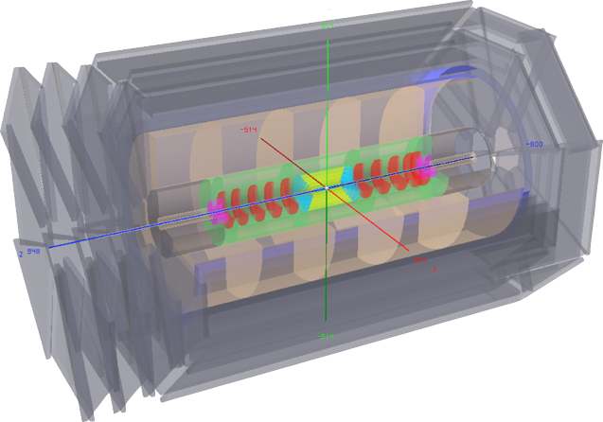*Figure 2: Layout of the LHeC collider detector with tracking detectors, electromagnetic and hadron calorimetry inside a 3.5 T magnetic solenoidal field surrounded by a large scale muon detector. The acceptance extends from 1 to 179o for both the scattered electron and the hadronic final state. (if you wish, I can send you an extended caption)*