Zur Emeritierung von Gary Koopmann am 27. Juni 2009

Some time, a few years ago, we were at a meeting of the Humboldt Foundation in the South-West of Germany in order to celebrate a good friend from France, who had received a prestigious fellowship for joining us in Germany, at DESY, Hamburg, where for years we have been working on the world’s highest resolution microscope, HERA, the only high energy electron-proton collider, with which the structure of the proton and interaction dynamics of its constituents, quarks and gluons, have been resolved. Here we were attending a dinner, and had made the decision, or mistake, to go early. We decided to sit on a then empty table taking the risk of a boring evening with more or less interesting people telling us about the miserable world, perhaps, or their personal overriding achievements or the weather, talking about which is not the worst thing which can happen. But here came something better, a couple asking whether they could join us and we were so clever to say “Ja natürlich”, because here came Barbara and Gary . It is not impossible that we started discussing the obvious, the weather perhaps or the beauty of the village. We then went on to discuss many things, they were the exotic Americans, who knew Germany and Berlin, we were the exotic East Germans, deep in the West, knowing a bit of the US. From this evening on we have been close friends. There are friendships, which need regular, frequent refreshing. With Barbara and Gary, we can continue a conversation, which took place a year ago, as if we had been friends since we were a bit younger. We did spend more time together at the Humboldt meeting and not long after they visited us at Teupitz, a small village south of Berlin. We prepared a barbecue, and when Gary and I stood at the fire, Gary said, “you know what, we need to make it stronger”. I had not considered that it was early spring and rather cold. We have seen more often, how Gary had been able to find a simple, intelligent, constructive, practical way out of a dilemma, a small one in that case, or a solution to a problem, and we are confident, some people will regret that he now retires, and likely others will doubt he really will. Last year he was driving us around Washington DC, when we came over from Philadelphia to visit Barbara and Gary in their wonderful Mies van Rohe house and exotic garden, in which, as we hope, Gary will not get lost now that he is free of the regular burden of daily work. As Jo Rotblath, the famous peace Nobel price winner and president of Pugwash, once wrote to a good German friend, at the occasion of his friend’s 65th birthday: “you have now reached the moment where you can enjoy the freedom to decide on what to do”, one notices that the mean age of the Pugwash movement is perhaps 70, so they rely on the activity of the elder activists, mostly scientists. Watching my parents, who now are 85, and knowing Gary a bit, one has no doubt in his ability to make the best use of his time as in his readiness to be available when needed by his family and friends. Perhaps Barbara and Gary now will have more time together. Gary also apparently must have thought about the freedom (and responsibility) to stand on his own before. In this regards one expects, from a distance, that perhaps not so much will change after today, which would be a perhaps not unexpected surprise to Barbara, who certainly understands all that is going on. Our so far last closer interaction happened in relation to the new president of the United States. There was no doubt, back at the dinner with Humboldt, about the tragedy the former president brought to the country and the irritation to the world. Max could attend Grand Park Chicago on the 4th of November when new hope appeared for the country and the world. And finally on a very cold day in January, Barbara and Gary joined a further mass movement to celebrate the oath of Obama at the place Gary had shown to us with his wonderful cabriolet. He took the time, prior to his retirement, to write us a long letter about his impression of the situation, both excited and rational in his judgement. One rarely wishes success to a president, here we do.
We are glad to see Gary healthy and full of energy in this moment, together with his friend, and we regret not to be with you in the Grand Park of Alexandria. We send our best wishes, in this moment Uta from Liverpool and Max from Geneva, and keep believing that someday Barbara and Gary will come over to the small island, from the United States to a United Kingdom. Enjoy the time, the noise, the moment and be sure you have many more friends than those who enjoy the party with you, we consider it to be a pleasure and honour to belong to them. As my grandfather onces said, the best thing one can do to people is to show them an old couple which loves and talks to each other. Thank you both for having joined our table, in yonder Bamberg, D.
Alles Gute, Glück und bis auf bald, sehr herzlich, Max und Uta Klein
12 Swansea Close, L19 2HF Liverpool, UK.

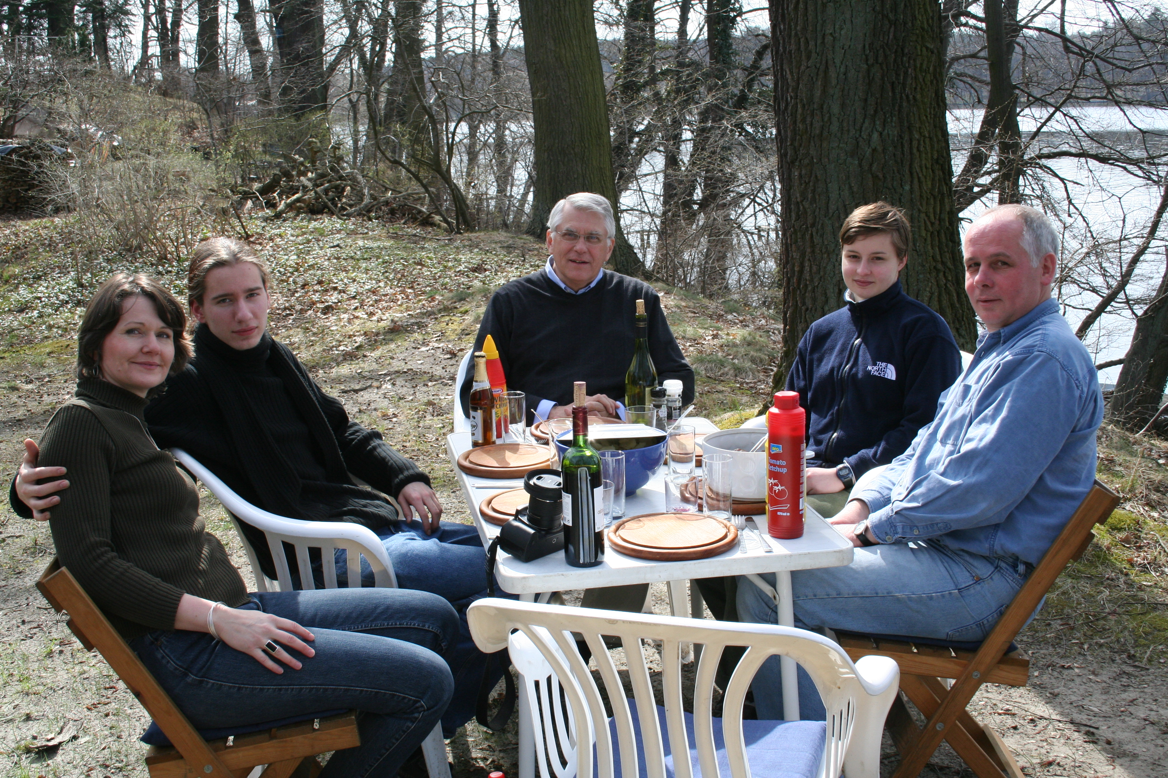
co BB
mit Uta, Sebastian Mascha und Max in Teupitz, 17/4/2006

