СИБИРСКОЕ ОТДЕЛЕНИЕ РАН  ИНСТИТУТ ЯДЕРНОЙ ФИЗИКИ  им. Г.И.Будкера  630090 Новосибирск.  РОССИЯ |  | The Budker INSTITUTE OF NUCLEAR PHYSICS SB RAS  630090 Novosibirsk,  RUSSIA

Models of dipole magnets for LHeC, CERN.

Report
Revised version



Novosibirsk
2010
Models of dipole magnets for LHeC, CERN.

Report
Revised version

1. The purpose of the work, initial requirements. 1
2. Problems and suggested solutions. 1
3. Properties of the anisotropic electric steel. 2
4. Models of magnets. 2
5. Technique of measurements. 3
6. Results of measurements 4
6.1. H-shape magnet. 4
6.2. C-shape magnet. 5
6.2.1. C-shape ⊥ magnet. 6
6.2.2. C-shape║ magnet. 8
7. Summary 9
8. Recomendations. 9
9. Conclusion 10

1. The purpose of the work, initial requirements.
The purpose of the work is a study of the anisotropic (grain oriented grades) electric steel for manufacturing the LHeC dipole magnets with small residual fields. The influence of residual fields on the magnetic field topography is investigated.
The initial data was taken from the MEMORANDUM from 23 July 2009:
Magnetic field@ injection 0.019 T (0.19 kGs);
Magnetic field@ peak energy 0.135 T (1.35 kGs);
Good field horizontal region ±20mm;
Total magnet free aperture 60x35 mm.

2. Problems and suggested solutions.
Isotropic (non grain oriented grades) electric steels used for manufacturing accelerator magnets have a coercive force ~ 40 ÷120 A/m (0.5÷1.5 Oe). The residual magnetization of yokes can substantially change the magnetic field topography, see [1].
We suggest to use the anisotropic electric steel (usually, transformer steel) for manufacturing the magnet yoke. This steel has a coercive force ∼ 5 ÷10 A/m (0.06÷0.125 Oe) along the rolling a direction. Across the direction of rolling, this value is not normalized, but it is a few times higher. We proposed designs of magnets where the direction of magnetic force lines coincides, basically, with the rolling direction of a steel sheet. The construction with a rather expensive and not technological material as ferrite was of only research interest and it was not modeled.
The H-shape magnet model was also of only scientific. The design of the vacuum chamber demands the C-shape magnet. The C-shape magnet design is realized in two versions - with replaceable closing parts of yoke. These details have different directions of a steel sheet rolling.
On the models made by sketches, the changes of the magnetic field topography (change of the field quality in the set area) were studied. The required quality of a field can be achieved after taking decision on the further actions.

3. Properties of the anisotropic electric steel.
The anisotropic steel 3408 of Russian production was used in experiments. The thickness of a sheet is of 0.35 mm with a solid inorganic and thermal resistance coating of ET-type.
The reference value of the coercive force H _{|| c} along the rolling direction is 6 A/m. On special samples, the coercive force H _{|| c} along a rolling direction and H_{⊥c} across a rolling direction have been measured as functions of magnetization fields. Measurements were carried out on both the annealed and annealed samples. Annealing has reduced H _{|| c} and H_{⊥c} approximately by 25 % Measurement results are given in Fig.1.
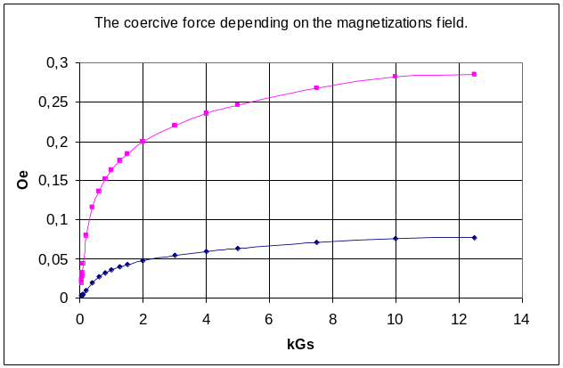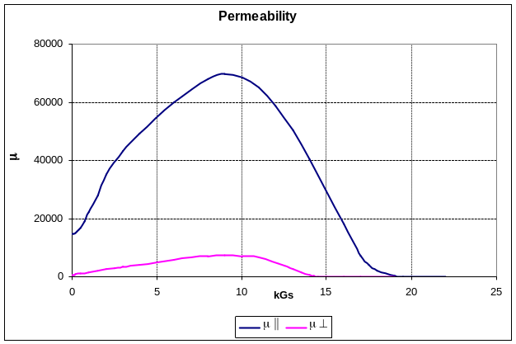
Fig. 1. Coercive force. Fig. 2. Permeability.
H _{|| c} maximum value is 6.1 A/m (0.076 Oe), H_{⊥c} - 22.4 A/m (0,28 Oe).
The anisotropic steel has the minimal permeability and, accordingly, maximal coercive force at an angle 55° to a rolling direction. The coercive force in this direction is approximately 10 % larger than H_{⊥c}. Fig.2 shows the magnetic permeability for two directions with respect to a rolling direction [2].
Magnets are designed with an account of these results. Fig.1 shows that the small residual magnetization can be obtained if the yoke induction is small - 0.1÷0.2 kGs. But it means that the yoke overall dimensions should be ∼10÷15 times larger than the characteristic dimension of the horizontal aperture (it should be ∼1m). The second version is to achieve the yoke induction up to 5÷6 kGs. Thus, the yoke residual magnetization will change slightly at various cycles of operation. This version is accepted for realization.

4. Models of magnets.
Manufactured models of magnets are shown in Figs. 3,4,5,6.

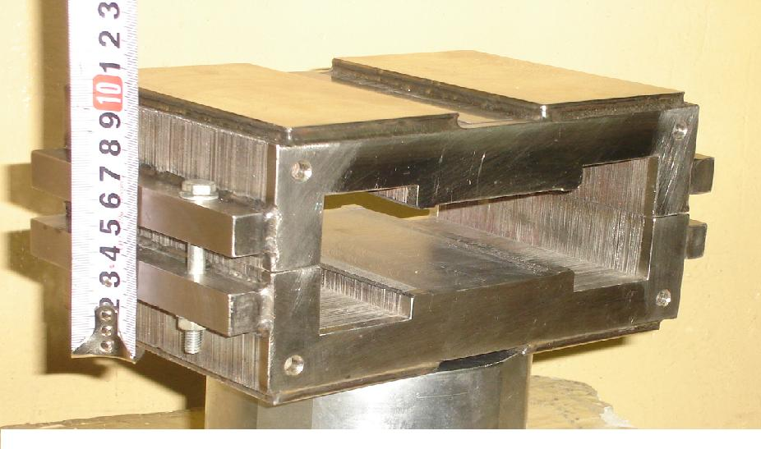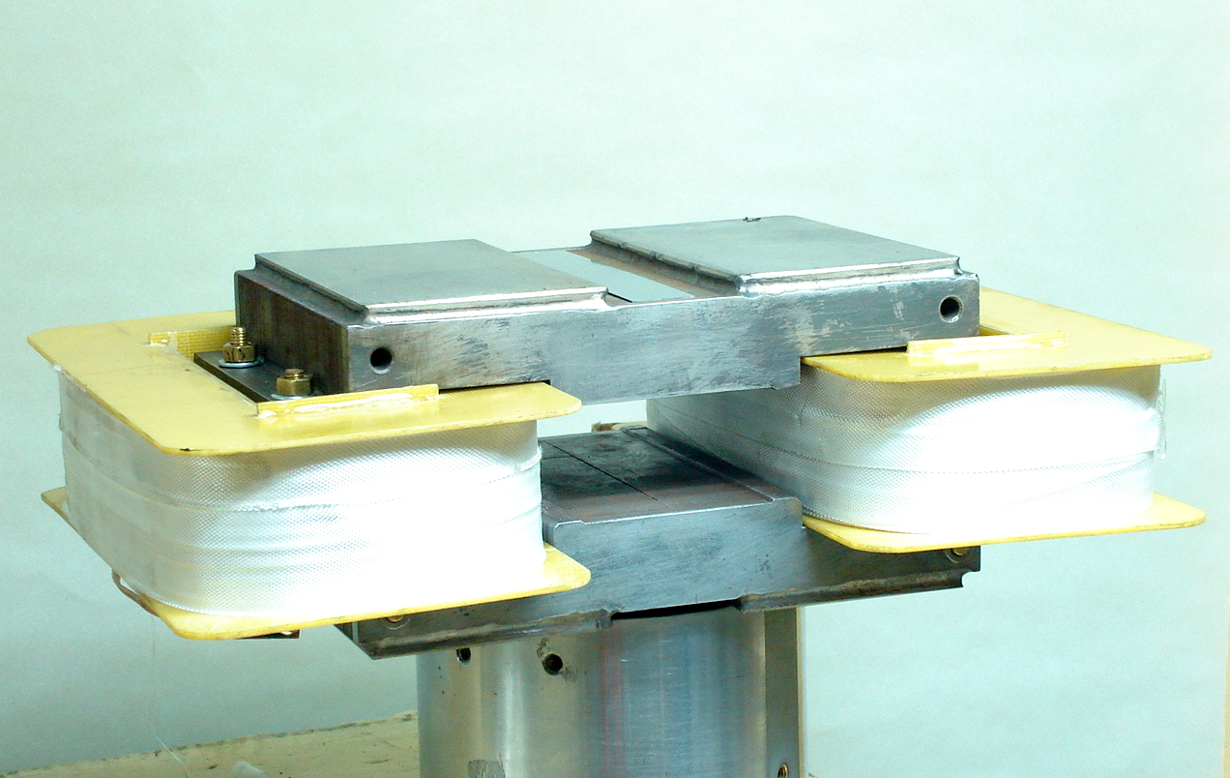
Fig.3. H-shape yoke. Fig.4. H-shape magnet.

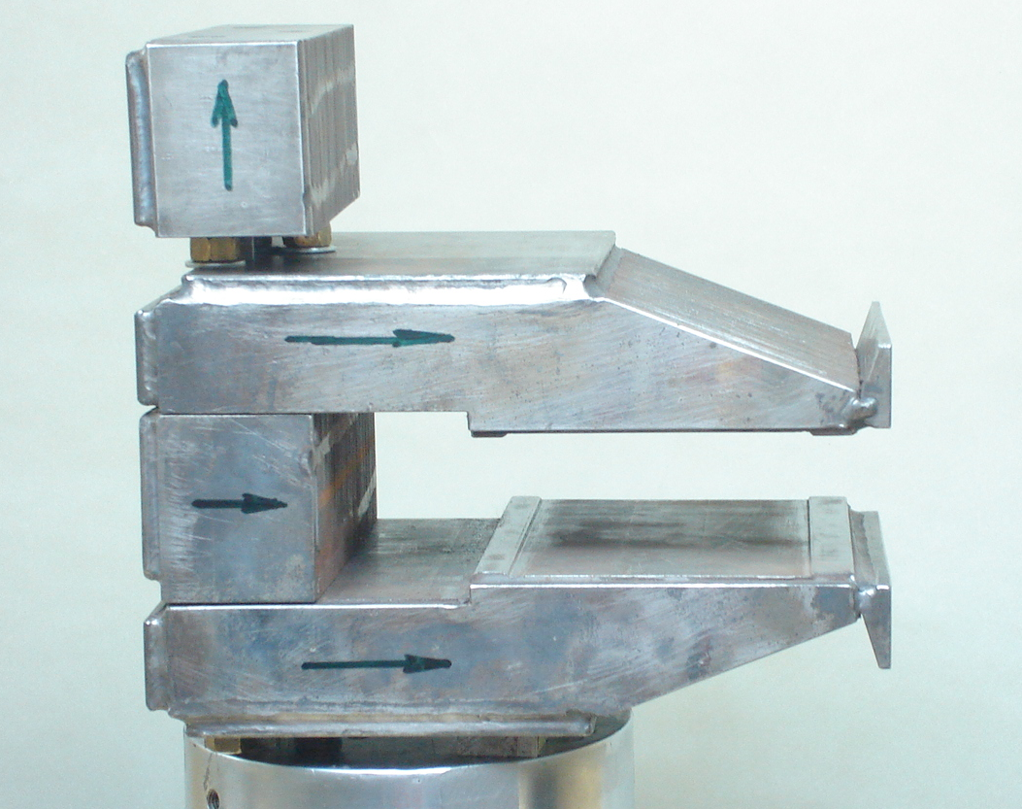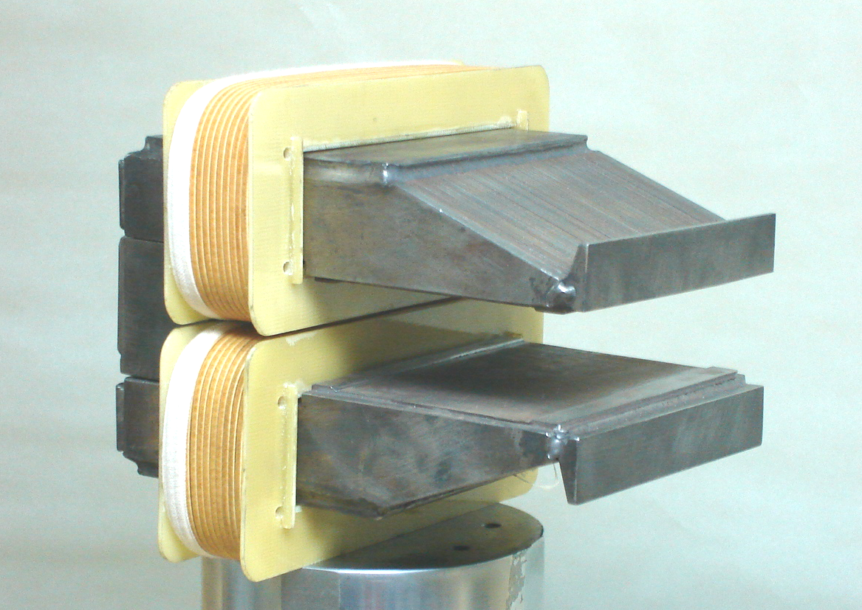
Fig.5. C-shape yoke. Fig.6. C-shape magnet.

Plates with a certain orientation on the rolling direction were preliminary cut. Plates were compressed and fixed by welding to plates made of nonmagnetic steel. The obtained packages were processed on the milling machine tool and annealed. A C-shape yoke has a replaceable part. The yoke length is 120 mm. Excitation coils are not cooled but enable magnetic measurements. Coils of H-shape magnet have 238 turns, H-shape magnet coils have123 turns.

5. Technique of measurements.
Measurements of the magnetic field topography were made by the Hall probes. On the common basis 11 probes (a ruler of gauges) are fixed. A distance between the next two probes (except for extreme) is 5 mm, extreme distances are of 2.1 mm, so the whole measured range is
44.2 mm. The probes were placed in the middle of the magnet aperture and did not move during the entire cycle of measurements. The meat quadratic errors of probes were 0.04 Gs on intrinsic convergence.
Prior to measurements, the magnets were degaussed by AC. At the first field rise, the yoke was magnetized on the normal curve magnetization, see Fig. 7.

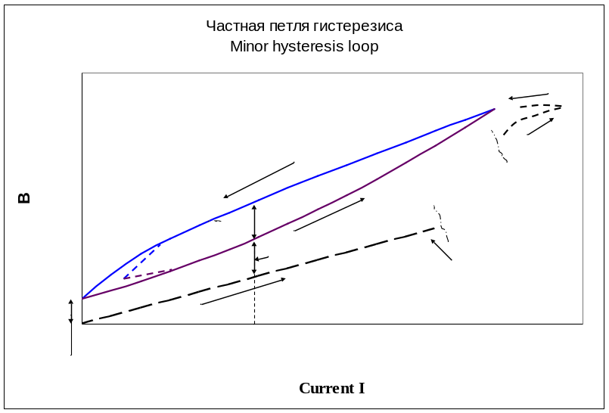

Fig.7. Minor hysteresis loop.
The magnetic field topography was measured at different values of B (I).
Then various cycles on minor hysteresis loops were carried out. The topography on drop-down curve and increasing curve of loops was measured at the same current. Minor hysteresis loops were passed from I=0 and at minimal rating values Bmin=0.1 kGs, 0.2kGs up to maximal rating values B_{max} = 1kGs, 1.4kGs, 1.6 kGs. Cycles were carried out from one to six.

6. Results of measurements.
The most exhaustive results are given for a C-shape magnet with an insert with a rolling direction perpendicular to the force lines, which are of the most practical interest for the further activity.

6.1. H-shape magnet.
Fig. 8 shows a ¼ th part of the magnet section with the topography of magnetic force lines. It is seen that in the core there is no dominant direction of force lines. Therefore the core is assembled alternately from the plates, which have been cut out in two perpendicular directions with respect to the rolling direction. The positive effect caused by such an assembly was obtained in a study of the steel samples.

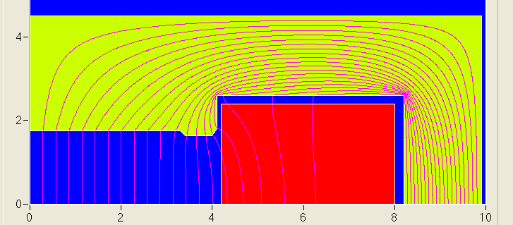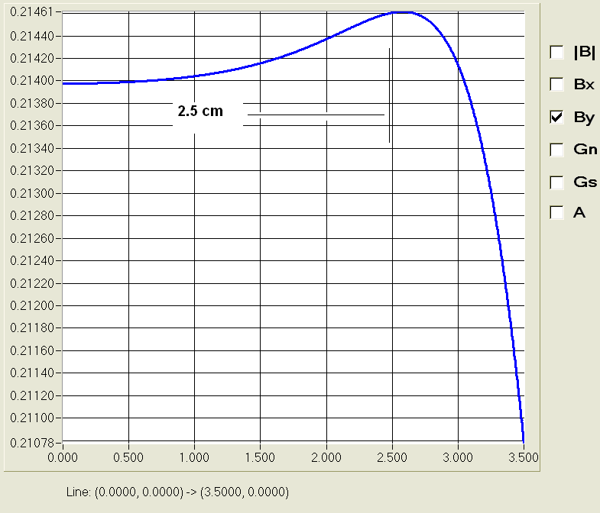
Fig.8. Fig. 9.

Fig. 9 shows the calculated induction distribution in an area ± 3.5 cm taking into account actual sizes of the model. Further calculations and results of measurements are given for an area ± 2.5 cm.
Fig. 10 shows the correspondence of the design and measured results at a nominal field of 0.7kGs. The field topography for other nominal values (from 0.2 up to 1.6 kGs) differs from that given above insignificantly, within the limits of measurement errors.

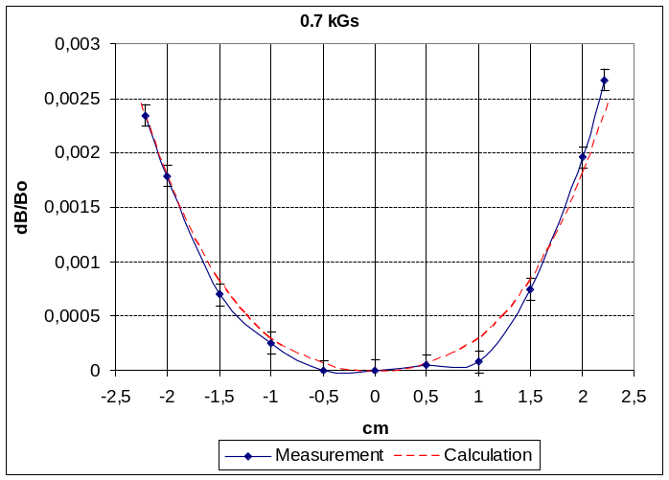
Fig.10.
Figs.11, 12, 13 show the field topography at various levels and cycles of magnetization:

dB_{i}/B = (B_{i} –B₀)/B₀ + ΔB_{hist} /B₀+dB_{hist}/B₀ (1)

where ΔB_{hist} is a height of a loop of a hysteresis, dB_{his} is the difference in a field at initial magnetization and on an increasing curve of hysteresis loop, see Fig. 7. Cycles of magnetization were the following: a degaussed state →1.4 kGs → (I=0)→ 1.4 kGs→ (I=0)….

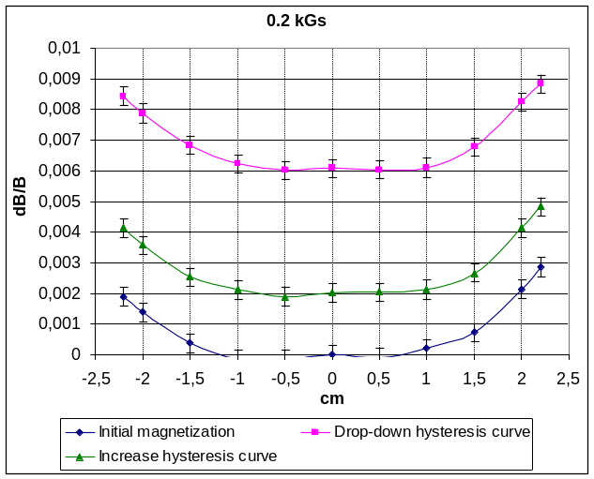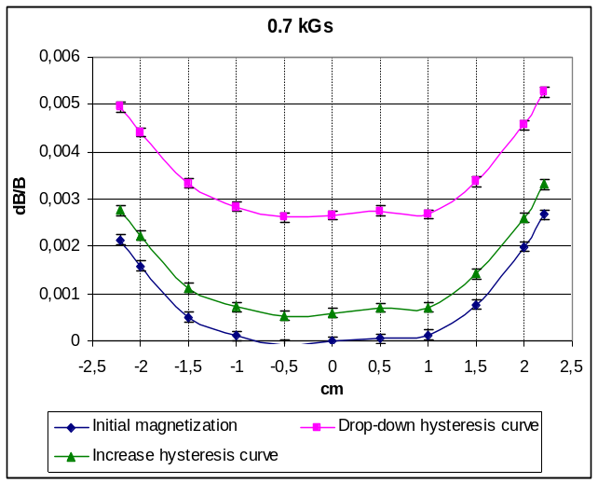
Fig.11. Fig.12.
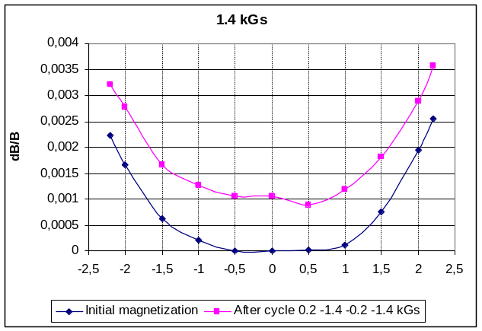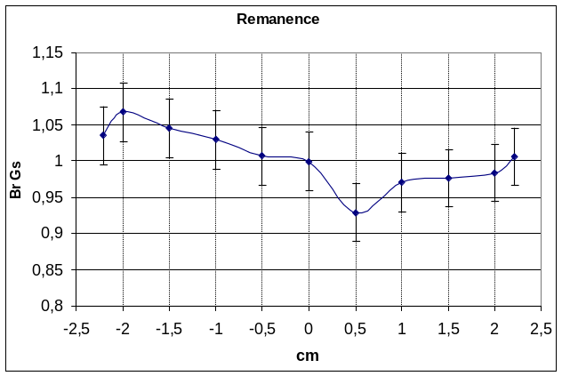
Fig.13. Fig.14.
As is seen from Figure, the relative field topography was not varied within the limits of measurement errors. Only the level of a field was changed.
ΔB_{hist} = 0.8 Gs at B 0.2 kGs and ΔB_{hist} = 1.4 Gs at B 0.7 kGs. dB_{hist} =0.4; 0.4; 1.6 Gs at B 0.2 kGs; 0.7 kGs; 1.4 kGs, respectively. The residual magnetization is B_{r} =1.0 Gs, as shown in Fig. 14.
At other nominal values B and other magnetization cycles, results obtained are similar.

6.2. C-shape magnet.
Fig. 15 shows a half section of a magnet with the topography of the magnetic force lines. It is seen that in the yoke there are two sites with a primary direction of force lines. The top green site was made of plates with a horizontal rolling direction. The yellow closing removable part of the yoke is made in two versions - with a rolling direction perpendicular to the force lines (C-shape ⊥) and along them (C-shape ║).

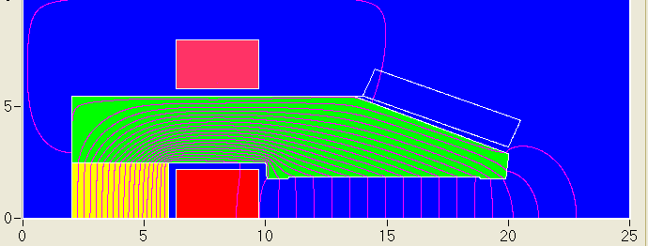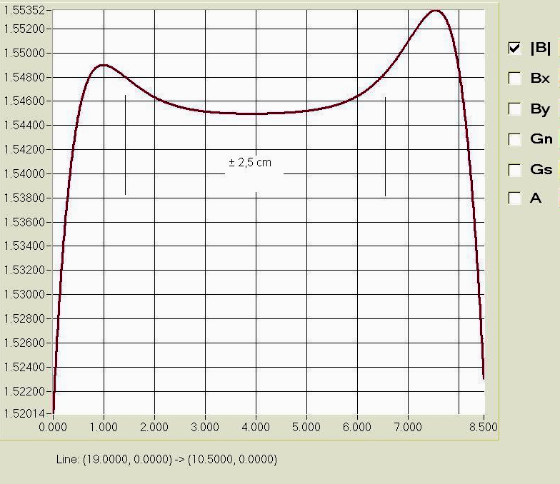
Fig.15. Fig. 16.

Fig.16 shows the calculated induction distribution in the range of 8.5 cm taking into account
actual sizes of the model. Further calculations and results of measurements are give3n for the range ± 2.5 cm.

6.2.1. C-shape ⊥ magnet.
Figs. 17-20 show the correspondence of the calculated and measured results at nominal fields 0.2, 0.5, 1.0, 1.5 kGs.

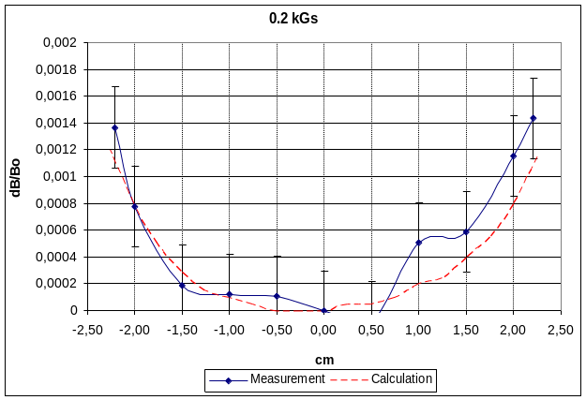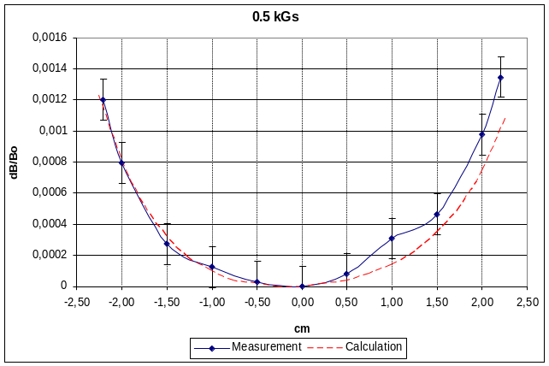
a) b)
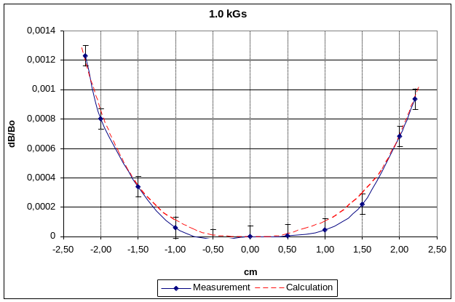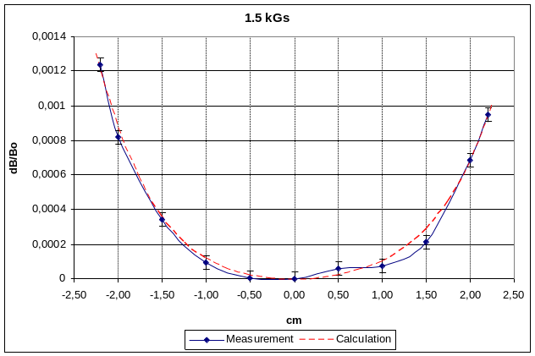
c) d)
Fig.17. Calculated and measured results.
Measurements are made at different cycles of magnetization. In cycles, values B_{min} and B_{max} are changed (see Fig. 7). Cycles are executed: B_{min} =0.1 kGs → B_{max}=1.0 kGs; B_{min} =0.1 kGs → B_{max}=1.6 kGs; B_{min} =0.2 kGs → B_{max}=1.4 kGs. Each cycle was carried out several times. "Stabilization" of fields (within the limits of measurement error) occurred after three - four cycles.
Fig. 18 shows the field topography at various levels and cycles, a) ÷c) according to (1), d) - quality of a field without taking into account a displacement of its level (without ΔB_{hist} and dB_{hist}).

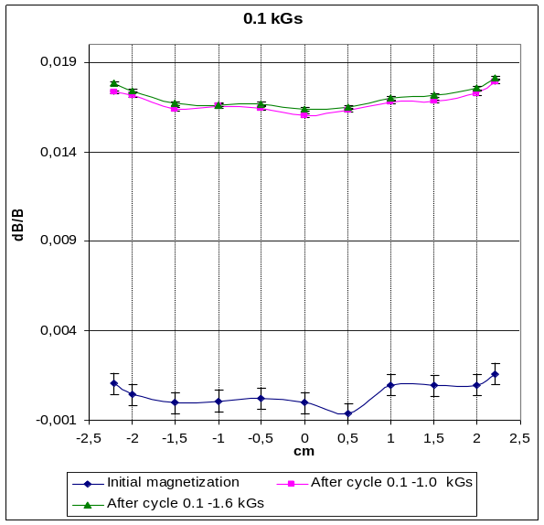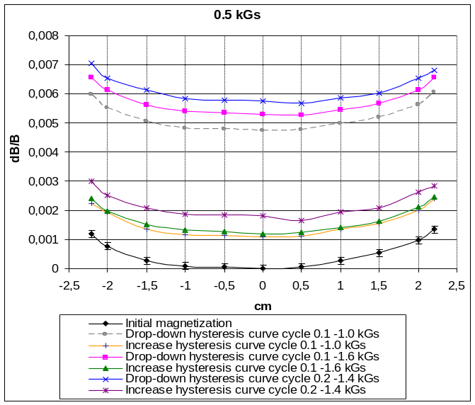
a) b)
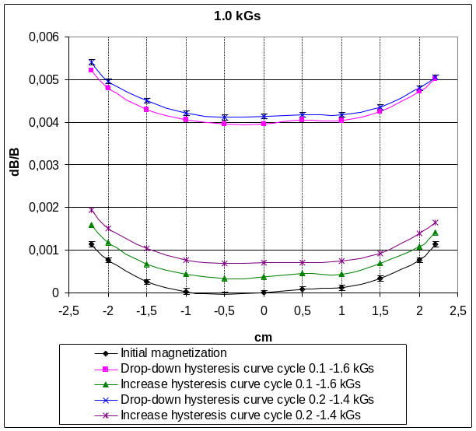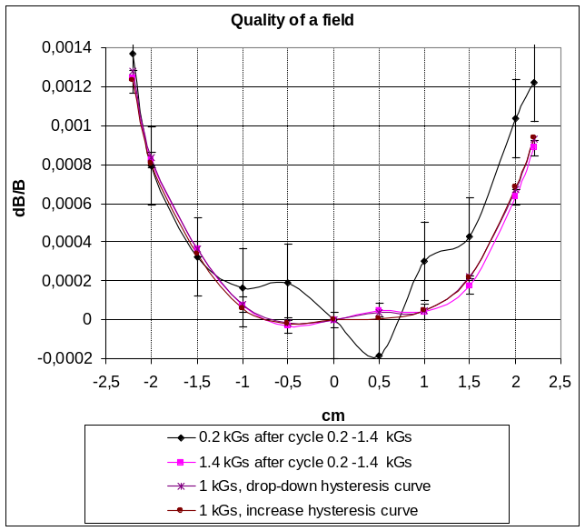
- d)
Fig. 18. Relative field topography.
Given results show that the relative field topography is not changed within the limits of measurement errors. The field level changes only. Thus, it is seen that the change level depends on changes in B_{min} more considerably, than that of B_{max} on hysteresis loops. Recurrence of a field level after 6 cycles B_{min} =0.2 kGs → B_{max}=1.4 kGs was 0.04÷0.05 Gs.
Fig. 19 shows the residual magnetization B_{r}. Another experiment shows that B_{r} does not increase with the growth of B_{max} up to 2 kGs. It indicates that H _{|| c} and H_{⊥c} are close to limiting values, see Fig.1.

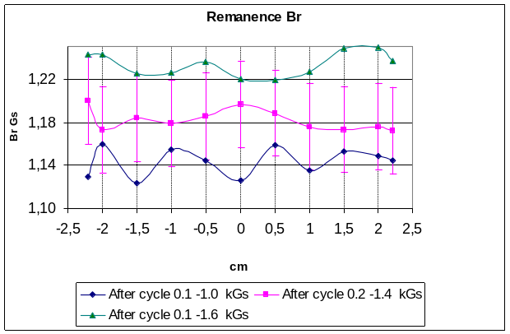
Fig. 19. Remanence B_{r} .
For the planned operating cycle B_{min} =0.2 kGs → B_{max}=1.4 kGs ΔB_{hist} = 1.9 Gs at B= 0.5 kGs and ΔB_{hist} = 3.3 Gs at B =1.0 kGs; dB_{hist} =0.9 Gs and 0.7 Gs , respectively. The residual magnetization is B_{r}=1.23Gs.

6.2.2. C-shape║ magnet.
Similar measurements have been performed for the C-shape║ magnet and similar results are obtained. Some of them are shown in Fig. 19.
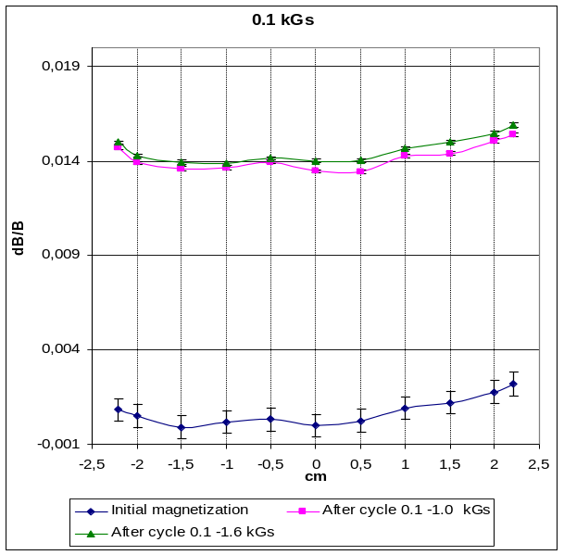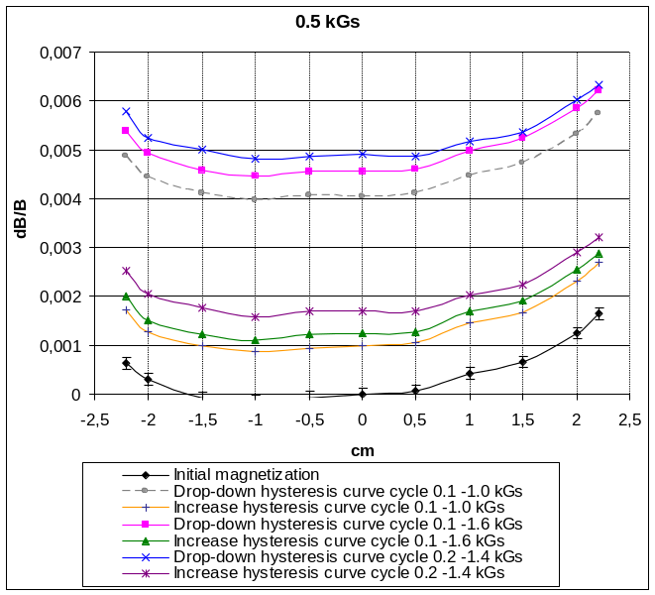
a) b)
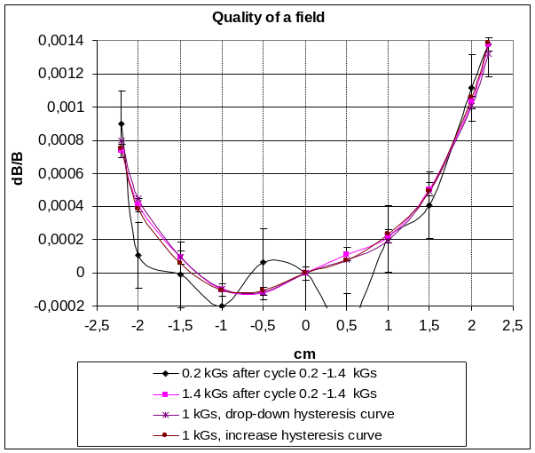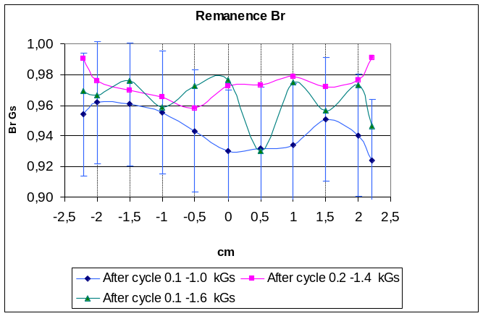
c) d)
Fig.19. Relative field topography and remanence.
The features of curves insignificantly differ from those of curves for the C-shape ⊥ magnet thus indicating that replaceable parts of the yoke on model insignificantly differ on parallelism of horizontal flat surfaces (not parallelism ≈ 0.04 mm). But the field quality is also kept at various modes.
Difference C-shape║ magnet from C-shape ⊥ magnet consists in smaller values of ΔB_{hist} , dB_{hist} , B_{r max} . Minor hysteresis loops are narrower and closer to the normal magnetization curve. For the planned operative cycle, B_{min} =0.2 kGs → B_{max}=1.4 kGs ΔB_{hist} = 1.5 Gs at B 0.5 kGs and ΔB_{hist} = 2.9 Gs at B 1.0 kGs, dB_{hist} =0.8 Gs and 0.8 Gs, respectively. Residual magnetization is B_{r max} =0.97 Gs.

7. Summary
Test results are summarized in the Table.

Magnet shapes | B_{r max}  Gs | ΔB_{hist} Gs  at B =1kGs | dB_{hist}  Gs | Preservation  of field quality | Opportunities on realization
H-shape | 1.0 | 2.2 | 0.7 | OK | Problems with the vacuum chamber
C-shape ⊥ | 1.23 | 3.3 | 0.9 | OK | Preferable to manufacture
C-shape║ | 0.97 | 2.9 | 0.8 | OK | More difficultly for manufacturing

The selected type of steel and design of magnets provide keeping the magnetic field topography at operating cycles. The small residual magnetization does not cause the occurrence of a field gradient observed in Ref.[1.] The C-shape ⊥ and C-shape║ magnets differ insignificantly in the residual magnetization.

8. Recomendations.
In connection with all stated above, it is suggested to consider the following design of a magnet. C-shape ⊥ magnet is selected, see Fig. 20.

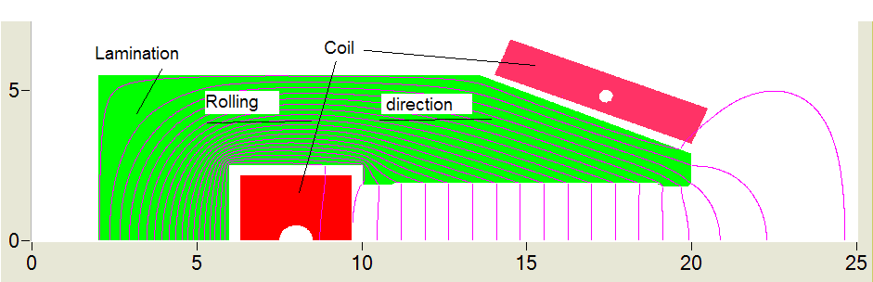
Fig.20.

The magnet yoke has symmetric top and bottom halves. Laminations are stamped as shown in Fig.20. The halves are fastened by stud pins passing through the closing part of the yoke as that in the C-shape models. The coil has one turn inside the yoke and two branches connected in parallel by current outside of yoke. Such a design is compact, has the minimal scattered field (hence - the minimal inductance). Isolation of a conductor is inorganic, plasma spraying of aluminum oxide; proof to radiation. Fastenings of a conductor are also made of inorganic insulation materials.

Weight per meter of magnet ∼ 160 kg/m.
Maximum current ∼ 4 kA.
Running inductance 0.045 mH/m.
Running thermal capacity 385 W/m at the maximal field.

For a magnet of ∼ 15м in length:
Inductance ∼ 0.7 mH.
Voltage drop on one conductor 0.72 V at the maximal field.
Thermal capacity ∼ 6 kW at the maximal field.

At the pressure drop of 4 bar, the temperature drop in cooling water is ∼10° C.
The magnet consists of four straight sections. Sagitta ∼1 mm. Sections are joined at an angle. At fastening each quarter of a magnet in points of the least deflection, the design rigidity will provide maximal bending of ∼0.1 mm.
It is possible to use LEPs bus-bars for magnet to magnet connections (if available).

9. Conclusion
BINP it is ready for the further cooperation with CERN on the design and manufacture of the dipole magnets LHeC.

[1]. LEP DESIGN REPORT VOL.II, p. 53; CERN-LEP/84-01
[2]. Cold-roll electrotechnical steels. Reference Book edited by B.V.Molotilov. Moscow. 1989.

Report is prepared by Yu. A. Pupkov on 30/07/2010

Pupkov@inp.nsk.su
Yurpupkov@mail.ru

