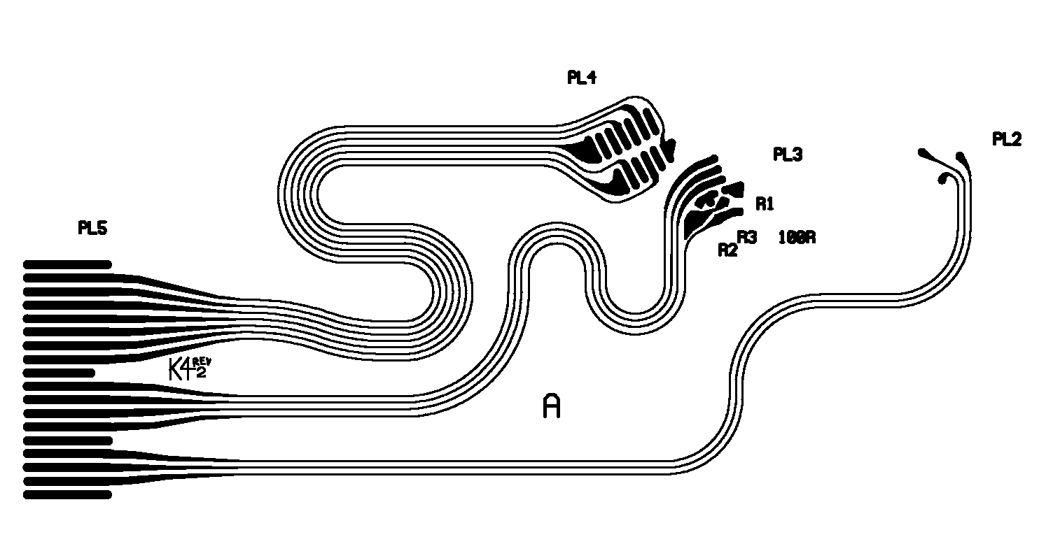
1 x 100Ω (0603 package)
2 x 4K7 (0603 package)

